Surface modification of alumina nanoparticles: A dispersion study in organic media

Esmaiel Soleimani*, Narges Zamani

Inorganic Chemistry Research Laboratory, Faculty of Chemistry, Shahrood University of Technology, Shahrood, IRAN

Abstract The alumina NPs have been synthesized from reaction between alum with ammonia and then calcined the precipitate at 1200 °C for 4 h. Its surface was modified by oleic acid (OA) and trimethoxyvinylsilane (TMVS) in o-xylene at 50 °C. The alumina NPs and its modified were characterized by XRD, FT-IR, SEM, EDX and TGA. The TGA analysis indicates that the grafting amount of OA and TMVS are 6.8 and 4.3 % respectively. The dispersion of modified NPs was determined in monomers such as methyl methacrylate (MMA), butyl acrylate (BuA) and styrene (St) and in solvents such as ethanol, hexane and acetone. The experimental results showed that the highest dispersion was happened NPs modified by oleic acid in n-hexane, while the highest dispersion was observed NPs modified by TMVS in acetone. The results indicate that NPs modified by oleic acid formed a stable dispersion in MMA and BuA. The highest amount of dispersion happened NPs modified by oleic acid in MMA and BuA in initial weight of 5 % and 2.5 % respectively, while stable dispersion is formed in styrene when TMVS is used as modifier. The highest amount of dispersion was happened NPs modified by TMVS in styrene in initial weight of 2.5 %.
Keywords: Surface modification; alumina nanoparticles; oleic acid; trimethoxyvinylsilane; dispersibility; lipophilic degree
RUNNING TITLE: SURFACE MODIFICATION OF ALUMINA NANOPARTICLES
*Corresponding author; Tel-fax: 98 23 32395441,
E-mail: essoleimani@shshroodut.ac.ir; ssoleimani64@gmail.com
1. Introduction
In recent decades, the superfine particles in the nanoscale were of great interest due to their high surface area.^{1,2} Nano-sized ceramic powders, because of their excellent properties such as structural, optical and electrical behavior are effective in many fields.³⁻⁵
Alumina is an important component of ceramic oxides. Alumina due to the cheapness and having good mechanical and optical properties used in the chemical industry, metallurgy, pharmaceutical and food industries.^{6,7} Al₂O₃ has been widely used as catalyst and catalyst support, and also it has extensive applications in ceramic industry and structural composites.⁸
The Surface of mostly ceramic NPs such as alumina is polar and hydrophilic nature. That's why they do not disperse in organic environments. This feature prevents their use in the industry. This limitation can be overcome by modifying their surface by appropriate modifiers. Fatty acids are used as modifiers for surface NPs.⁹⁻¹¹
The surface of SiO₂ NPs was modified by oleic acid. Oleic acid was connected through an ester bond to the surface of nano-SiO₂. Results showed the modified NPs dispersion capabilities in non-polar solvents such as petroleum or mineral oils.¹²
The surface modified ZnO NPs increases dispersibility NPs in organic solvents and reduces photocatalyst behavior. To do this, the surface of ZnO NPs was modified through using plasticizers silane (γ-methacryloxypropyltrimethoxysilan) and modified by polystyrene. Experimental results showed good dispersion of NPs in non-polar solvents such as acetone after surface modification.¹³
The surface HfO₂ NPs was modified by oleic acid. The presence of organic groups on the surface of the hafnium oxide NPs was proved by FT-IR spectra, and it indicated that oleic acid is attached to the carboxylate form on the surface of the HfO₂ NPs. The surface of NPs changed from hydrophilic to hydrophobic by surface modification, so they were dispersed well in hexane.¹⁴
The nanocomposites containing nonaggregated nanoparticles were functionalized by two coupling agents, citric acid and ascorbic acid. Surface morphology indicated a picturesque network structure due to the existence of hydrogen bonds in the modiﬁed Al₂O₃. It also proved good dispersion of modified NPs in the polymer matrix.¹⁵
The surface of alumina NPs was modified using epoxy-containing alkoxysilanes. Coupling of organic groups onto the surface of oxides using alkoxysilanes occurs via the formation of Si-O-M or metallasiloxane bonds. The surface modification decreased the thermal stability of alumina, in comparison with pristine alumina NPs.¹⁶
The surface of Al₂O₃ NPs was modified using vinyltrimethoxysilane (VTMS) layer. Analyses revealed that the silane coupling successfully adsorbed on the surface of nano Al₂O₃ via chemical interaction. Results show that nanocomposite with 3 % VTMS was in good agreement with the storage modulus and glass transition temperature values revealed by DMTA analysis.¹⁷
Several protocols reported for the surface modification of Al₂O₃ NPs, In this regard, different surfactants and organic compounds such as a silane coupling agent, isocyanate group, stearic acid, dimethyl sulfoxide, and acetic acid have been used as modifying agents.¹⁸⁻²¹ To the best of our knowledge, there is no report on the comparison of the effectiveness of different modifiers for Al₂O₃ NPs and their compatibility in various organic solvents.
In this study, the surface of alumina NPs was modified by two modifiers such as oleic acid (OA), trimethoxyvinylsilane (TMVS), as well as a mixture of two modified in three ratio (3:1), (1:1) and (1:3). Then the dispersibility of modified NPs was investigated in monomers such as methyl methacrylat (MMA), butyl acrylate (BuA) and styrene (St) and also in solvents including acetone, n-hexane and ethanol with different levels of hydrophobicity.

2. Experimental
2.1 Material and Methods
In this work, the chemicals such as trimethoxyvinylsilane (TMVS), oleic acid (OA), ethanol, n-hexane, o-xylene, ammonia (25 %) and acetone were used as purchased by the chemical company (Merk) without any purification. Alum was prepared in our laboratory according to literature.
The X-ray diffraction patterns (XRD) of powder samples were recorded by XRD system BRUKER-XS for characterizing the crystalline structure of the nanocomposites (NCs). The XRD diffractometer is operated at a voltage of 40 kV and Cu Kα radiation over Bragg angles ranging from 10 to 80° with the scanning rate of 0.05 °C min⁻¹. The surface morphology of samples was recorded using SEM, Hitachi Gapan, and TESCAN model. The instrument was equipped with EDX analysis for the determination of elemental analysis. The EDX model and its detector type were S4800 (I) and 7747/17-ME, respectively. The FT-IR spectra of the samples were recorded on FT-IR Rayleigh WQF-510 a spectrophotometer. The spectra of solids were obtained using KBr pellets. Ultrasonic irradiation was carried out with an ultrasonic equipped with a probe which was immersed directly in the mixture solution system with frequency of 2.25 × 104 Hz and power of 100 W. Thermo-gravimetric analysis (TGA) was carried out on a TG-209 thermo-analyzer (Netzsch, Germany), oxygen atmosphere, heating rate 10 °C min⁻¹. An electric furnace of Raypa with HM-9 model was used for calcimining samples.
2.2 Preparation of Al₂O₃ NPs
The alumina NPs precursors were synthesized by the precipitation method and then calcination sediment. Firstly, 25 mL of 3.0 M ammonia solution was dropped gradually and slowly into 25 mL of ammonium alum [(NH₄)Al(SO4)₂·12H₂O] 1.0 M with vigorous stirring for 45 minutes. After a vigorous stirring for an hour, the reaction mixture was heated to 95 °C and then kept at that temperature for 3 hours for precipitation. The precipitate obtained was first washed three times with distilled water and then washed three times with anhydrous alcohol and then dried in an oven at 60 °C within 10 hours. Finally, the dried precipitate was then calcined at 1200 °C for 4 hours with a heating rate of 5 °C min⁻¹. After cooling in the room temperature, the samples were milled and collected for characterization.
2.3 Surface modification of Al₂O₃ NPs
The experimental method of surface modification of alumina NPs using both modifiers oleic acid (OA) and trimethoxyvinylsilanes (TMVS) is the same as follows:
1.5 g of oleic acid (or TMVS) was dissolved in 50 ml of o-xylene and then 3.0 g of alumina NPs were added to it. The resulting suspension is heated at 50 °C within an hour along with magnetic stirring. The precipitate was centrifuged, and washed three times with 5 ml toluene. Precipitate was dried in the oven at 60 °C in 24 hours.
2.4 Effect of modifiers concentration
Using the above method, various amount of oleic or TMVS (0.025, 0.05, 0.15, 0.25, 0.35 and 0.45, 0.50 g) were dissolved in 10 ml o-xylene, and each solution was used in turn for modifying 1.0 g samples of Al₂O₃ NPs, and was stirred at 50 °C for an hour. The sediments were separated, washed three times with 5 ml toluene and dried in the oven at 60 °C in 24 hours. Lipophilicity of modified alumina NPs were carried out as below:
First 0.1 g of modified alumina NPs is added to 10 ml water. Then methanol is added drop wise through a burette to these floated NPs until no more sediment are formed. The volume of methanol is used to calculate the degree of lipophilicity of the surface of NPs.
2.5 Measurement of lipophilic degree
One way to measure the lipophilic degree (LD) of the surface of NPs is dispere a certain amount of modified NPs in water, and then to carry out titration with an organic solvent such as methanol.²²
When unmodified alumina NPs are added to water, sedimentation takes place promptly, whereas the alumina NPs modified by oleic acid (or TMVS) will float on the surface of water. Drop wise addition of methanol from a burette to a solution of modified NPs (0.1 g in 10 ml water) causes the modified NPs to sediment gradually. The degree of lipophilicity can be calculated using equation (2-1) by knowing the volume of the methanol used:
LD = {V/(V+10)} × 100 (2-1)
In this equation, V is the volume of methanol (mL) used. Measuring the degree of lipophilicity is used as a guide for surface modification.
2.6 Dispersibitity modified alumina NPs
0.05 g of modified alumina NPs were dispersed in 10 mL of solvents such as n-hexane, ethanol and acetone, and was then ultrasound within 30 minutes. Then, the samples were allowed to stand without shaking for 72 hours in the lab, the particles were deposited. The precipitate then was centrifuged and dried in the oven at 60 °C in 24 hours. The amount of stable particles in dispersion was determined gravimetrically (%). The initial weight percent of the modified alumina NPs varied from 2.5 to 30 %.

3. Results and Discussion
The Al₂O₃ NPs have been synthesized through chemical precipitation method from reaction between ammonium alum [NH₄Al(SO₄)₂·12H₂O] with ammonia solution and then calcined the precipitate at 1200 ºC during 4 hours. The reaction equations are as follows:
NH₄Al(SO₄)₂·12H₂O $\underset{→}{Dissolution in water }$ NH₄⁺_{(aq)} + Al³⁺_{(aq)} + SO₄²⁻_{(aq)} +12 H₂O_{(l)} (3-1)
NH_{3 (aq)} + H₂O _{(l)} NH₄⁺ _{(aq)} + OH⁻_{(aq)} (3-2)
Al³⁺_{(aq)} + 3 OH⁻_{(aq)} Al(OH)₃ _{(s)} (3-3)
$2 Al{(OH)}_{3 (s)}\underset{→}{calcined 1200 ℃, 4 h } Al\text{2}O\text{3 (s)} +{3 H}_{2}O \text{(g)}$ (3-4)

Preparation method of Al₂O₃ NPs is of unique advantages. Nanoparticles are obtained from inexpensive and easily available precursors, and without needing surfactants (surface active). The surface of alumina NPs was modified by two modifiers such as oleic acid (OA), trimethoxyvinylsilane (TMVS), as well as a mixture of two modified in three ratio (3:1), (1:1) and (1:3).
In order to confirm that the surface of alumina NPs is covered by the modifiers, the surface was studied by the usual methods of identification and morphology consideration.

3.1 X-ray Diffraction pattern
The X-ray diffraction pattern of alumina NPs before and after modification by oleic acid and TMVS were recorded, and results are presented in Fig. 1. The eight characteristic angles viz 2θ equal to 18.8, 32.9, 34.9, 36.9, 39.4, 45.6, 61.2 and 67.2 degrees, which correspond well to the standard JCPDS card with number 29-1486, confirms that the crystal structure of Al₂O₃ is tetragonal.^{23,24} Figs. 1b and 1c show that the characteristics of peaks after surface modification have not changed, and are the same as those of unmodified nano-alumina with tetragonal crystal structure. The average size of Al₂O₃ NPs modified by oleic acid and TMVS calculated from XRD diffraction pattern according to Debye-Sherer formula are 29.08 and 30.04 nm respectively.
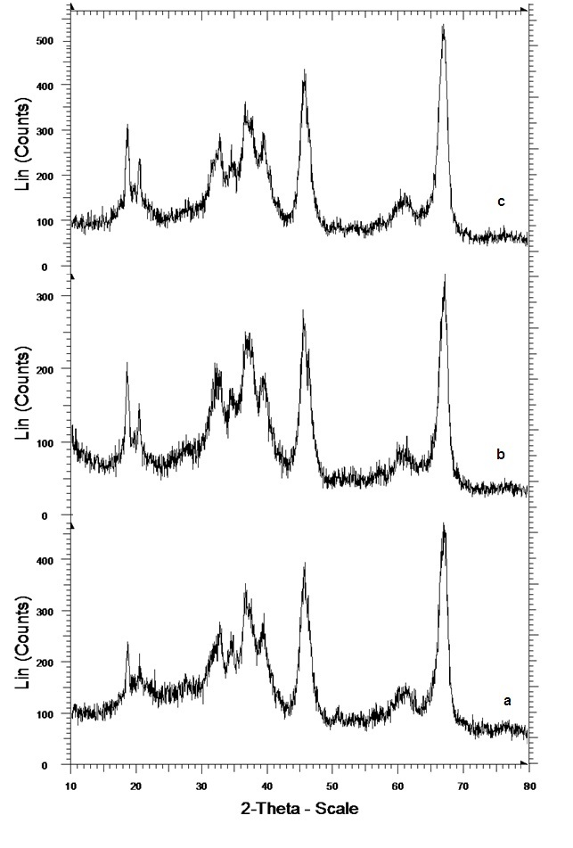Fig. 1 XRD diffraction patterns of: (a) Al₂O₃ NPs; (b) Al₂O₃ NPs modified by oleic acid; (c) Al₂O₃ NPs modified by TMVS.
3.2 FT-IR spectra
In order to study the bonds formed, FT-IR spectra of NPs were recorded before and after surface modification by oleic acid and TMVS. These spectra are shown in Fig. 2. The observed band at 672 cm⁻¹ in FT-IR of unmodified NPs (Fig. 2a) is due to stretching frequency of Al-O in Al₂O₃.²⁵ The broad peaks at around 3442 and 1630 cm^{–1} are attributed to the stretching and bending bands of O–H groups on the surface of alumina, respectively.^{26,27}
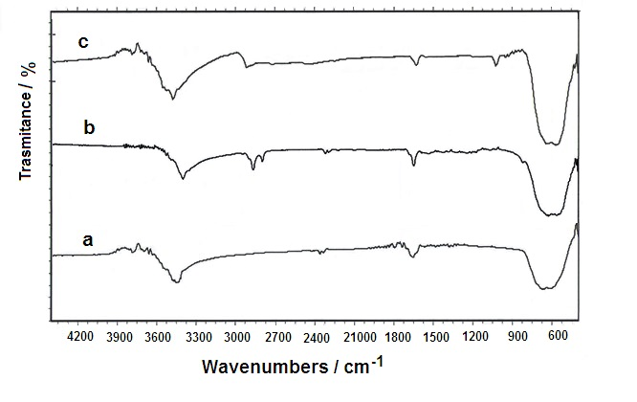Fig. 2 FT-IR spectra of: (a) bare Al₂O₃ NPs; (b Al₂O₃ NPs modified by oleic acid; (c Al₂O₃ NPs modified by TMVS.
In the FT-IR spectra of nano-alumina modified with oleic acid (OA) and trimethoxy-vinylsilane (TMVS) in Figs. 2b and 2c, in addition to the absorption bands of vibration frequencies Al-O and -OH groups, new bands were observed. Two absorption bands at 2854 and 2924 cm^{–1} (Fig. 2b) are due to the vibrational frequencies of CH₂ and CH₃ groups of oleic acid covering the surface of nanoparticles.²⁸ An absorption band at 1625 cm⁻¹ (Fig. 2c) is related to the presence of vinyl double bonds (C=C) of trimethoxyvinylsilane coated on the surface of alumina NPs.²⁹ The observed band at 1016 cm⁻¹ is due to the stretching frequency of Si-O in silane.³⁰ These observations in FT-IR spectra confirm that the surface of Al₂O₃ NPs is modified by oleic acid and TMVS.
3.3 SEM Images & EDX Analysis
Nanoparticles have a tendency to aggregate because of high surface energy. Therefore, surface modification is expected to decrease aggregation and improve dispersibility.³¹⁻³³ Thus, to studying dispersibility, SEM images of alumina nanoparticles before and after modification by oleic acid and TMVS have been recorded which are shown in Fig. 3. As it can be seen in Fig. 3a, alumina unmodified NPs are highly aggregated which is due to large surface area to volume ratio and high energy of the surface of nanoparticles. Whereas in Figs. 3b and 3c good dispersibility can be seen which are due to modification of NPs by oleic acid and TMVS respectively? This improvement in dispersibility of NPs certainly confirms the surface modification of NPs by oleic acid and TMVS.

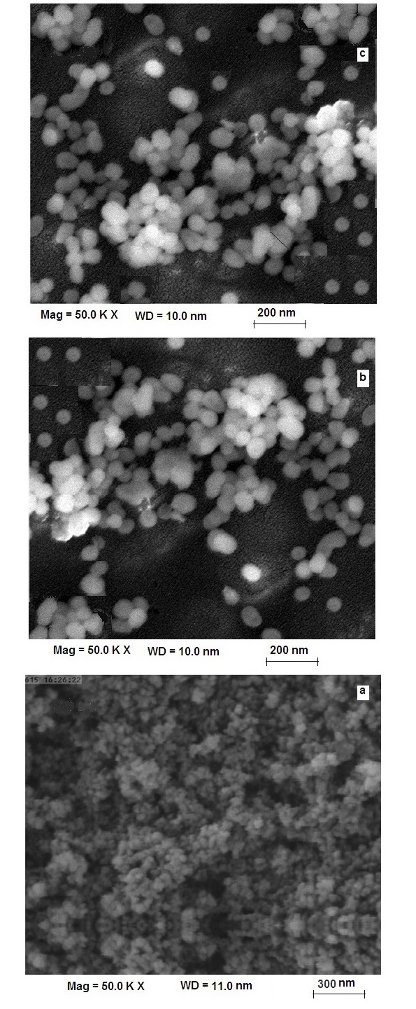
Fig. 3 SEM images of: (a) Al₂O₃ NPs; (b Al₂O₃ NPs modified by oleic acid; (c Al₂O₃ NPs modified by TMVS.
The EDX spectra of Al₂O₃ NPs and its modified by oleic acid and TMVS are shown in Fig. 4. The EDX spectrum given in Fig. 4a shows the presence of Al and O as the only elementary components of Al₂O₃ NPs. The presence of carbon and oxygen in alumina NPs modified by oleic acid (Fig. 4b), and presence of carbon, oxygen and silicon in alumina NPs modified by TMVS (Fig. 4c) are the proof for surface modification of Al₂O₃ NPs respectively, and which were absent in bare alumina NPs.

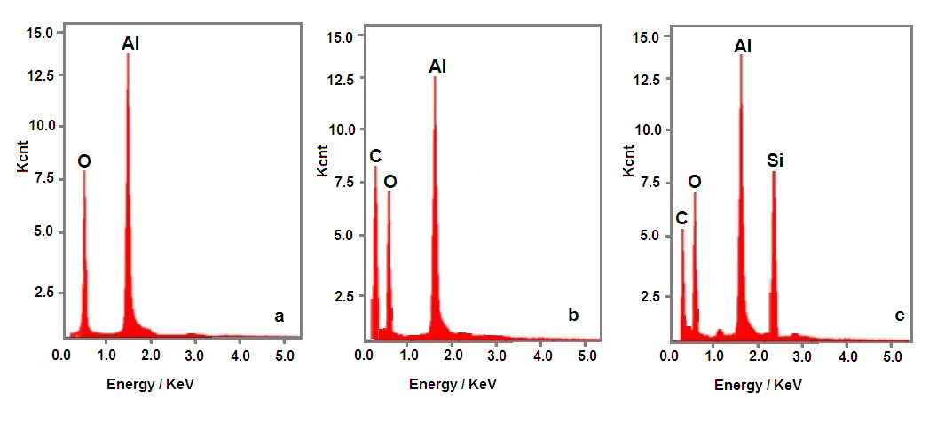
Fig. 4 EDX spectra of: (a) Al₂O₃ NPs; (b) Al₂O₃ NPs modified by oleic acid; (c Al₂O₃ NPs modified by TMVS.

3.4 TGA Analysis
TGA analysis is taken to prove that how many of modifier is grafted on the surface of nanoparticles. TGA curves alumina NPs and its modified by oleic acid and TMVS are given in Fig. 5. For un-modified alumina, there is a weight loss of 10.7 % when the sample is heated from 220 to 430 °C, which is due to the removal of physically adsorbed water, and the decomposition of hydroxyl groups on surfaces (Fig. 5a). The alumina NPs modified by oleic acid has a total weight loss of 17.5 %, when the temperature changes from 248 to 450 °C, which may be caused by the removal of physically adsorbed water, and the desorption of oleate in the modified alumina NPs (Fig.5b). The similar behaviour was observed in alumina NPs modified by TMVS, with a total weight loss of 15 %, when the temperature changes from 275 to 485 °C, which may be caused by the removal of physically adsorbed water, and the desorption of silane compound in the modified alumina NPs (Fig. 5c). Compared with un-modified alumina NPs, the total weight losses of the hydrophobic alumina NPs indicate that the grafting amount of oleic acid and TMVS are 6.8 and 4.3 % respectively.

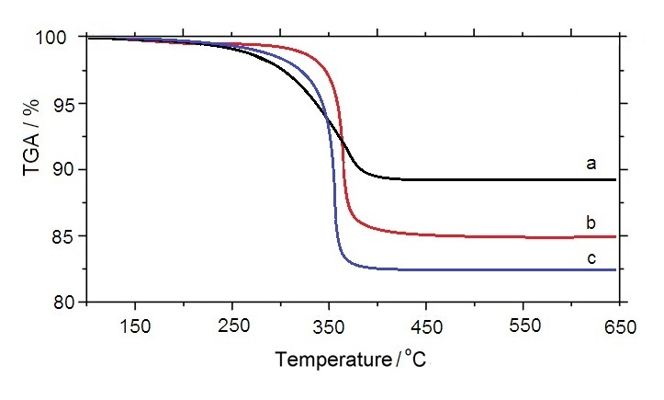
Fig. 5 TGA thermo-gram of: (a) un-modified alumina NPs; (b) alumina NPs by oleic acid; (c) alumina NPs by TMVS.

3.5 The amount of surface modifier
Different amount of oleic acid and TMVS (2.5, 5.0, 7.5, 10.0, 12.5, 15.0 and 20%) as surface modifier were applied on alumina NPs, and the lipophilic degree (LD) of the modified NPs was measured. The results obtained are presented in Table 1 as the variation of lipophilic degree versus amount of modifier. It can be seen from data that lipophilicity increases with the rise of amount of modifier up to 12.5 % for oleic acid, and 10.0 % for TMVS. However, if the amount of modifier is increased above this amount the lipophilicity starts to decrease. It may be due to enlarging of chain hydrocarbon of the modifier which can stop the carboxylic group (-COOH) of oleic acid or methoxy moiety (-OCH₃) of TMVS to react with the hydroxyl group on the surface of alumina NPs.¹⁴

Table 1 The lipophilic degree of alumina NPs modified by oleic acid (OA) and TMVS (%) in different amount of modifiers.
Amount of modifiers (%) | 2.5 | 5.0 | 7.5 | 10.0 | 12.5 | 15.0 | 20.0
Lipophlic degree NPs modified by OA (%) | 15.22 | 15.85 | 18.47 | 22.15 | 24.71 | 18.95 | 14.27
Lipophlic degree NPs modified by TMVS (%) | 11.11 | 16.13 | 18.75 | 23.45 | 18.25 | 14.75 | 13.07
Reaction conditions: Amount of alumina NPs 1.0 g, o-xylene as solvent 10 ml, temperature 50 °C and reaction time 1 h.

3.6 Dispersibility of the modified alumina NPs
Knowing that the incorporation of NPs into polymers can leads to improved mechanical behavior and thermal stability of polymers. Uniform and stable dispersion of NPs in the monomer is an important factor in the preparation of polymeric nanocomposites. Therefore, effect of type and amount of modifiers were investigated on the dispersion of NPs in the monomers such as methylmethacrylate (MMA), butylacrylat (BuA) and styrene (St). To do this, certain amount of modified alumina NPs was dispersed in each monomer under stirring for one hour at room temperature. The percent of the initial weight of the modified alumina NPs varied from 2.5 to 30 %. Then, modified alumina NPs loaded monomers were allowed to stand at room temperature for 72 hours. The precipitated part of the NPs was separated and the amount of the stable particles in dispersion was determined gravimetrically. The results are shown in Table 2.

Table 2 Dispersion of alumina NPs modified with oleic acid (OA) and trimethoxy-vinylsilan (TMVS) in some organic media /%.
Dispersion in St (%) |  | Dispersion in BuA (%) |  | Dispersion in MMA (%) |  | Initial weight percent alumina NPs (%)
TMVS | OA | TMVS | OA | TMVS | OA | Initial weight percent alumina NPs (%)
2.04 | 1.52 | 1.54 | 1.93 | 1.73 | 2.12 | 2.5
3.75 | 3.12 | 2.74 | 3.47 | 3.64 | 4.15 | 5
7.88 | 6.44 | 6.85 | 7.54 | 6.14 | 8.24 | 10
10.49 | 9.12 | 9.22 | 10.51 | 9.45 | 12.04 | 15
14.17 | 11.27 | 11.95 | 14.12 | 11.42 | 15.25 | 20
17.81 | 13.94 | 14.01 | 15.84 | 13.94 | 18.63 | 25
21.48 | 17.01 | 16.04 | 20.46 | 17.22 | 22.74 | 30

As it can be seen in the above table, the results indicate that the majority of modified Al₂O₃ NPs by oleic acid (OA) precipitate in styrene; While OA-Al₂O₃ NPs formed a stable dispersion in MMA and BuA monomers. The highest amount of dispersion of OA-Al₂O₃ NPs in methyl methacrylate monomer happened in initial weight of 5 and 10 %. Similarly, the highest amount of dispersibility of OA-Al₂O₃ NPs in butyl acrylate monomer occurred in initial weight of 2.5 and 10 %. The results also represent that when TMVS is used as modifier, TMVS-Al₂O₃ NPs are stable in Styrene, however they were settled down in MMA and BuA monomers. The highest amount of dispersion of TMVS-Al₂O₃ NPs in styrene monomer happened in initial weight of 2.5, 10 and 5 %.
Moreover, when a mixture of modifiers was used and the ratio of oleic acid to trimethoxyvinylsilan (OA: TMVS) was varied from 3:1 to 1:3 dispersibility behavior of modified Al₂O₃ NPs was changed, solid content of final stable dispersions are shown in Table 3. The amount of dispersibility of NPs was increased in all three monomers when the amount of oleic acid was high in the mixture modifiers (OA: TMVS, 3:1). On the other hand, the amount of dispersibility of alumina NPs increased in styrene monomer in all three cases including: the mixture of oleic acid (OA) and trimethylvinylsilane (TMVS) modifiers (3:1, 1:1 and 1:3).

Table 3 Dispersion of alumina NPs modified with different ratios of mixtures of OA: TMVS (3:1, 1:1 and1:3) in some organic media.
Dispersion in St (%) |  |  | Dispersion in BuA (%) |  |  | Dispersion in MMA (%) |  |  | Initial weight percent alumina NPs (%)
OA:TMVS)) |  |  | OA:TMVS)) |  |  | OA:TMVS)) |  |  | Initial weight percent alumina NPs (%)
(1:3) | (1:1) | (3:1) | (1:3) | (1:1) | (3:1) | (1:3) | (1:1) | (3:1) | Initial weight percent alumina NPs (%)
1.32 | 1.87 | 2.25 | 0.95 | 1.12 | 1.35 | 0.75 | 0.98 | 1.11 | 2.5
3.11 | 3.42 | 3.87 | 1.84 | 2.05 | 2.78 | 1.25 | 1.75 | 2.15 | 5
6.45 | 7.04 | 8.09 | 5.28 | 5.88 | 7.13 | 3.73 | 5.24 | 6.04 | 10
10.04 | 10.23 | 13.91 | 8.94 | 9.86 | 13.56 | 8.22 | 9.08 | 13.21 | 15
14.93 | 15.85 | 17.44 | 13.09 | 14.55 | 15.25 | 12.28 | 13.15 | 14.75 | 20
17.05 | 18.44 | 20.03 | 14.83 | 16.34 | 18.84 | 15.63 | 17.22 | 17.73 | 25
21.17 | 21.58 | 24.79 | 17.56 | 19.74 | 22.47 | 15.11 | 18.35 | 20.34 | 30

These findings illustrated that the surface modification of Al₂O₃ NPs with oleic acid, trimethoxyvinylsilan and mixture of modifiers OA-TMVS would increase the compatibility between NPs with MMA and styrene, respectively. Either this contributes to a better dispersibility of NPs in MMA or Styrene. One can justify this fact by comparing the polarity of monomer and relevant modifier.
The dispersion percentage of the modified alumina NPs by oleic acid and TMVS also were investigated in solvents such as n-hexane, acetone and ethanol and the results are shown in Table 4. The highest dispersion of alumina NPs modified with oleic acid happened in n-hexane and the lowest occurred in ethanol. While the highest dispersion of alumina NPs modified by TMVS can be seen in acetone and lowest dispersion occur in ethanol.

Table 4 Dispersion of alumina NPs modified with oleic acid (OA) and trimethoxy-vinylsilan (TMVS) in some organic solvents.
Dispersion in ethanol  (%) |  | Dispersion in acetone (%) |  | Dispersion in n-hexane  (%) |  | Initial weight percent alumina NPs (%)
TMVS | OA | TMVS | OA | TMVS | OA | Initial weight percent alumina NPs (%)
1.41 | 1.25 | 1.95 | 1.71 | 1.62 | 2.01 | 2.5
1.94 | 2.12 | 3.85 | 3.15 | 3.25 | 4.12 | 5
4.15 | 3.74 | 6.04 | 5.45 | 4.93 | 7.24 | 10
4.31 | 4.92 | 8.82 | 7.37 | 6.16 | 10.46 | 15
7.08 | 7.15 | 11.25 | 11.29 | 10.72 | 13.48 | 20
9.48 | 9.29 | 13.91 | 12.83 | 11.07 | 15.94 | 25
9.95 | 10.87 | 17.42 | 14.12 | 13.97 | 20.42 | 30

4. Conclusions
The alumina NPs have been synthesized from reaction between ammonium alum with ammonia solution and then calcined the precipitate at 1200 °C. The surface of alumina NPs was changed to the hydrophobic nature due to surface modified by oleic acid (OA) and trimethoxyvinylsilane (TMVS). TGA analysis for alumina NPs indicates that the grafting amount of oleic acid and TMVS are 6.8 and 4.3 % respectively. The presence of organic groups on the surface of NPs was proved by FT-IR spectra, and shown that oleic acid is attached to the carboxylate form and TMVS connected via the formation of Si-O-M bond on the surface of alumina NPs. The change of behavior of hydrophobic surfaces of modified alumina NPs was confirmed through lipophilic degree (LD) experiments. The results obtained are presented that lipophilic degree increased with the rise of amount of modifier up to 12.5 % for oleic acid, and 10.0 % for TMVS. Experimental results showed that the highest dispersion was happened alumina NPs modified by oleic acid in n-hexane and the lowest in ethanol, while the highest dispersion was observed alumina NPs modified by TMVS in acetone and lowest dispersion in ethanol. The results indicate that modified Al₂O₃ NPs by oleic acid (OA) formed a stable dispersion in MMA and BuA monomers. The highest amount of dispersion was happened OA-Al₂O₃ NPs in MMA and BuA monomers in initial weight of 5 and 2.5 % respectively, while stable dispersion are formed in styrene when TMVS is used as modifier. The highest amount of dispersion was happened TMVS-Al₂O₃ NPs in styrene monomer in initial weight of 2.5 %.

5. Acknowledgements
The authors would like to appreciate the Research Council of Shahrood University of Technology for supporting this project financially.

6. References
1. Y. Xia, P. Yang, Y. Sun, Y. Wu, B. Mayers, B. Gates, Y. Yin, F. Kim, H. Yan, Adv. Mater. 2003, 15, 353–389.
2. N. A. M. Barakat, K. A. Khalil, I. H. Mahmoud, M. A. Kanjwal, F. A. Sheikh, H. Y. Kim, J. Phys. Chem. C 2010, 114, 15589–15593.
3. D. Gal, G. Hodes, D. Lincot, H. W. Schock, Thin Solid Films 2000, 361–362, 79–83.
4. K. Hara, T. Horiguchi, T. Kinoshita, K. Sayama, H. Sugihara, H. Arakawa, Sol. Energy Mater. Sol. Cells 2000, 64, 115–134.
5. T. Pauporte, D. Lincot, Electrochim. Acta 2000, 45 3345–3353.
6. S. Guobin, Z. Huaiying, C. Weiquan, X. Jianmin, L. Huizhou, Biophys. J. 2005, 89, L58–L60.
7. S. Chibowski, M. Paszkiewicz, M. Krupa, Powder Technol. 2000, 107, 251–225.
8. H. Y. Zhang, G. B. Shan, H. Z. Liu, J. M. Xing, Surf. Coat. Tech. 2007, 201, 6917–6921.
9. C. Wang, Y. Sheng, H. Bala, X. Zhao, J. Zhao, X. Ma, Z. Wang, Mater. Sci. Eng. C 2007, 27, 42–45.
10. C. Wang, X. Zhao, J. Zhao, Y. Liu, Y. Sheng, Z. Wang, Appl. Surf. Sci. 2007, 253, 4768–4772.
11. X. Ma, Y. Liu, Y. Yu, H. Lei, X. Lv, L. Zhao, S. Ren, Z. Wang, J. Appl. Polym. Sci. 2008, 108, 1421–1425.
12. Z. Li, Y. Zhu, Appl. Surf. Sci. 2003, 211, 315–320.
13. R. Y. Hong, J. H. Li, L. L. Chen, D. Q. Liu, H. Z. Li, Y. Zheng, J. Ding, Powder Technol. 2009, 189, 426–432.
14. R. Ramos-González, L. A. García-Cerda, M. A. Quevedo-López, Appl. Surf. Sci. 2012, 258, 6034–6039.
15. S. Mallakpour, R. Sadeghzadeh, Adv. Polym. Technol., doi:10.1002/adv. 21622
16. L. A. S. A. Prado, M. Sriyai, M. Ghislandi, A. Barros-Timmons, K. Schulte, J. Braz. Chem. Soc. 2010, 21, 2238–2245.
17. M. Rostam, J. Nanomed. Nanotechnol. 2016, 7, 365.
18. S. Mallakpour, E. Khadem, J. Mol. Struct. 2014, 1075, 196–203.
19. S. Mallakpour, P. Sirous, Polym. Plast. Technol. Eng. 2015, 54, 532–540.
20. S. Mallakpour, E. Khadem, Synth. React. Inorg. Met.-Org. Nano-Met. Chem. 2015, 45, 1773–1779.
21. Y. P. Zheng, J. X. Zhang, Q. Li, W. Chen, X. Zhang, Polym. Plast. Technol. Eng. 2009, 48, 384–388.
22. R. Y. Hong, L. L. Chen, J. H. Li, H. Z. Li, Y. Zheng, J. Ding, Polym. Adv. Technol. 2007, 18, 901–909.
23. Z. Ghezelbash, D. Ashouri, S. Mousavian, A. M. Ghandi, Y. Rahnama, Bull. Mater. Sci. 2012, 35, 925–931.
24. R. Y. Hong, J. Z. Qian, J. X. Cao, Powder Technol. 2006, 163, 160–168.
25. Y. Sui, Y. Cui, Y. Nie, G. M. Xia, G. X. Sun, J. T. Han, Colloids Surfaces B 2012, 93, 24–28.
26. Y. Wang, W. Eli, L. Zhang, H. Gao, Y. Liu, P. Li, Adv. Powder Technol. 2010, 21, 203–205.
27. T. F. Gan, B. Q. Shentu, Z. X. Weng, Chin. J. Polym. Sci. 2008, 26, 489–494.
28. J. Zhao, M. Milanova, M. M. C. G. Warmoeskerken, V. Dutschk, Colloids Surfaces A 2012, 413, 273–279.
29. M.-E. Becerra, N.-P. Arias, O.-H. Giraldo, F.-E. López-Suárez, M.-J. Illán-Gómez, A. Bueno-López, Catalysts 2012, 2, 352–367.
30. F. Klose, T. Wolff, H. Lorenz, A. Seidel-Morgenstern, Y. Suchorski, M. Piórkowska, H. Weiss, J. Catal. 2007, 247, 176–193.
31. B. Faure, G. Salazar-Alvarez, A. Ahniyaz, I. Villaluenga, G. Berriozabal, Y. R. De Miguel, L. Bergström, Sci. Technol. Adv. Mater. 2013, 14, 023001.
32. A. A. Keller, H. Wang, D. Zhou, H. S. Lenihan, G. Cherr, B. J. Cardinale, R. Miller, Z. Ji, Environ. Sci. Technol. 2010, 44, 1962–1967.
33. S. Mallakpour, M. Madani, Prog. Org. Coat. 2015, 86, 194–207.

