Graphical Abstract
Synthesis of Some Substituted 6-Phenyl Purine Analogues and Their Biological Evaluation as Cytotoxic Agents
Asligul Kucukdumlu¹ · Meral Tuncbilek¹ · Ebru Bilget Guven² · Rengul Cetin Atalay³

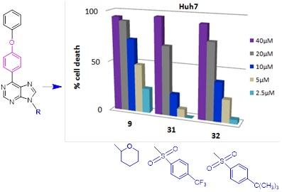
Novel 6- and 6, 9-disubstituted purine analogs were synthesized. Compounds 9, 31 and 32 had better cytotoxic activities (IC₅₀ 5.4-13.6 μM) than 5-FU, Fludarabine and Pentostatine on Huh7.

