Supporting Information

Synthesis, X-ray structural characterization, and DFT calculations of binuclear mixed-ligand copper(II) complexes containing diamine, acetate and methacrylate ligands
Rasoul Vafazadeh,^{1,}* Mansoor Namazian¹, Mahshad Chavoshiyan,¹ Anthony C. Willis² and Paul D. Carr²

¹ Department of Chemistry, Faculty of Science, Yazd University, Yazd, Iran.
² Research School of Chemistry, Australian National University, Canberra, ACT 2601, Australia.

*Corresponding author: e-mail address: rvafazadeh@yazd.ac.ir
Tel: +98 3538214778; Fax: +98 3537250110

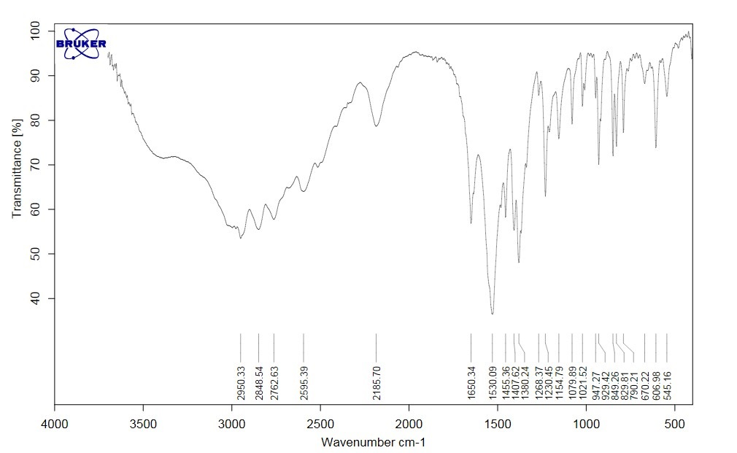
L¹ ligand
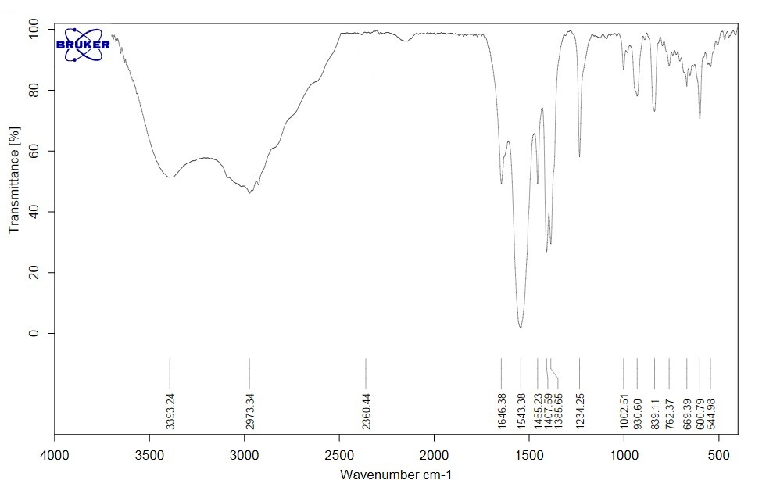
L² ligand
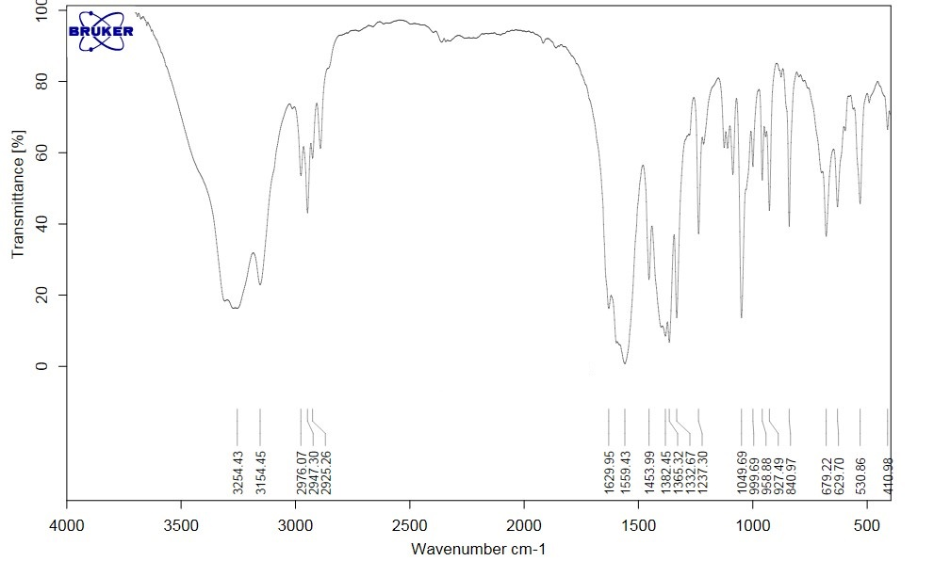
Complex 1

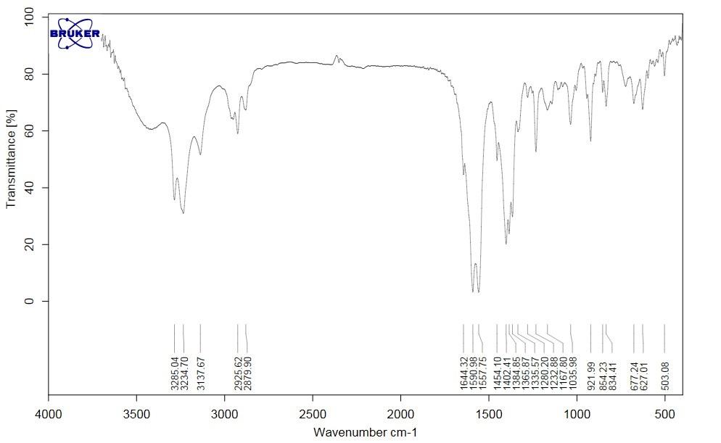
Complex 2
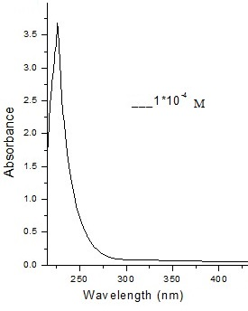
L¹ ligand
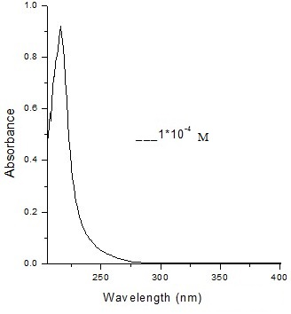
L² ligand
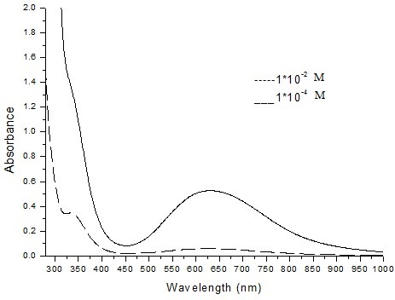
Complex 1

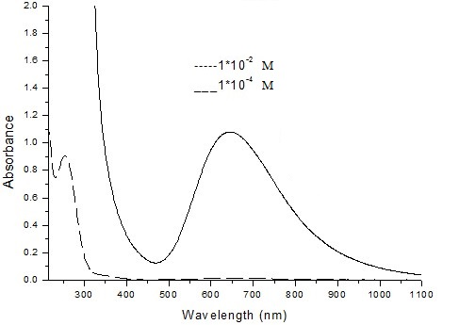
Complex 2

Gaussian calculations in terms of Gaussian archives:
Complex 1:
1\1\GINC-R40\FOpt\RB3LYP\Gen\C16H32Cu2N4O8\ROOT\04-Aug-2016\0\\#B3LYP/
Gen Opt Freq Pseudo=Read\\Complex 1\\0,1\Cu,-1.0552987236,-1.001876473
2,-0.5277704202\O,-0.2111885438,0.5962534649,-1.399559596\C,-0.5917277
149,1.4811316452,-2.2663176174\O,-0.0497833725,2.5850350197,-2.3649617
287\C,-1.7545480691,1.1005997693,-3.1689086587\H,-1.9543415623,1.89510
70764,-3.8882701216\H,-2.641448171,0.9207225183,-2.554016636\H,-1.5333
841724,0.1699273936,-3.7016615798\O,-2.5771490999,0.0878005514,0.08241
23508\C,-3.7907822222,-0.3807645735,0.0848928983\O,-4.1154510034,-1.52
20373498,-0.2432739043\C,-4.8445123893,0.6185167493,0.525465624\C,-6.1
144109473,0.211110367,0.5674994479\H,-6.917368179,0.8767510579,0.86895
31586\H,-6.3679178797,-0.8066189556,0.2957973705\C,-4.4190234984,2.016
4089376,0.886831229\H,-5.2847580641,2.6346452069,1.139428607\H,-3.7392
4515,2.0152930834,1.7467594422\H,-3.8822822561,2.4939984873,0.05986041
9\N,0.5964100142,-2.0555604233,-1.251112931\C,0.5143408258,-3.46729312
68,-0.8194731288\C,-0.9594184896,-3.8810804133,-0.760334176\N,-1.67040
65457,-2.8824704196,0.044525705\H,-1.3512513862,-2.8933102106,1.020815
6568\H,-2.6872003701,-2.8589299967,-0.0433862972\H,-1.0483220652,-4.89
46983125,-0.347539289\H,-1.395510245,-3.8924905542,-1.7662243372\H,0.9
357146735,-3.528076953,0.1862985076\H,1.0842280124,-4.1322779698,-1.47
8820737\H,1.4085029295,-1.5514175781,-0.8810238731\H,0.6001744143,-1.9
553359218,-2.2616757705\Cu,1.0552258345,1.001828958,0.527606836\O,0.21
12291564,-0.5963871044,1.3993270873\C,0.5918279451,-1.4812955657,2.266
027884\O,0.0499488902,-2.5852365472,2.3646040383\C,1.7546765974,-1.100
7777959,3.1685899117\H,1.954534456,-1.8953244756,3.8878899307\H,2.6415
426459,-0.92082699,2.553669903\H,1.5335024882,-0.1701490103,3.70141475
92\O,2.5772208597,-0.087694364,-0.0825424704\C,3.7908268711,0.38095107
04,-0.0849173841\O,4.1154098383,1.5222051719,0.2433950302\C,4.84466887
92,-0.6182429885,-0.525423772\C,6.1145456855,-0.2107514875,-0.56728813
02\H,6.9175826662,-0.8763246851,-0.8686779298\H,6.3679537131,0.8069812
75,-0.2955062921\C,4.4193198347,-2.01614924,-0.8868992368\H,5.28512733
82,-2.6343113015,-1.1394273662\H,3.7396386277,-2.0150443653,-1.7469036
303\H,3.8825215582,-2.4938154856,-0.0600096342\N,-0.5966143732,2.05532
33303,1.2509287509\C,-0.5146615697,3.467087166,0.8193633099\C,0.959063
8192,3.8810124625,0.7603014276\N,1.6701817083,2.8825107588,-0.04457869
92\H,1.3510539768,2.8933765408,-1.0208751139\H,2.6869743842,2.85906439
04,0.0433667893\H,1.0478861476,4.8946592336,0.3475606631\H,1.395118101
8,3.8924136103,1.7662079423\H,-0.9359989945,3.5278838271,-0.1864215464
\H,-1.0846357059,4.1319836669,1.4787253588\H,-1.4086395298,1.551119634
5,0.880783368\H,-0.6004145996,1.9550502139,2.2614866011\\Version=ES64L
-G09RevE.01\State=1-A\HF=-1842.3262119\RMSD=4.920e-09\RMSF=7.758e-06\D
ipole=-0.0004267,-0.0000652,0.0000445\Quadrupole=-11.5645962,11.238217
,0.3263791,-11.5089961,-2.4371737,17.2380477\PG=C01 [X(C16H32Cu2N4O8)]
\\@

Complex 2:
1\1\GINC-R55\FOpt\RB3LYP\Gen\C18H36Cu2N4O8\ROOT\04-Aug-2016\0\\#B3LYP/
Gen Opt Freq Pseudo=Read\\Complex 2\\0,1\Cu,5.2026220224,4.537959207,5
.0019735114\O,6.7350150592,6.2139439287,5.562931567\O,8.2258002763,5.1
143739328,6.7856761805\O,5.5901993327,4.1979605573,3.0607020966\O,6.56
40419038,2.1710194038,3.1871229366\N,4.2689518059,4.8998356205,6.88939
31268\N,6.4222889568,3.1361894231,5.7726968333\C,4.2041960143,3.868084
8534,7.9373731585\C,5.5287824083,3.1193143626,8.1030560949\C,5.9472890
117,2.2977530984,6.8788486987\C,7.7743446311,6.1726287056,6.3454693117
\C,8.4246985729,7.501113202,6.6925461195\C,6.1588502617,3.1527414041,2
.5544584684\C,6.305341053,3.1920486723,1.0441657103\C,6.861717764,2.14
47091121,0.432956233\C,5.8138495457,4.4093923404,0.3071789884\H,4.8229
586646,5.710178486,7.1723831451\H,3.3500833841,5.2623906488,6.65583267
76\H,7.2263059956,3.7098816332,6.0723465507\H,6.6356371289,2.591956001
2,4.9194338651\H,3.9135812932,4.3111317687,8.9003381964\H,3.4152096597
,3.1607029403,7.6560975387\H,6.3312656685,3.8244967442,8.3517139988\H,
5.4240616215,2.4424538772,8.9583113656\H,6.7459701791,1.6035325657,7.1
768133357\H,5.1101022566,1.6846914537,6.5228745634\H,9.2652248146,7.34
33075736,7.3686714022\H,7.6785687413,8.1557306281,7.1504840784\H,8.782
5181511,7.9939700477,5.7814055994\H,6.9886831572,2.1133375365,-0.64501
31752\H,7.2004919893,1.2941294202,1.0125241615\H,5.9349987892,4.289121
5571,-0.7730135022\H,6.3663977069,5.3062246821,0.6126934865\H,4.758591
1738,4.6072165989,0.5205923616\Cu,5.6148742628,7.7732810145,4.98405892
27\O,4.0825011462,6.0973000876,4.4230620665\O,2.5917047875,7.196870774
1,3.2003362643\O,5.227205818,8.1131534269,6.9253316661\O,4.2530884522,
10.1399722557,6.7989955542\N,6.5485938938,7.4115022133,3.0966472288\N,
4.3951898675,9.1750438499,4.2133571786\C,6.6133634889,8.4433013515,2.0
487161308\C,5.2887687875,9.1920564195,1.8830284397\C,4.8702057004,10.0
135477741,3.1072635946\C,3.0431683203,6.1386143471,3.6405302418\C,2.39
28429875,4.8101255754,3.2934151596\C,4.6584906969,9.1583131122,7.43162
25604\C,4.5116828336,9.1187545909,8.9418757069\C,3.9550259478,10.16592
06556,9.5531268186\C,5.0031678435,7.9013547535,9.6787741519\H,5.994609
4733,6.6011609256,2.8136068644\H,7.4674612413,7.0489514632,3.330217481
\H,3.5911993022,8.6013375152,3.9136558509\H,4.1817979972,9.7192308418,
5.0666384035\H,6.9040153683,8.0003029758,1.0857398842\H,7.4023273583,9
.1506863476,2.3300462984\H,4.4863079735,8.4868705015,1.6343063549\H,5.
3935027113,9.868960793,1.027809754\H,4.0715163651,10.7077633983,2.8093
097392\H,5.707367399,10.6266124711,3.4632904615\H,1.5523231507,4.96793
02545,2.6172817563\H,3.138991265,4.1555317843,2.8354720361\H,2.0350194
027,4.3172416755,4.2045396819\H,3.8278219084,10.1971055486,10.63107342
18\H,3.6162558665,11.0165423717,8.9736181796\H,4.8817535533,8.02143086
37,10.758958486\H,4.4508137126,7.0044969069,9.3729827881\H,6.058502122
3,7.7037091723,9.4655721881\\Version=ES64L-G09RevE.01\State=1-A\HF=-19
20.965679\RMSD=3.051e-09\RMSF=8.864e-06\Dipole=0.0002159,0.0001924,-0.
0000328\Quadrupole=-5.4404537,-6.4040624,11.8445161,14.4503939,-8.5848
798,-17.5323886\PG=C01 [X(C18H36Cu2N4O8)]\\@

