Supplementary Material:

Cold plasma and acid treatment modification effects on phonolite.
José Miguel Hidalgo-Herrador*, Zdeněk Tišler, Pavlína Hajková, Lenka Soukupová, Lenka Zárybnická, Karla Černá
Unipetrol Centre for Research and Education / UNICRE, Areál Chempark, 436 70, Záluží 1, Czech Republic.
*Corresponding author e-mail: jose.hidalgo@unicre.cz

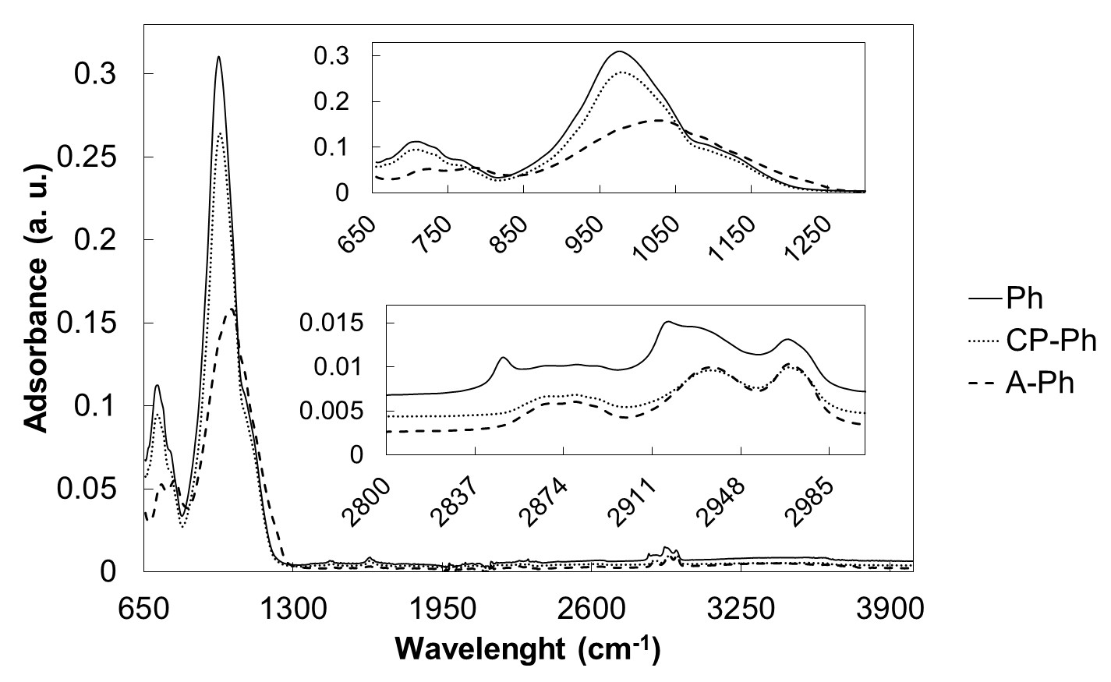
Fig. 1. FT-IR spectra of samples Ph, CP-Ph and A-Ph heated at 100 °C.

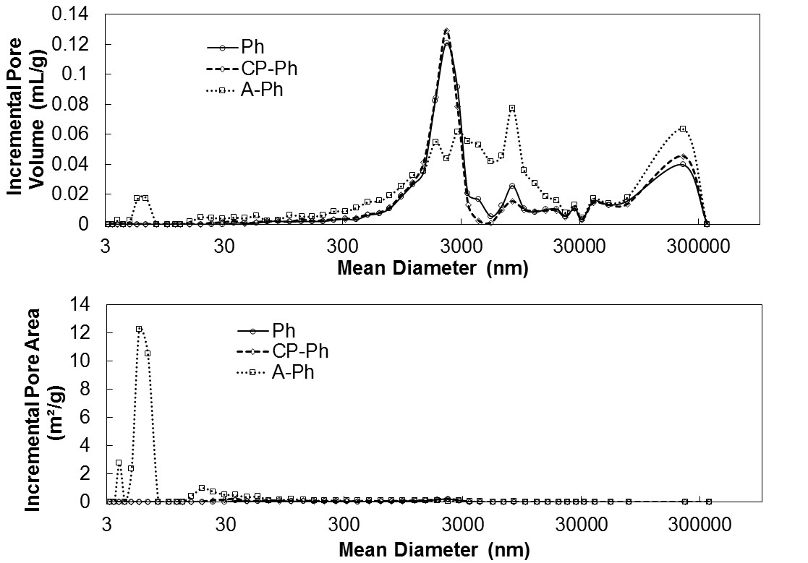
Fig. 2. Incremental pore volume and incremental pore area for samples Ph, CP-Ph and A-Ph.

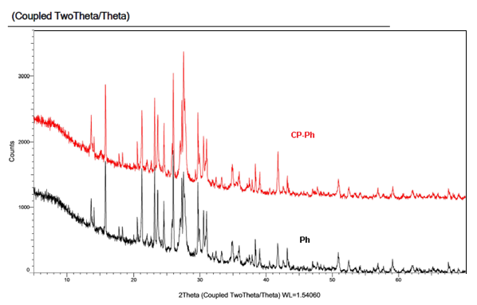
Fig. 3. XRD patterns of CP-Ph and Ph samples.

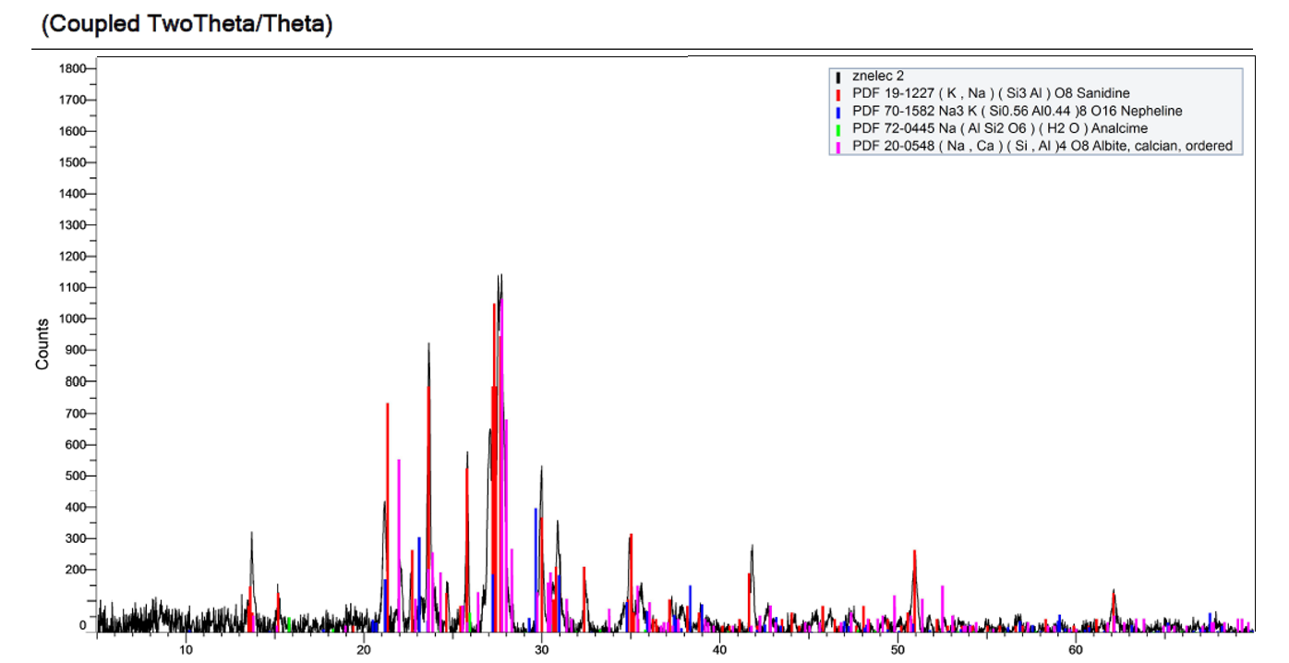
Fig. 4. XRD of A-Ph sample and calibration patterns.
NH₃-TPD experimental:
Acid properties of materials were characterized by means of NH₃ temperature programmed desorption (TPD) using Autochem 2950 HP (Micromeritics Instrument Corporation). Typically 100 mg of sample in a quartz U-tube reactor was pretreated in He to 500 °C with temperature ramp of 10 °C/min. The sample was cooled to 50 °C and then it was saturated with ammonia by flow of 25 ml/min of 10 vol. % NH3/He for 30 min. Subsequently, the gas was changed to helium (25 ml/min) in order to remove physically/weakly adsorbed ammonia and flushing out until the baseline was constant (60 minutes). After this procedure the temperature was increased to 500 °C with a rate of 15 °C/min to obtain the NH₃-TPD curves. TPD curves were obtained by increasing the temperature from 50 °C to 900 °C with the ramp of 15 °C/min. The changes of gas concentration were monitored by a TCD detector.

