Supplementary Material:

Cold plasma and acid treatment modification effects on phonolite.
José Miguel Hidalgo-Herrador*, Zdeněk Tišler, Pavlína Hajková, Lenka Soukupová, Lenka Zárybnická, Karla Černá
Unipetrol Centre for Research and Education / UNICRE, Areál Chempark, 436 70, Záluží 1, Czech Republic.
*Corresponding author e-mail: jose.hidalgo@unicre.cz

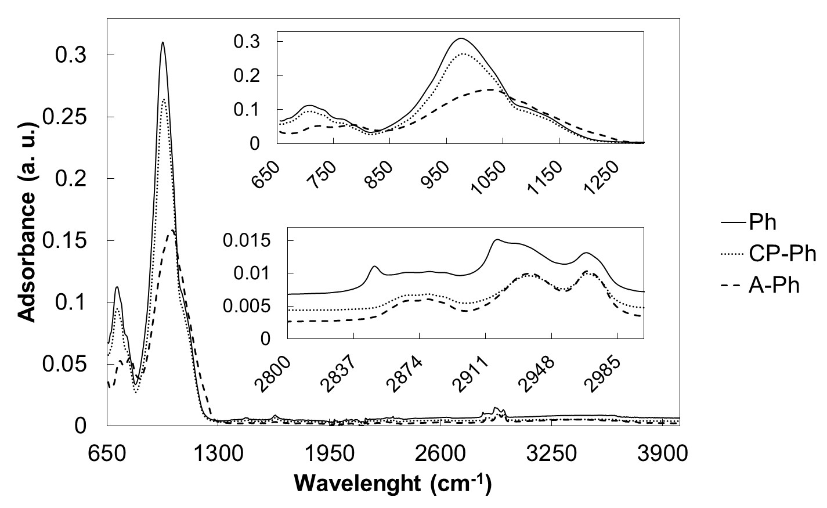
Fig. 1. FT-IR spectra of samples Ph, CP-Ph and A-Ph heated at 100 °C. ATR using an instrument Nicolet iS 10-Thermo Scientific (crystal diamond; number of scans = 64; resolution 4 cm⁻¹).

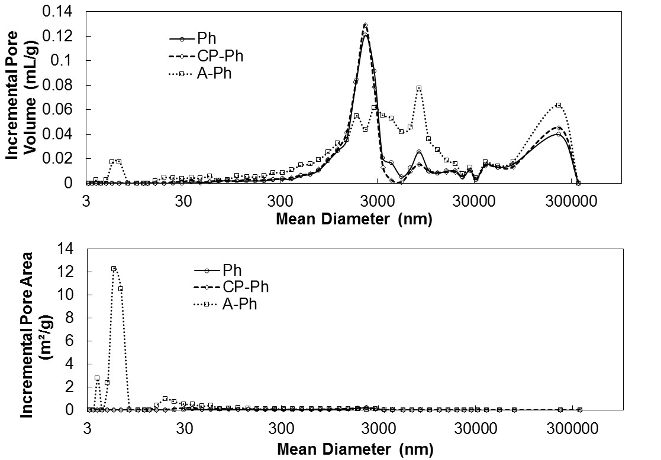
Fig. 2. Incremental pore volume and incremental pore area for samples Ph, CP-Ph and A-Ph. Mercury porosimetry measurements were performed on a Micromeritics AutoPore IV 9510 mercury porosimeter.

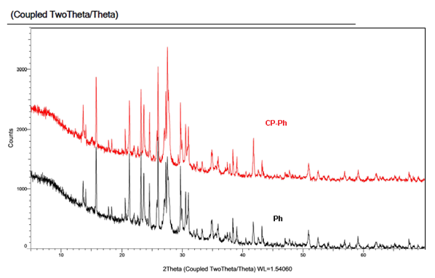
Fig. 3. XRD patterns of CP-Ph and Ph samples.

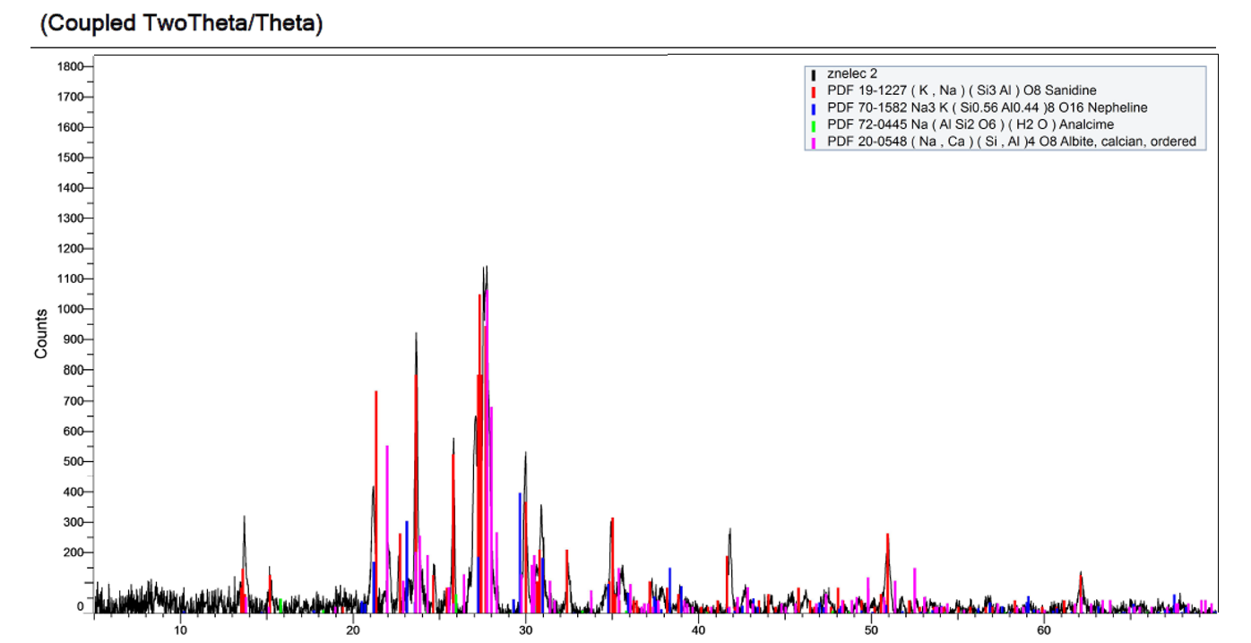
Fig. 4. XRD of A-Ph sample and calibration patterns.
NH₃-TPD experimental:
Acid properties of materials were characterized by means of NH₃ temperature programmed desorption (TPD) using Autochem 2950 HP (Micromeritics Instrument Corporation). Typically 100 mg of sample in a quartz U-tube reactor was pretreated in He to 500 °C with temperature ramp of 10 °C/min. The sample was cooled to 50 °C and then it was saturated with ammonia by flow of 25 ml/min of 10 vol. % NH3/He for 30 min. Subsequently, the gas was changed to helium (25 ml/min) in order to remove physically/weakly adsorbed ammonia and flushing out until the baseline was constant (60 minutes). After this procedure the temperature was increased to 500 °C with a rate of 15 °C/min to obtain the NH₃-TPD curves. TPD curves were obtained by increasing the temperature from 50 °C to 900 °C with the ramp of 15 °C/min. The changes of gas concentration were monitored by a TCD detector.
SEM experimental:
The analyzes were performed on ZEISS Ultra Plus Ultra High Resolution (UHF-FE-SEM), which was equipped with OXFORD X-Max20 energy-dispersive X-Max20 RTG detector for local chemical analysis. The images were taken at a low accelerating voltage (2 and 0.5 kV), and an InLens Secondary Electron Detector integrated into the tube was used to display the structure of the sample surface. The samples were not modified before the observation (sputtering of the conductive layer), they were only fixed by a double-sided carbon band on the aluminum discs. EDS analyzes were performed at an accelerating voltage of 10 kV, the data obtained was processed in SW AZtec 3.1. Charging was offset by local N₂.
All SEM images:
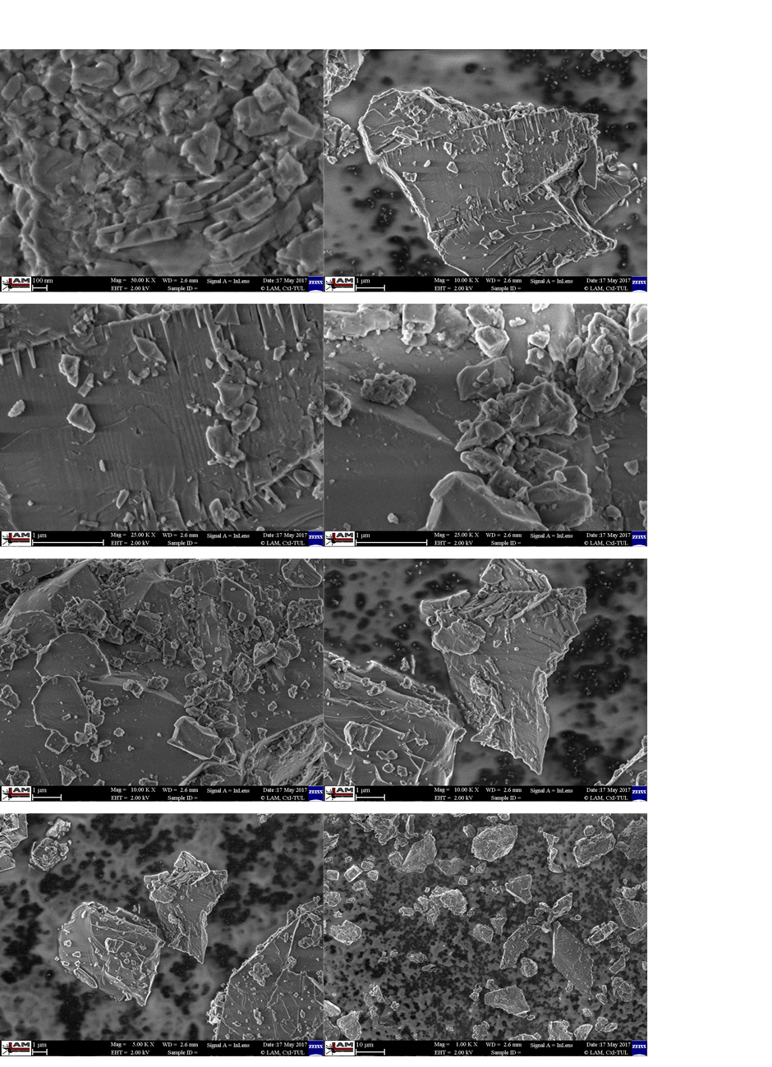
Fig. 5. Phonolite (Ph).
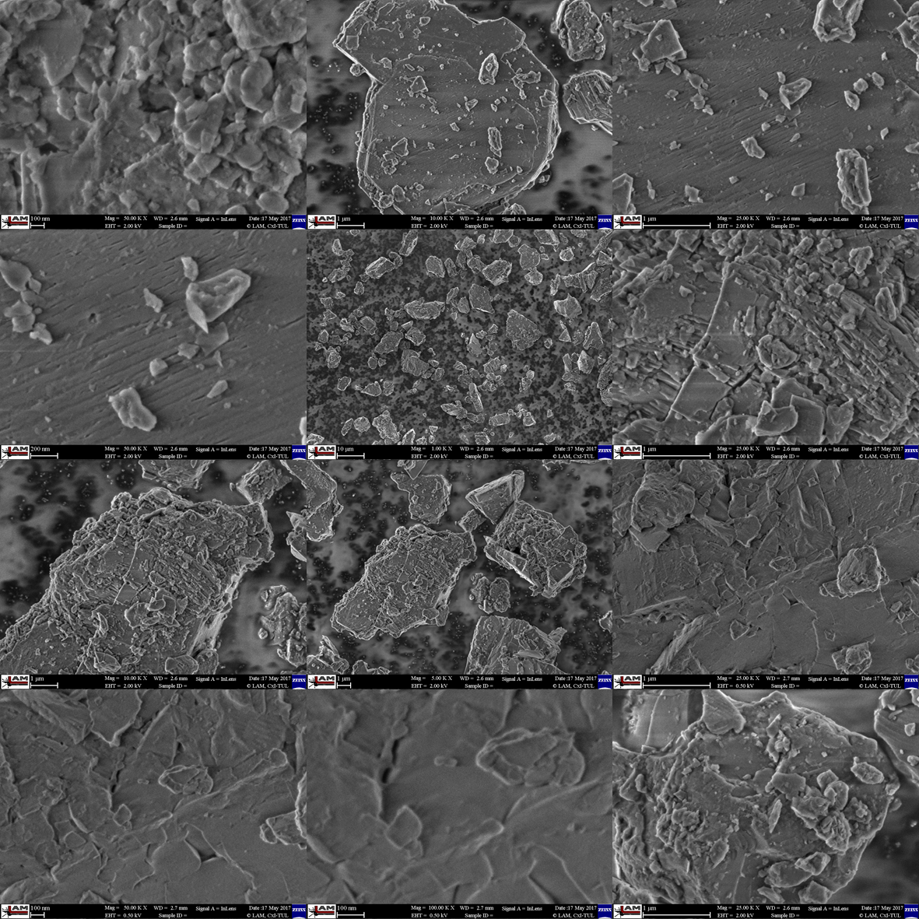
Fig. 6. Plasma modified Phonolite (CP-Ph).
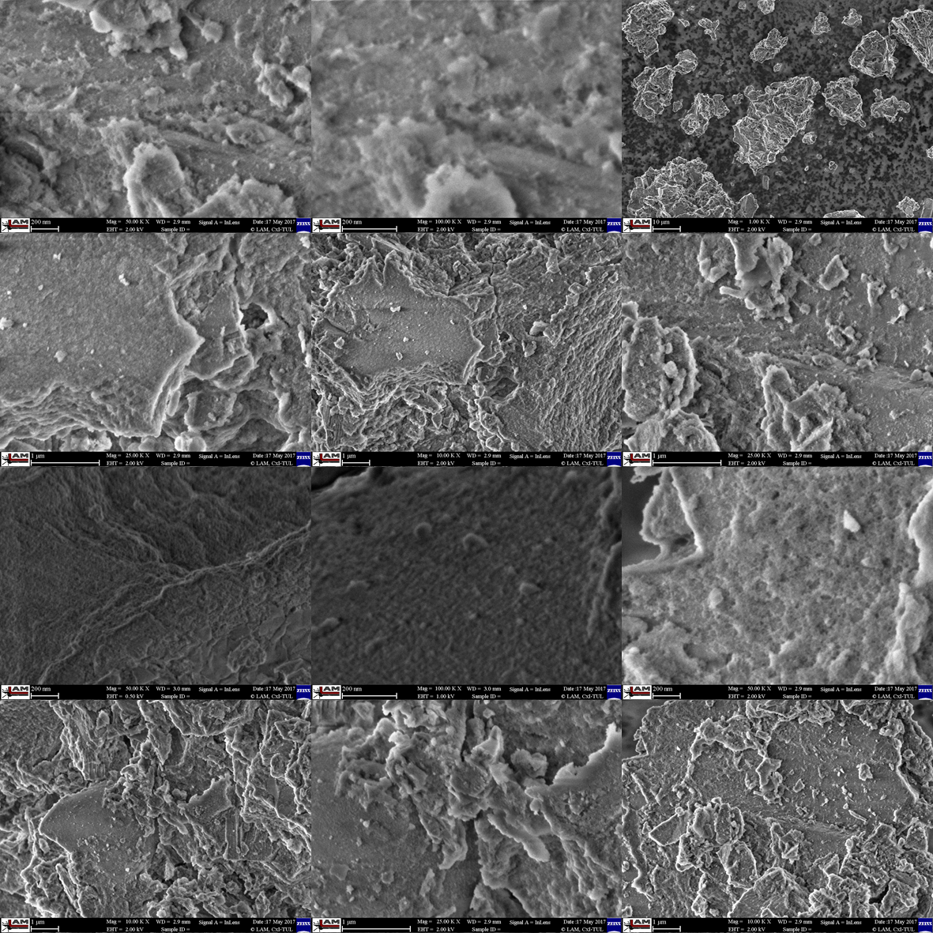
Fig. 7. Acid modified Phonolite (A-Ph)

