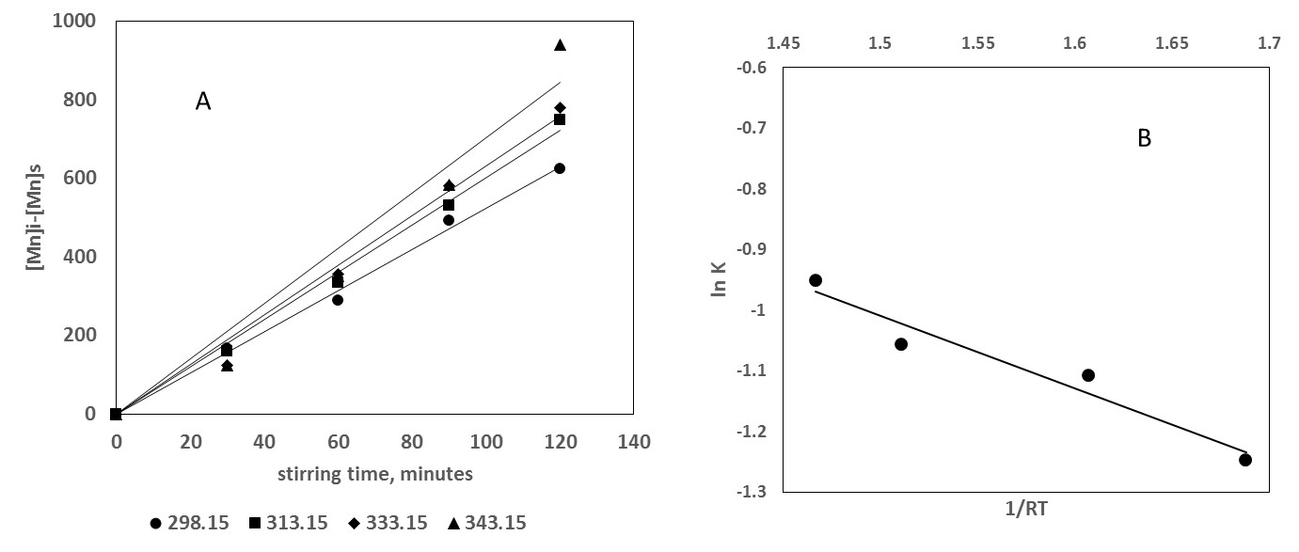
Figure 1. A: Initial manganese (mg/L) minus manganese remaining in solution as a function of stirring time. The slopes are: 5.24, 6.02, 6.33 and 7.04 for 298.15, 313.15, 333.15 and 343.15 K, respectively. B: Estimation of activation energy by means of the Arrhenius equation. lnK = -1.2*(1/RT)+0.797 (R2 = 0.94).

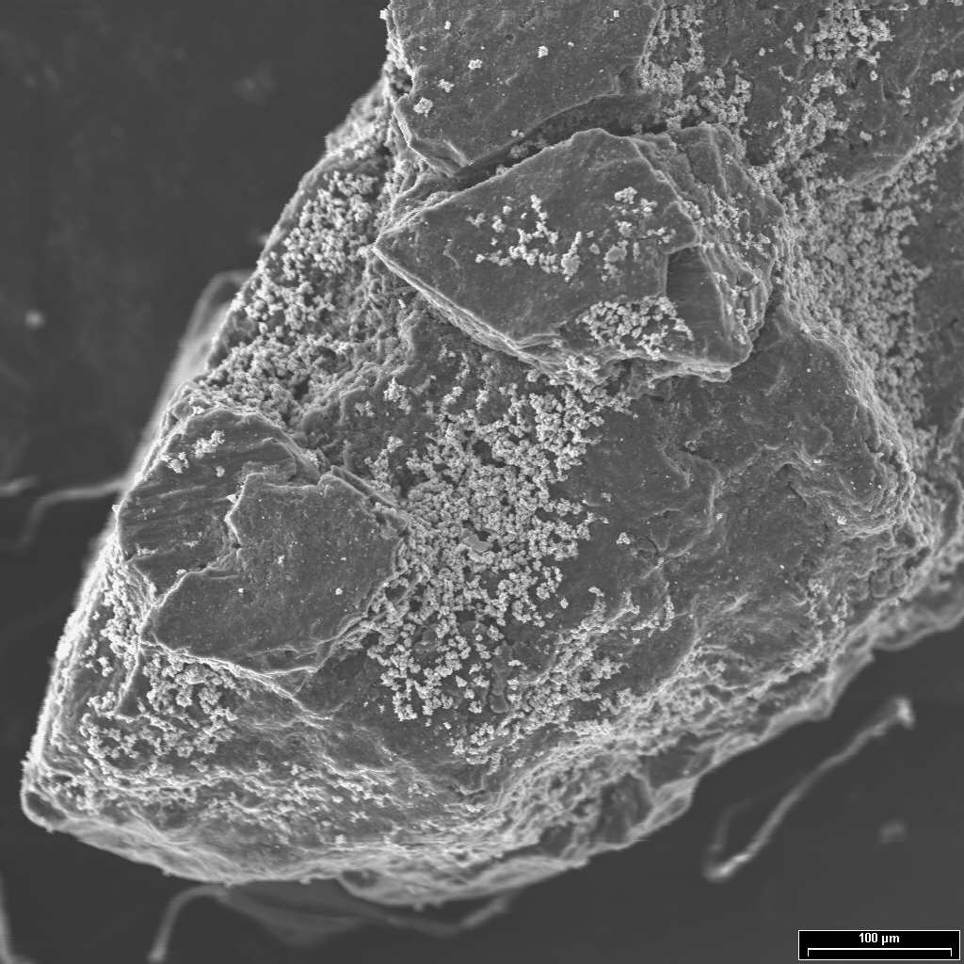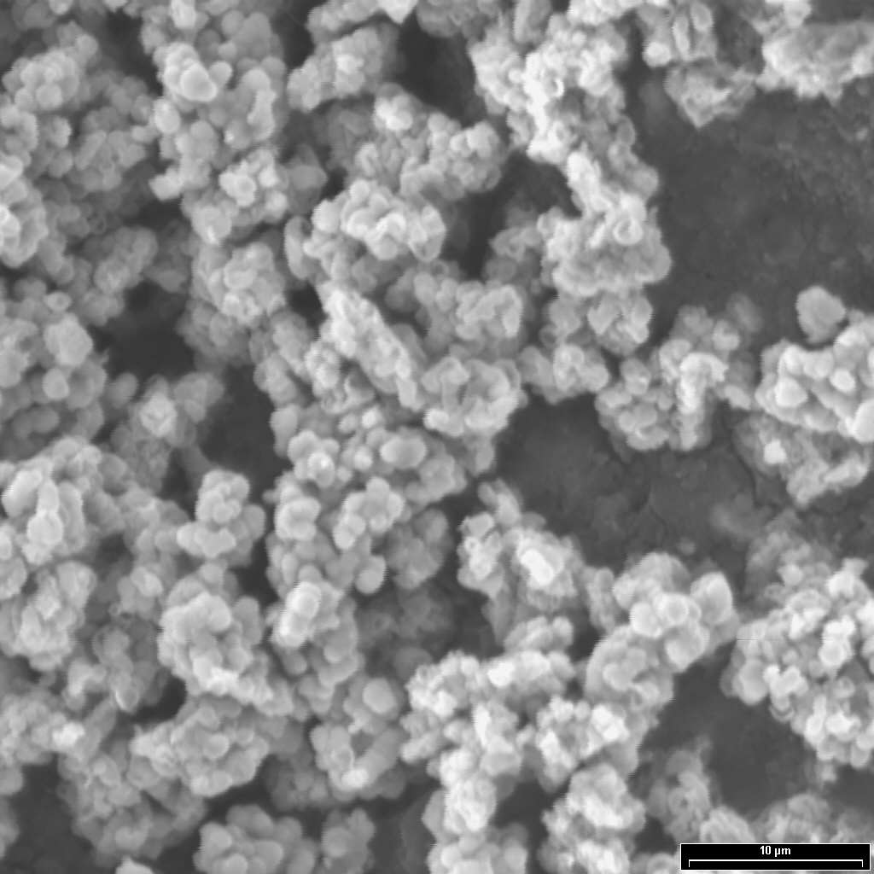
a) b)
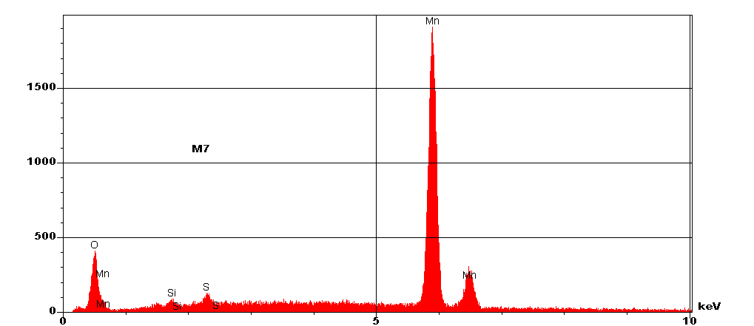
c)
Figure 2. Typical micrographies of the synthetized materials. (a) 150X, (b) 2000X, (c) EDS obtained in micrography.

