Synthesis of MnO₂ on activated carbon and their potential application in the adsorption of As⁵⁺ and Pb²⁺ in aqueous solutions
R. Contreras-Bustos¹, E. Manríquez-Reza¹, J. Jiménez-Becerril^{2,*}, M. Jiménez-Reyes², B. Cercado-Quezada¹.
¹Centro de Investigación y Desarrollo Tecnológico en Electroquímica S. C., Parque Tecnológico Querétaro, Sanfandila, Pedro Escobedo, C. P. 76703,
Querétaro. México.
²Departamento de Química, Instituto Nacional de Investigaciones Nucleares, Apartado Postal 18-1027. C. P. 11801, Distrito Federal, México.

ABSTRACT
The conditions for the synthesis of a material consisting of MnO₂ (OMD) on activated carbon (AC) were studied; these conditions were; reaction time, temperature, stirring speed, [AC], [H₂SO₄], [O₃] in solution, and particle size. Agglomerates on AC were observed by means of SEM, and EDS revealed the presence of OMD deposited on the surface. The activation energy and the factor of frequency for the reaction were determined as E_{a} = 1.2 Kcal/mol and A = 2.2. The value of E_{a} indicates that the precipitation of OMD on the AC was controlled by mass transfer in aqueous solution, the order reaction of which was zero. The AC adsorption capacity values without - with OMD were 14 - 90.5 and 9.1- 25.4 mg /g for Pb²⁺ and As⁵⁺ respectively. Therefore, the fixing of OMD on the surface of the AC greatly improved the removal of Pb²⁺ and As⁵⁺ from the aqueous solutions.

Key words: MnO₂; Activated carbon; Lead, Arsenic; Adsorption

*Corresponding author.
E-mail: jaime.jimenez@inin.gob.mx
Telephone: + (55) 53297200

INTRODUCTION
Studies about absorbing materials for natural and anthropogenic contaminant ions, in both surface water and groundwater, remain of interest. Among the pollutants that severely affect human health are arsenic and lead ions. In Mexico, their presence has been detected in aquifers, especially in the north of the country,¹ they cause various diseases including skin diseases, bone diseases and diseases in other vital organs, and they are a cause of death when the exposure is continuous at high doses. Thus, it is important to find efficient alternatives for the removal of these ions from water and to reduce the risks to human health.
Arsenic is present in the atmosphere, soil, rocks, natural water and organisms. Most environmental problems related to arsenic contamination are due to the mobilization under natural conditions. For human beings, it has an important impact through mining activity, the burning of fossil fuels and the use of arsenic-containing pesticides, herbicides and livestock feed.² The presence of arsenic in water is usually an indication that there are nearby mines or metallurgical industries in operation or agricultural areas where materials with arsenic are being used.³ The average levels of arsenic in groundwater are between 0.001 and 0.002 mg/L; however, in areas with volcanic rocks and sulfide ore deposits, these levels are > 3 mg/L. The World Health Organization established that the arsenic in water for human consumption should not exceed 0.01 mg/L.⁴ This is a provisional value due to the uncertainty of the risks associated with a lower concentration; the WHO established in 1984 a previous limit value of 0.05 mg/L. The US Environmental Protection Agency indicates an arsenic maximum permissible limit concentration of 0.01 mg/L for drinking water.⁵ The Mexican Official Norm established a maximum permissible limit concentration of 0.05 mg/L.⁶
Lead is present in the environment, including in the air, dust, soil and water. This element and its compounds are widely used for batteries, pigments, ammunitions, welds, pipes, coated cables and bearings. Other sources of contamination are mining and smelting waste, petrol and paintings.⁷
The maximum permissible limit of lead in drinking water established by the WHO for water is 0.01 mg/L. This limit increases to 0.015 mg/L according to the US-EPA’s rules, but it is also 0.01 mg/L according to the Mexican Official Standard.⁴⁻⁶
There are several technologies for the treatment of contaminated water with arsenic and lead ions such as coagulation-filtration, chemical precipitation, ion exchange and lime softening, among others.⁷⁻¹⁵ In recent years, research has been conducted on low-cost and easy-to-obtain materials that may be useful for absorbing heavy metals. Among these materials are: activated charcoal,^{16, 17} zeolites, chitosan, clays, biocarbon and sand.^{18, 19} In order to increase the capacity of adsorption of these natural adsorbents, changes to their surfaces have been proposed. For lead removal, several possibilities have been tested, among them: manganese dioxide onto zeolites, sand or resins; cellulose; carbon nanotubes; pretreated clinoptilolite; and graphene, among others.²⁰⁻²⁵ Regarding arsenic removal, the deposition of MnO₂ onto polystyrene resins, zeolites and MCM-41 has been proposed.^{10, 11, 26-30}
The manganese ions oxidation by ozone in aqueous solution has been widely studied, and it is a feasible alternative for the production of OMD.³¹ Ozone is one of the strongest oxidants and offers the advantage of not introducing unwanted species into the system and therefore guaranteeing the purity of the product obtained.
Ozone may be generated by the exposure of oxygen molecules to ultraviolet radiation or to a high discharge of electrical energy in mechanical ozone generators. The OMD has better characteristics than those produced by other methods and it exhibits good behavior for ion exchange.³²⁻³⁴ The ion-exchange behavior of OMD is even better when it is produced at low temperatures and high acidity in aqueous solutions, because it contains a certain amount of water that may be free (as humidity) and combined, which promotes the exchange between hydrogen ions in the solid and cations in the solution. Preferentially, OMD exchanges ions with others ions in the order Pb²⁺ > Zn²⁺ > Cd²⁺ > Tl¹⁺.³⁵ However, OMD cannot be used in columns because of the small size of its particles.
The activated carbon (AC) is a low-cost adsorbent that, depending on the conditions of the adsorbate, can be used in a wide range of pH. Its adsorption capacity is due not only to its surface area but also to its chemical nature, which is obtained during the activation process.³⁶⁻³⁸
Therefore, in the present investigation, the synthesis of an adsorbent material is proposed, which consists of OMD supported by activated carbon; the purpose is to examine whether their physical and chemical characteristics are suitable to application in the adsorption columns used in water purification. The aims of the present investigation were: 1) to establish the best conditions for the synthesis of OMD/AC, 2) to characterize the material, and 3) to determine the sorption capacity of the material for Pb²⁺ and As⁵⁺ ions.

EXPERIMENTAL
Synthesis of MnO₂/CA
For the synthesis of the OMD, MnSO₄ (Karal S. A. de C. V., reagent grade) and H₂SO₄ (Baker, reagent grade) were used. The granular activated carbon (AC) type CAGR 8 x 30 (Clarimex), certified by the NSF and previously characterized, was used.³⁹ The AC is of lignitic origin, activated by vapor steam, with an average pore diameter of 35 Ǻ (3.5 nm) and a surface area of 664 m²/g. The determinations by the ICP (Perkin Elmer, mod. 330) gave the following data: Al: 256 mg/kg, Si: 143 mg/kg, Na: 1085 mg/kg, K 300: mg/kg, Ca: 872 mg/kg, Sr: 756 mg/kg and V: 14 mg/kg.
OMD synthesis was performed by the oxidation of Mn²⁺ in aqueous solution by ozonation. A solution of 1 g/L of MnSO₄ and 1M H₂SO₄ was prepared with deionized water and was deposited in a glass reactor, which was packed with 2 g of AC. System was stirred to 600 rpm during 2 h, and temperature was controlled at 25 °C. A gaseous mixture of O₂-O₃, produced in an ozone generator (PCI Ozone & Control Systems, mod. GL-1) supplied with oxygen, was introduced into the reactor. Samples were taken at 0, 30, 60, 90 and 120 minutes of reaction. The samples were filtered, and the solid was washed with 100 mL of deionized water. These samples were identified as AC-OMD. Finally, the samples were stored in a desiccator. Liquid samples were analyzed by inductively coupled plasma (ICP) spectrometry.
Each one of the parameters that define the process was investigated independently. The basic conditions were stablished as follows: temperature, 25 °C; agitation, 600 rpm; concentration of AC, 2 g/L; [H₂SO₄], 1 M; [O₃] in solution, 1.32 mol/L; and particle size of AC, +0.59 mm. The temperature varied from 25 to 70 °C; the concentration of AC varied from 0.5 to 5 g/L; the ozone concentration in solution varied from 0.35 to 1.65 mol/L; the concentration of H₂SO₄ varied from 1 to 3 M; stirring varied from 200 to 800 rpm; and the particle size varied from AC of +0.59 to +1.6 mm.
The resulting solid material was characterized by SEM and microanalysis X-ray scattering (EDS) (Jeol, mod. JSM35CFLV) in order to corroborate the presence of manganese deposits on the surface of the AC and to identify other elements in the samples.

Sorption of lead and arsenic
Solutions of 100 mg/L, Pb(NO₃)₂ (Baker, reagent grade) or Na₂HAsO₄·7H₂O (Mallinckrodt Chemical Works, reagent grade) were put in contact with samples of 0.1 g of AC-OMD, prepared in different conditions. The contact was done in an isothermal bath, shaking at 300 rpm, and at 25 °C during 24 h. Subsequently, the solutions were filtered, 2 mL of HNO₃ were added to maintain the pH<2 and the solutions were stored in polyethylene bottles. The AC-OMD was flushed with 100 mL of deionized water, was dried up to 35 °C for 12 h and was stored in a desiccator with silica gel. The filtrated samples were analyzed for Pb²⁺ or As⁵⁺ by ICP.
To determine the influence of each individual condition during synthesis of AC-OMD, the adsorption capacity of the material for Pb²⁺ and As⁵⁺ was tested using the material obtained under different conditions: stirring speed, ozone concentration, acidity, concentration of AC, temperature and particle size of AC.
The equation used for the calculation of the adsorption capacity is shown below:⁴⁰
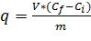 (1)
where q is the adsorption capacity (mg ion/g AC-OMD), m is the mass of the adsorbent (g), C_{i} is the initial concentration of ions in solution (mg/L), C_{f} is the final concentration of ions in solution (mg/L) and V is the volume of solution (L).

RESULTS AND DISCUSSION
OMD/AC synthesis
Stirring speed
The values of Mn²⁺ when remaining in the solution for the same time are very similar (Table 1); this means that the parameter does not practically affect the rate reaction of oxidation. It can be deduced that the mass transfer phenomena in that range of stirring speed are not important. A light increase of Mn²⁺ deposition was observed, however, with a stirring speed of 800 rpm and 120 minutes of reaction. Mn²⁺ probably spreads in the AC by means of electrostatic attraction with the electrically charged sites of the surface, and then, when ions are already deposited, oxidation occurs in order to form OMD.

Table 1. Manganese concentration (mg/L) remaining in solution, stirring speed (rpm), ozone concentration (M) and reaction time (minutes).
t(min) | Stirring (rpm) |  |  |  | [O₃] (M)
t(min) | 200 | 400 | 600 | 800 | 0.35 | 1.32 | 1.35 | 1.65
0 | 1000 | 1000 | 1000 | 1000 | 1000 | 1000 | 1000 | 1000
30 | 920 | 826 | 834 | 816 | 890 | 834 | 790 | 680
60 | 770 | 705 | 711 | 642 | 780 | 670 | 590 | 360
90 | 608 | 550 | 508 | 410 | 670 | 508 | 388 | 38
120 | 423 | 380 | 377 | 184 | 565 | 340 | 180 | 299

Ozone concentration
Table 1 shows the influence of the concentration of ozone in the rate reaction of oxidation of Mn⁺² in the presence of AC. The oxidation rate increases according to the concentration of ozone in solution. The best conditions to attain the lowest concentration of Mn²⁺ in solution are 1.35 mol/L and 120 minutes of reaction.
With > 90 min of ozonation and a concentration of O₃ of 1.65 M, a re-dissolution of manganese ions was observed due to the oxidation of the ions Mn⁴⁺ up to Mn⁷⁺, which can be noticed by its characteristic violet color. In accordance with the Pourbaix diagram at the experimental pH, the Mn²⁺ can be oxidized to MnO₂ and subsequently to MnO₄⁻,⁴¹
The calculation of the order of reaction was performed with the following equation:
$\log\left(-r_{A}\right)=log k+nlog C_{A}$ (2)
where (r_{A}) expresses the variation of the concentration of a species (Mn²⁺) with respect to time, (C_{A}) is the concentration of ozone, k is the rate constant and (n) is the order of the reaction.
The graphics (figure not included) corresponding to 30, 60 and 90 minutes of agitation and ozone concentrations of 0.35 to 1.35 M have slopes ≈ 0.5; this is considered a zero order reaction. The value of log (-r_{A}) has a tendency to be higher, indicating a change in slope, only in the case of 90 minutes and the 1.35 M ozone. For the lowest concentrations of ozone in solution, the mass transport phenomena have more influence in the process than the chemical reaction itself during oxidation of Mn²⁺. However, as the concentration of dissociated ozone increases, the chemical reaction becomes more important.⁴²

Table 2. Manganese concentration (mg/L) remaining in solution, considering initial sulphuric acid concentration, quantity of activated carbon (g) and reaction time (in minutes).
t(min) | [H₂SO₄] (M) |  |  | [CA] (g)
t(min) | 1 | 2 | 3 | 0 | 0.5 | 1 | 2 | 3 | 5
0 | 1000 | 1000 | 1000 | 1000 | 1000 | 1000 | 1000 | 1000 | 1000
30 | 834 | 959 | 992 | 743 | 723 | 761 | 834 | 787 | 742
60 | 711 | 852 | 925 | 592 | 549 | 629 | 711 | 651 | 657
90 | 508 | 654 | 848 | 439 | 351 | 392 | 508 | 489 | 448
120 | 377 | 452 | 805 | 255 | 143 | 269 | 377 | 246 | 276

Sulfuric acid concentration.
The rate reaction of Mn²⁺ oxidation decreases with the increase in sulfuric acid concentration (Table 2). For the range of acidity used, the best condition is 1M H₂SO₄. Moreover, the startup time for reaction increases when the acid concentration increases. The low rate of oxidation with high concentrations of H₂SO₄ may be due to a competition between the H⁺ ions and ions Mn²⁺ for the active sites of AC.

AC concentration
As can be seen in Table 2, the values corresponding to the change of Mn²⁺ for the oxidation reaction without AC have a very similar tendency with regard to the tests carried out with the presence of AC. Rodríguez-Santillan et al. mention that the AC favors the decomposition of O₃ in solution even at low pH,⁴³ however, in the conditions of the present work, this was not observed.
According to the calculations using equation 1, the oxidation reaction is of zero order with respect to this variable. This means that, in the interval of the AC used, this parameter does not have a significant influence on the rate of oxidation of Mn²⁺ by ozone.

Particle size of AC
The rate reaction is very similar for the three particle sizes, 0.59, 1.19 and 1.6 mm (Table 3). Thus, it can be deduced that this variable does no influence the process of oxidation of Mn²⁺.

Table 3. Manganese concentration (mg/L) remaining in solution, considering Particle size of activated carbon (mm), temperature (°C) and reaction time (in minutes).
t(min) | Particle size (mm) |  |  | Temperature (°C)
t(min) | 0.59 | 1.19 | 1.6 | 25 | 40 | 60 | 70
0 | 1000 | 1000 | 1000 | 1000 | 1000 | 1000 | 1000
30 | 834 | 751 | 793 | 834 | 840 | 876 | 876
60 | 711 | 589 | 618 | 711 | 666 | 643 | 647
90 | 508 | 404 | 412 | 508 | 469 | 419 | 417
120 | 377 | 242 | 251 | 377 | 251 | 221 | 60

Temperature
The increase of the temperature up to 70 °C and a length of reaction time greater than 60 minutes favors the oxidation; for temperatures below this, there is not noticeable difference (Table 3), as reported in the literature.³⁵
The k values for temperatures of 25, 40, 60 and 70 °C were calculated considering the slopes of the graphs of Figure 1A and the value of 0.0549 mmol/g of Mn. These values were used to determine the activation energy by the Arrhenius linear equation:
$\ln{k=lnA-E_{a}}/RT$, (3)
where k is the rate constant, A is the factor of frequency, E_{a} is the activation energy (Kcal/mol), R is the universal constant of the gases and T is temperature (K).
Figure 1B shows a graph in which the activation energy and the factor of frequency are the slope and the intercept of the line, respectively. These values are E_{a} = 1.2 Kcal/mol and A = 2.2. According to Peters and Bolton,⁴⁴ E_{a} values are less than 4.7 Kcal/mol and sometimes less than 2.3 Kcal/mol for those mechanisms that are controlled by mass transfer in aqueous solution; therefore, this process can be considered as such. Thus, temperature does not influence the process of MnO₂ precipitation.

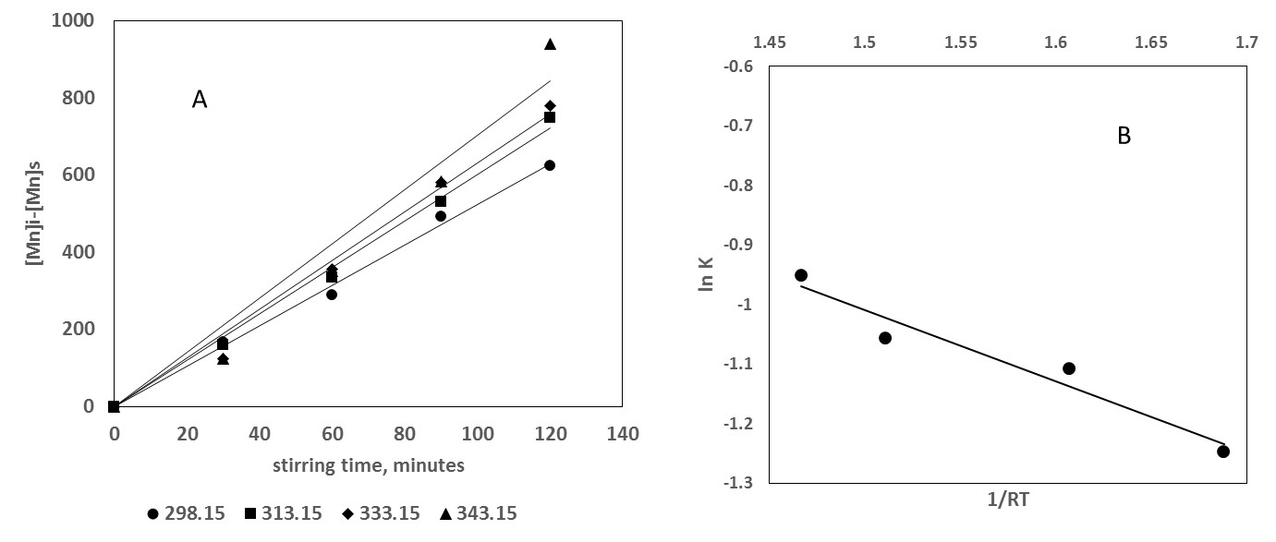
Figure 1. A: Initial manganese (mg/L) minus manganese remaining in solution as a function of stirring time. The slopes are: 5.24, 6.02, 6.33 and 7.04 for 298.15, 313.15, 333.15 and 343.15 K, respectively. B: Estimation of activation energy by means of the Arrhenius equation. lnK = -1.2*(1/RT)+0.797 (R² = 0.94)

Characterization by SEM
Figure 2 shows typical images obtained by scanning electron microscopy. In the photomicrograph taken to the scale of 150X and 100 µm (a), fine particles were observed on the AC. In the photomicrograph taken to the scale of 2000X and 10 µm (b), agglomerates of OMD are seen deposited on the surface of the AC. The EDS (c) revealed the presence of manganese and silicon, which is located on the AC surface.
When low ozone concentrations were used for synthesis, the images show less deposits of manganese on the AC than on those samples synthesized with high concentrations of ozone; thus, the increase of ozone does not favor precipitation.
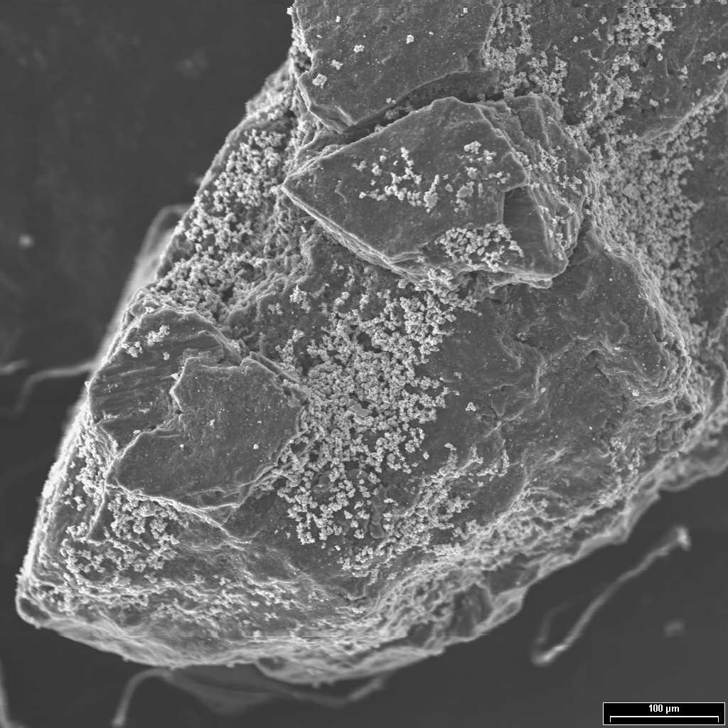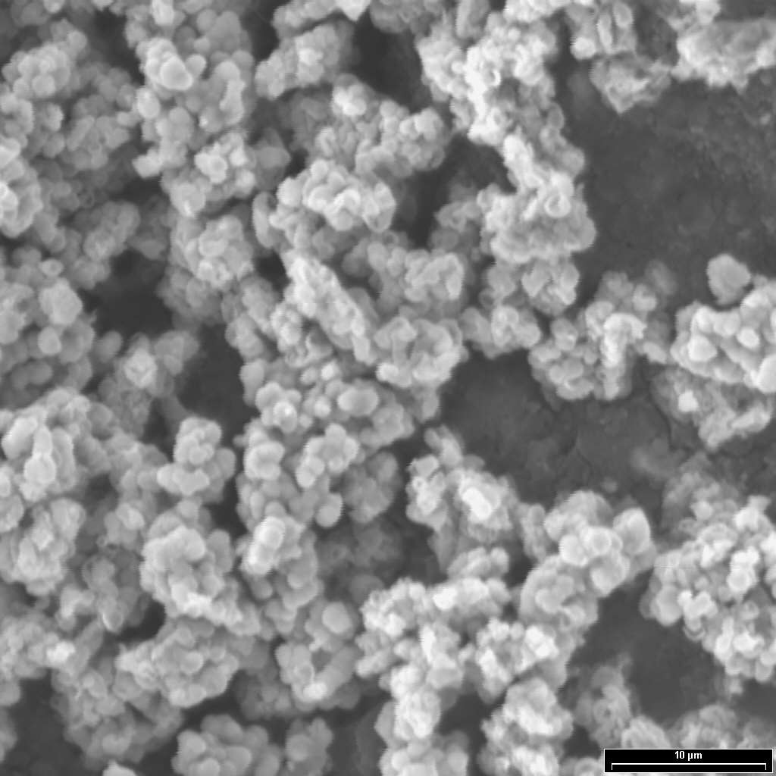
a) b)
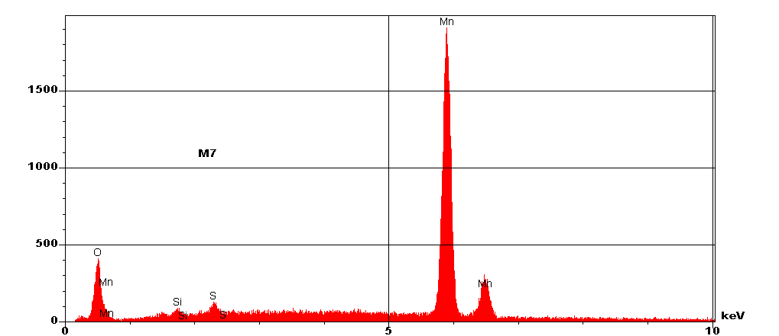
c)
Figure 2. Typical micrographies of the synthetized materials. (a) 150X, (b) 2000X, (c) EDS obtained in micrography

Adsorption of Pb²⁺ in AC-OMD
Experiments were carried out at pH = 4.7 to ensure that the removal of Pb²⁺ is due to the adsorption on the AC-OMD and to avoid the precipitation of lead as hydroxide.⁸ Table 4 shows the influence of the different conditions of synthesis of OMD on the surface of the AC for the adsorption capacity of lead. The adsorption capacity of the material increases as the stirring speed increases, probably due to more homogeneous deposits of the OMD. However, the AC-OMD formed at 800 rpm does not present the best features to remove Pb²⁺, because the dissemination processes do not favor the solid-liquid interface or the reduced contact time between the particles of OMD and AC. In that condition of synthesis, fractures could also be generated in the particles of AC, and, therefore, the OMD deposited on them could be detached.

Table 4. Adsorption capacity of AC-OMD for Pb²⁺. [Pb²⁺]_{initial concentration}: 100 mg/L. Without OMD, q₀ = 14.0 mg/g de AC.

Synthesis parameter for CA-OMD | Condition | q= mg Pb²⁺/g AC-OMD
Temperature (°C) | 25 | 71.7
Temperature (°C) | 40 | 82.7
Temperature (°C) | 60 | 70.7
Temperature (°C) | 70 | 71.0
Stirring (rpm) | 200 | 54.6
Stirring (rpm) | 400 | 60.9
Stirring (rpm) | 600 | 71.7
Stirring (rpm) | 800 | 39.3
[O₃] (M) | 0.35 | 40.0
[O₃] (M) | 1.32 | 71.7
[O₃] (M) | 1.35 | 56.6
[O₃] (M) | 1.65 | 76.8
[AC] (g/L) | 0.5 | 84.6
[AC] (g/L) | 1.0 | 81.4
[AC] (g/L) | 3.0 | 20.3
[AC] (g/L) | 5.0 | 44.0
[H₂SO₄] (M) | 1.0 | 71.7
[H₂SO₄] (M) | 2.0 | 90.6
[H₂SO₄] (M) | 3.0 | 34.7
Particle size of AC (mm) | 0.59 | 71.7
Particle size of AC (mm) | 1.19 | 49.5
Particle size of AC (mm) | 1.60 | 85.8

The adsorption capacity of lead in the AC-OMD increased when the concentration of ozone used in the synthesis of the material was from 0.35 to 1.32 m (Table 4); however, with higher concentrations, that adsorption capacity decreased. This can be explained by a partial re-dissolution of manganese as MnO₄⁻ during the synthesis, and, therefore, by the decrease of manganese as an oxide on the surface of the AC, which is the chemical species that allows for efficient adsorption.
Table 4 also shows the influence of the concentration of sulfuric acid. When the concentration of the acid comes up to 2 M, the formation of γ-MnO₂ is promoted,⁴⁵ thereby increasing the adsorption capacity. A higher concentration of sulfuric acid (3 M) favors the formation of Mn³⁺, intermediate specie between the Mn²⁺ and the MnO₂.³⁵ In addition, in this case, the decrease of manganese as an oxide on the surface of the AC reduces the lead adsorption capacity of the material.
The adsorption capacity of Pb²⁺ by AC-OMD decreases when the concentration of AC used in the synthesis of the material increases (Table 4), because the amount of OMD present in the adsorbent material is proportionally smaller.
The best adsorption capacity with respect to the temperature of the formation of the AC-OMD was 82.7 mg Pb²⁺/g in the material prepared at 40 °C. The adsorption capacity of the material is less at higher temperatures during the synthesis and Umetsu et al. reported similar behavior,⁴⁶ they observed that OMD does not present adsorption at a synthesis temperature of 70 °C. Although there is a great amount of deposits of OMD in the synthesized material at that temperature, the results indicate that the main factor responsible for the removal of Pb²⁺ is the AC.
Regarding the size of the particle, the best adsorption capacity (85.8 mg Pb²⁺/g AC-OMD) was obtained using the synthesized material with the largest particle size of AC, because it presents more deposits of OMD on the surface. In the synthesized material with AC of intermediate size, the removal of Pb²⁺ decreased due to the small amount of deposits of OMD, which was observed in the micrographs for particles of size 0.59 and 1.6 mm. Finally, when using the smallest particles of AC, the Pb²⁺ removal was again high (71.7 mg Pb²⁺/g AC-OMD), despite such material containing few deposits of OMD, the adsorption capacity increased if the size of the AC was reduced.
The conditions of synthesis of AC-OMD with the maximum capacity of adsorption of Pb²⁺ are: 2M sulfuric acid, temperature 25 °C, agitation 600 rpm, particle size of AC of +0.59 mm, [O₃] 1.35 M and [AC] 2 g/L. The value of the adsorption capacity in these conditions is 90.5 mg Pb²⁺/g AC-OMD; for AC, on the other hand, it is 14 mg Pb²⁺/g AC. Therefore, the fixing of MnO₂ on the surface of the AC greatly improves the removal of ions Pb²⁺ of aqueous solutions.

Adsorption of As⁵⁺ in AC-OMD
Table 5. Adsorption capacity of AC-OMD for As⁵⁺. [As⁵⁺]_{initial concentration}: 100 mg/L. Without OMD, q₀ = 9.1 mg/g de AC.

Synthesis parameter for AC-OMD | Condition | q₀ = mg As⁵⁺/g AC-OMD
Temperature (°C) | 25 | 4.3
Temperature (°C) | 40 | 19.0
Temperature (°C) | 60 | 18.8
Temperature (°C) | 70 | 8.0
Stirring (rpm) | 200 | 17.3
Stirring (rpm) | 400 | 18.5
Stirring (rpm) | 600 | 4.3
Stirring (rpm) | 800 | 4.7
[O₃] (M) | 0.35 | 5.6
[O₃] (M) | 1.32 | 4.3
[O₃] (M) | 1.35 | 1.0
[O₃] (M) | 1.65 | 4.5
[AC] (g/L) | 0.5 | 17.6
[AC] (g/L) | 1 | 25.1
[AC] (g/L) | 2 | 4.3
[AC] (g/L) | 3 | 1.8
[AC] (g/L) | 5 | 7.3
[H₂SO₄] (M) | 1 | 4.3
[H₂SO₄] (M) | 2 | 16.5
[H₂SO₄] (M) | 3 | 19.5
Particle size of AC (mm) | 0.59 | 4.3
Particle size of AC (mm) | 1.19 | 19.7
Particle size of AC (mm) | 1.60 | 10.1
The results of the experiments carried out to determine the adsorption capacity of As⁵⁺ on the material in each of the conditions of synthesis was calculated in the same way as described for lead, following equation 3 and determining the influence of each individual parameter. The values obtained are shown in Table 5.
The pH of the experimental solutions was 8.8, at which level As⁵⁺ can be found only as anionic species H₂AsO₄⁻ and/or H₂AsO₄²⁻.⁴⁷ Even if the OMD is considered a cation exchanger, the use of this material to remove As⁵⁺ has been reported in the literature.⁹
The relationship of the speed of agitation of the synthesis process of AC-OMD and its adsorption capacity for As⁵⁺ was studied. Table 5 shows that the adsorption capacity was better when slow stirring speeds were used during the synthesis (200 and 400 rpm); the highest value obtained was with 400 rpm (18.5 mg As⁵⁺/g AC-OMD). The increase of stirring speeds resulted in a drastic decrease in the adsorption capacity due to fewer deposits of manganese, which gives the adsorption.
The ozone concentration used for the synthesis of AC-OMD does not have a significant influence on the adsorption capacity for arsenic ions. The maximum adsorption capacity is less than 6 mg As⁵⁺/g AC-OMD for a concentration of O₃ = 1.65 mol/L. This behavior is different to that observed with the adsorption of Pb²⁺ regarding the same parameter, since the mechanism of ion exchange of the OMD is different for cations and anions.
The adsorption capacity of As⁵⁺ in AC-OMD depends upon the H₂SO₄ concentration; it increased when that concentration went from 1 to 3 M. The best adsorption capacity was 19.5 mg As⁵⁺/g AC-OMD for 3 M of H₂SO₄. The increase of the anion exchange of the OMD is given by the presence of sulphate ions at the surface,⁴⁸ allowing for a greater exchange of anions. However, the variation of the adsorption capacity between 2 and 3 M was not noticeable. The amount of OMD deposited on the AC decreased when the concentration of the acid increased, and, therefore, the adsorption of As⁵⁺decreased as well.
A capacity of adsorption of 25.1 As⁵⁺/g AC-OMD was obtained when the concentration of CA was 1 g/L; with higher concentrations, smaller values were obtained. This behavior is similar to that observed with Pb²⁺, and, in the same way, it can be related to the amount of OMD present in the adsorbent material, which is proportionally smaller.
With respect to the temperature of the synthesis of AC-OMD, the tendency is the same for the As⁵⁺ as for the Pb²⁺. At low synthesis temperatures, the adsorption capacity was higher, showing the best results at 40 °C, although it remained virtually constant up to 60 °C, with 19.0 and 18.5 mg As⁵⁺/g AC-OMD, respectively. At 70 °C a significant decrease in the adsorption capacity was observed. The reduction of ion exchange capacity of AC-OMD had the consequence that the capacity for retention of the material decreased when more deposits of manganese were present in the adsorbent material.
The adsorption of As⁵⁺ with respect to particle size displayed the opposite behavior to the adsorption of Pb²⁺. In this case, with the smallest particle size, the capacity of adsorption was the lowest. The sample used for this experiment probably had few amounts of deposits of OMD, so the main adsorbent was the AC. For the other particle size, deposits of OMD were corroborated; however, no high adsorption capacity was observed. The greater adsorption capacity was 19.7 mg As⁵⁺/g, with a particle size of AC = +1.19 mm. The removal of As⁵⁺ does not present an evident tendency with regard to the particle size used for the synthesis of AC-OMD in the present work.
The best adsorption capacity obtained was 25.4 mg As⁵⁺/g AC-OMD with a material prepared as follows: AC concentration = 1 g/L, temperature = 25 °C, shaking speed = 600 rpm, particle size of AC = +0.59 mm, [O₃] = 1.35 M and [H₂SO₄] = 1 M. The adsorption capacity of As⁵⁺ in AC is 9.1 mg As⁵⁺ /g AC; therefore, it can be seen that the presence of OMD greatly improves the absorption of As⁵⁺.
The mechanism of removing the As⁵⁺ in anionic form from water by the AC-OMD is complicated. The first stage is probably the formation of complexes on the surface of the AC, followed by ion exchange.⁴⁷ The adsorption of anions has been related to reactions of complex formations on protonated sites or the presence of electrophilic sites. The As⁵⁺ are quite basic, which suggests that its adsorption in AC has a close relationship with the concentration of functional strong acid groups.

CONCLUSIONS
The conditions for the synthesis of a material consisting of MnO₂ (OMD) on activated carbon (AC) were studied. It can be deduced that mass transfer phenomena in the range of the stirring speed are not important. The oxidation rate increases according to the concentration of ozone in solution, and the best conditions for attaining the lowest concentration of Mn²⁺ in solution are 1.35 mol/L and 120 minutes of reaction. The rate reaction of Mn²⁺ oxidation decreases with the increase in sulfuric acid concentration. Neither the concentration nor the particle size of AC influences the process of oxidation of Mn²⁺. The increase in the temperature up to 70 °C and a reaction time longer than 60 minutes favors the oxidation; for temperatures below this, the oxidation is not noticeable difference.
For all the experimental conditions, agglomerates on AC were observed by means of SEM and EDS, and the presence of manganese dioxide deposited on the surface of the AC was identified. The activation energy and the factor of frequency for the reaction were determined as E_{a}= 1.2 Kcal/mol and A = 2.2. The value of E_{a} indicates that the precipitation of manganese dioxide in the AC is controlled by mass transfer in aqueous solution. The order of this reaction is zero. The best conditions of synthesis of AC-OMD for the maximum capacity of adsorption for Pb²⁺ and As⁵⁺ were established. These values are 90.5 mg Pb²⁺/g AC-OMD and 25.4 mg As⁵⁺/g AC-OMD; when only AC, on the other hand, is used, they are 14 mg Pb²⁺/g AC and 9.1 mg As⁵⁺/g AC. Therefore, the fixing of MnO₂ on the surface of the AC greatly improves the removal of Pb²⁺ and As⁵⁺ from aqueous solutions.

ACKNOWLEDGEMENT
The authors appreciate the support of CONACYT-Mexico for the financing of this work (Key No 59989) and for the scholarship awarded to M C Elizabeth Manríquez R. for her master program studies

REFERENCES
- M. Fuentes, Arsénico en las Incrustaciones en las Redes de Distribución de Agua Potable en el Norte de México y su Desprendimiento, Agua Latinoamérica, Marzo/abril, 15, 2005.
http://www.bvsde.paho.org/bvsAIDIS/PuertoRico29/fuentes.pdf (assessed: January 27, 2017)
- WHO, Air Quality Guidelines - Second Edition. Chapter 6.7 Lead, World Health Organization, Regional Office for Europe, Copenhagen, Denmark, 2001.
http://www.euro.who.int/__data/assets/pdf_file/0020/123077/AQG2ndEd_6_7Lead.pdf (assessed: January 27, 2017)
- F. N. Kemmer and J. McCallion, Manual del agua. Su naturaleza, tratamiento y
aplicaciones. Tomo I, II. 1ra. ed. McGraw - Hill. México, 1989. ISBN 9684225156
- WHO. Guidelines for drinking-water quality [electronic resource]: incorporating first addendum. Vol. 1, Recommendations. – 3rd ed., World Health Organization, ISBN 92 4 154696 4, NML classification: WA 675, 2006.
http://www.who.int/water_sanitation_health/dwq/gdwq0506.pdf (assessed: January 27, 2017).
- US-EPA, National Primary Drinking Water Regulations EPA 816-F-03-016 U.S. Environmental Protection Agency, 2003. https://www.epa.gov/ground-water-and-drinking-water/table-regulated-drinking-water-contaminants (assessed: January 27, 2017)
- Secretaria de Salud, Norma Oficial Mexicana NOM-127-SSA1-1994, Salud ambiental. Agua para uso y consumo humano. Límites permisibles de calidad y tratamientos a que debe someterse el agua para su potabilización, 2000.
http://www.gob.mx/cms/uploads/attachment/file/110534/NOM_127_SSA1_1994.pdf (assessed: January 27, 2017)
- J. R. Conner, Chemical fixation and solidification of hazardous wastes, Springer Netherlands, 1990. ISBN 978-0-442-20511-9
- P. C. Hayes, Process Selection in extractive metallurgy, Hayes Publishing Co. 1985. ISBN 0958919712
- V. Lenoble, C. Laclautre, B. Serpaud, V. Deluchat and J. C. Bollinger, Sci. Total Environ., 2004 326(1-3), 197-207.
http://dx.doi.org/10.1016/j.scitotenv.2003.12.012
- V. Petkova, M. de L. Rivera, M. Piña, M. Avilés, and S. Pérez, Evaluación de diversos minerales para la remoción de arsénico de agua para consumo humano, Memorias técnicas. XI Congreso Nacional de Ingeniería Sanitaria y Ambiental. Zacatecas, 1 1997. http://www.zeocat.es/docs/aguaarsenico.pdf (assessed: January 31 2017)
- M. L. Rivera and M. Piña, Tratamiento de agua para remoción de arsénico mediante adsorción sobre zeolita natural acondicionada, 2005.
http://www.zeocat.es/docs/aguaarsenico2.pdf (assessed: January 27, 2017)
- US EPA, Technologies and Costs for Removal of Arsenic from Drinking Water, EPA 815R00028, Prepared by Malcolm Pirnie, Inc. under contract 68C60039 for EPA ORD, December 2000.
https://nepis.epa.gov/Exe/ZyPDF.cgi/P1004WDI.PDF?Dockey=P1004WDI.PDF (assessed: January 27, 2017)
- US-EPA, Arsenic Treatment Technologies for soil, waste and water, U.S. Environmental Protection Agency, EPA-542-R-02-004, 2002.
https://www.epa.gov/sites/production/files/2015-04/documents/arsenic_report.pdf (assessed: January 31, 2017)
- J. G. Parsons, M. L. Lopez, J. R. Peralta-Videa and J. L. Gardea-Torresdey, Microchem. J., 2009, 91(1), 100-106.
http://dx.doi.org/10.1016/j.microc.2008.08.012
- R. Contreras-Bustos, F. Espejel-Ayala, B. Cercado-Quezada, J. Jiménez-Becerril and M. Jiménez-Reyes, Pol. J. Chem. Technol., 2016, 18(1), 46-50. https://doi.org/10.1515/pjct-2016-0008
- V. López-Ramón, C. Moreno-Castilla, J. Rivera-Utrilla and L.R. Radovic, Carbon, 2002, 41(10), 2020-2022. http://dx.doi.org/10.1016/S0008-6223(03)00184-2
- M. M. Rao, A. Ramesh, G. P. C. Rao and K. Seshaiah, J. Hazard. Mater., 2006, 129(1-3), 123-129. http://dx.doi.org/10.1016/j.jhazmat.2005.08.018
- L. Beesley and M. Marmiroli, Environ. Pollut., 2011, 159(2), 474-480. http://dx.doi.org/10.1016/j.envpol.2010.10.016
- A. Bogusz, P. Oleszczuk and R. Dobrowolski, Bioresource Technol., 2015, 196, 540-549. http://dx.doi.org/10.1016/j.biortech.2015.08.006
- D. Dong, L. Liu, X. Hua and Y. Lu, Microchem. J., 2007, 85(2), 270-275.
http://dx.doi.org/10.1016/j.microc.2006.06.015
- L. Dong, Z. Zhu, H. Ma, Y. Qiu and J. Zhao, J., Environ. Sci., 2010, 22(2), 225-229. http://dx.doi.org/10.1016/S1001-0742(09)60097-8
- A. Günay, E. Arslankaya and I. Tosun, J. Hazard. Mater., 2007,146(1-2), 362-371.
http://dx.doi.org/10.1016/j.jhazmat.2006.12.034
- Z. Song, F. Lian, Z. Yu, L. Zhu, B. Xing and W. Qiu, Chem. Eng. J., 2014, 242, 36-42. http://dx.doi.org/10.1016/j.cej.2013.12.061
- Y. Ren, N. Yan, J. Feng, J. Ma, Q. Wen, N. Li and Q. Dong, Mater. Chem. Phys., 2012, 136(2-3), 538-544. http://dx.doi.org/10.1016/j.matchemphys.2012.07.023
- S. Wang, B. Gao, Y. Li, A. Meuse, A. R. Zimmerman, L. Q. Ma, W. G. Harris and K. W. Migliaccio, Bioresour. Technol., 2015, 181, 13-17.
http://dx.doi.org/10.1016/j.biortech.2015.01.044
- L. M. Camacho, R. R. Parra and S. Deng, J. Hazard. Mater., 2011, 189(1-2), 286-293. http://dx.doi.org/10.1016/j.jhazmat.2011.02.035
- R. Han, W. Zou, Z. Zhang, J. Shi and J. Yang, J. Hazard. Mater., 2006, 137, 384-395. http://dx.doi.org/10.1016/j.jhazmat.2006.02.021
- S. Wang, W. Gong, X. Liu, Y. Yao, B. Gao and Q. Yue, Sep. Purif. Technol., 2017, 58(1), 17-23. http://dx.doi.org/10.1016/j.seppur.2007.07.006
- Y. Wu, S. Yang, M. Zhang, A. Aierken and Y. Wu, Korean J. Chem. Eng., 2015, 32 (8), 1667-1677. http://dx.doi.org/10.1007/s11814-014-0352-4
- T. M. Albayati, G. M. Alwan and O. S. Mahdy, Korean J. Chem. Eng., 2017, 34(1), 259-265. http://dx.doi.org/10.1007/s11814-016-0231-2
- N. Kijima, H. Yasuda, T. Sato and Y. Yoshimura, J. Solid State Chem., 2001, 159(1), 94-102. http://dx.doi.org/10.1006/jssc.2001.9136
- R. Contreras and G. T. Lapidus, J. Colloid Interf. Sci., 1999, 213(1), 251-257. http://dx.doi.org/10.1006/jcis.1999.6114
- C. Bigliocca, F. Girardi, J. Pauly, E. Sabbioni, S. Meloni and A. Provasoli, Anal. Chem., 1967, 39(13), 1634-1639. http://dx.doi.org/10.1021/ac50156a040
- D. Glover, B. Schumm and A. Kozawa, Handbook of Manganese Dioxides Battery grade, International Battery Material Association (IBA Inc.), USA, 1989.
- R. Contreras, Producción de dióxido de manganeso por ozonización y estudio de sus propiedades de intercambio iónico, Doctoral dissertation, Universidad Autónoma Metropolitana, campus Iztapalapa, Mexico, 1999.
http://tesiuami.izt.uam.mx/uam/aspuam/presentatesis.php?recno=468&docs=UAM0468.PDF
- K. Schaeffer, Agua latinoamericana, 2003, 3(5), 1-5.
http://www.agualatinoamerica.com/docs/pdf/Intermedio.pdf (assessed: January 31, 2017)
- R. Leyva, L. G. Velázquez, J. Mendoza and R. M. Guerrero, J. Mex. Chem. Soc. (former Revista de la Sociedad Química de México), 2002, 46(2), 159-166.
http://www.redalyc.org/pdf/475/47546214.pdf
- A. J. Rubin and D. L. Mercer, In: Adsorption of Inorganics at Solid-Liquid Interfaces; Anderson, M. A.; Rubin, A. J. Ed.; Ann Arbor Science Publishers Inc.: 1981; p. 300.
- H. Pérez, Modificación termoquímica y caracterización de un carbón activado lignítico, Barchelor dissertation, Universidad Veracruzana, 2006.
- M. Al-Anber and Z. A. Al-Anber, Desalination, 2008, 225(1-3), 70-81.
http://dx.doi.org/10.1016/j.desal.2007.07.006
- M. Pourbaix, Atlas d'équilibres électrochimiques, Gauthier-Villars, Paris, 1963.
- C. Gottschalk, J. A. Libra and A. Saupe, Ozonation of water and waste water: A practical guide to understanding ozone and its applications, 2nd Ed., Wiley-VCH, Germany, 2010. ISBN: 978-3-527-31962-6
- J. L. Rodríguez-Santillán, T. Poznyak and J. L. Mayorga, Efecto del pH y Carbón Activado Sobre la Descomposición de Ozono en Solución Acuosa, In: XXVII Encuentro Nacional de la AMIDIQ, 2006.
https://www.dropbox.com/s/57sdrecsy8amha3/2006.rar (assesed: January 31, 2017)
- E. Peters and G. Bolton, Hydrometallurgy: Theory and Practice, Center for metallurgical and Process Engineering Department and Metallurgical Engineering, Chapter I, UBC. Vancouver, B. C. 1999. ISBN-13: 978-0444896568
- T. Nishimura and Y. Umetsu, Shigen-to-Sozai, 1992, 108(5), 373-377.
https://www.jstage.jst.go.jp/article/shigentosozai1989/108/5/108_5_373/_pdf
- Y. Umetsu, T. Nishimura and R. C. Bustos, M. Tokuda, Shigen-to-Sozai, 2000, 116(12), 999-1004.
https://www.jstage.jst.go.jp/article/shigentosozai/116/12/116_12_999/_pdf
- F. Di Natale, A. Erto, A. Lancia and D. Musmarra, Water Res., 2008, 42(8-9), 2007-2016. http://dx.doi.org/10.1016/j.watres.2007.12.008
- T. Nishimura, T. Kamaya and Y. Umetsu, Shigen-to-Sozai, 1992, 108(6), 473-477.
https://www.jstage.jst.go.jp/article/shigentosozai1989/108/6/108_6_473/_pdf

