Reaction Monitoring by Means of Multivariate Data Analysis of Near-Infrared and Raman Spectroscopy

Dardan Hetemi ^{a,b*}, Steve Janagap ^{c}

ª Department of Chemistry, University of Bergen, Allégaten 41, N-5007 Bergen, Norway
^{b}Pharmacy Department, Medical Faculty, University of Prishtina “Hasan Prishtina”, Rr. Dëshmorët e Kombit” p.n., 10000 Prishtina, Kosovo
^{c}Department of Chemistry, College of Arts and Sciences, University of the Philippines Visayas, 5023 Miagao, Iloilo, Philippines

Table of Contents

GC-MS shows 2-nitrobiphenyl 2
¹H NMR of 2-nitrobiphenyl 3

GC-MS shows 2-nitrobiphenyl

¹H NMR shows characteristic peaks of of 2-nitrobiphenyl

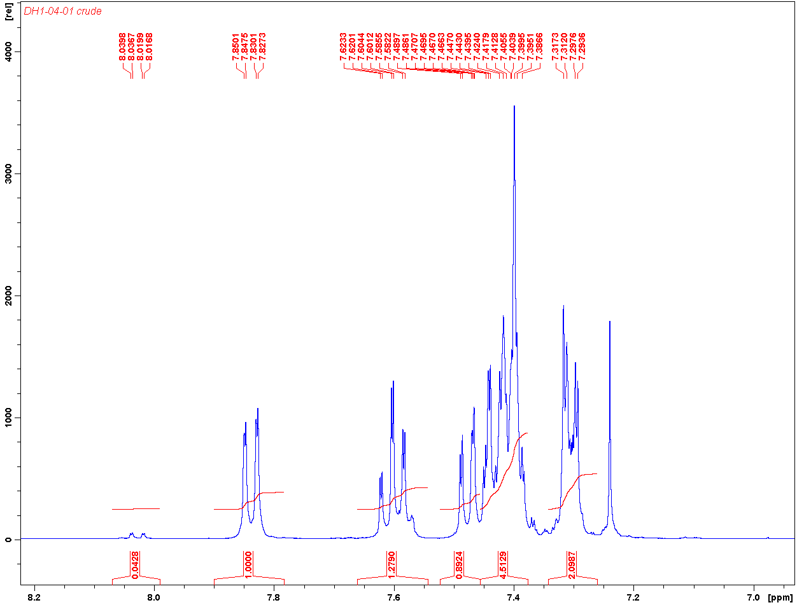

The NMR spectrum shows characteristic peaks of 2-nitrobipheyl (C₁₂H₉NO₂, MW 199.21): δ 7.85-7.82 [dd, 1H], 7.62-7.58 [td, 1H], 7.48-7.38 [m, 5H], and 7.31-7.29 [m, 2H].

