Discrimination between Synechocystis members (Cyanobacteria)
based on heterogeneity of their 16S rRNA and ITS regions

Appendix

Figure A represents a concatenated phylogenetic tree based on alignments of both the 16S rDNA variable region sequences and ITS regions. This tree shows rather minor differences when compared to single trees (Fig. 4 in the paper) and can be considered a suitable representation of phylogenetic relatedness based on sequences of the two analysed genomic regions.
Figure B depicts the location of species/strains that we have analysed in the context of other cyanobacterial groups. Presentation of the phylogenetic tree was on purpose made in a similar manner to Fig. 1 in ²⁴ for easier comparison.

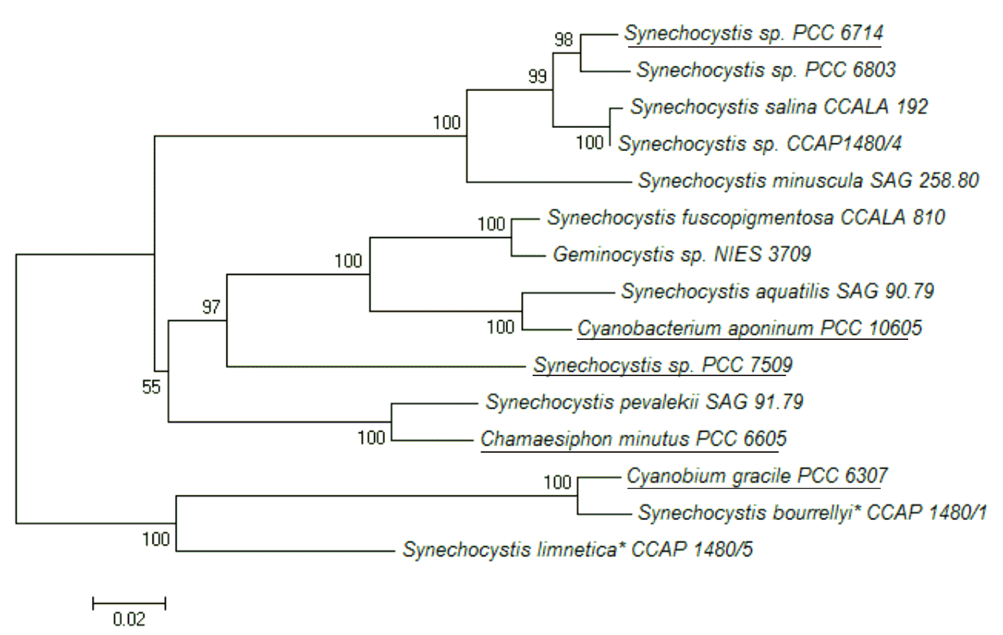
Figure A. A concatenated phylogenetic tree for the analysed members of the Synechocystis genus. Tree is based on our sequencing results of the 16S rRNA coding region and the ITS region combined (S. nigrescens is not included as its ITS region(s) could not be amplified). It was built by the neighbourghood-joining method applying Jukes-Cantor model. Bootstrap values are given at nodes of the tree. The tree is drawn to scale with evolutionary distances in the units of the number of base substitutions per site. For comparison, sequence data for PCC 6714 and PCC 7509 as deposited in GenBank were included along with some non-Synechocystis members for which we found a high sequence similarity with strains from Table 1. Strains whose sequences are from GenBank are underlined.

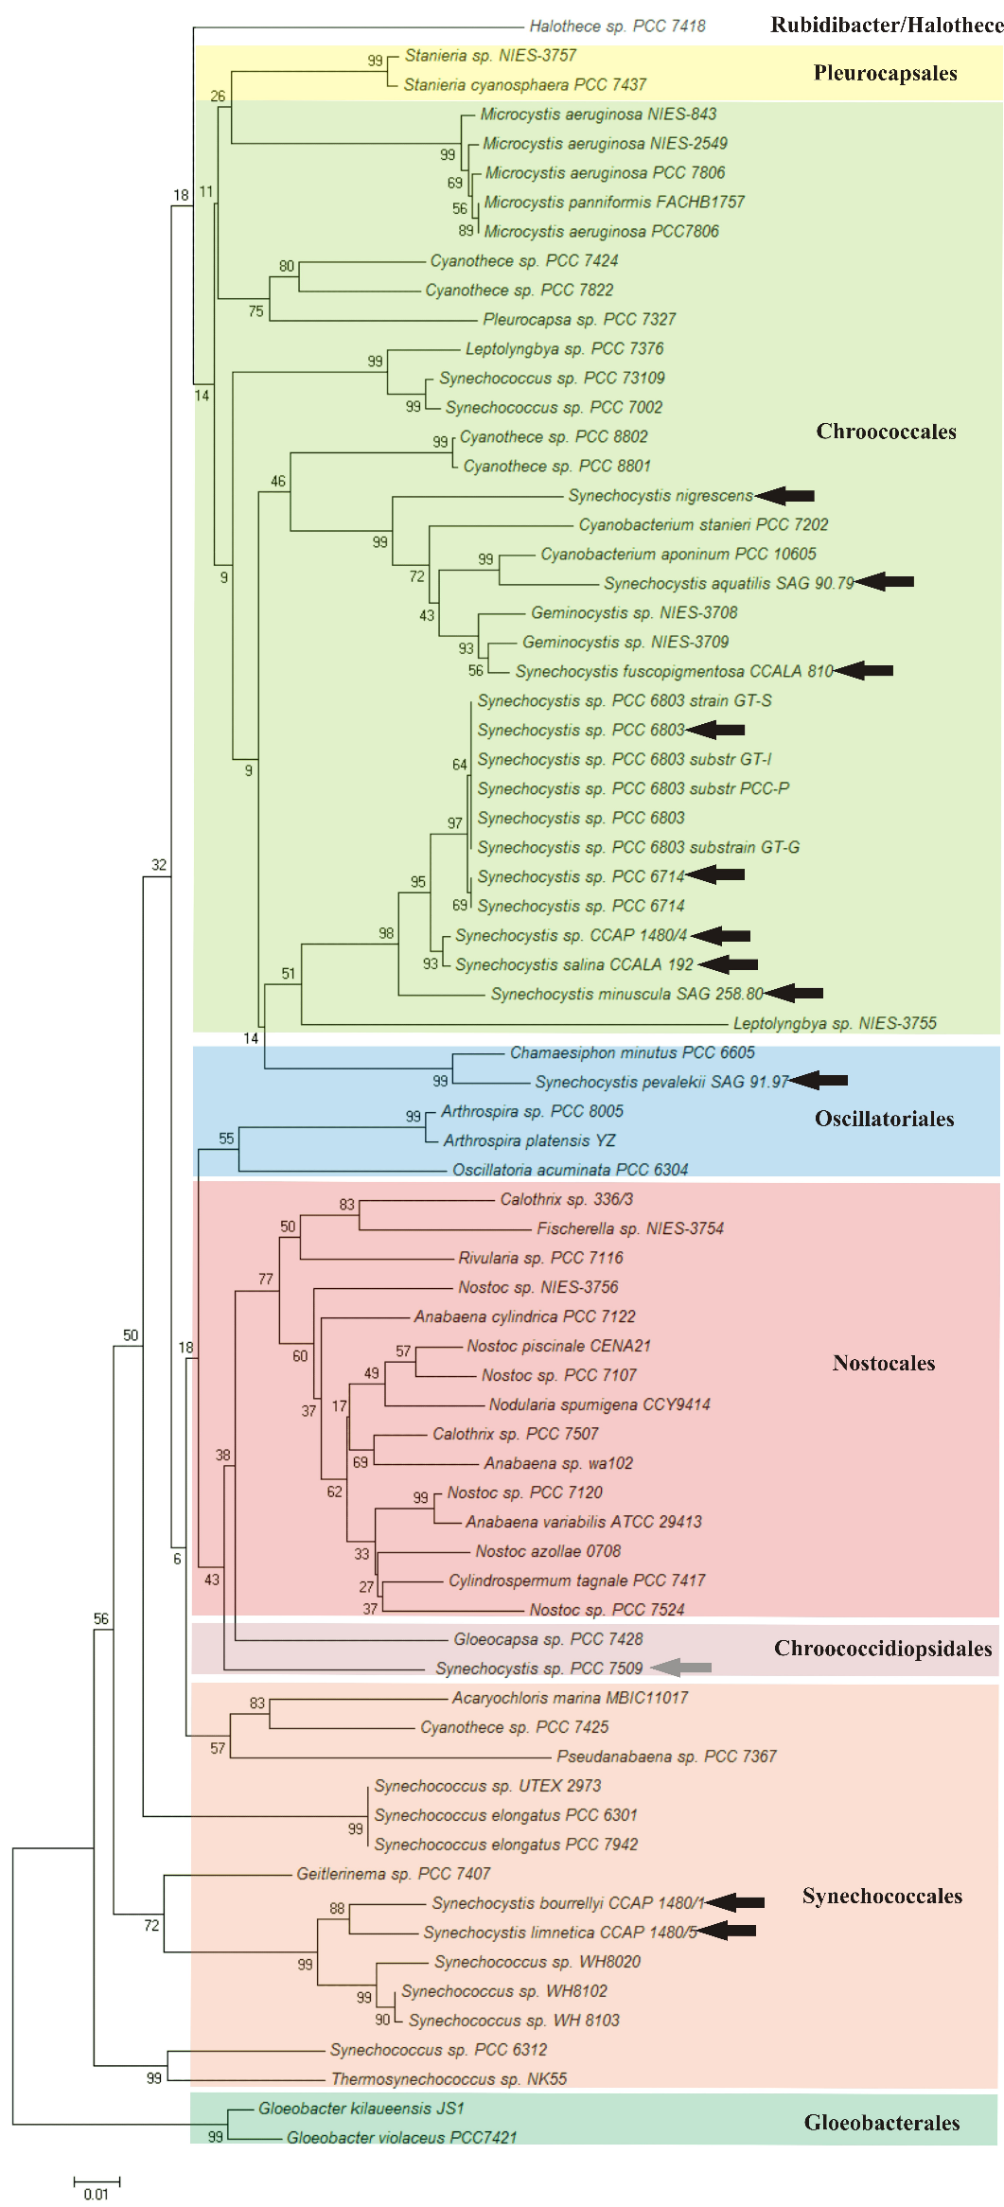
Figure B. A phylogenetic tree representing the analysed members of the Synechocystis genus in context of other cyanobacteria.
This tree is based on our sequencing results of the 16S rRNA region along with database data for selected members of other cyanobacterial orders. It was built by the neighbourghood-joining method applying Jukes-Cantor model. Bootstrap values are given at nodes of the tree. The tree is drawn to scale with evolutionary distances in the units of the number of base substitutions per site. Species/strains that were positioned in the tree based on our results are marked with black arrows. An additional member of the genus that evades (based on database sequences) the expected Chroococcales order is marked with a grey arrow.

