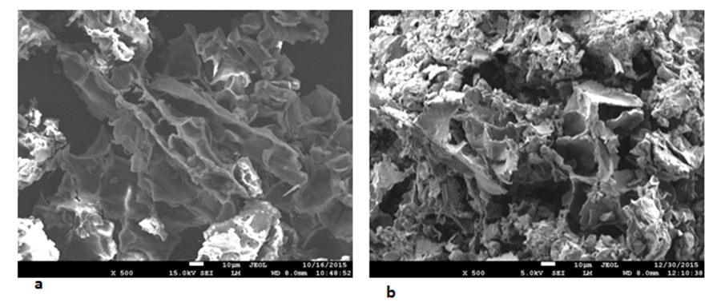

Figure 5. SEM pictures of sweetgum bark samples a) before the sorption of 2,4-DCP b) after the sorption of 2,4-DCP

