Biosorption of 2,4 dichlorophenol onto Turkish Sweetgum bark in a batch system: Analysis, equilibrium and kinetic modeling
Dilek YILDIZ,^{a,*} Feyyaz KESKİN,ª Ahmet DEMİRAK^{b}
ª Mugla Sıtkı Kocman University, Research and Application Centre For Research Laboratories, 48000 Mugla, Turkey
^{b} Mugla Sıtkı Kocman University, Department of Chemistry, 48000 Mugla, Turkey
Corresponding author at: Mugla Sıtkı Kocman University, Research and Application Centre For Research Laboratories, 48000 Mugla, Turkey, Tel: +90 0 252 211 1675
E-mail address: dilekyildiz2003@hotmail.com

Abstract

In this study, Turkish Sweetgum bark was used as a new biosorbent to investigate hazardous 2, 4 dichlorophenol (2,4-DCP) from aqueous solutions in batch biosoption experiments. The effective usage of Turkish sweetgum bark is a meaningful work for environmental utilization of agricultural residues. The effects of experimental parameters like solution pH, contact time, initial concentration of adsorbate and amount of bisorbent dosage were investigated in a series of batch studies at 25 ºC. Taguchi’s Orthogonal Array (OA) analysis was used to find the best experimental parameters for the optimum design process in this study. The functional groups and surface properties of biosorbent were characterized by using Fourier transformer infrared (FTIR) and scanning electron microscopy (SEM) techniques. The experimental data were fitted to Langmuir isotherm and Freundlich isotherm models. There is a good agreement between the parameters and this confirms the monolayer adsorption of 2,4-DCP onto sweetgum bark. As a result of kinetic studies, the pseudo-second-order kinetic model was found to be suitable for all the data.
Keywords: 2,4 dichlorophenol; Biosorption; Turkish Sweetgum; Kinetics; Taguchi’s Orthogonal Array
- Introduction
One type of dangerous wastes that are chiefly produced during chemical and many othr industrial and agricultural activities is phenols and phenol compounds.¹⁻⁶ If the low concentrations of pollutants are harmful to organism, these pollutants are considered as priority pollutants. Many of them have potential to harm human health; therefore, they have been classified as hazardous pollutants.⁷ United State Environmental Protection Agency (USEPA) has registered phenolic compounds as priority pollutants. Most of the phenolic compounds are toxic and hardly biodegradable, and it can be really difficult to get rid of them in the environment. Especially chlorophenols (CPs) are believed to create bad taste and odor in drinking water at concentrations below 0.1 g/L and cause adverse impacts on the environment.⁸
Some physicochemical and biological methods including adsorption, extraction by chemical solvents, air stripping, freezing and crystallization, chemical oxidation, wet oxidation, advanced oxidation processes, biological degradation biosorption, coagulation, chlorination and liquid membrane permeation have been developed for the removal of phenolic compounds from aqueous solutions.^{6,7,9,10-13} Among these methods, the ones used for the concentration of the chlorinated phenols on the solid phase are adsorption and ion exchange methods but they are not for complete mineralization. The ones used for complete mineralization and combination of chlorophenols are chemical or biological oxidation methods. While one advantage of chemical oxidation methods is their being fast, they might result in undesirable by-products and they are expensive. Biodegradation of chlorophenols are more specific and relatively cheap than chemical oxidation methods. Biodegradation methods of chlorophenols were also investigated by many researchers.⁷⁻¹⁰ According to recent studies, some natural minerals, industrial wastes, agricultural wastes, and forest wastes are low-cost adsorbent materials.¹⁴⁻¹⁷ Agricultural wastes among them are one of the most promising groups of adsorbent materials. Their unique chemical composition makes these wastes economic and eco-friendly alternatives the removal of chlorophenols.^{6,7,18,19} We are interested in bark of Turkish Sweetgum as biosorbent. The sweetgum, which is widely known as Turkish sweetgum. is a deciduous tree native to the eastern Mediterranean region Styrax liquidus obtained from sweetgum have been known since very old times and they are known to have been used to mummify pharoses in ancient Egypt . The volatile oil extracted from Styrax liquidus has been utilized for the production of pharmaceutical and cosmetic products and they are made available in Turkey through export.²⁰ The barks of sweetgum are a forest wastes to obtain the export goods from sweetgum plant and Styrax liquidus. There are main objective of the present study is to explore the ability of sweetgum (Turkish Sweetgum) bark to remove 2,4-DCP from aqueous solutions. For this reason, biosorbent was characterized using Fourier transformer infrared spectroscopy (FTIR) and Scanning Electron Microscopy (SEM). In addition, experimental parameters such as solution pH, contact time, initial concentration of adsorbate and amount of biosorbent dosage were investigated. A statistical optimization was used to determine the optimum biosorption conditions for removal of 2,4-DCP from aqueous solutions in sweetgum bark. Moreover, adsorption isotherm models and kinetics models were studied.
2. Materials and Methods
2.1 Materials
The bark of sweetgum was obtained from the Mugla Manager ship of Governmental Operation of Forestry, General Directorate of Forestry, Ministry of Environment and Forestry, Republic of Turkey at November, 2015. All chemicals were obtained from Merck in this study.
2.2 Equipment and Analysis
A pH meter (WTW) was used for the measurement of pH. The concentrations of phenol compound were analyzed calorimetrically by using 4-aminoantipyrine and potassium ferriciyanid at pH 7.9±0.1 according to the Standard Methods.²¹ All the analyses of this study were performed in the laboratory that has a framework of ISO IEC 17025 Laboratory accreditation
2.3 Biosorbent
The barks of sweetgum were dried in the oven at 60 °C for 48 h and then passed through a 100-mesh size screen to use it in the study.
2.4. Preparation of synthetic sample
It was prepared for a stock solution of 2,4-DCP (1000 mg/l) with distilled water. To obtain all the solutions of varying concentrations, the stock solution was used in the current study. The pH of each solution was adjusted to the desired value using 0.1 M HCl and 0.1 M NaOH.
2.5. Batch sorption experiments
The batch technique was used to conduct the experiments of sorption in a routine manner. Closed polyethylene bottles containing a volume of 100 cm³ of the solutions of 2, 4-DCP that known-concentration were placed in a shaking assembly. The dry biomass (1,0 g) was shaken with 50 ml of 2, 4-DCP solution at a concentration of 150 mg/l in a shaker at room temperature (20±0.5 °C) for about 150 minutes. For the separation of the particles of sweetgum barks by filtration, a 0.45 μm membrane filter was used. The amounts of sweetgum barks adsorbed in each case were measured by calculating the difference between the initial and the final concentrations of 2.4-DCP.
By using the difference between the initial concentration and equilibrium (qe) of 2.4 concentration, biosorption capacity at equilibrium time (qe) was calculated as follows:
qe$={V(Co-Ce)}/M$
where V is the sample volume (L), Co is the initial concentration of 2,4-DCP (mg/l), Ce is the equilibrium or final concentration of 2,4-DCP (mg/l), M is the dry weight of (0.5 g for this study), and qe is the biomass biosorption capacity of the biomass at equilibrium time.

2.6 Optimization study
There are two important advantages of the use of experimental design technique for the sorption process. Firstly, the design technique provides statistical optimization models that help in understanding the interactions among the experimental parameters that have been optimized. Secondly, small number of experiments and little time to carry out these experiments are needed.²²
As a technique, Taguchi’s Orthogonal Array (OA) analysis was used to produce the best parameters for the optimum design process, with the least number of experiments. Experimental parameters and their levels, determined in the light of preliminary tests, are given in Table 1.

Table 1. Factors and levels for experimental parameters used to in sorption capacity test

Levels | A (pH) | B (amount of biosorbent (g) | C (initial concentration of adsorbate (mg/L) | D (contact time (min)
1 | 2 | 0,2 | 25 | 30
2 | 4 | 0,4 | 50 | 60
3 | 6 | 0,6 | 100 | 90
4  5 | 8 | 0,8 | 150 | 120
4  5 | 10 | 1,0 | 200 | 150

The experimental data were analyzed using the statistical software MINITAB 15. The data (y_{i}) and corresponding S/N ratios were calculated on the basis of Taguchi’s “larger is better” approach.
2.7. Scanning electron microscopy
Scanning Electron Microscopy with Energy Dispersive Spectroscopy (SEM-EDS) was used to characterize the structures of the samples (JEOL SEM 7700F) in the Research Centre Laboratory at Mugla Sıtkı Koçman University (Turkey).
2.8. FTIR Analysis
FTIR spektra of the samples were performed in Perkin Elmer Each spektrum was recorded in a freguency of 400-4000 cm⁻¹ using potassium bromide (KBr) disc. The KBr was oven-dired to minimize the interference of water.
3. Results and Discussion
3.1. Optimization study
As the orthogonal array experimental design method was found to be the most appropriate for the conditions under investigation, it was chosen to determine the experimental plan, L25 (5⁵) (Table 2); four parameters each with five values. The effect of the noise sources on the adsorbtion process was observed by repeating each experiment twice under the same conditions. The optimum design for the adsorption of 2,4-DCP by Sweetgum bark is an important aspect in the production of the adsorption process. It can be concluded that the values of optimum experimental parameters for adsorption capacity of 2,4-DCP are as below: contact time (150 min) , amount biosorbent (1 g), initial concentration of adsorbate (150 mg/L) and pH (2) (figure1).

Table 2. L25 Experimental and expected results from Taguchi’s Orthogonal Array (OA) analysis

Experiment no. | pH | Amount of  biosorbent | Initial concentration  of adsorbate | Contact time
 | 1 | 1 | 1 | 1
 | 1 | 2 | 2 | 2
 | 1 | 3 | 3 | 3
 | 1 | 4 | 4 | 4
 | 1 | 5 | 5 | 5
 | 2 | 1 | 2 | 3
 | 2 | 2 | 3 | 4
 | 2 | 3 | 4 | 5
 | 2 | 4 | 5 | 1
 | 2 | 5 | 1 | 2
 | 3 | 1 | 3 | 5
 | 3 | 2 | 4 | 1
 | 3 | 3 | 5 | 2
 | 3 | 4 | 1 | 3
 | 3 | 5 | 2 | 4
 | 4 | 1 | 4 | 2
 | 4 | 2 | 5 | 3
 | 4 | 3 | 1 | 4
 | 4 | 4 | 2 | 5
 | 4 | 5 | 3 | 1
 | 5 | 1 | 5 | 4
 | 5 | 2 | 1 | 5
 | 5 | 3 | 2 | 1
 | 5 | 4 | 3 | 2
 | 5 | 5 | 4 | 3

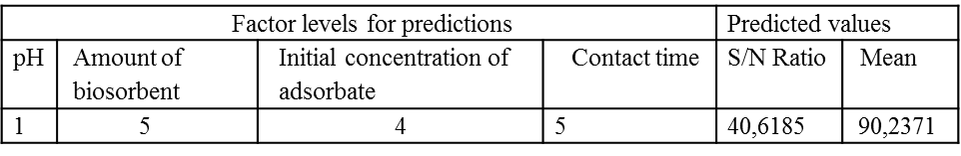
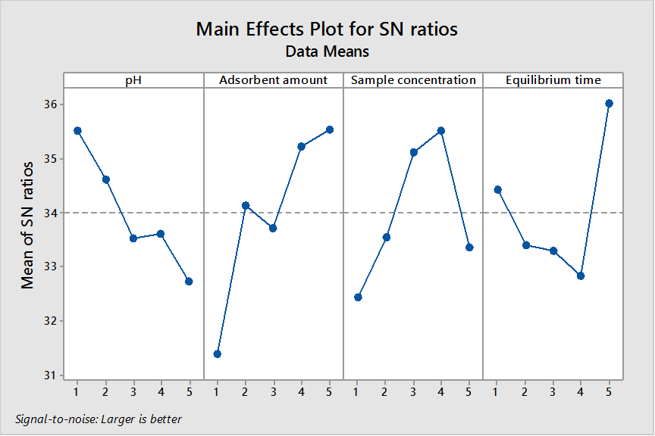

Figure 1. Main effects plot for SN ratios, Factor levels for predictions, Predicted values
3.2 Influence of pH
The previous studies have shown that pH of the solution is a critical parameter affecting biosorption of 2,4-DCP.^{7,12,23} The pH ranges of 2-10 were used in this study to ensure the presence of the protonated form of 2,4-DCP and the increase of negative charges at the surface of the particles of bark of sweetgum. The initial pH of the solution was increased with the decrease in the adsorption capacity of 2,4-DCP (figure 2). The figure shows that maximum adsorption capacity of 2,4-DCP was observed at a pH of 2.0. Also it was found the same values of initial pH of the solution using Taguchi’s Orthogonal Array (OA) analysis (figure 1)
The Henderson–Hasselbalch equation (pH$=pKa+log{[A-]}/{[AH]}⁡$ ) is useful for estimating the pH of acidic compounds, such as 2.4-DCP. The value of pKa for 2,4-DCP which is known to be weak acid is 7.85. The value of pH (2) is lower than pKa (7.85), the dissociation degree of 2,4-DCP to form anions increases. The sweetgum bark consists of hydrolyzable tannin compounds.²⁴ The hydroxyl groups of the carbohydrate in hydrolyzable tannin compounds provide negative charge in surface of the biomass as the pH increases. Consequently, the electrostatic impulse between the identical charged target molecules decreases the adsorption capacity of 2,4-DCP in increasing pH of the 2,4-DCP in aqueous solution.

Figure 2.The effect of pH on the equilibrium sorption capacities of sweetgum bark, for 2,4-DCP
3.3. Effect of contact time and initial concentration
The relationship between contact time and 2,4-DCP sorption on sweetgum bark at different initial 2,4-DCP concentrations is presented in Figure 3. The rate of sorption capacities increased slightly at contact time of 150 min. The sorption was not very rapid and the equilibrium time for 2,4-DCP calculated from this study is more than what is reported for phenols onto different biomass¹. The initial concentration of aqueous solution ensures an important locomotive strength to accomplish all mass transfer resistances of adsorbate between the aqueous solid phase and therefore increases the rate of adsorbate molecules passing from the solution to the adsorbent surface.^{1,25-27} Accordingly, a low initial concentration of 2,4-DCP would decrease the process of adsorption (Figure 3). Also Taguchi’s Orthogonal Array (OA) analysis indicates that the optimum of equilibrium time and initial concentration of 2,4-DCP in this study are 150 min and 150 mg/L, respectively (Figure 1).

Figure 3. The sorption equilibration time of 2,4-DCP by dried sweetgum bark (biomass: 1 g, 2,4-DCP concentration: 25,50,100,150, 200 mg/I: temperature 20±0.5, agitation rate: 125 rpm)
3.4. Adsorption kinetic models
The pseudo - first-order model and the pseudo - second-order model were performed to the experimental parameters to evaluate the adsorption kinetics of 2,4-DCP onto sweetgum bark in this study.
Pseudo-first-order model and Pseudo-second-order model
The kinetic of biosorption by any biological material in an aqueous solution has been tested for the pseudo-first-order model equation given by Lagergren. The pseudo-second-order model may provide a better description of the adsorption kinetics.^{7,18}
The pseud-first-order Lagergren equation is:
$\log\left(qe-qt\right)=\log{qecal -({K1}/{2,303 }}$)t (2)
where qe and qt are the amount of 2,4-DCP adsorbed per unit of biomass (mg/g) at equilibrium and at time t, t is the contact time (min) and k₁ is the rate constant of this equation (1/min). The values of K₁ and q_{ecal} were calculated from a plot of log (qe−qt) versus t.
The pseudo-second-order kinetic equation is^{18,28}
$t/{qt}$=$1/{K_{2 }. q_{ecal}^{2}}$ $+ t/{q_{ecal}}$ h=$K_{2}$ $q_{ecal}^{2}$ (3)
where h represents the initial adsorption rate (mg/g min), and K₂ is the rate constant in the pseudo-second-order kinetic model (g / mg.min). The values of q_{ecal}, K₂ and h can be obtained by a linear plot of t/qt versus t.
The linear regression correlation coefficient ( R²) values for Lagergren-first order kinetic model ranged from 0.8140 to 0.9922, which was lower than the R² values for Pseudo-second order kinetic model which ranged from 0.8140 to 0.9999 (Table 3). The reaction involved in present biosorption system may not be of the Lagergren -first-order kinetic model. The whole range of data might not be sufficiently described by the Lagergren-first order kinetics. Moreover, the q_{ecal} values for pseudo-second-order kinetic model were closer to the experimental qe values than the calculated q_{ecal} values for Lagergren -frist-order kinetic model (Table 3). These values show that pseudo-second-order kinetic fits for the biosorption of 2,4- DCP on the sweetgum bark. Figure 4 was the linearized plots of the pseudo-second-order kinetic for 2,4-DCP biosorption. The Pseudo-second-order kinetic model was suitable for all the data. The process of the Pseudo-first-order kinetic model has been used for adsorption of reversible with an equilibrium being established between adsorbate and adsorbent systems although the process of the Pseudo-second-order kinetic model demonstrates chemisorptions which control the adsorption such as Vander Waals, hydrogen bonding, ion exchange etc.²⁹ The process of 2,4- DCP adsorption in sweetgum bark can be chemisorptions.
Table3. Parameters of Lagergren-first order kinetic model Pseudo-second order kinetic model for 2,4- DCP adsorption onto sweetgum bark (pH: 2; biomass: 1 g, temperature 20±0.5, agitation rate: 125 rpm)

(mg/L) | Lagergren-first order kinetic model |  |  |  | Pseudo-second order kinetic model
2.4 DCP | q_{e}(mg/g) | K₁(min⁻¹) | q_{ecal} (mg/g) | R² | q_{eca}l  (mg/g) | K₂  (gmg⁻¹) min⁻¹) | R²
25 | 0,269 | 1,74 | 0,029 | 0,8124 | 0,514 | 0,0187 | 0,814
50 | 0,963 | 2,43 | 0,004 | 0,9922 | 1,049 | 0,0257 | 0,8619
100 | 2,013 | 1,74 | 0,029 | 0,8124 | 2,077 | 0,0984 | 0,9999
150 | 5,243 | 1,28 | 0,013 | 0,9609 | 5,482 | 0,0182 | 0,9967
200 | 4,828 | 2,16 | 0,012 | 0,9483 | 4,900 | 0,0584 | 0,9995

Figure 4. Pseudo-second –order plots at different initial 2.4 DCP concentrations (pH: 2; biomass: 1 g, temperature 20±0.5, agitation rate: 125 rpm)
3.5. Adsorption isotherm models
Adsorption isotherm models are important in order to describe the sorption process. The data of adsorption isotherm models are also important to predict the adsorption capacity and describe the surface properties and affinity of the adsorbent.¹⁸ Two adsorption isotherm models were used to studies in the present study: the Langmuir isotherm model and Freundlich isotherm model. The general Langmuir equation whose linearized form is given as follows:
${Ce}/{qe}$ $=1/{Qm.b}$ $+1/{Qm.Ce}$ (4)
where C_{e} is the equilibrium concentration of the adsorbate (mg/L), q_{e} is the amount of the adsorbate adsorbed per unit mass of the adsorbent (mg/g), b is the Langmuir adsorption constant (L/mg), and Q_{m} is the maximum adsorption amount (mg/g). Qm and b can be determined from the linear plot of Ce/qe versus Ce.^{1,18}
The dimensionless separation factor or equilibrium constant (R_{L}) describes the essential characteristics of Langmuir isotherm. R_{L} is defined as;
R_{L} $=$ $1/{1+b.Co}$ (5)
where Co is the initial concentration (mg/I), and b is the Langmuir constant. This indicates the nature of adsorption as;
R_{L} > 1 unfavourable, R_{L} = 1 linear, 0<R_{L} < 1 favourable, R_{L} = 0 irreversible.²⁸ The Freundlich isotherm is an empirical relationship that describes the sorption on a heterogeneous surface. It can be linearized in logarithmic form as follows:
$\log{qe=1/n}$ $\log{Ce+\log{Kf}}$ (6)
where C_{e} is the equilibrium concentration of the adsorbate (mg/L), q_{e}is the amount of the adsorbate adsorbed per unit mass of the adsorbent (mg/g), K_{f}and n are the Freundlich constants, whereas K_{f} and n are indicators of adsorption capacity and adsorption intensity of the sorbents, respectively.¹⁸
The regression correlation coefficients (R²) values of Freundlich isotherm model and Langmuir isotherm model for initial concentration (150 mg/L) of 2,4-DCP are 0.9989 and 0.9898, respectively (Table 4), suggesting that the Freundlich isotherm model provided the best fit and Freundlich isotherm model exhibited a slightly better fit to the biosrption data of 2,4- DCP onto sweetgum bark than the Langmuir isotherm model in the initial concentration (150 mg/).
The adsorption equilibrium of heavy metals on various types of adsorbent was described by Freundlich isotherm and Langmuir isotherm models. However, the descriptions of adsorption equilibrium of organic pollutants such as phenol and chlorophenols were used the Freundlich isotherm model better than Langmuir isotherm model¹.
Table 4. Adsorption isotherm constants for 2.4-DCP onto sweetgum bark
 | Langmuir model |  |  | Freundlich model
Phenol | Q_{m} | b | R² | K_{f} | n | R²
2,4-DCP | 8,176 | 52,36 | 0,9898 | 0,0077 | 0,722 | 0,9989

The magnitude of Q_{m} (8, 176) for Langmuir isotherm model shows the amount of 2,4-DCP per unit weight of sorbent to form complete monolayer on the surface of a sample.
The value of adsorption capacity (Q_{m}) for 2,4-DCP in present study was compared with the adsorption capacity of different adsorbents for 2,4-DCP (Table 5).
Table 5. Comparison of adsorption capacity for 2,4-DCP between sweetgum bark and other various adsorbents reported in the literature.
Adsorbent | Q_{m} (mg/g) | Reference
P.ocenica fibers  Rice Husk  Fly ask  Mycelial pellets  Papermill sludge  Sweetgum brk | 1,11  40,5  5,57  4,09  4,49  8.176 | Demirak et al., 2011⁷  Vadivelan et al., 2005³⁰  Kumar et al., 2005³¹  Wu and Yu., 2006¹  Calace et al., 2002³²  This study

According to the equation (5), the value of R_{L} is 0.0001. This value indicates that sorption of 2,4-DCP on sweetgum bark may be irreversible. On the other hand, a value of correlation coefficient (R²) for initial concentration of 150 mg/L 2,4-DCP in Langmiur isotherm model is 0.9898. This value indicates that there is a good agreement between the parameters and confirms the monolayer adsorption of 2,4-DCP onto sweetgum bark (Table 4).
The constant values calculated from the Freundlich model for the biosorption equilibrium are given in Table 4. The values of n in this study are less than 1, a favorable adsorption is indicated and chemical rather than physical adsorption is dominant.
3.6. Surface Characterization
SEM analysis
SEM was used to observe the surface morphology of sweetgum bark samples and it is shown in Figure 5. SEM micrographs were taken at 1 kV accelerating voltage and magnification was fixed according to x1000. The SEM micrographs show that it was obtained to different from the morphology of the samples. There is clear indicator of sorption of 2,4-DCP on dried sweetgum bark in SEM pictures.
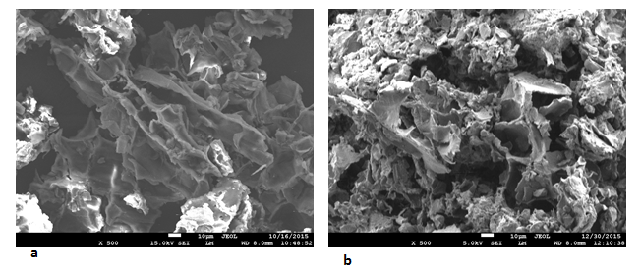
Figure 5. SEM pictures of sweetgum bark samples a) before the sorption of 2,4-DCP b) after the sorption of 2,4-DCP

FTIR analysis
FTIR spectroscopy of the extracts showed that the polar extractive spectra were consistent with the hydrolysabletannin compounds isolated during extractions of sweetgum bark.²⁴ At the center of a hydrolyzabletannin molecule, there is a carbohydrate. Phenolic groups were used to partially or totally esterify the hydroxyl groups of the carbohydrate.³³ The information on the nature of the bonds on biomasses surface allowing the determination of different functional groups is offered by FTIR.
Figure 6 shows the changes of FTIR peaks for raw sweetgum bark compared to those after biosorption with 2,4-DCP Several peaks were observed from the spectra and this indicates that sweetgum bark is composed of various functional groups (Table 6).
In the spectra a new band is observed at 1708 cm⁻¹, which can be assigned to ester formation. This peak indicates that he hydroxyl groups of the carbohydrate in sweetgum bark are esterified with 2,4-DCP. These may be because of the interaction between the functional groups of sweetgum bark with 2,4-DCP compounds during the adsorption process.

Wavelength  Range (cm-1) | Before Biosorp. | After  Biosorp. | Differences | Assignment
3500-3200 | 3447 | 3423 | 24 | Bonded hydroxyl groups (phenolic OH and aliphatic OH
1705-1715 |  | 1711 | New peak | C=O stretching (unconjugated ketone, carbonyl and ester groups
1670-1500 | 1635 | 1623 | 12 | Carboxylic groups
1450-1375 | 1454 | 1452 | 2 | Symmetric bending of CH3
1300-1000 | 1317  1036 | 1371  1036 | 0  0 | -SO3 stretching  C-O-C stretching in ethers.

Table 6. The FTIR spectral characteristics of sweetgum bark before and after biosorption of 2,4-DCP (İbrahim et al., 2011; Chen et al., 2014; Nelson et al., 2015) .
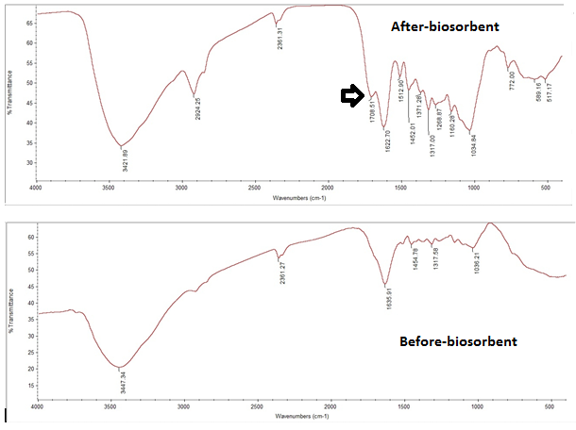
Figure 6. FTIR spectrum of biosorbent (before biosorption and after biosorbent)

Conclusions
- This study has been performed by using the Turkish sweetgum bark as a potent biosorbent for the removal of 2,4-DCP.
- The choice of the Turkish sweetgum bark was made according to some criteria, including its forest wastes.
- The maximum adsorption capacity of 2, 4-DCP was observed at a pH of 2.0.
- The rate of sorption capacities increased slightly at contact time of 150 min.
- Taguchi’s Orthogonal Array (OA) analysis was used to determine the values of optimum experimental parameters for adsorption capacity of 2,4-DCP onto Turkish sweetgum bark.
- The values of optimum experimental parameters for adsorption capacity of 2,4-DCP onto Turkish sweetgum bark can be explained clearly by Taguchi’s Orthogonal Array (OA) analysis.
- Biosorption was determined by a Pseudo-second-order model predicting a chemisorption process.
- The equilibrium data were well characterized by the Langmuir isotherm model, which confirmed the mono-layer coverage.
- The Freundlich isotherm model was found to represent the measured sorption data well.
- A new band is observed at 1708cm⁻¹ in FTIR, which can be assigned to ester formation. This peak indicate that hydroxyl groups of the carbohydrate in sweetgum bark are esterified with 2,4-DCP
Acknowledgements
This research was supported by Muğla Sıtkı Koçman University (Project no: 15/017)
References
- W.Juan, Y. Han-Qing, J Hazard Mater B, 2006, 137, 498–508.
- N.S. Kumar, M.V. Subbaiah, A.S. Reddy, A. Krishnaiah, J Chem Tech Biotechnol 2009, 84, 972–981.
- V.C. Srivastava, M.M. Swamy, I.D. Mall, B. Prasad and I.M. Mishra, Colloid Surface A 2006, 272, 89–104.
- S.P. Kamble, P.A. Mangrulkar, A.K. Bansiwal, S.S. Rayalu, Chem Eng J 2008, 138, 73–83.
- N.S. Kumar, K. Min, Chem Eng J 2011, 168, 562–571.
- A.Gholizadeh, M. Kermani, M. Gholami, M. Farzadkia, K. Yaghmaeian Asian J Chem 2013, 25, 7, 3871–3878.
- A. Demirak, Ö. Dalman, E. Tilkan, D. Yıldız, E. Yavuz, C. Gökçe, Microchem. J 2011, 99, 97-102.
- A.S. Ghatbandhea, H.G. Jahagirdara, M.K.N. Yenkieb, and S.D. Deosarkarc, Russ J Phys Chem A 2013, 87, 8, 1362–1366.
- M.W. Jung, K.H. Ahn, Y. Lee, K.P. Kim, Microchem. J. 2001, 70, 123–131.
- F. Kargi, S. Eker, Process Biochem 40,6, 2005, 2105–2111.
- E. Rubin, P. Rodriguez, R. Herrero, M.E. Sastre de Vicente J Chem Tech Biotechnol 2006, 81, 1093–1099.
- M. Akhtar, M.I. Bhanger, S. Iqbal, S.M. Hasany, J. Hazard. Mater. B 2006, 128, 44–52.
- S.K. Nadavala, K. Swayampakula, V.M. Boddu, K. Abburi, J Hazard Mater 2009, 162, 482–489
- M. Sathishkumar, A.R. Binupriya, D. Kavitha, S.E. Yun, Bioresour. Technol. 2007, 98, 866–873.
- M. Sathishkumar, K. Vijayaraghavan, A.R. Binupriya, A.M. Stephan, J.G. Chai, S.E. Yun, J Colloid Interface Sci. 2008, 320, 1, 22-29.
- M. Sathishkumar, A.R. Binupriya, D. Kavitha, R. Selvakumar, R. Jayabalan, J.G. Choi, S.E. Yun, Chem. Eng. J. 2009, 147, 265–271.
- A. Bhatnagar, A.K. Minocha, J. Hazard. Mater. 2009, 168, 1111–1117.
- L. Wang, J. Zhang , R. Zhao, C. Zhang, C. Li, Y. Li, Desalination 2011, 266, 175–181.
- A. Gholizadeh, M. Kermani, M. Gholami and M. Farzadkia, J. Environ. Health Sci. Eng. 2013 DOI: 10.1186/2052-336X-11-29
- I. Gurbuz, E. Yesilada, B. Demirci, E. Sezik, F. Demirci, K.H. Baser, J Ethnopharmacol 2013, 148, 332–336.
- Standard Methods for the examination of water and wastewater, Washington, D.C.: APHA-AWWA-WEF, 2005.
- Z. Alam, S. A. Muyibi, J. Toramae, J Envıron Sci 2007, 19, 674–677
- Z. Aksu, J. Yener, A Waste Manag. 2001, 21, 695–702.
- L. Thomas, N.L. Eberhardt, C.L. Seok. Kim, K.G. Reed, D.J. Leduc, J.M. Warren, Trees, 2015, 29, 1735–1747.
- F.A. Banat, B. Al-Bashir, S. Al-Asheh, O. Hayajneh, Environ. Pollut 2000, 107
- , 3, 391– 398.
- Z. Aksu, D. Akpinar, Separation Purif. Technol. 2000, 21, 87–99.
- Z. Aksu, Separation Purif Technol. 2001, 21,3, 285–294.
- S Kuppusamy, T Palanisami, M Megharaj, K Venkateswarlu, R Naidu Rev Envıron Contam T, 2016, 236, 117-192.
- Z. Chen, H. Deng, C. Chen, Y. Yang, H. Xu, J. Environ. Health Sci. Eng. 2014, 12, 63, 1-10.
- V. Vadivelan, K. Kumar, J. Colloid Interf. Sci. 2005, 286, 90-100.
- K.V. Kumar, V. Ramamurthi, S. Sivanesan, J. Colloid Interf. Sci. 2005, 284, 14-21.
- N. Calace, E. Nardi, B.M. Petronio, M. Pietroleytti, Environ. Pollut. 2002, 118, 315–319.
- https://en.wikipedia.org/wiki/Hydrolysable_tannin

