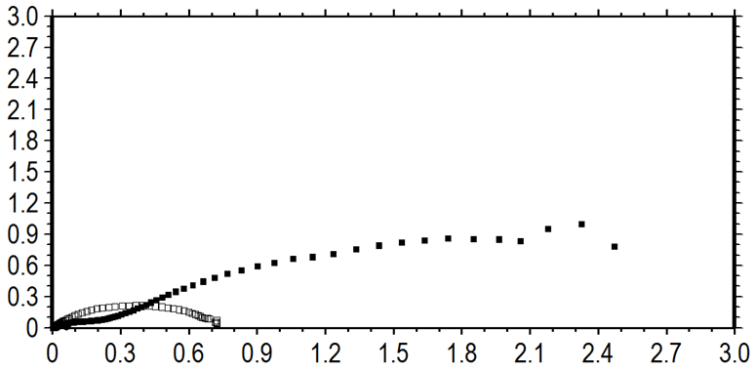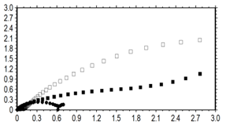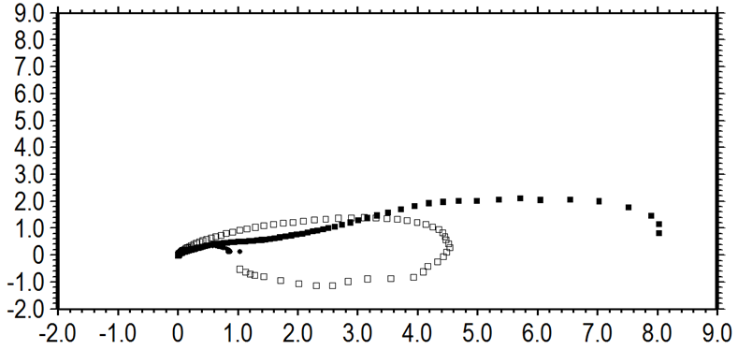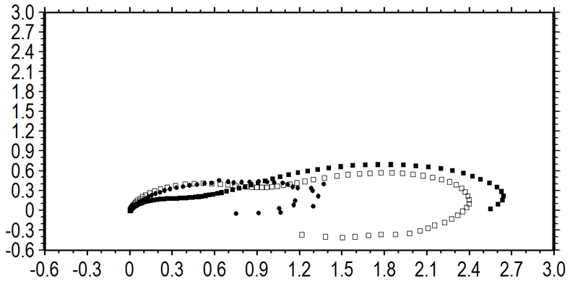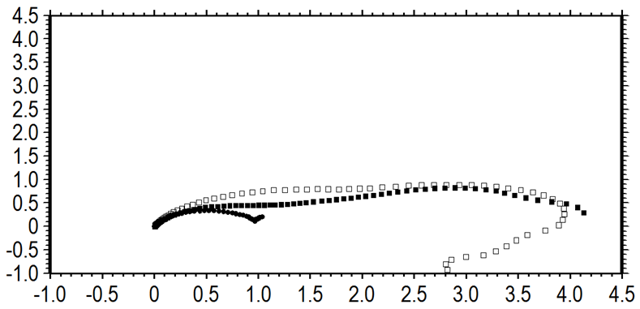
-Z ˈˈ(10⁵ ohm)
Zˈ(10⁵ ohm)
(d)
Zˈ(10⁴ ohm)
-Z ˈˈ(10⁴ ohm)
-Z ˈˈ(10⁴ ohm)
Zˈ(10⁴ ohm)
(c)
(a)
Zˈ(10⁴ ohm)
-Z ˈˈ(10⁴ ohm)
(b)
Zˈ(10⁴ ohm)
-Z ˈˈ(10⁴ ohm)

