Protective Properties of Poly(N-methylpyrrole) Film on ZnNi Plated Carbon Steel Electrode

Abdurrahman Akdagª* and Ali Tuncay Ozyilmaz^{b}

ª Department of Medical Laboratory Techniques, Vocational School of Health Services, Harran University, 63300, Sanliurfa, Turkey
^{b} Department of Chemistry, Faculty of Arts and Sciences, Mustafa Kemal University, 31040, Hatay, Turkey

Abstract
In this study, zinc–nickel (ZnNi) particles were electrochemically deposited on carbon steel (CS) electrode applying constant current of 1 mA with chronopotentiometry technique. Poly(N-methylpyrrole) (PNMP) film on CS/ZnNi electrode was synthesized with cyclic voltammetry technique from 0.10 M N-methylpyrrole containing 0.20 M sodium oxalate solution. The corrosion performances of coated and uncoated electrodes in 3.5 % NaCl solution were evaluated with the help of AC impedance spectroscopy (EIS) and anodic polarisation curves. Scanning electron microscopy (SEM) and linear sweep voltammetry (LSV) were used to characterization of coatings. It was shown that the ZnNi particles exhibited important barrier effect on CS substrate. The polymer film exhibited an effective barrier property and electrocatalytic behaviour protection of substrate for longer exposure time.
Keywords: Alloy plating, corrosion, conducting polymer, poly(N-methylpyrrole)

*Corresponding author: Abdurrahman Akdag
Phone: +90-414-3183209, Fax: +90-414-3183211
E-mail: ab.ak@hotmail.com

1. Introduction
Corrosion of the metals is one of the most serious problems in industry. Zinc coating provides good protection for ferrous substrates. Zinc and zinc alloys (ZnCo, ZnNi) are widely used in the corrosion protection of steel.¹⁻⁷ But these zinc alloys exhibit a significantly higher corrosion resistance than pure zinc coating.⁸⁻¹⁵ Conducting polymers like polyaniline, polythiophene and polypyrrole have shown wide range of applications due to their very interesting physical properties. Some of their important properties include electrical conductivity, electroactivity, electrochromism, environmental stability, chemical stability and corrosion inhibitive property.¹⁶ Conducting polymers act as anodic protection and constitute effective physical barrier against corrosive products in the protection of metals. These polymers significantly reduce the rate of corrosion.¹⁷ Introduced advantages by these organic coatings are a good adhesion at the metal surface and non toxic corrosion problems as than occurs in the commonly painting systems.¹⁸ Due to these properties polypyrrole and polyaniline and its derivatives are most extensively studied conducting polymers.¹⁶⁻²⁶
The purpose of the present study was to synthesize electrochemically PNMP film on thin zinc–nickel (ZnNi) plated carbon steel in sodium oxalate (NaOX) solution. The corrosion behaviors of ZnNi deposited carbon steel electrodes with and without PNMP film have been investigated in 3.5 % NaCl and compared by using AC impedance spectroscopy (EIS) technique, open circuit potential-time measurements linear sweep voltammetry (LCV) technique and anodic polarization curves.
2. Experimental
All electrochemical experiments were performed in a standard one-compartment three-electrode cell. The reference electrode was Ag/AgCl (3 M, KCl) and the counter electrode was a platinum sheet. Surface area of platinum sheet and working electrode were 0.18 cm² and 0.05 cm², respectively. The working electrode used in this study was carbon steel with the composition: 0.0561 % C, 0.4498 % Mn, 0.0103 % P, 0.0036 % S, 0.14085 Si and 99.3394 % Fe. The surface of this electrode was carefully polished with abrasive paper (1200 grid), degreased with 1/1 ethanol/acetone mixture, washed with distilled water and dried. CHI 606C and CHI 660B model digital electrochemical analyzers were used for all electrochemical measurements. Zinc-nickel plating was carried out in a bath including 200 gl⁻¹ ZnSO₄.7H₂O, 140 gl⁻¹ NiSO₄.6H₂O, 20 gl⁻¹ H₃BO₃, 2 gl⁻¹ CH₃C₆H₄SO₃H.H₂O. Meanwhile pH was approximately 5.5. The plating time was 400 sec applying 1 mA constant current. ZnNi plating was accomplished under atmospheric condition without stirring the solution. The thickness of alloy plating was determined by estimation of the passing charge amount applying 1 mA constant current and the thickness of ZnNi alloy plating was estimated to be between approx. 2.73 - 3.80 μm. Poly(N-methylpyrrole) film was electrochemically synthesized using cyclic voltammetry technique. Electrochemical impedance measurements were obtained at measured open circuit potential values applying 7 mV of amplitude in frequency range from 10⁵ to 10⁻³ Hz. The anodic polarization curves were recorded after 168 h of immersion time in corrosive test solution. The scan rate was 4 mV/s and the measured open circuit potential value was the initial potential for the scan. SEM was employed to characterize the surface morphology with a JEOL JSM-5500LV scanning electron microscope at 10 kV.

3. Results and discussion
In this study, zinc–nickel (ZnNi) plating was electrochemically deposited on carbon steel (CS) electrode applying constant current of 1 mA with chronopotentiometry technique.
The cyclic voltammograms recorded for zinc-nickel plated carbon steel (CS/ZnNi) in monomer containing NaOX solution are given in Fig. 1. PNMP coating was synthesized in two steps. The first cycle was obtained in the potential range from -1.10 to +1.80 V. Then the film growth was carried out in the potential range between 0.00 and 1.80 V. Fifty segment were employed for the preparation of PNMP covered CS/ZnNi electrode. The scan rate was 100 mVs⁻¹ for both cases. In Fig. 1a, anodic current values started to increase at approximately -0.70 V due to the zinc and nickel dissolution process, which continued in a wide potential range. The passivation of the surface was observed to terminate at approximately 0.56 V. The passivation mechanism resulted from the formation of insoluble zinc and nickel oxalate compounds. In Fig. 1b, there are growth curves of PNMP film synthesized on the surface of CS/ZnNi electrode. At anodic scan, the current waves observed at around 1.07 V were attributed to monomer oxidation. The current values of these waves decreased proportional number of cycles. This case showed that the PNMP film covered the CS/ZnNi electrode surface.

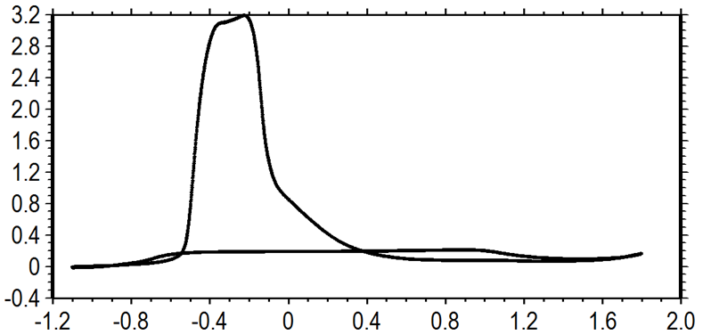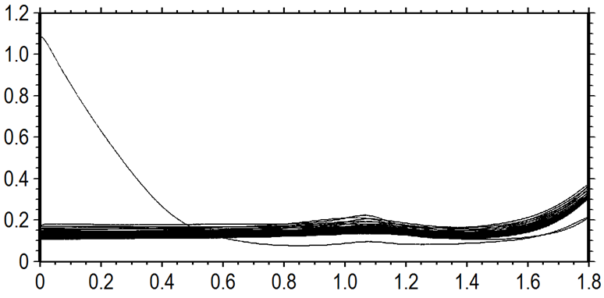
(a)
E (V)
I (mA)
(b)
E (V)
I (mA)

Fig. 1. First CV (a) and film growth curves (b) recorded for CS/ZnNi electrode in
0.10 M N-methylpyrrole containing 0.20 M NaOX solution, scan rate: 100 mVs⁻¹

SEM images of bare CS, CS/ZnNi and CS/ZnNi/PNMP electrodes are given in Fig. 2. The bare electrode showed the evidence of emery. The emery traces observed for CS electrode disappeared for CS/ZnNi and CS/ZnNi/PNMP electrodes. It can be seen that CS/ZnNi electrode was smooth structure. The surface of CS/ZnNi electrode was covered with granular structure of PNMP film.

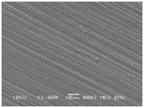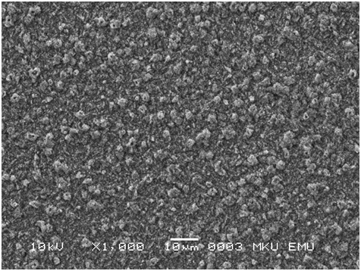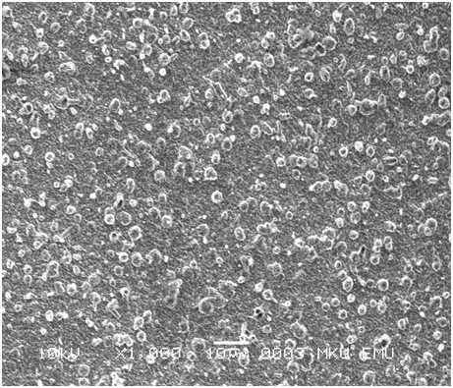
(a)
(c)
(b)

Fig. 2. SEM images of bare CS (a), CS/ZnNi (b) and CS/ZnNi/PNMP (c) electrodes.

The Nyquist diagrams recorded for CS, CS/ZnNi and CS/ZnNi/PNMP electrodes in 3.5 % NaCl solution are given in Fig. 3, after various immersion times. As seen from Fig. 3, there were one depressed semicircle at high frequency and an inductive loop at low frequency region, in presence of CS electrode, while these plots for CS/ZnNi and CS/ZnNi/PNMP electrodes consisted two depressed semicircles which could not be well resolved from each other at high and mid frequency regions, after 2 h of exposure time. The depressed semicircle at high frequency region obtained for CS electrode was related to the charge transfer resistance (R_{ct}) that was responsible for the anodic dissolution of bare metal and oxide layer resistance (R_{o}). On the other hand, there were R_{ct} at high frequency region and alloy plating (R_{ZnNi}) + R_{o} or R_{ZnNi} + R_{o} + polymer film resistance (R_{pf}) for CS/ZnNi or CS/ZnNi/PNMP electrodes, respectively. The inductive loop at low frequency region was related to adsorption of different corrosion intermediates. In this study, R_{p} values were used in stern-Geary equation for calculation of corrosion current (I_{corr}).
I_{corr}$=\frac{B}{R_{p}}$ (1)
In this equation, B value was equal to ; β_{a} and β_{c} were anodic and cathodic Tafel slopes, respectively. The value of B was taken as 0.026 V for uncoated electrode and 0.052 V for coated electrode. The protection efficiency values (E %) were calculated by using the fallowing equation.²⁷
(2)
After 2h of exposure time, R_{p} values for CS/ZnNi and CS/ZnNi/PNMP electrodes were found to be higher than CS electrode, while the highest R_{p} value was obtained for CS/ZnNi/PNMP electrode. This case was related to barrier effect of PNMP film and supported that the value of I_{corr} and E % are presented in Table 1. After 48 h, R_{p} values of all electrodes were greater than those of 2 h exposure times. This case showed that oxide layers formed with time. Protection efficiency value of CS/ZnNi/PNMP electrode was 75.36 % that it was relatively higher value than that of CS/ZnNi electrode. After 96 h, I_{corr} value obtained for CS/ZnNi/PNMP electrode was 0.63 µA that the lowest value when compared with those of all electrodes. E % value of CS/ZnNi/PNMP electrode was 88.54 % that was nine times higher than CS/ZnNi electrode. At the same time, the R_{p} value of CS/ZnNi electrode decreased significantly, while this value increased from 40578 to 82115 Ω for CS/ZnNi/PNMP electrode. This increase in R_{p} value of CS/ZnNi/PNMP electrode was related to electrocatalytic behaviour of polymer film. Electrocatalytic property of polymer film contributed to the polarization resistance due to the formation of protective oxide layers and the reduction of polymer film. When the ions diffused the pores of the coating, zinc and nickel were oxidized thereby yielding the formation of their oxide layers. Then, polymer film was reduced at metal/polymer interface.²⁷ After 168 h of immersion time, the R_{p} value observed for CS/ZnNi/PNMP electrode was approx. 298350 Ω.
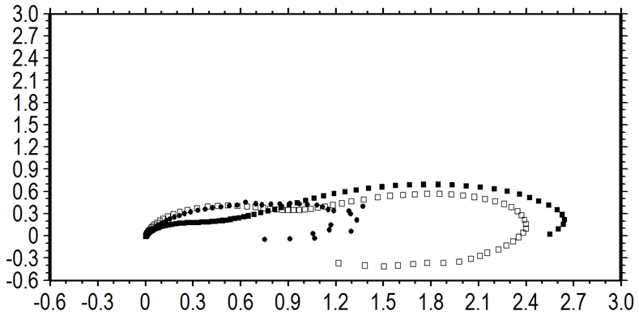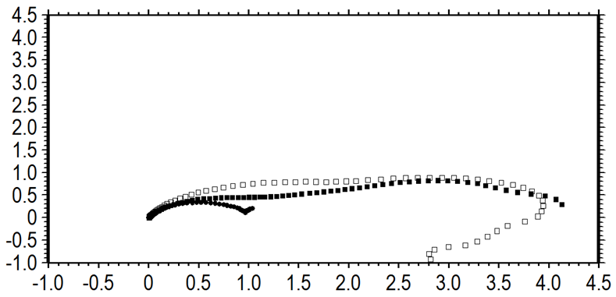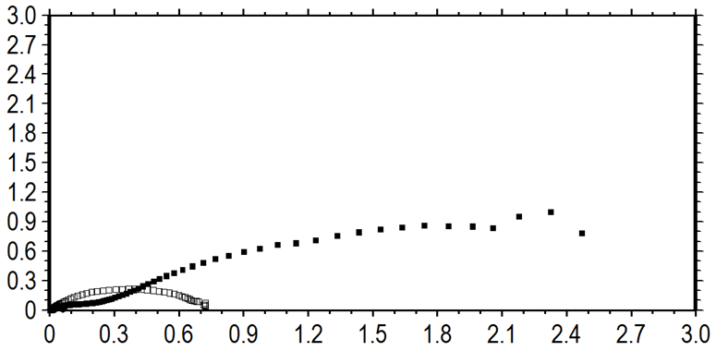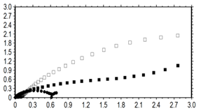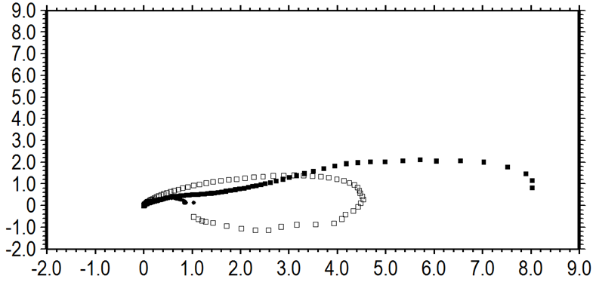
(a)
Zˈ(10⁴ ohm)
-Z ˈˈ(10⁴ ohm)
(b)
Zˈ(10⁴ ohm)
-Z ˈˈ(10⁴ ohm)
-Z ˈˈ(10⁵ ohm)
Zˈ(10⁵ ohm)
(d)
Zˈ(10⁴ ohm)
-Z ˈˈ(10⁴ ohm)
-Z ˈˈ(10⁴ ohm)
Zˈ(10⁴ ohm)
(c)

Fig. 3. The Nyquist plots recorded for CS (●), CS/ZnNi (□) and CS/ZnNi/PNMP (■) electrodes after 2 (a), 48 (b), 96 (c) and 168 h (d) of exposure time in 3.5 % NaCl solution.

This value is fairly higher than those of CS and CS/ZnNi electrode values. The results clearly showed that the PNMP coating on ZnNi plated carbon steel exhibited an effective anticorrosive property on ZnNi plated carbon steel.

Table 1. The R_{p}, E_{ocp}, I_{corr} and E % for CS, CS/ZnNi and CS/ZnNi/PNMP electrodes after various exposure times in 3.5 % NaCl.

Samples | t (h) | E_{ocp} (V) | R_{p} (Ω) | I_{cor r} (µA) | E %
CS | 2 | -0.585 | 7504 | 3.46 | -
CS | 48 | -0.669 | 10000 | 2.60 | -
CS | 96 | -0.665 | 9413 | 2.76 | -
CS | 168 | -0.655 | 6776 | 3.84 | -
 | 2 | -0.974 | 12163 | 4.28 | 38.30
 | 48 | -0.968 | 27980 | 1.86 | 64.26
CS/ZnNi | 96 | -0.956 | 10345 | 5.03 | 9.01
 | 168 | -0.598 | 71250 | 0.73 | 90.49
 | 2 | -0.981 | 25620 | 2.03 | 70.71
 | 48 | -0.964 | 40578 | 1.28 | 75.36
CS/ZnNi/PNMP | 96 | -0.945 | 82115 | 0.63 | 88.54
 | 168 | -0.572 | 298350 | 0.17 | 97.66

Fig. 4a compares the anodic polarization curves of CS, CS/ZnNi and CS/ZnNi/PNMP electrodes after 168 h of immersion time in 3.5 % NaCl corrosive solution. In the case of CS electrode, the corrosion potential (E_{corr}) value was measured to be -0.652 V. Current values increased so rapidly that there was not any possibility for passivation of the CS electrode under the corrosive condition. The E_{corr} values recorded for CS/ZnNi and CS/ZnNi/PNMP electrodes were measured -0.507 V and -0.314 V, respectively. It was clearly seen that both electrodes exhibited significantly lower current values and E_{corr} values shifted towards nobler potential regions with respect to the bare CS electrode. But it must be noted that much lower current values in near the E_{corr} region were recorded for CS/ZnNi/PNMP electrode with respect to CS/ZnNi electrode. These results showed that PNMP coating provided much better barrier efficiency against the attack of corrosive species like dissolved oxygen and chloride ions.

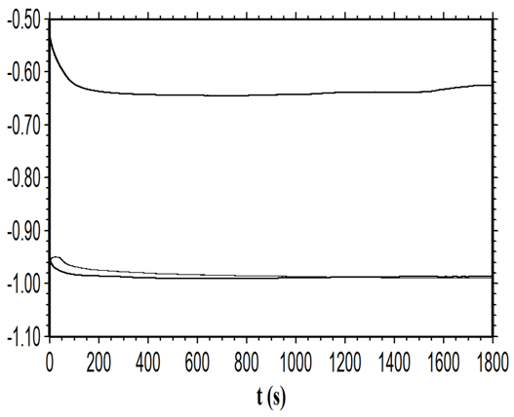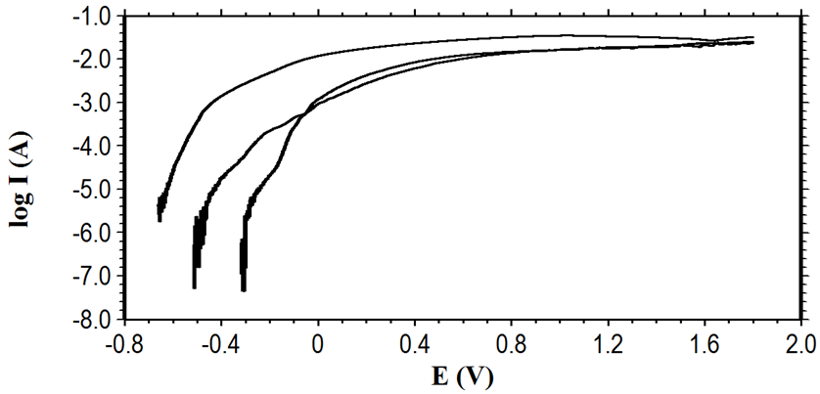
■
□
●
(b)
(a)
□

■
□
●

Fig. 4. The anodic polarization (a) and E_{ocp}-time curves (b) recorded for CS (●), CS/ZnNi (□) and CS/ZnNi/PNMP (■) electrodes in 3.5 % NaCl solution.

Immediately after the immersion time, open circuit potential (E_{ocp}) - time curves of CS, CS/ZnNi and CS/ZnNi/PNMP electrodes in 3.5 % NaCl solution are given in Fig. 4b. It was clearly seen that E_{ocp} values of CS/ZnNi and CS/ZnNi/PNMP electrodes were the negative direction when compared with CS electrode. Consequently, this behaviour of coated electrodes showed the presence of a layer on CS substrate. Those of CS electrode were at approx. -0.640 V, while E_{ocp} values recorded for coated electrodes were generally observed at approx. -0.985 V. These values obtained for coated electrodes indicated the presence of Zn metal on CS electrode. The E_{ocp} values of coated electrodes were closely each other, after 1800 s of immersion time. But, it was shown in Table 1 that E_{ocp} values of PNMP coated CS/ZnNi electrode was relatively higher than that of ZnNi coated CS electrode, after 48, 96 and 168 h of exposure times. This case was related to anodic protection behavior of polymer film.

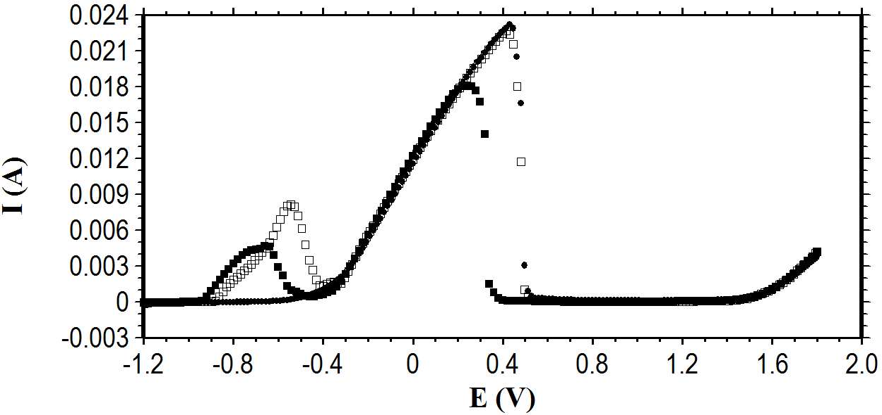

Fig. 5. The linear sweep voltammograms recorded for CS (●), CS/ZnNi (□) and
CS/ZnNi/PNMP (■) electrodes in 0.05 M EDTA containing 0.50 M sodium
sulphate solution.

Anodic linear sweep voltammograms obtained for CS, CS/ZnNi and CS/ZnNi/PNMP electrodes in 0.05 M EDTA containing 0.50 M sodium sulphate are given in Fig. 5. All measurements were taken at scan rate of 5 mVs⁻¹. In the anodic linear sweep voltammetry technique, different phase structures and chemical forms existing in the metal and metal alloy plating will lead to dissolution at present potential values depending on their equilibrum an kinetic properties. Hence, the peak properties produced are the characteristics of the alloy substrates and phase structure of the coating. There were only single anodic peak for bare CS electrode and two anodic dissolution peaks for CS/ZnNi and CS/ZnNi/PNMP electrodes. The peaks at approximately -0.65 V for CS/ZnNi and -0.55 V for CS/ZnNi/PNMP electrodes were due to dissolution of zinc and nickel and formation of zinc and nickel complex with EDTA. This peak in this potential was not seen for bare CS electrode. Therefore, this behavior of CS/ZnNi/PNMP electrode indicated the presence of alloy coating underlying the PNMP homopolymer film. The peaks at approximately 0.43 V for CS and CS/ZnNi and 0.25 V for CS/ZnNi/PNMP electrodes were anodic dissolution of iron substrate. The current values recorded for dissolution peak of iron were the lowest in presence of PNMP film. It was clear that PNMP coating on CS/ZnNi electrode provided an adequate physical protection to metal between the corrosive environment and ZnNi alloy plating.
4. Conclusions
ZnNi alloy plating was successfully deposited on the CS electrode. PNMP film was synthesized on ZnNi alloy deposited carbon steel electrode with cyclic voltammetry techniques from 0.20 M N-methylpyrrole containing 0.20 M NaOX solution. It was shown that ZnNi alloy plating contributed to the corrosion resistance of CS electrode. The corrosion test showed that CS/ZnNi/PNMP electrode exhibited the highest protection efficiency and the lowest corrosion current values. The polarization resistance of PNMP coated CS/ZnNi electrode was fairly higher when compared with CS and CS/ZnNi electrodes. The protective effect of PNMP film formed on CS/ZnNi grew in parallel extended exposure time by its electrocatalytic behavior.

5. References
1. A. C. Hegde, K. Venkatakrishna, N. Eliaz. Surf. & Coat. Techn. 2010, 205, 2031–
2041.
2. J. B. Bajat, S. Stankovic, B. M. Jokic, J. Sol. St. Electrochem. 2009, 13, 755–762.
3. A. P. Ordine, S. L. Diaz, I. C. P. Margarit, O. R. Mattos. Electrochim. Acta. 2004,
49, 2815-2823.
4. R. Ramanauskas, P. Quintana, L. Maldonado, R. Porn, M.A. Surf. & Coat. Techn.
1997, 92, 16-21.
5. N. R. Short, S. Zhou, J. K. Dennis. Surf. & Coat. Techn. 1996, 79, 218-224.
6. A. El Hajjami, M. P. Gigandet, M. De Petris-Wery, J. C. Catonne, J. J. Duprat, L.
Thiery, F. Raulin, N. Pommier, B. Starck, P. Remy. Appl. Surf. Sci. 2007, 254,
480-489.
7. H. Park, J.A. Szpunar. Corr. Sci, 1998, 40, (4/5), 525-545.
8. Z.L. Wang, Y.X. Yang, Y.R. Chen. Jour. Corros. Sci. Eng. 2005, 7, 18.
9. M. A. Pech-Canul, R. Ramanauskas, L. Maldonado. Electrochim. Acta, 1997, 42,
(2), 255-260.
10. I. Kirilova , I. Ivanov, S. Rashkov. Jour. Appl. Electrochem. 1997, 27, (12),
1380-1384.
11. G. Roventi , T. Bellezze, R. Fratesi. Electrochim. Acta. 2006, 51, 2691–2697.
12. Z. F. Lodhi, J. M. C. Mol, W. J. Hamer, H.A. Terryn, J. H. W. De Wit.
Electrochim. Acta, 2007, 52, 5444–5452.
13. I. H. Karahan, O. Karabulut, U. Alver. Phys. Scr. 2009, 79, 55801.
14. P. D. L. Neto, A. N. Correia, R. P. Colares, W. S. Araujo. J. Braz. Chem. Soc.
2007, 18, (6), 1164-1175.
15. N. Boshkov, K. Petrov, S. Vitkova, S. Nemska, G. Raichevsky. Surf. & Coat.
Techn. 2002, 157, 171–178.
16. R. Rajagopalan, J. O. Iroh. Appl. Surf. Sci. 2003, 218, 58-69.
17. J. O. Iroh, W. Su. Electrochim. Acta. 2000, 46, 15-24
18. J. I. Martins, T. C. Reis, M. Bazzaoui, E. A. Bazzaoui, L. Martins. Corros. Sci.
2004, 46, 2361-2381.
19. A.T. Ozyilmaz, A. Akdag. Trans. IMF. 2011, 89 (4), 215–224.
20. A.T. Özyilmaz, A. Akdag. Trans. IMF. 2013, 91 (1), 44-51.
21. N. M. Martyak, P. Mc Andrew, J. E. McCaskie, D. Dijon. Sci. Tech. Advan. Mat.
2002, 3, 345–352.
22. D. J. Shirale, V. K. Gade, P. D. Gaikwad, H. J. Kharat, K. P. Kakde, P. A. Mat.
Letters, 2006, 60, 1407-1411.
23. S.U. Rahman. Surf. & Coat. Techn. 2011, 205, 3035-3042.

24. A. T. Ozyilmaz, A. Akdag, I. H. Karahan, G. Ozyilmaz. Prog. Org. Coat. 2014,
77, 872–879.
25. A. T. Ozyilmaz, A. E. Aydin, A. Akdag. Trans. IMF. 2014, 92, (1), 34-40.
26. R. Singh, A. K. Narula, R. P. Tandon, S. U. M. Rao, V. S. Panwar, S. Chandra,
A. Mansingh. Synt. Met. 1996, 79, (1), 1-6.
27. A.T. Özyilmaz. Poly-Plas. Techn. Engin. 2006, 45, 285–291.
28. Walter, G. W. Corros. Sci. 1986, 26, (9), 681-703.

