Scientific paper

3-(Allylamino)propanenitrile as a Ligand.
Synthesis and X-ray Structure of [Cu(HL⁺)]NO₃]NO₃, [Cu(HL⁺)(H₂O)₂]SiF₆, [Cu(HL⁺)(H₂O)BF₄]BF₄∙H₂O and [Cu(HL⁺)(NH₂SO₃)₂] π-complexes

Mykhailo Luk’yanov^{a,}*, Evgeny Goreshnik^{b}, Vasyl Kinzhybalo^{c}, and
Marian Mys’kivª

ªDepartment of Inorganic Chemistry, Ivan Franko National University of Lviv, Kyryla i Mefodiya Str., 6, 79005, Lviv, Ukraine
^{b}Department of Inorganic Chemistry and Technology, Jožef Stefan Institute, Jamova 39, SI-1000 Ljubljana, Slovenia
^{c}Institute of Low Temperature and Structure Research, Okolna 2, Wroclaw, 50-422, Poland

* Corresponding author: e-mail: mishalukianov@gmail.com; Tel.: +380 32 23 94 506

Received:

Abstract
Four copper(I) π-complexes: [Cu(HL⁺)NO₃]NO₃ (1), [Cu(HL⁺)(H₂O)₂]SiF₆ (2), [Cu(HL⁺)(H₂O)BF₄]BF₄·H₂O (3) and [Cu(HL⁺)(NH₂SO₃)₂] (4) were prepared using alternating–current electrochemical technique, starting from alcohol solutions of 3-(prop-2-en-1-ylamino)propanenitrile (L) titrated with appropriate acid and copper(II) salts (Cu(NO₃)₂∙3H₂O, CuSiF₆∙4H₂O, Cu(BF₄)₂∙6H₂O or Cu(NH₂SO₃)₂∙xH₂O respectively). Obtained compounds were characterized by single-crystal X-ray diffraction and partially by IR spectroscopy.
In the structures of complexes of 1, 2 and 4 Cu^{I} cation possesses a tetrahedral environment formed by the C=C bond of one organic cation HL⁺, the N atom of CN-group from another HL⁺ moiety, and two oxygen (from NO₃– anions in 1, from H₂O molecules in 2) or N atoms (anions NH₂SO₃– in 4). In compound 3 strongly pronounced trigonal-pyramidal coordination environment of Cu^{I} is formed by a mid-point of C=C-bond of one HL⁺ cation, nitrogen atom (of cyano-group) of another HL⁺ unit, oxygen atom of H₂O molecule in the basal plane, and F atom of BF₄– anion at the apical position.

Keywords: Copper(I); π-complexes; 3-(allylamino)propanenitrile; crystal structure; electrochemical technique; coordination polymer

1. Introduction
For almost two centuries the attention of scientists within different branches has been paid to aminonitriles, ranging from α-aminonitriles discovered by A. Strecker as far as in 1850,¹ to various β-, γ-, o-, ω- aminonitriles obtained in our days.² Representatives of this class are well-known not only as versatile intermediates in organic synthesis and in many other reactions,^{3,4} but also as reagents for synthesis of heterocyclic compounds,⁵ inhibitors of enzymes,⁶ precursors of peptides,⁷ amino-acids,⁸ which, in turn, exhibit antibiotic,⁹ antifungal,¹⁰ and other important biological and pharmacological properties.^{11,12}
The coordination behaviour of aminonitriles in the complexation reactions with Cu(I) salts can be characterized on the basis of only several related,^{13,14} or closely related,¹⁵ compounds, though the matter under discussion is still relevant. It has been noticed that atoms of Cl or Br compete for space in coordination polyhedron with allyl groups and cyano group in the halide complexes of Cu(I) with diallylaminopropanenitrile (the tertiary amine N-atom is protonated).¹⁶⁻¹⁷ Still one of the two olefin bonds and halide atoms have a priority, and CN-group (as well as the second С=С-bond) does not coordinate to the metal atom.
Generally speaking, there are few ways for allylaminopropanenitrile-moiety to coordinate with Cu atoms. Depending on the status (cation or molecular) of allylaminopropanenitrile the number of active groups for coordination changes, which, in turn, influences the composition of coordination polyhedron of the Cu atom (other ligand moieties, such as solvent molecules or anions, occupy usually the apical position of the coordination polyhedron) and complexity of the arisen inorganic component in a compound: from (CuCl)₂ to (Cu₂Cl₃)_{n}^{n–}.¹⁶ Thus, being in molecular state, L is coordinated to Cu with allyl- and amino- group and Cl– in the following sequence (С=С ≥ NH >…), whereas C≡N-group is not coordinated. Cationic form of HL⁺ provides these groups the same chance to be coordinated with the metal atom: С=С ≥ С≡N ˃ Hal. In order to study a coordination ability of С=С-bond or C≡N-group to the copper atom, the compounds with ionic copper salts have been studied.
Therefore, we have undertaken the synthesis and crystal structure determination of copper(I)-π-complexes with 3-(allylamino)propanenitrile.

2. Experimental
2.1. Synthesis of 3-(allylamino)propanenitrile (C₃H₅NHC₂H₄CN, L)
A mixture of 0.15 moles allylamine (11.2 mL) and 0.1 mole acrylonitrile (6.8 mL) was continuously stirred and cooled (5 h, 20 °С) preventing the temperature rising not higher than 30 °С,¹⁸ then it was heated for 1 h in a water bath with a reflux condenser at 60 °С. The product (orange liquid) was purified by distillation in a vacuum of a water-jet pump (85 °C /40 mm Hg). The yield of L was 88% (15 mL). IR (KBr) n 3315(w), 3077(m), 2977(m) 2912(s), 2837(s), 2247(s), 1642 (m), 1528(wv), 1465(s), 1419(s), 1118(s), 996(s), 922(vs) cm^{–1}.

2.2. Preparation of complexes
Four crystalline copper(I) compounds with 3-(allylamino)propanenitrile were prepared using alternating-current electrochemical syntheses.¹⁹ The density of crystals of 1–4 was determined by the flotation method in a chloroform-bromoform mixture (Table 1).

2.2.1. Preparation of [Cu(HL⁺)NO₃]NO₃ (1)
The L (4.8 mmol) in 2 mL of C₂H₅OH titrated by HNO₃ to pH 5.5 were mixed with of Cu(NO₃)₂∙3H₂O (4.3 mmol) in 2 mL of C₂H₅OH. The solution was placed into a small test-tube and copper-wire electrodes in cork were inserted. After applying U=0.50 V of alternating-current (frequency 50 Hz, I_{init}=0.5 mA) tension for 16 h a coloured solution was discoloured and good quality colourless crystals of 1 appeared on the copper electrodes. Yield of complex 1 was 70%.

2.2.2. Preparation of [Cu(HL⁺)(H₂O)₂]SiF₆ (2)
The same synthesis (frequency 50 Hz, U=0.55 V, I_{init}=0.4 mA), starting from CuSiF₆∙4H₂O (3.8 mmol) and 4 mL of methanolic solution of the L (4.2 mmol), previously titrated with an aqueous solution of 19% H₂SiF₆ to pH 3, resulted in a formation of good quality crystals of 2 in 12 h. Yield of the complex was 95 %. IR (Nujol) n 3434(vs), 2953(vs), 2846(vs), 2260(w), 1642 (s), 1458(s), 1376(m), 1019(s), 953(w), 728(s) cm^{–1}.

2.2.3. Preparation of [Cu(HL⁺)(H₂O)BF₄]BF₄∙H₂O (3)
Good quality crystals of complex 3 were obtained in a similar way (alternating-current, U = 0.65 V, I_{init} = 0.5 mA) starting from 4mL of propanol solution of the 4 mmol of L (titrated with НBF₄ to pH=4) and Cu(BF₄)₂⋅6H₂O (4 mmol). Colourless prismatic crystals of compound 3 appeared on copper wire electrodes after 120 h. The yield was 60%.
2.2.4. Preparation of [Cu(HL⁺)(NH₂SO₃)₂] (4)
Colourless needle-like crystals of complex 4 appeared from a methanol solution (4 mL) of Cu(NH₂SO₃)₂∙xH₂O (4.1 mmol) and L (4.1 mmol) previously titrated with water solution of 50% NH₂SO₃H to pH 6.5 under conditions of the alternating-current electrochemical technique (U=0.6 V, I_{init}=0.4 mA) during 7 days. A yield of 4 was 65%. IR (KBr) n 3787(vw), 3264(w), 2923(m), 2361(s), 1662(w), 1249(vs), 1203(vs), 1055(m), 787(w), 643(vw), 593(vw), 560(vw) cm^{–1}.
2.3. Crystallography
The experimental details, crystallographic parameters and summaries of the data collection for 1-4 are presented in Table 1. Single crystals of 1-4 were preliminarily studied by the photo-method and then diffraction data were collected on a Rigaku AFC7R (for 1-2) or KUMA-KM4/CCD (for 3-4) (graphite monochromated MoK_{α} radiation) diffractometers. Corrections to the Lorentz and polarization factors were applied to reflection intensities.
The X-ray experimental data were processed using the Rigaku Crystal Clear program,²⁰ for compounds 1 and 2. The CrysAlisRED program was used for processing the X-ray data for complexes 3 and 4.²¹ An absorption correction was applied by the analytical method.²²
Structures 1-4 were solved using direct methods, and light atoms were revealed from the difference Fourier syntheses using the SHELX program package.²³ Full-matrix least-squares refinements based on F² were carried out for the positional and thermal parameters of all non-hydrogen atoms. The hydrogen atoms in structures 1, 2, 3 and 4 were revealed from the difference Fourier syntheses and refined in the riding model along with the non-hydrogen atoms (fixed C–H distances and with U_{iso}(H) equal to 1.2U_{eq}(C)). Hydrogen atoms of amino group and water were refined freely.
The figures were prepared using DIAMOND 3.1 software.²⁴ The CCDC reference numbers for 1, 2, 3 and 4 are 913397, 913398, 913399 and 913400, respectively.

Table 1. Crystallographic data and experimental details for structures 1–4

Compound | 1 | 2 | 3 | 4
CCDC N | 913397 | 913398 | 913399 | 913400
Empirical formula | C₆H₁₁CuN₄O₆ | C₆H₁₅CuN₂O₂F₆Si | C₆H₁₅CuN₂O₂B₂F₈ | C₁₂H₃₀Cu₂N₈O₁₂S₄
Formula weight | 298.73 | 352.83 | 384.36 | 733.76
Crystal size (mm³) | 0.25×0.20×0.10 | 0.50×0.20×0.10 | 0.25×0.20×0.20 | 0.30×0.20×0.05
Temperature (K) | 200(2) | 200(2) | 100(2) | 100(2)
Wavelength, Å | 0.71069 | 0.71069 | 0.71073 | 0.71073
Space group | P2₁/n | P2₁/c | P2₁/n | P
Diffractometer | Rigaku AFC7 | Rigaku AFC7 | КUMА-КМ4/ССD | КUMА-КМ4/ССD
Unit cell dimensions (Å, °)
a  b  c  α  β  γ | 8.2341(4)  7.9905(3)  17.4008(8)  90  98.959(2)  90 | 8.5929(9)  9.7426(8)  15.2109(16)  90  103.448(4)  90 | 12.351(4)  8.607(2)  13.497(4)  90  97.98(3)  90 | 8.217(2)  9.018(3)  17.439(5)  91.93(3)  92.52(3)  90.21(3)
Volume (Å³), Z | 1130.91(9), 4 | 1238.5(2), 4 | 1420.9(7), 4 | 1290.3(6), 2
D_{c} (g∙cm⁻³) | 1.755 | 1.892 | 1.797 | 1.889
D_{m} (g∙cm⁻³) | 1.73 | 1.88 | 1.80 | 1.88
Absorption coefficient (mm⁻¹) | 1.96 | 1.93 | 1.63 | 2.05
F(000) | 608 | 712 | 768 | 752
Theta range for data  collection (°) | 1.2-28.9 | 1.4-29.0 | 2.8-32.6 | 2.5-35.1
Measured reflections | 4673 | 5091 | 14002 | 11271
Independent reflections | 2552 | 2795 | 4825 | 8361
Observed reflections  [I > 2σ(I)] | 2163 | 2542 | 3266 | 6055
Goodness-of-fit on F² | 1.09 | 1.12 | 0.99 | 1.00
Parameters refined | 155 | 204 | 226 | 343
Final R indices  [I > 2σ(I)] | R1 = 0.049,  wR2 = 0.134 | R1 = 0.052,  wR2 = 0.145 | R1 = 0.036,  wR2 = 0.087 | R1 = 0.032,  wR2 = 0.073

3. Results and Discussion
Analysis of the obtained new Cu(I) π-complexes proves that the type of anion influences strongly on a structure formation in these complexes.^{25,26} Complex 1 – [Cu(HL⁺)NO₃]NO₃ - is formed with anion NO₃– which is structurally related to halogenide ones. In this compound due to bridged functions of both L and NO₃– units [Cu(NO₃)]₂ inorganic fragments (similar to ²⁷⁻²⁹) are interconnected with organic cations HL⁺ forming goffer chains in the direction [111] (Fig. 1). The angle between planes passing through two neighbouring inorganic linkers [Cu(NO₃)]₂ of the polymer is 67° (for comparison, the analogous angle between planes passing through two neighbouring inorganic units [CuCl]₂ in the halide complex,¹⁶ is 65°).
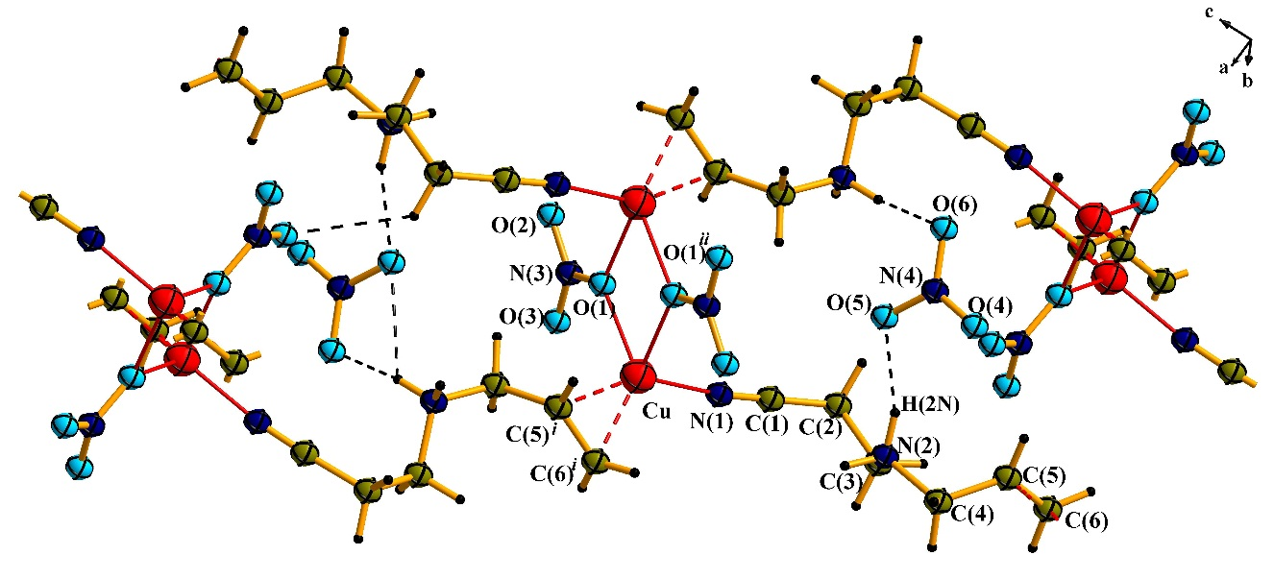
Figure 1. Infinite chains and hydrogen bonding in complex 1. Symmetry operations: (i) 2–x, –y, 2–z; (ii) ½ +x, ½–y, ½+z; (iii) 1,5–x, –½+y, 1,5–z. (50% probability displacement ellipsoids).

The metal atom possesses a tetrahedral surrounding consisting of the middle (further m) of double С(5)=С(6)-bond, N (C≡N-group) and 2 oxygen atoms from two NO₃– anions). Lengths of the bonds are Cu–m 1.933, Cu–N 1.939(3), Cu–O(1) 2.102(2) and Cu–O(1)′ 2.202(2) Å. The angle, formed by three Cu atoms in the chain [Cu(HL⁺)²⁺]_{n}, equals to 152°. The chain is not straight because of an influence of the non-coordinated to Cu(I) NO₃–-anion, which forms N–H...O and С–H…O hydrogen bonds (Table 2).³⁰

Table 2. Geometry of essential hydrogen bonds in 1-4.
Bond | D–H | H∙∙∙A | D∙∙∙A | ∠(DHA)
1ª
N(2)–H(1N)···O(5)^{i} | 0.90 | 2.48 | 3.116(4) | 128
N(2)–H(1N)···O(6)^{i} | 0.90 | 1.94 | 2.798(2) | 159
N(2)–H(2N)···O(5) | 0.90 | 1.94 | 2.807(4) | 161
C(6)–H(6A)···O(3) ^{ii} | 0.93 | 2.35 | 3.247(2) | 161
2^{b}
O(1w)–H(1w1)···F(6)^{i} | 0.98 | 1.95 | 2.850(9) | 153
O(1w)–H(1w1)···F(7)^{i} | 0.98 | 1.78 | 2.700(6) | 157
O(1w)–H(1w1)···F(8)^{i} | 0.98 | 2.21 | 3.015(9) | 139
N(2)–H(1N)···F(1) | 0.90 | 1.89 | 2.784(8) | 174
O(1w)–H(2w1)···F(2)^{ii} | 0.97 | 1.70 | 2.661(1) | 170
N(2)–H(2N)···F(2)^{iii} | 0.90 | 1.95 | 2.812(5) | 160
N(2)–H(2N)···F(4)^{iii} | 0.90 | 2.26 | 2.947(5) | 133
N(2)–H(2N)···F(5)^{iii} | 0.90 | 2.32 | 3.019(1) | 135
O(2w)–H(1w2)···F(9)^{ii} | 0.96 | 1.92 | 2.837(7) | 158
O(2w)–H(1w2)···F(10)^{ii} | 0.96 | 1.84 | 2.741(4) | 155
O(2w)–H(2w2)···F(1) | 0.96 | 2.39 | 3.259(6) | 151
O(2w)–H(2w2)···F(8) | 0.96 | 2.47 | 3.230(2) | 136
O(2w)–H(2w2)···F(9) | 0.96 | 1.92 | 2.742(1) | 142
O(2w)–H(2w2)···F(10) | 0.96 | 2.41 | 3.261(5) | 147
C(2)–H(2B)···F(10)^{iv} | 0.97 | 2.25 | 3.089(4) | 144
C(3)–H(3B)···F(7)^{v} | 0.97 | 2.47 | 3.354(1) | 151
C(3)–H(3B)···F(8)^{v} | 0.97 | 2.28 | 3.050(2) | 136
3^{c}
O(1w)–H(1w1)···F(4)^{i} | 0.73 | 1.99 | 2.710(6) | 169
N(2)–H(1N)···O(2w)^{ii} | 0.86 | 1.88 | 2.725(2) | 168
O(1w)–H(2w1)···F(5)^{iii} | 0.72 | 2.01 | 2.716(1) | 169
N(2)–H(2N)···F(1) | 0.96 | 1.96 | 2.755(1) | 139
O(2w)–H(1w2)···F(7)^{iv} | 0.92 | 1.95 | 2.834(9) | 160
O(2w)–H(2w2)···F(8) | 0.84 | 2.09 | 2.827(3) | 146
C(4)–H(4B)···F(1)^{v} | 0.99 | 2.42 | 3.260(4) | 142
4^{d}
N(12)–H(1N1)···O(21)^{i} | 0.92 | 2.19 | 3.023(7) | 150
N(12)–H(1N1)···O(22)^{i} | 0.92 | 2.17 | 2.949(6) | 142
N(1)–H(1B)···O(21)^{ii} | 0.92 | 2.02 | 2.919(1) | 165
N(1)–H(1A)···O(23) | 0.92 | 2.08 | 2.924(5) | 151
N(12)–H(2N1)···O(11)^{iii} | 0.92 | 1.97 | 2.806(5) | 150
N(2)–H(2A)···O(31) | 0.92 | 1.93 | 2.820(8) | 162
N(2)–H(2B)···O(12)^{iii} | 0.92 | 2.07 | 2.992(1) | 176
N(22)–H(1N2)···O(23)^{iv} | 0.92 | 2.24 | 2.951(1) | 134
N(3)–H(3A)···O(41) | 0.92 | 2.06 | 2.872(2) | 147
N(3)–H(3B)···O(43)^{v} | 0.92 | 2.01 | 2.925(2) | 173
N(22)–H(2N2)···O(42)^{vi} | 0.92 | 1.81 | 2.730(3) | 178
N(4)–H(4A)···O(13)^{iii} | 0.92 | 2.10 | 2.963(9) | 156
N(4)–H(4B)···O(32)^{iii} | 0.92 | 2.07 | 2.992(6) | 177
C(12)–H(12B)···O(12)^{ii} | 0.99 | 2.39 | 3.248(3) | 145
C(13)–H(13A)···O(41)^{vii} | 0.99 | 2.29 | 3.180(9) | 150
C(14)–H(14B)···O(31)^{vii} | 0.99 | 2.48 | 3.327(1) | 144
C(22)–H(22A)···O(22)^{iv} | 0.99 | 2.47 | 3.393(3) | 156
Symmetry operations:
ª(i) ½–x, y–½, ½–z; (ii) 2–x,1–y,1–z;
^{b}(i) x, ½–y, z–½; (ii) –x, 1 – y, –z; (iii) 1 – x, y – ½, –z; (iv) 1 – x, 1 – y, –z; (v) 1 + x, y, z;
^{c}(i) –x, –y, 1–z; (ii) x–½, ½–y, z–½; (iii) x–1, y, z; (iv) 1,5-x, ½+y, ½–z; (v) ½–x, ½+y, ½–z.
^{d}(i) 1–x, –y, –z; (ii) 2–x, –y, –z; (iii) x–1, y, z; (iv) 1–x, –y, 1–z; (v) 1–x, 1–y, 1–z; (vi) –x, 1–y, 1–z; (vii) 1–x, 1–y, –z.

In following two complexes 2 and 3 H₂O molecules act as co-ligands. The structure of the compound 2 ([Cu(HL⁺)(H₂O)₂]SiF₆) consists of infinite metal-organic spiral-like ribbons of [Cu(HL⁺)(H₂O)₂]²⁺ composition. The angle between three neighbouring copper atoms is 63°. Located between mentioned ribbons SiF₆^{2–} anions are bound to metal-organic fragment via O–H...F and N–H…F hydrogen bonds (Fig. 2). Despite of existence of Cu^{I} complexes with hexaflourosilicate-anion with the direct Cu^{I}–F–SiF₅ bond,³¹ SiF₆^{2–}-anion does not enter the internal coordination sphere of the metal. Tetrahedral coordination polyhedron of copper(I) ion is formed by a mid-point of С(5)=С(6) bond, one nitrogen (C≡N) and two O (H₂O molecules) atoms. Respective bond lengths are Cu–m 1.933, Cu–N(1) 1.939(3), Cu–O(1) 2.102(2) and Cu–O(1)′ 2.202(2) Å. A system of hydrogen bonds is much more developed in the given complex (table 2) in comparison with 1. This promotes relatively dense packing of metal-organic chains and the inorganic anions.
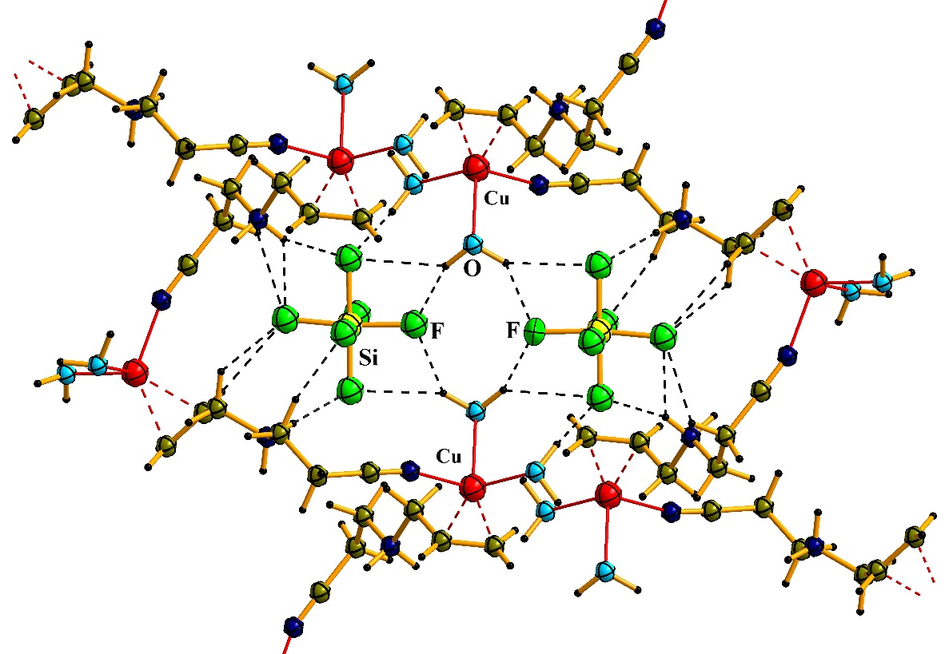
Figure 2. Fragment of molecular structure 2. (50% probability displacement ellipsoids).

In the complex of [Cu(HL⁺)(H₂O)BF₄]BF₄·H₂O (3) H₂O molecules and BF₄– anions (apart from the active centers of L) are included in the internal coordination sphere of Cu. The presence of BF₄– anions promotes transformation of coordination polyhedron of the metal from tetrahedron to trigonal pyramid formed by m of (C=C)-bond, N (C≡N-group) and O (H₂O) atoms in the basal plane. Fluorine atom from BF₄– anion occupies the apical position (Сu–F 2.640(2) Å) of coordination polyhedron. Atom of Cu is somewhat (Δ = 0.03 Å) removed from the (m, N, O) plane. Another crystallographically independent H₂O molecule and BF₄–-anion are not coordinated to copper(I) and fixed in a crystal space by relatively strong hydrogen bonds. As one can see from figure 3, the structure 3 is similar to 2, but separate fragments of coordination polymer due to the L flexibility demonstrate bulbous chain structure (the angle between three atoms of Cu [Cu(HL⁺)²⁺]_{n} equals to 59°). Since one distance of Cu–O(1w) equals to 1.992(2) Å, and the other opposite Cu–O(1w)′ is equal to 2.900(2) Å, one may regard from a certain distance (Сu(H₂O))₂ moiety as dimeric fragment and Cu(I) polyhedron as a trigonal bipyramid.
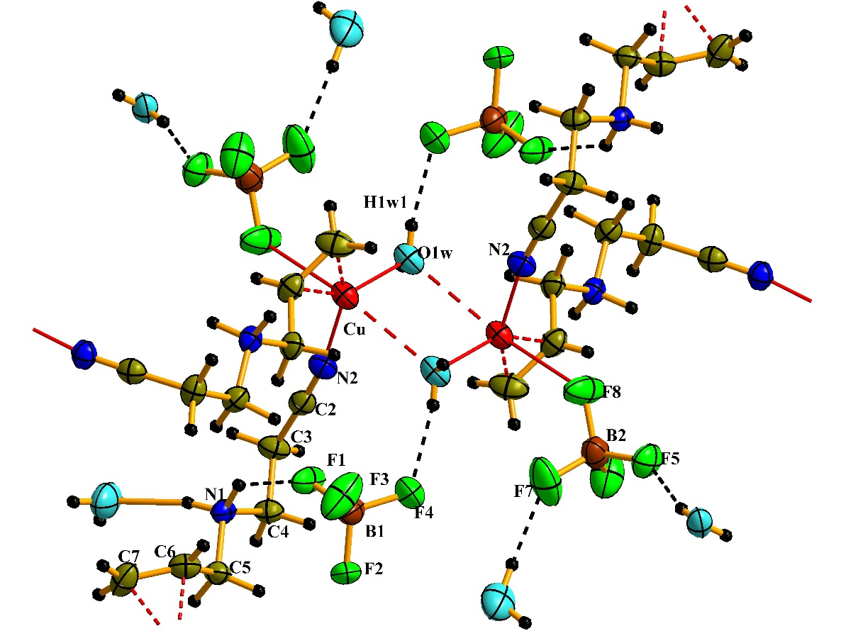
Figure 3. Cu(I) coordination in 3. Structure fragment of complex 3. (80% probability displacement ellipsoids).

As in complexes 1 and 2, in the compound 4 coordination polyhedron for both independent Cu(I) atoms possess tetrahedral shape. The Cu(1) environment comprises of the mid-point of С(15)=С(16) bond (m1), N(11) atom from CN-group and two nitrogen atoms from two NH₂SO₃– anions. The Cu(2) polyhedron involves m2 (С(25)=С(26)), N(21) (C≡N) and N(3) and N(4) (NH₂SO₃–) centers. Bonds lengths: Cu(1)–m1 1.977(7), Cu(1)–N(11) 1.990(2), Cu(1)–N(1) 2.061(8) and Cu1–N(2) 2.275(9) Å; Cu(2)–m2 1.971(7), Cu(2)–N(21) 2.130(2), Cu(2)–N(3) 2.039(8) and Cu(2)–N(4) 2.143(9) Å.
The main structural feature of the complex 4 is appearance of [Cu(HL⁺)]₂ rings (Fig. 4). Two closest rings are tilted by 72° and linked with H-bonds among inorganic anions and organic cations (N(2)–H(2A)···O(31) 1.93, C(14)–H(14B)···O(31) 2.48 Å etc. Table. 2).
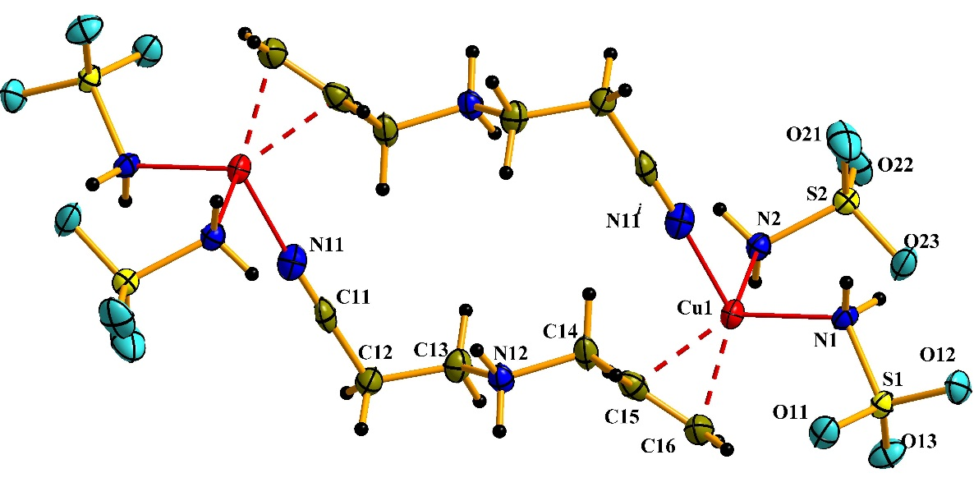
Figure 4. Copper(I) coordination in 4 and [Cu(HL⁺)]₂. Symmetry operations: (i) 1–x, 1–y, –z; (80% probability displacement ellipsoids).

4. Conclusions
Flexibility of L allows it using as a convenient tool in a construction of coordination compounds. In all the above-mentioned compounds L totally realizes its coordination abilities attaching to the metal atom with (С=С)-bond of allyl- and N atom of cyano-group. The protonated N-amine atom being deprived of its donor ability participates actively in a formation of strong N-H…X hydrogen bonds (Table 2). On the other hand, the combination of HL⁺ with ionic copper(I) salts (CuNO₃, Cu₂SiF₆, CuBF₄, CuSO₃NH₂) promotes an effective interaction of both π- and σ-ligands with the central atom, which serve to a formation of stable frameworks.

5. Supplementary material
CCDC 913397 (1), 913398 (2), 913399 (3) and 913400 (4) contain the supplementary crystallographic data for this article. These data can be obtained free of charge via http://www.ccdc.cam.ac.uk/conts/retrieving.html (or from the CCDC, 12 Union Road, Cambridge CB2 1EZ, UK; Fax: þ44 1223 336033; E-mail: deposit@ccdc.cam.ac.uk).

6. References
- A. Strecker, Ann. Chem. Pharm., 1850, 75, 27–45.
- V. Chhiba, M.L. Bode, K. Mathiba, W. Kwezi, D. Brady, J. Mol. Catal. B: Enz., 2012, 76, 68–74.
- D. Enders, J.P. Shilvock, Chem. Soc. Rev., 2000, 29, 359–373.
- E. Rafiee, A. Azad, M. Joshaghani, Lett. Org. Chem., 2007, 4, 60–63.
- E.C. Taylor, J.G. Berger, J. Org. Chem., 1967, 32, 2376–2378.
- Sh.-Sh. Tang, Ph.C. Trackman, H.M. Kagang, J. Biol. Chem., 1983, 258, 4331–4338.
- G. Cardillo, C. Tomasini, Chem. Soc. Rev., 1996, 25, 117–128.
- M. Preiml, K. Hillmayer, N. Klempier, Tetrahedron Lett., 2003, 44, 5057–5059.
- S.G. Davies, O. Ichihara, I. Lenoir, I.A.S. Walters, J. Chem. Soc. Perkin Trans. 1, 1994, 11, 1411–1415.
- F. Theil, S. Ballschuh, Tetrahedron Asymmetry, 1996, 7, 3565–3572.
- D. Steinhuebel, Y. Sun, K. Matsumura, N. Sayo, T. Saito, J. Am. Chem. Soc., 2009, 131, 11316–11317.
- M. Liu, M.P. Sibi, Tetrahedron, 2002, 58, 7991–8035.
- A. Albinati, M.L. Carraro, S. Gross, M. Rancan, S. Rizzato, E. Tondello, A. Venzo, Eur. J. Inorg. Chem., 2009, 35, 5346–5351.
- Ya.E. Filinchuk, V.V. Olijnik, V.N. Davydov, Russ. J. Coord. Chem., 1997, 23, 843–845.
- E.A.Goreshnik, V.V.Oliinik, Russ. J. Inorg.Chem., 1996, 41, 206–208.
- M.Yu. Luk’yanov, A.V. Pavlyuk, M.G. Mys’kiv, Russ. J. Coord. Chem., 2012, 38, 92–97.
- M. Luk’yanov, V. Kinzhybalo, E. Goreshnik, O. Pavlyuk, M. Mys’kiv, Chem. Met. Alloys., 2012, 5, 66–76.
- Houben-Weil. Methoden der organischen Chemie, Stuttgart: Georg Thieme 1949, 4.
- B.M. Mykhalichko, M.G. Mys’kiv. Ukraine Patent UA25450A, Bull. N. 6 1998.
- Crystal Clear. Woodlands (Texas, USA): Rigaku Corporation (1999).
- CrysAlis RED. Version 1.171.31.8 (Release 12-01-2007. CrysAlis 171.NET) Oxford: Oxford Diffraction Ltd. (2007).
- R.C. Clark, J.S. Reid, Acta Crystallogr., Sect. A: Found. Crystallogr., 1995, 51, 887–897.
- G.M. Sheldrick, Acta Cryst., Sect. A: Found. Crystallogr., 2008, A64, 112–122.
- DIAMOND v3.1. Crystal Impact GbR, Bonn, Germany (2004–2005).
- E. Goreshnik, M. Mys’kiv, J. Chem. Crystallogr., 2010, 40, 381–383.
- M.Yu. Luk’yanov, A.V. Pavlyuk, E.A. Goreshnik, M.G. Mys’kiv, Russ. J. Coord. Chem., 2012, 38, 663–670.
- Soh Ping Neo, Zhong-Yuan Zhou, Thomas C. W. Mak, T. S. Andy Hor, J. Chem. Soc., Dalton Trans., 1994, 23, 3451–3458.
- R.D. Hart, G.A. Bowmaker, J.D. Kildea, E.N. de Silva, B.W. Skelton, A.H. White, Aust. J. Chem., 1997, 50, 604–620.
- E.A. Goreshnik, M.G. Mys’kiv, Acta. Chim. Slov., 2011, 58, 772–775.
- G.R. Desiraju, Angew. Chem. Int. Ed., 2011, 50, 52−59.
- E.A. Goreshnik, Yu.I. Slyvka, M.G. Mys’kiv, Inorg. Chim. Acta, 2011, 377, 177−180.

