Interaction of PER2 with the constitutive androstane receptor possibly links circadian rhythms to metabolism

Tomaž Martini¹, Jurij Stojan², Damjana Rozman¹, Uršula Prosenc Zmrzljak^{1,*}

¹Center for Functional Genomics and Bio-chips, Institute of Biochemistry, Faculty of Medicine, University of Ljubljana, Zaloška cesta 4, Ljubljana, Slovenia
²Institute of Biochemistry, Faculty of Medicine, University of Ljubljana, Vrazov trg 2, Ljubljana, Slovenia

*Corresponding author:
Uršula Prosenc Zmrzljak
Center for Functional Genomics and Bio-chips,
Institute of Biochemistry,
Faculty of Medicine,
University of Ljubljana,
Zaloška cesta 4,
Ljubljana, Slovenia
Tel: +386 1 543 75 92
Fax: +386 1 543 75 88

Email addresses:
TM: tomaz.martini@unifr.ch
JS: stojan@mf.uni-lj.si
DR: damjana.rozman@mf.uni-lj.si
UPZ: ursula.prosenc@mf.uni-lj.si

Abstract
Period 2 (PER2) is an important player in daily oscillations called circadian rhythms, which are emerging as one of the most important regulatory networks, responsible for homeostasis and transcriptional regulation of a number of genes. Our work shows that PER2 could act as a co-activator of the constitutive androstane receptor (CAR), a key nuclear receptor (NR) that regulates metabolism of endobiotics and xenobiotics. Bioinformatic analysis shows that PER2 and CAR possess structural elements that could enable them to interact. This was further supported by our experiments. PER2 and CAR co-immunoprecipitate. Co-transfection of mouse hepatocarcinoma cells with plasmids overexpressing Per2 and Car increases expression of Bmal1, a potential CAR target gene, more than transfections with Car only. This is the first report indicating the interaction of PER2 and CAR.

Keywords
circadian rhythms, metabolism, period 2, constitutive androstane receptor, co-activator

Introduction
Circadian rhythms are daily oscillations in most cells and organisms. They are governed by autonomous molecular circadian oscillators that are synchronized by external cues, such as light and food. The circadian machinery is composed of positive and negative transcriptional and translational feedback loops. The major positive loop comprises transcriptional activators BMAL1 and CLOCK that can heterodimerize and drive their own transcription as well as of elements of the negative loop, such as Period (PER) homologues, Cryptochromes and Rev-erbα. The transcriptional repression of Bmal1 due to REV-ERBα can be counter-balanced by RORα and PPARα.^{1–3}
PER2 is involved in the negative loop where it directly interacts with the transactivation complex of BMAL1-CLOCK and represses its transcriptional activation capability. It also acts in the positive loop where it drives Bmal1 expression by acting as a co-activator of NRs, eg PPARα.¹ PER2 in metabolic and mental disorders, cancer and other pathologies is currently being intensively studied.^{4–8} Due to its two LXXLL structural motifs, which can interact with a hydrophobic pocket of NRs, it has been studied as a nuclear receptor co-activator.⁹ Perhaps one of the most important transcriptional regulator of metabolism is CAR, a NR that regulates primary and secondary metabolism. CAR binds endogenous ligands, eg bilirubin, and xenobiotics, eg barbiturates.^{10–17} After ligand binding it interacts with co-activators and heterodimerization partners, most often the retinoid X receptor (RXR). The final protein complex can transactivate enzymes of the cytochrome P450 (CYP), glucuronosyltransferase (UGT) and multi drug resistance protein (MRP) families.^{3,13,15,18–20}
The interaction between nuclear receptors and their co-activators is a well-documented interaction that is highly conserved among species.^{9,21} Nuclear receptors have high similarity in their ligand binding domains, especially in the region of helices 3, 4 and 5. These helices form a hydrophobic cleft which interacts with leucines of the co-activators' LXXLL motifs. The two residues between the three leucines have little or no importance to binding of LXXLL motifs as they are in direct contact with the surrounding aqueous solution. Charged residues of the helices 3-5 form interactions with amino acids surrounding the LXXLL motifs and this is crucial for specificity of interactions and recognition of appropriate co-activators. The most important for specificity of co-activators are the two residues just before the first leucine of the LXXLL motif, usually referred as –2 and –1. We were mostly interested in class 3 of LXXLL motifs, according to Savkur and Burris, which encompasses motifs SXLXXLL.^{9,22}
Here we show that CAR and PER2 interact and activate Bmal1 transcription. The initial prediction was made on the basis of homology of LXXLL motifs of PER2 and several known CAR co-activators and was confirmed experimentally. Our data presents the first report of communication between drug metabolism and the circadian rhythm at the level of direct interaction between PER2 and CAR.

Results
Bioinformatic analysis of transcription factor binding sites using MatInspector, Matrix Library 9.4 and User-defined IUPAC strings revealed potential binding sites for CAR on Bmal1 promoter, eg for CAR/RXR at 414-438 (positive strand) of GXP_5050588 (Bmal1 Mus musculus).^{23–25} This provided a sufficient basis for transfection experiments that showed induced expression of a Bmal1 luc reporter when Hepa 1-6 cells were transfected with Car (P < 0.01). The induction was further enhanced when co-transfection with Car and Per2 was performed (P < 0.01) which suggests an either direct or indirect influence of PER2 on CAR transactivation of Bmal1 (Figure 1). Surprisingly, the transactivation of Bmal1 with vectors overexpressing CAR and PER2 was not significantly different than transactivation with positive control overexpressing PPARα and PER2 (Figure 1) that co-immunoprecipitate at Bmal1 regulatory sites.¹ The lack of a statistically significant difference might suggest a similar mechanism of transactivation which lead us to explore structural properties of both PER2 and CAR to evaluate if a direct interaction between the proteins is plausible.
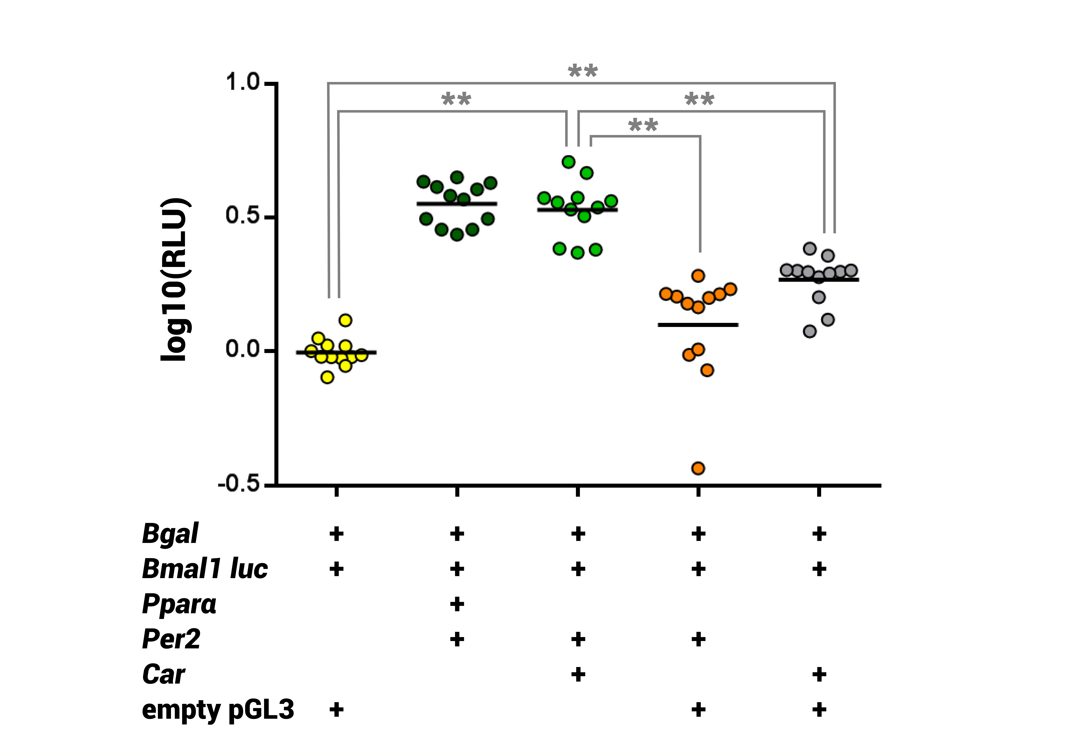
Figure 1. Co-transfection of Hepa 1-6 cells with CAR and PER2 overexpression plasmids induces promoter activity of Bmal1 luc reporter. This induction is similar to the one observed when performing co-transfections with Pparα and Per2 (P < 0.01) and different to the one observed when performing transfections with Car only (P < 0.01). The log10 relative luciferase units of individual wells for specific transfection mix are shown. ** - P < 0.01

Our bioinformatic analysis showed that PGC1α (PPARγC1A), a known CAR and PPARγ co-activator, possibly interacts with CAR via its motif SLLKKLL (Mus musculus), which is homologous to both SXLXXLL motifs of PER2 (Figure 2), namely SGLLNLL (Mus musculus) and SDLLNLL (Mus musculus).^{26–28} A further co-activator of CAR and PPARγ, PGC1β, which has three LXXLL motifs, all with a serine at a 1 or -2 position, also exists. A similar arrangement with a serine residue in front of a LXXLL motif can also be observed in NCoA6, another CAR co-activator.^{27,29}
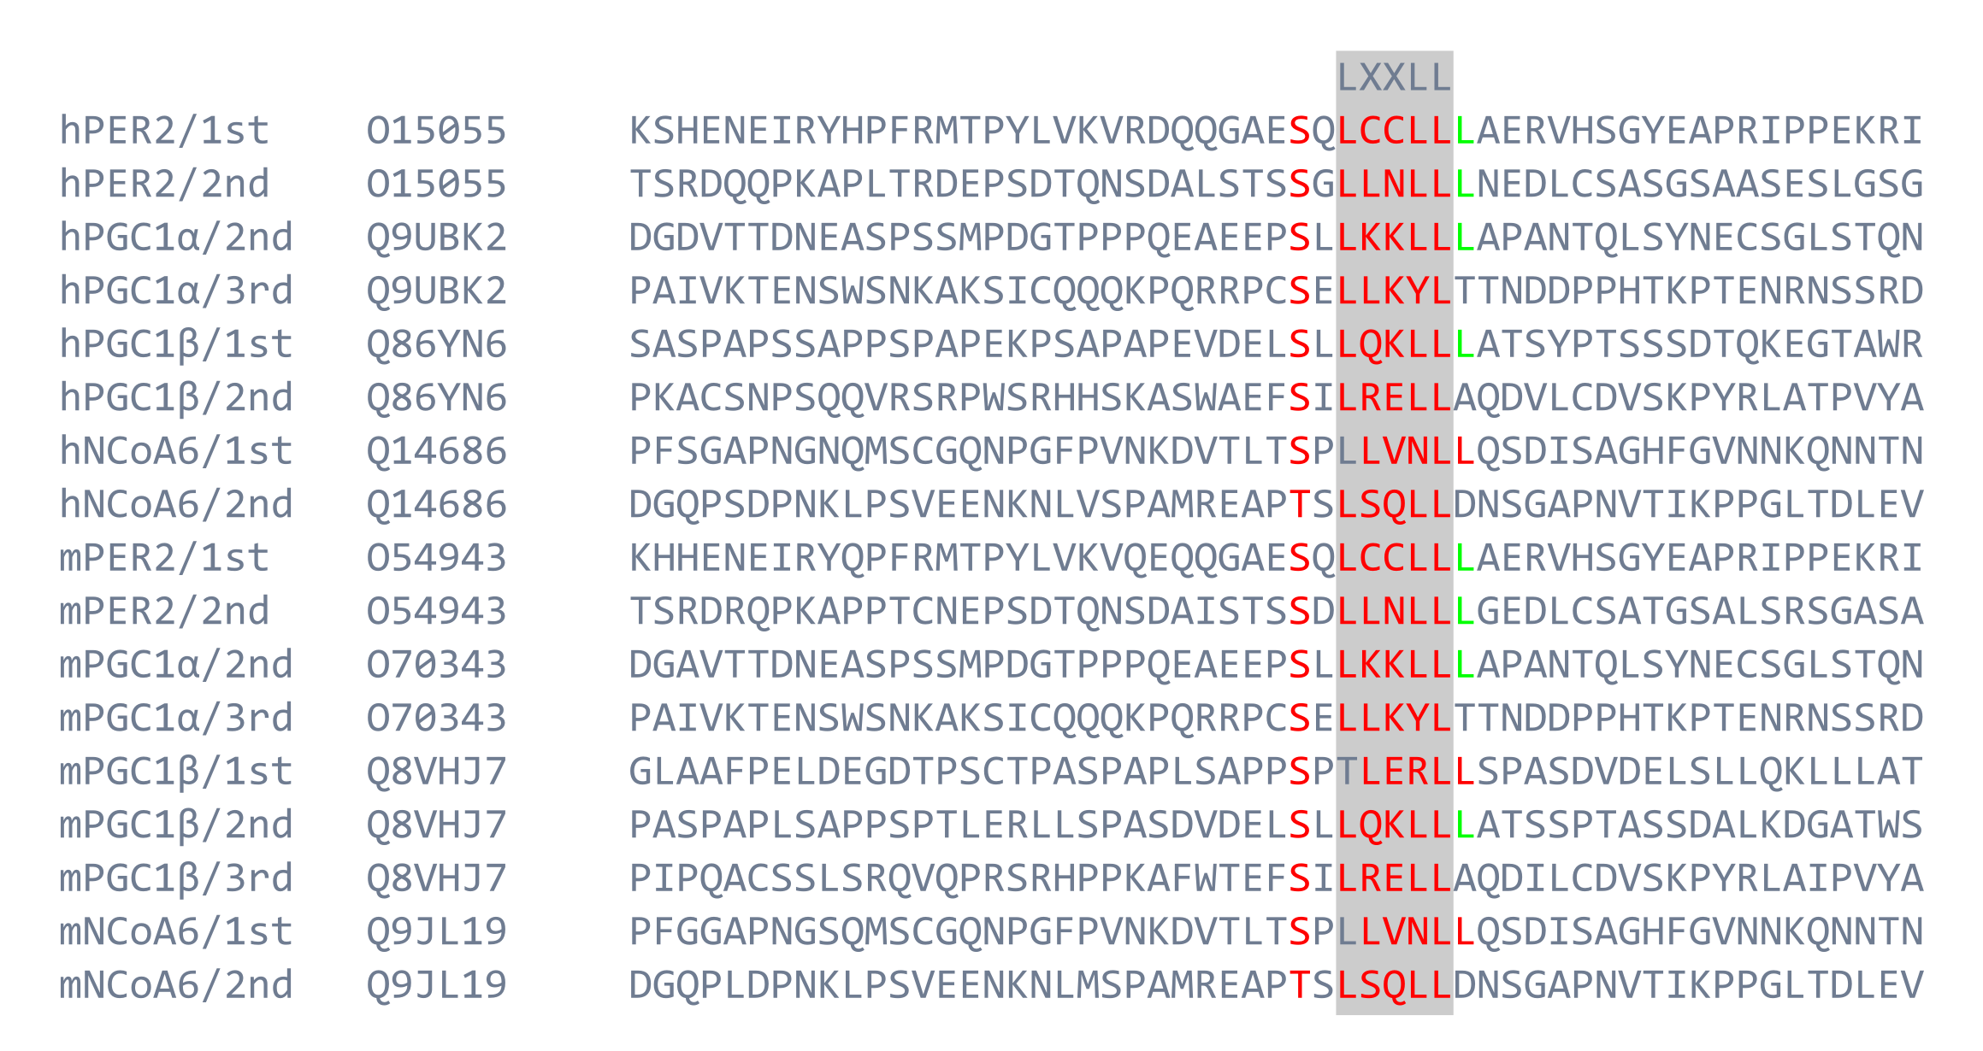
Figure 2. Alignment showing similarity between PER2 and known co-activator LXXLL motifs of CAR, namely PGC1alpha, NCoA6 and PGC1beta.^{27,29} The letters h and m before the protein name designate species Homo sapiens and Mus musculus, with the sequential number of the noted LXXLL and UniProt/Swiss-Prot entry number following the protein name. The predicted LXXLL motifs with residues marked as 1-5 are shown in red, as are serines just before LXXLL. Note negatively charged side-chain or a hydroxyl group containing residues (E, S, T) just in front of the -2 serine.²⁸

As both PER2 and PGC1α are co-activators of PPARγ, a NR involved in lipid and carbohydrate metabolism, we focused our attention on nuclear receptor homology. Most receptor residues that are in contact with LXXLL motifs have no charge pointing towards the co-activator motifs besides two very distincs lysins at both CAR and PPARγ on homologous positions. The receptors also seem to have high 3D similarity of the hydrophobic cleft as helices 3, 4, 5 are positioned in a similar manner. Both receptors seem to bind LXXLL motifs in an "end of helix 5" to "end of helix 3" fashion, which coincides with the lysine positioning.^{30–34} Even though this could be projected onto many nuclear receptors, the position of the lysine at helix 5 could additionally explain favouring co-activators with a serine before LXXLL.^{9,28,35}
The presumption that PER2 and CAR interact directly was confirmed with co-immunoprecipitation (Figure 3). For this, Car-Flag and Per2-V5 co-transfection was performed. Initial release of proteins from Sepharose beads was performed at 70° C and revealed just the V5 reactive protein at approximate size of 40 kDa. After additional heating of Sepharose at 95° C for 2 min, 135 kDa protein was released (Figure 3A), corresponding to the expected size of PER2.²⁸ The FLAG reactive protein was detected very faintly, irrespective of temperature, at 40 kDa (Figure 3B). This could correspond to CAR.²⁸ This corroborates with our prediction that the two proteins could interact in a co-activator and nuclear receptor manner.
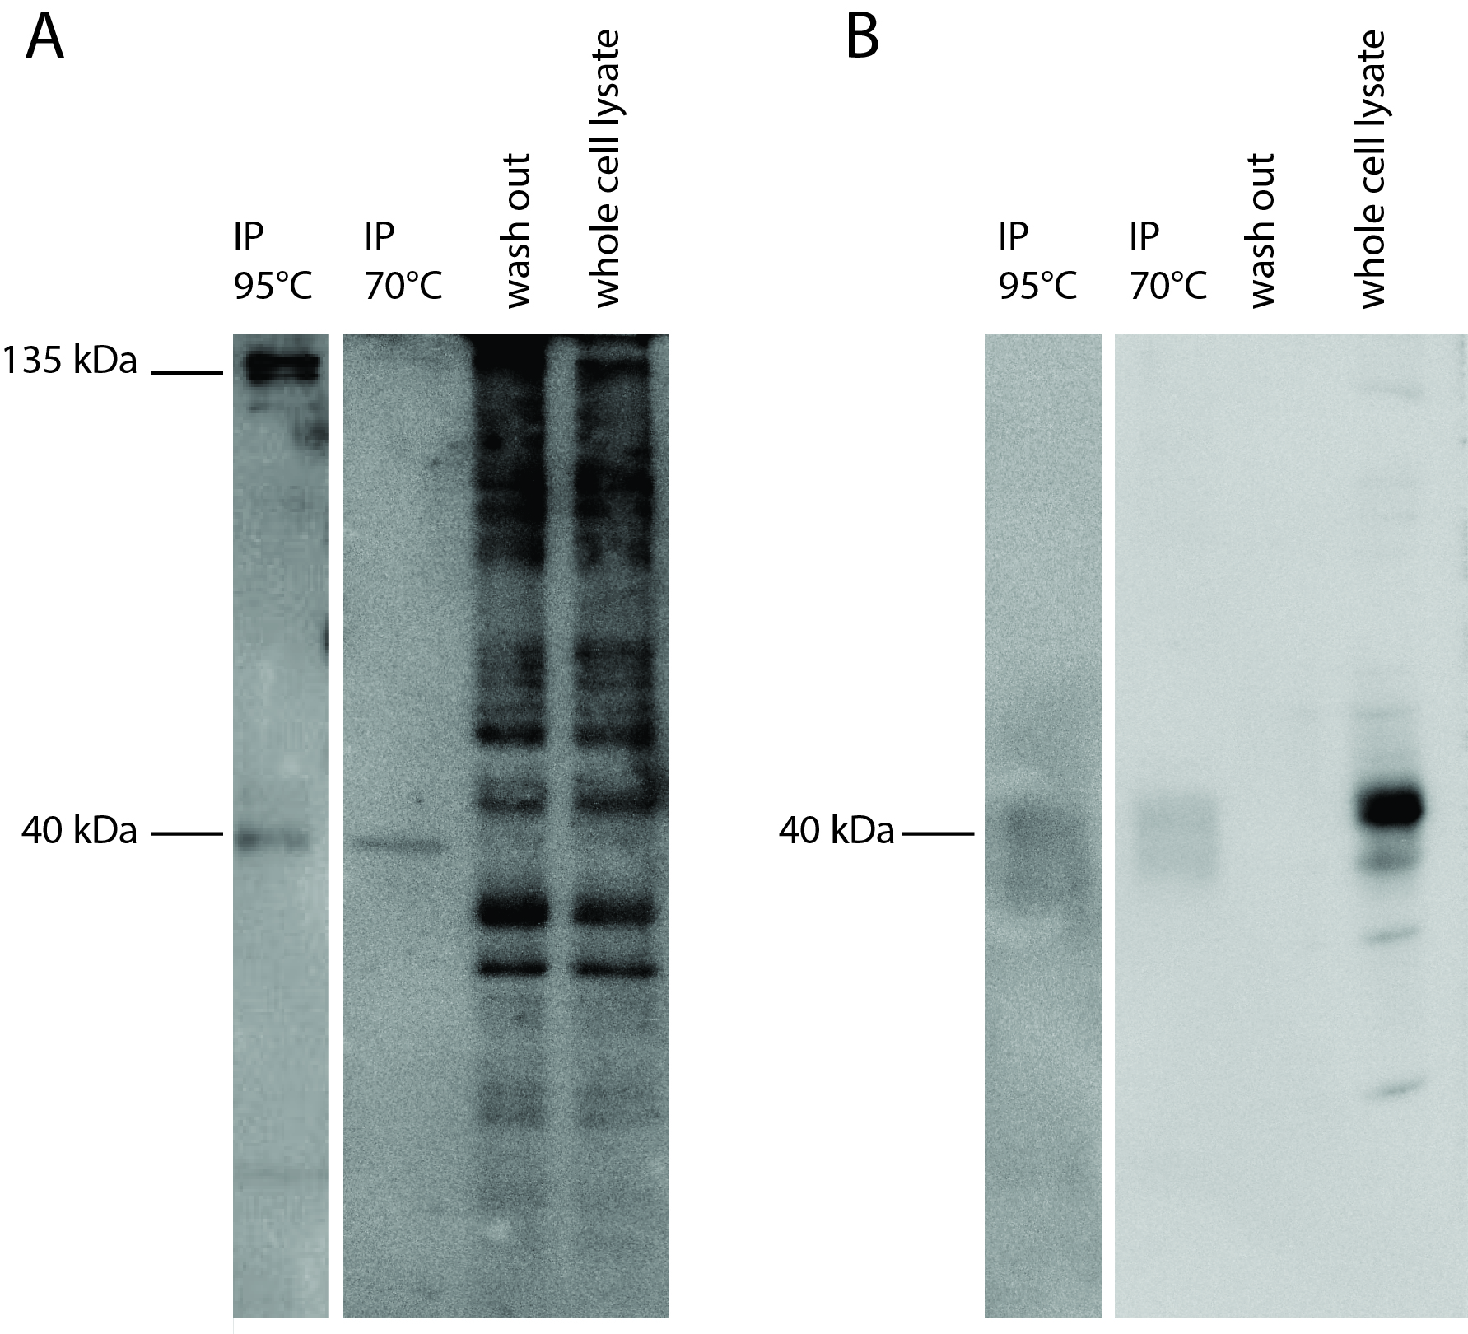
Figure 3. Co-immunoprecipitation with FLAG Ab conjugated Sepharose of Car-Flag and Per2-V5. A: Western blot with V5 Ab – PER2 shows two bands, at 40 and 135 kDa. After the final incubation of Sepharose beads at 70° C, only the 40 kDa form was visible on the blot. The 135 kDa isoform was visible after additional incubation at 95° C. B: Western blot with FLAG Ab – the signal of CAR is in the range of expected protein size (40 kDa).

Materials and methods

Plasmids
Bmal1 luc, having a Bmal1 promoter cloned into a pGL3 luciferase reporter vector, Per2, coding for a V5-tagged PER2, and Pparα constructs were kindly provided by J. Ripperger and U. Albrecht (Department of Biology, Faculty of Science, University of Fribourg, Switzerland) and have been previously described in more detail.¹
The Car expression construct was kindly provided by JeanMarc Pascussi (Institut de genomique fonctionnelle, Montpellier, France) and it was constructed by Negishi Masahiko (NIH, North Carolina, USA) and has previously been described in more detail.³⁶
The Car-Flag plasmid was kindly provided by Negishi Masahiko (NIH, North Carolina, USA) and has previously been described in more detail.³⁷
An empty pGL3 basic vector (Promega) was used to perform transfections with equal ammounts of DNA. All wells were transfected with 50 ng Bgal - pSV-β-Galactosidase Control Vector (Promega), for normalization. All constructs besides the commercial pGl3 basic and Bgal represent Mus musculus.

Transfections
Transfections were performed on Hepa 1-6 cells available from the European Collection of Authenticated Cell Cultures. The cells were held at 5% CO2 and 37° C and transfered to 96-well microplates 24 hours prior to transfections with 5 × 10⁶ cells in DMEM and 10% FBS. For transfections X-tremeGENE HP DNA (Roche) was used according to manufacturer's instructions. Total plasmid mass was equal to 200 ng per well, with each construct of interest at 50 ng and total mass added to 200 ng with the pGL3 basic vector. The negative control represents transfections with Bgal, Bmal1 luc and pGL3 basic vector, a positive control of Bgal, Bmal1 luc, Pparα and Per2 was used.

Luciferase assay and statistical analysis of results
Cells were lysed using Passive Lysis Buffer (Promega). Luciferase assay was performed using the ONE-Glo Luciferase (Promega) according to manufacturer's instructions and measurements were performed on Synergy H4 (BioTek). Results were normalized using analysis of β-galactosidase activity and additional normalization to positive control using luciferase activity was performed for microplate comparisson. Analysis of variance was performed and results were logarithmized to achieve variance homogeneity.

Co-immunoprecipitation (co-IP)
HeLa cells were seeded on 6-well plates and co-transfected with Car-Flag and V5-tagged Per2 using Lipofectamine 2000 (Thermo Fisher Scientific). Cells were harvested 2 days after transfection using 200 microliters of the lysis buffer: 50 mM Tris • HCl at pH 7.5, 150 mM NaCl, 0,5% (w/v) NP-40 and complemented with protease inhibitors (Roche). Cell lysate was agitated for 10 min at 4° C and centrifuged at 14000 g 20 min at 4° C. Supernatant was transferred to a tube containing FLAG-coupled Sepharose beads (Sigma-Aldrich) and rotated for 2 h at 4° C. After the centrifugation at 10000 g for 5 min at 4° C the supernatant was collected and stored as a whole cell lysate sample. Sepharose was washed 3 times with additional 200 microliters of lysis buffer and the first wash-out was collected as wash out sample. 50 microliters of Laemmli buffer was added to the Sepharose, followed by heating for 10 min at 70° C and again for 2 min at 95° C. Western blot was perfomed with 3 different samples: whole cell lysate, wash out and immunoprecipitate (IP) in two parallel conditions, one with anti-FLAG Ab A8592 (Sigma-Aldrich) and the other with anti-V5 Ab V8137 (Sigma-Aldrich).

Discussion
The comparable transactivation of Bmal1 after co-transfections with Car/Per2 or Pparα/Per2 might suggest a similar mechanism of transcriptional activation of Bmal1. If this is the case, and since we know that ChIP experiments reveal binding of PER2 and PPARα at regulatory regions of Bmal1,¹ this could further support our proposal that PER2 could potentially act as CAR's co-activator and that the pair can form, alone or with other partners, transactivation complexes. This is also supported by finding CAR binding sites at Bmal1 promotor. The discovery is interesting as both proteins are important for cell homeostasis.
Since some of our predictions were based on homology, it is worth noting that according to Savkur and Burris the amino acid at -1 of their class 3 LXXLL motifs should be an unpolar amino acid.⁹ However, since human and mouse 2nd PER2 LXXLL have G or D at -1, with high conservation of the rest of the sequence, motifs that do not follow this strict consensus of an unpolar -1 residue are shown in our alignment.²⁸ Also, the residue at -1 most probably points outwards from the hydrophobic pocket and does therefore not directly interact with helices 3-5 of NRs.³⁸ It would be worth exploring if it could interact with the charge clamp of NRs.^{9,30,39–41}
Another interesting observation is the presence of a band at approximately 40 kDa at the western blot with anti-V5 Ab. Previous work has shown the existance of a shorter PER2S isoform in Homo sapiens with the size of 45 kDa and co-IP at 55 kDa.⁴² If we observed a similar truncated form of PER2, it could be speculated that PER2 can interact with CAR with its first LXXLL. However, this does not exclude an interaction of PER2 with CAR with its second LXXLL.¹ It might be possible that a co-activator interacts with a NR with multiple LXXLL motifs, but with different affinity.
It is interesting to note that Car shows both diurnal expression patterns in liver, with Car mRNA levels oscillating in phase with Bmal1, and the possibility to be induced by ligands. The induction could very well be dependent on the phase or time of induction.^{43,44} If this is the case, such findings should be considered in pharmacokinetics of drug active ingredients, especially as CAR regulates the expression of several CYPs.^{12,20,45} Our work therefore provides an important new link in understanding the connection between clock machinery, metabolism and pharmacokinetics.
As CAR can be induced by xenobiotics, such as flavonoids, cathehins and similar poliphenols, and also active ingredients of drugs, eg barbiturates, paracetamol and some compounds with a steroid-like structure, it would also be interesting to see if such induction has any physiological effect on transcription of genes involved in circadian rhythms.^{13,16,18,45} However, such induction of CAR is unlikely to have a big impact on robust oscillatory mechanisms.
Our work also suggests that period homologues should be considered as possible NR co-activators, not only of NRs that have an established role in circadian rhythms. Perhaps such mechanisms of multiple co-activators being able to activate a single NR could provide a compensatory mechanism in case of co-activator deregulation. On the other hand, different co-activators are expressed differentially in tissues with different phases of expression, which could in fact define a NR's tissue and time specific function.
In conclusion, we show that CAR and PER2 can form an interaction which has implicaitons for circadian aspects of drug metabolism.

Authors' contributions
T. M. performed transfections, the luciferase assay and bioinformatical and structural analyses. The bioinformatical and structural analyses were performed under expert supervission and guidance of J. S. U. P. Z. first noticed the possibility of an interaction between CAR and PER2 during her preliminary screenings for interactions of PER2 with nuclear receptors. She also performed co-IP. Experiment planing and protocol preparation was performed by U.P.Z. and D. R. The manuscript draft was prepared by T. M. and finalised by all authors. All authors read and approved the final manuscript.

Acknowledgements
We would kindly like to thank J. Ripperger and U. Albrecht for providing Bmal1 luc, Per2 and Pparα constructs, JM. Pascussi for the Car expression construct and M. Nagishi for the Car-Flag. The view of J. Ačimovič on statistical analysis of transfection results is highly appreciated. A sincere thank you to M. Hafner, Ni. and Nu. Trošt and Ž. Urlep for their advice. We would also like to thank I. Mlinarič Raščan for a critical overview.. The work described here contains part of the master thesis work of T. M. and was supported by the Slovenian Research Agency program grants P1-0104 and P1-0390.

References
1. I. Schmutz, J. A. Ripperger, S. Baeriswyl-Aebischer, U. Albrecht, Genes Dev. 2010, 24, 345–357.
2. R. Chavan et al., Nat. Commun. 2017, 7, ncomms10580.
3. U. P. Zmrzljak, D. Rozman, Chem. Res. Toxicol. 2012, 25, 811–824.
4. M. Zeman, M. Vician, J. Monosikova, R. Reis, I. Herichova, Mol. Med. Rep. 2008, 1, 599–603.
5. T. Okabe et al., PLoS One 2014, 9, e109693.
6. S. T. Chen et al., Carcinogenesis 2005, 26, 1241-1246.
7. B. Grimaldi et al., Cell Metab. 2010, 12, 509–520.
8. G. Hampp et al, Curr. Biol. 2008, 18, 678–683.
9. R. S. Savkur, T. P. Burris, J. Pept. Res. 2004, 63, 207–212.
10. M. Hafner, T. Rezen, D. Rozman, Curr. Drug Metab. 2011, 12, 173–185.
11. T. Rezen, Expert Opin. Drug Metab. Toxicol. 2011, 7, 387–398.
12. J. Zhang, W. Huang, S. S. Chua, P. Wei, D. D. Moore, Science 2002, 298, 422–424.
13. T. Kawamoto et al., Mol. Cell. Biol. 1999, 19, 6318–6322.
14. W. Huang et al., Proc. Natl. Acad. Sci. U. S. A. 2003, 100, 4156–4161.
15. J. M. Maglich et al., J. Biol. Chem. 2004, 279, 19832–19838.
16. J. M. Pascussi, S. Gerbal-Chaloin, J.-M. Fabre, P. Maurel, M.-J. Vilarem, Mol. Pharmacol. 2000, 58, 1441–1450.
17. H. R. Kast et al., J. Biol. Chem. 2002, 277, 2908–2915.
18. R. Yao et al., J. Agric. Food Chem. 2010, 58, 2168–2173.
19. H. Yang, H. Wang, Protein Cell 2014, 5, 113–123.
20. K. Monostory, Z. Dvorak, Curr. Drug Metab. 2011, 12, 154–172.
21. A. Brenna, B. Grimaldi, P. Filetici, P. Ballario, Mol. Biol. Cell 2012, 23, 3863–3872.
22. K. Suino et al., Mol. Cell 2004, 16, 893–905.
23. K. Cartharius et al., Bioinformatics 2005, 21, 2933–2942.
24. C. Frank, M. M. Gonzalez, C. Oinonen, T. W. Dunlop, C. Carlberg, J. Biol. Chem. 2003, 278, 43299–43310.
25. K. A. Arnold, M. Eichelbaum, O. Burk, Nucl. Recept. 2004, 2.
26. G. B. Rha, G. Wu, S. E. Shoelson, Y. C. Chi, J. Biol. Chem. 2009, 284, 35165–35176.
27. T. Shiraki, N. Sakai, E. Kanaya, H. Jingami, J. Biol. Chem. 2003, 278, 11344–11350.
28. A. Bateman et al., Nucleic Acids Res. 2015, 43, D204–D212.
29. S. Surapureddi, R. Rana, J. K. Reddy, J. A. Goldstein, Mol. Pharmacol. 2008, 74, 913–923.
30. K. Suino et al., PDB ID: 1XLS, Mol. Cell 2004, 16, 893–905.
31. K. Wakabayashi et al., PDB ID: 3B1M, Biol. Pharm. Bull. 2011, 34, 1094–1104.
32. Y. Li, A. Kovach, K. Suino-Powell, D. Martynowski, H. E. Xu, PDB ID: 3CS8, J. Biol. Chem. 2008, 283, 19132–19139.
33. L. Shan et al., PDB ID: 1XNX, Mol. Cell 2004, 16, 907–917.
34. S. Hennig et al., PDB ID: 3GDI, PLoS Biol. 2009, 7, e94.
35. H. M. Berman et al., Nucleic Acids Res. 2000, 28, 235–242.
36. P. Honkakoski, I. Zelko, T. Sueyoshi, M. Negishi, Mol. Cell. Biol. 1998, 18, 5652–5658.
37. Y. E. Timsit, M. Negishi, PLoS One 2014, 9, e96092.
38. R. A. Sayle, E. J. Milner-White, Trends Biochem. Sci. 1995, 20, 374.
39. M. V. Milburn et al., Nature 1998, 395, 137–143.
40. C. Chang et al., Mol. Cell. Biol. 1999, 19, 8226–8239.
41. I. Dussault, et al., Mol. Cell. Biol. 2002, 22, 5270–5280.
42. D. Avitabile et al., Cell. Mol. Life Sci. 2014, 71, 2547–2559.
43. Y. Kanno, S. Otsuka, T. Hiromasa, T. Nakahama, Y Inouye, Nucl. Recept. 2004, 2, 6.
44. X. Yang et al., Cell 2006, 126, 801–810.
45. L. M. Slosky et al., Mol. Pharmacol. 2013, 84, 774–86.
46. R. A. Sayle, E. J. Milner-White, Trends Biochem. Sci. 1995, 20, 374.
47. D. W. Ritchie, V Venkatraman, V., Bioinformatics 2010, 26, 2398-2405.
48. N. Guex, Electrophoresis 1997, 18, 2714–2723.
49. M. Tarini, P. Cignoni, C. Montani, IEEE Trans. Vis. Comput. Graph. 2006, 12, 1237-1244..^{46–49}

