Synthesis of Some Unique Carbamate Derivatives bearing 2-Furoyl-1-piperazine as a Valuable Therapeutic Agents

Muhammad Athar Abbasi^{1,}*, Ghulam Hussain¹, Aziz-ur-Rehman¹, Sabahat Zahra Siddiqui¹, Syed Adnan Ali Shah^{2,3}, Muhammad Arif Lodhi⁴, Farman Ali Khan⁴, Muhammad Ashraf⁵, Qurat-ul-Ain⁵, Irshad Ahmad⁶, Rabia Malik⁶, Muhammad Shahid⁷, and Zahid Mushtaq⁷

¹Department of Chemistry, Government College University, Lahore-54000, Pakistan.
²Faculty of Pharmacy, Universiti Teknologi MARA, Puncak Alam Campus, 42300 Bandar Puncak Alam, Selangor Darul Ehsan, Malaysia.
³Atta-ur-Rahman Institute for Natural Products Discovery (AuRIns), Level 9, FF3, Universiti Teknologi MARA, Puncak Alam Campus, 42300 Bandar Puncak Alam, Selangor Darul Ehsan, Malaysia.
⁴Department of Biochemistry, Abdul Wali Khan University, Mardan-23200, Pakistan.
⁵Department of Chemistry, The Islamia University of Bahawalpur, Bahawalpur-63100, Pakistan.
⁶Department of Pharmacy, The Islamia University of Bahawalpur, Bahawalpur-63100, Pakistan.
⁷Department of Biochemistry, University of Agriculture, Faisalabad-38040, Pakistan.

*Corresponding Author: Dr. Muhammad Athar Abbasi, E-mail: atrabbasi@yahoo.com; abbasi@gcu.edu.pk Tel: (+92)-42-111000010 Ext.266.

Abstract
The aim of the research work was to synthesize different biologically active carbamate derivatives bearing 2-furoyl-1-piperazine and having modest toxicity. The synthesis was completed in multiple steps. The structural confirmation of all the synthesized compounds was carried out by EI-MS, IR and ¹H-NMR spectral data. The enzyme inhibition and antibacterial potential of the synthesized compounds was evaluated. Moreover, the cytotoxicity of the compounds was also checked to find their utility as possible therapeutic agents. All the compounds were active against acetylcholinesterase enzyme especially 12 and 14 showed very good inhibitory potential relative to Eserine, a reference standard. Almost all the compounds showed good activities against the both Gram-positive and Gram-negative bacterial strains.
Keywords:
2-Furoyl-1-piperazine; ¹H-NMR; Acetylcholinesterase; Antimicrobial activity; Hemolytic activity
1. Introduction
Heterocyclic compounds are cyclic compound having hetero atoms e.g, N, O & S having diverse medicinal importance.¹ Piperazine is a medicinally heterocyclic nucleus which consists a six membered ring containing two nitrogen atoms at 1 and 4 positions in the ring. The piperazine has been classified as a privileged structure and is frequently found in biologically active compounds across a number of different therapeutic areas² which encompass anti-microbial, anti-tubercular, anti-psychotic, anti-convulsant, anti-depressant, anti-inflammatory, cytotoxic, anti-malarial, anti-arrhythmic, anti-oxidant and anti-viral activities. ^{3,4}
Carbamates are derivatives of carbamic acid (NH₂COOH). A carbamate group, carbamate ester and carbamic acids functional groups are unified structurally and often are interconverted chemically. Carbamate esters are also called as urethanes. Although most of the articles concerns organic carbamates, yet, the inorganic salt ammonium carbamate is produced on a large scale from ammonia and carbondioxide. The amino groups of the lysine residues in urease and phosphotriesterase also attribute carbamate. The carbamate resulting from aminoimidazole is an intermediate in the biosynthesis of Inosine. Carbamoyl phosphate is generated from carboxyphosphate rather than CO₂.⁵ The carbamate insecticides feature the carbamate ester functional group, e.g, Aldicarb, Carbofuran, Carbaryl (Figure 1) etc. encompass this group.
Figure 1: Carbaryl (insecticides carbamate)
The organophosphate pesticides also hinder this enzyme, although irreversibly, and originate a more severe form of cholinergic poisoning.⁶ Iodopropynyl butylcarbamate is a wood and paint preservative and used in the cosmetics⁷. Urethane (ethylcarbamate) was once formed commercially in the United States as an anti-neoplastic agent and for other medicinal purposes. It was found toxic and largely ineffective and now seldom used as a veterinary medicine.⁸
α-Glucosidase comprises class of hydrolase enzymes, located in the brush border surface membrane of small intestinal cells.⁹ The vital function of α-glucosidase is to hydrolyze the 1,4 glycosidic linkage from the non reducing end of the α-glucosides, substrates to produce α-D-glucose and other monosaccharide which are operated as carbon and energy source.¹⁰ For oral anti-diabetic drugs for patients with type-2 Diabetic mellitus α-glucosidase inhibitors compounds are used. Postprandial hyperglycemia has a role in the growth of type-2 diabetes and problems associated with disease such as nephropathy and macroangipathy etc.¹¹ The inhibitors of enzyme can hinder the release of D-glucose of oligosaccharides and disaccharides beginning dietary complex carbohydrates and holdup glucose absorption, resulting in compact postprandial hyperglycemia.¹²
Acetyl and butyrylcholinesterases (AChE/BChE) comprise family of serine hydrolases. The different specificities for substrates and inhibitors for these enzymes are caused by the differences in amino acid residues of the active sites of AChE & BChE. The enzyme scheme is liable for the termination of acetylcholine at cholinergic synapses. These are main components of cholinergic brain synapses and neuromuscular junctions. The chief function of AChE and BChE is to catalyze the hydrolysis of the neurotransmitter acetylcholine.^{13,14} It has been found that BChE is present in appreciably higher quantities in Alzheimer's plaques in the normal age related to non dementia of brains. Cholinesterase inhibitors increase the amount of acetylcholine offered for neuromuscular and neuronal transmission through their skill to reversibly or irreversibly.¹⁵ Hence, the search for new cholinesterase inhibitors is consider an important strategy to introduce new drug candidates for the treatment of Alzheimer’s disease and other correlated diseases.¹⁶ Different microbes have been found to be involved in many diseases¹⁷⁻²² and some of them are included in the current study.
2. Results and Discussion
The aim of the present research work was to synthesize new biologically active compounds with low toxicity. Indeed, the need of the hour is to introduce pharmacologically active drugs to help pharmacy against the increasing resistance of microorganisms.
2.1. Chemistry
In the present research work, different carbamate derivatives bearing 2-furoyl-1-piperazine were synthesized in a series of steps by a reported method²³ as it is shown in Scheme 1 and then all the derivatives were screened for enzyme inhibition, antimicrobial and hemolytic activities. The molecule 16 was synthesized as off-white amorphous solid having melting point 80-92 ºC and molecular formula C₁₉H₂₀Br₃N₃O₄, which was confirmed through EI-MS having [M]⁺ peak at m/z 591 and by counting the number of protons in its ¹H-NMR spectrum. Its structure was corroborated by the distinct ion peak at m/z 93 related to N-furoyl group and other at m/z 332 for O-(2,6-dibromophenyl)-N-(allyl)carbamate part. The suggested mass fragmentation pattern is given in Figure 2. In its IR spectrum, characteristic peaks appeared at υ 3406 cm⁻¹ (N-H), 3086 cm⁻¹ (Ar C-H), 2882 cm⁻¹ (R C-H), 1657 cm⁻¹ (C=O), 1582 cm⁻¹ (Ar C=C), 1497 cm⁻¹ (N=O), 1197 cm⁻¹ (C-O-C), 1110 cm⁻¹ (C-N-C), 847 cm⁻¹ (C-N) and 548 cm⁻¹ (C-Br) which altogether confirmed the presence of carbamate group and 2-furoyl-1-piperazine ring. In the aromatic region its ¹H-NMR spectrum, a two-proton singlet appeared at δ 7.67 (s, 2H, H-3 & H-5) which was typical for a 2,4,6-tribromophenyl moiety attached with an oxygen atom in the molecule. The other three peaks in the aromatic region at δ 7.49 (br.s, 1H, H-5'''), 7.04 (d, J = 4.1 Hz, 1H, H-3''') and 6.49 (dd, J = 4.0, 2.0 Hz, 1H, H-4''') were characteristic for a 2-furyl ring. Moreover, a singlet δ 5.19 represented –NH of a carbamate group, while the 1,4-disubstituted piperazine ring was deduced through two broad singlets in aliphatic region, and each broad singlet representing two symmetrical methylene groups. These two singlets resonated at δ 3.94 (4H) and δ 3.47 (4H). The former was assigned to symmetrical CH₂-3'' and CH₂-5'' while latter was assigned to symmetrical CH₂-2'' & CH₂-6'' in the piperazine entity. Similary, the presence of a central 1,3-disubstitued propyl group was ascertained by the signals resonating at δ 4.12 (t, J = 6.6 Hz, 2H, CH₂-1'), 3.61-3.57 (m, 2H, CH₂-3') and 2.10 (quintet, J = 6.8 Hz, 2H, CH₂-2'). The ¹H-NMR spectrum of this molecule is shown in Figure 3. So, on the basis of aforementioned spectral evidences, the structure of 16 was confirmed as 2,4,6-tribromophenyl 3-[4-(2-furoyl)-1-piperazinyl]propylcarbamate. All the synthesized carbamate derivatives bearing 2-furoyl-1-piperazine, were characterized by IR, ¹H-NMR and EI-MS spectral analysis in a similar way.
Figure 2: Suggested mass fragmentation pattern of 2,4,6-tribromophenyl 3-[4-(2-furoyl)-1-piperazinyl]propylcarbamate (16)
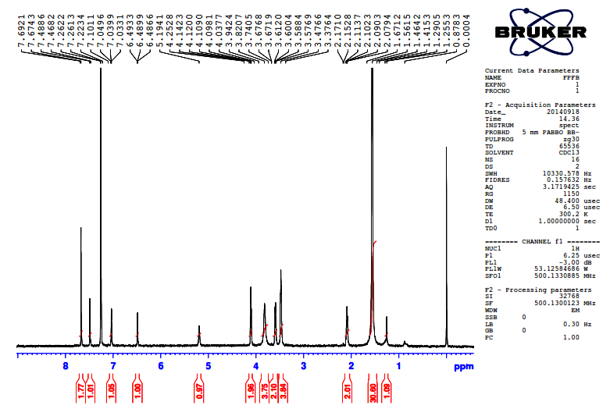
Figure 3: ¹H-NMR spectrum of 2,4,6-tribromophenyl-3-[4-(2-furoyl)-1-piperazinyl]propylcarbamate (16)

2.2. Biological Activities (in vitro)
2.2.1. Enzyme Inhibition Activity
The synthesized compounds exhibited variable inhibitory potentials against α-glucosidase, acetylcholinesterase and butyrylcholinesterase as evident from their IC₅₀ values mentioned in Table 1. Only two compounds, 2,4,6-tribromophenyl 2-[4-(2-furoyl)-1-piperazinyl]ethylcarbamate (9) and 2,4,6-tribromophenyl 3-[4-(2-furoyl)-1-piperazinyl]propylcarbamate (16) showed weak inhibitory potential against α-glucosidase having IC₅₀ value of 345.16 ± 0.16 μM and 422.61 ± 0.13 μM, respectively, relative to Acarbose, used as reference standard having IC₅₀ value of 38.25 ± 0.12 μM. This inhibitory potential might be attributed to the presence of 2,4,6-tribromophenyl group in both molecules. All the molecules were active against acetylcholinesterase enzyme but among all molecules phenyl 3-[4-(2-furoyl)-1-piperazinyl]propylcarbamate (12) exhibited best inhibitory potential against this enzyme with IC₅₀ value of 18.91 ± 0.04 μM, relative to Eserine, a reference standard having IC₅₀ value of 0.04 ± 0.0001 μM. This enhanced inhibitory potential of 12 can be an outcome of its unique skeleton as a whole. Moreover, this was the only molecule which showed some inhibitory tendency against butyrylcholinesterase enzyme with IC₅₀ value of 361.27 ± 0.13 μM. In future some modified derivatives of this molecule are recommended to acquire much closer IC₅₀ value to the standard, Eserine.

Table 1: Bioactivity studies of different carbamate derivatives bearing 2-furoyl-1-piperazine
Compound | α-Glucosidase |  | AchE |  | BChE
Compound | % age Inhibition | IC₅₀  (µM) | % age Inhibition | IC₅₀  (µM) | % age  Inhibition | IC₅₀  (µM)
5 | 25.45 ± 0.31 | - | 78.59 ± 0.23 | 34.62 ± 0.19 | 28.35 ± 0.16 | -
7 | - | - | 81.35 ± 0.96 | 456.45 ± 0.29 | - | -
9 | 94.32 ± 0.28 | 345.16 ± 0.60 | 77.15 ± 0.18 | 32.51 ± 0.03 | 48.16 ± 0.27 | -
12 | 32.34 ± 0.26 | - | 81.63 ± 0.15 | 18.91 ± 0.04 | 55.71 ± 0.24 | 361.27 ± 0.13
14 | 27.67 ± 0.45 | - | 82.45 ± 0.11 | 23.22 ± 0.05 | 33.26 ± 0.25 | -
16 | 85.54 ± 0.32 | 422.61 ± 0.30 | 81.76 ± 0.12 | 24.71 ± 0.07 | 43.45 ± 0.21 | -
Control | 92.23 ± 0.14ª | 38.25 ± 0.12ª | 91.27 ± 1.17^{b} | 0.04 ± 0.0001^{b} | 82.82 ± 1.09^{b} | 0.85 ± 0.0001^{b}
NOTE: All compounds were dissolved in methanol and experiments were performed in triplicate (mean±SEM, n=3).
a = Acarbose, b = Eserine, AChE = Acetylcholinesterase, BChE = Butyrylcholinesterase

2.2.2. Antibacterial Activity
All the synthesized molecules were screened against Gram-positive and Gram-negative bacteria, and were found to be excellent to good antibacterial agents. The results are tabulated as MIC values in Table 2. Among the synthesized carbamates, 16 showed the lowest MIC value (8.96 ± 0.49 μM) against S. typhi credibly because of the presence of 2,4,6-tribromophenyl group. In case of E. coli, carbamate 14 showed lowest MIC value (9.95 ± 0.48 μM) probably due to the presence of 2,4,6-trinitrophenyl group. Against P. aeruginosa and B. subtilis, 16 and 9 exhibited excellent antibacterial potential with MIC values 9.27 ± 0.16 μM and 9.43 ± 0.85 μM, respectively, predominantly because of the presence of 2,4,6-trinitrophenyl group and 2,4,6-tribromophenyl group respectively, in these molecules. Similarly, the carbamate 16 also rendered a great antibacterial activity against S. aureus with MIC value 16.87±0.41 μM. Amongst the synthesized compounds, 5 and 16 showed MIC values against all the bacterial strains while compound 16 showed the excellent MIC value regarding to following order in all bacterial strains S. typhi > P. aeroginosa > B. subtilis > E. coli > S. aureus probably due to the presence of 2,4,6-tribromophenyl moiety. In general, we can say that most of the carbamates possessed very good antibacterial activities against both Gram-positive and Gram-negative bacterial strains and hence, these molecules might lead to the discovery very potent antibacterial agents in future.
2.2.3. Hemolytic Activity
Most of the molecules exhibited very modest cytotoxicity values except 14 (72.38 %), yet it was lower than the positive control (Triton-X-100). The lowest activity was shown by molecule 16 (9.20 %), although it was little higher than the negative controls (PBS). So it can concluded that these molecules might be further tested for their therapeutic applications in the drug designing program because of their moderate toxicity, as shown in Table 2.

Table 2: Antibacterial activity (MIC) and hemolytic activity of different carbamate derivatives bearing 2-furoyl-1-piperazine
Compound | MIC  (µM) |  |  |  |  | Hemolytic activity
Compound | S. typhi  (-) | E. coli  (-) | P.aeroginosa (-) | B. subtilis (+) | S. aureus (+) | % age
5 | 9.08 ± 0.50 | 17.43 ± 0.61 | 19.87 ± 0.51 | 10.85 ± 0.14 | 19.98 ± 0.58 | 24.26
7 | 9.14 ± 0.15 | 16.98 ± 0.75 | 18.34 ± 0.92 | 10.78 ± 0.93 | - | 15.94
9 | 9.89 ± 0.17 | 14.43 ± 0.05 | 9.87 ± 0.43 | 9.43 ± 0.85 | - | 12.10
12 | 9.88 ± 0.75 | 15.64 ± 0.32 | 17.67 ± 0.34 | 11.76 ± 0.54 | - | 53.13
14 | 9.78 ± 0.90 | 9.95 ± 0.48 | 17.78 ± 0.33 | 16.49 ± 0.27 | - | 72.38
16 | 8.96 ± 0.49 | 10.64 ± 0.58 | 9.27 ± 0.16 | 9.78 ± 0.62 | 16.87 ± 0.41 | 9.20
Ciprofloxacin | 7.45 ± 0.58 | 7.16 ± 0.58 | 7.14 ± 0.18 | 7.29 ± 0.90 | 7.80 ± 0.19
PBS |  |  |  |  |  | 0.09
Triton |  |  |  |  |  | 100

2.2.4. Computational Docking
In order to know about the validity of accuracy, the co-crystallized ligands of the following enzymes were extracted and then re-docked into the binding pockets of the receptors. In all these cases, RMSD values between docked and co-crystallized ligands were less than 2 which indicated about the reliability of docking method and thus our protocol can be used for further studies. Almost all the synthesized derivatives were computationally docked against α-glucosidase, AChE & BChE to explore the binding modes of all the ligands. The carbamate 12 was docked against acetylcholinesterase. There were observed four prominent interactions between 12 and active residues of the protein. First strongest side chain donor interaction was found between TyrA130 and carbonyl oxygen giving a bond length of 1.77 Å, second between SerA122 and another carbonyl oxygen with a bond length of 3.67 Å. Third strong back bone donor interaction was established between GlyA117 and amide proton of the ligand with a bond distance of 2.09 Å. Similarly the last hydrophobic interaction of a bond distance of 3.10 Å was found between TrpA81 and phenyl ring of the ligand as shown in Figure 4 & 5. From the same compound 12 protein docked complex of butyrylcholinesterase, this interacted weakly with Tyr332 and His438 amino acid residues. Tyr332 made arene-arene interaction with furoyl ring to have a bond length of 3.36 Å while His438 gave arene cation interaction with phenyl ring to show a distance of 3.74 Å as it is shown in Figure 6 & 7.
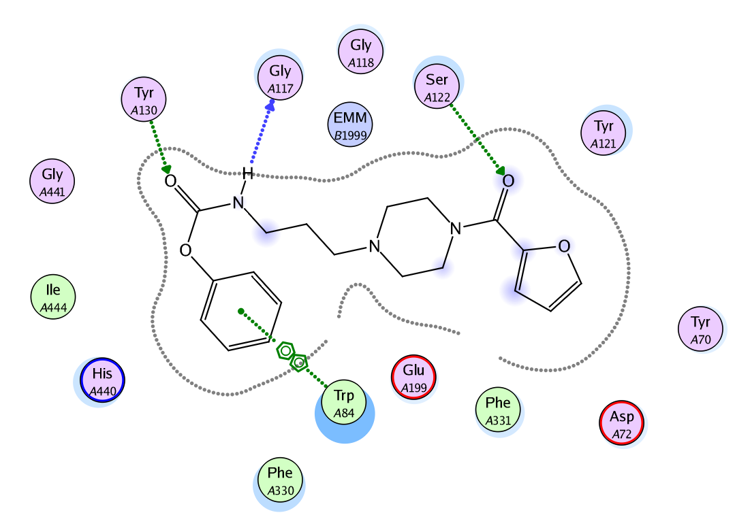
Figure 4: 2D interacted image of phenyl 3-[4-(2-furoyl)-1-piperazinyl]propylcarbamate (12) against acetylcholinestrase.
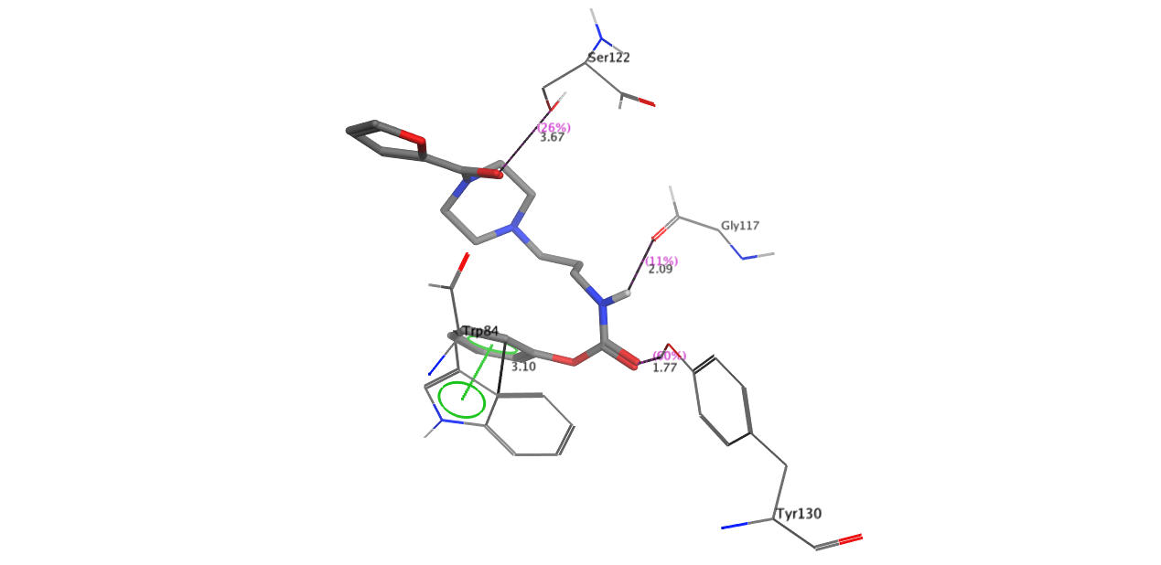
Figure 5: 3D interacted image of phenyl 3-[4-(2-furoyl)-1-piperazinyl]propylcarbamate (12) against acetylcholinestrase.
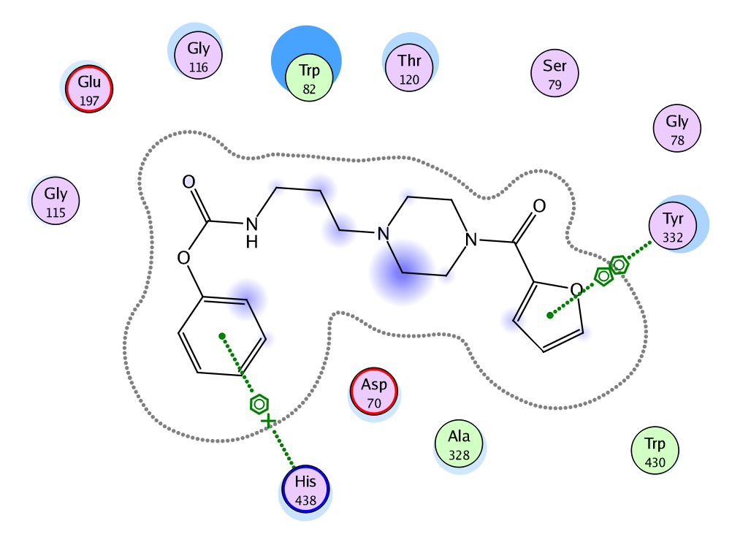
Figure 6: 2D interacted image of phenyl 3-[4-(2-furoyl)-1-piperazinyl]propylcarbamate (12) against butyrylcholinesterase.
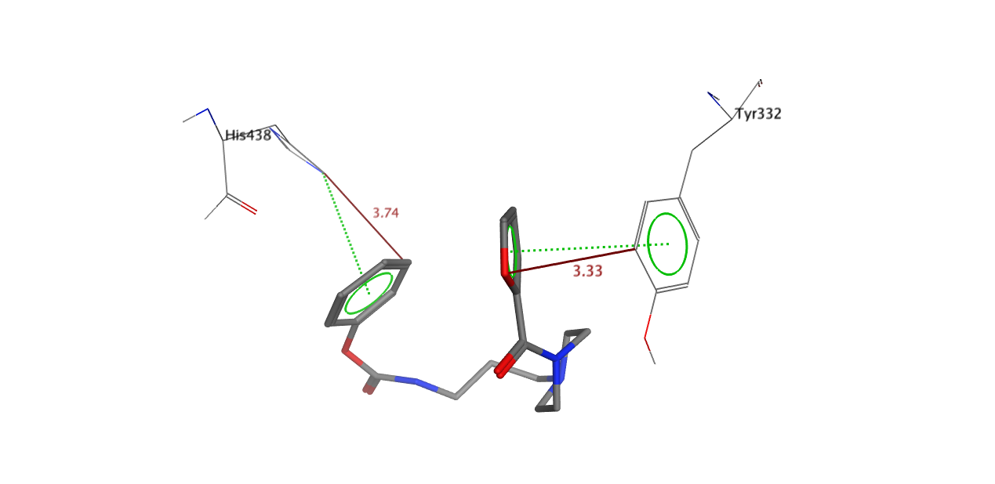
Figure 7: 3D interacted image of phenyl 3-[4-(2-furoyl)-1-piperazinyl]propylcarbamate (12) against butyrylcholinesterase.
3. Experimental
3.1. General
Chemicals and solvents of analytical grade were purchased from Sigma Aldrich and Alfa Aesar (Germany). By using an open capillary tube method, melting points were taken on Griffin and George apparatus and were uncorrected. By using thin layer chromatography in various percentages of ethyl acetate and n-hexane as mobile phase, initial purity of compounds was detected at 254 nm. IR peaks were recorded on a Jasco-320-A spectrometer by using a KBr pellet method. ¹H-NMR signals were recorded at 500 MHz in CDCl₃ using Bruker spectrometers. EI-MS signals were recorded by utilizing a JMS-HX-110 spectrometer.

3.2. Synthesis of Phenyl (N-substituted)carbamates (3, 11)
2-Chloroethylamine (2-chloro-1-ethanamine; 2; 0.1 mol) and 3-bromopropylamine (10; 0.1 mol) were taken separately in two iodine flasks, each containing 10 ml distilled water. The pH of the solution was maintained at 9-10 by 10 % aqueous Na₂CO₃ followed by the addition of phenyl carbonochloridic acid (phenylchloroformate; 1; 0.1mol,) in equimolar ratios in each flask along with vigorous shaking. The reaction mixture in each case was stirred at room temperature for 3-4 hrs. Progress of reaction was confirmed by TLC (n-hexane: EtOAc; 70:30), visualized by UV lamp. Phenyl 2-chloroethylcarbamate (3) and phenyl 3-bromopropylcarbamate (11) were collected as white precipitates by filtration. These were washed with distilled water and dried to acquire pure compounds.

3.3. Nitration of Phenyl (N-substituted)carbamates (6 & 13)
Phenyl 2-chloroethylcarbamate (3; 0.1 mol) and phenyl 3-bromopropylcarbamate (11; 0.1 mol) were taken separately in two 50 mL round bottom flasks. 5-10 mL concentrated H₂SO₄ was added in each flask to dissolve the respective compound. Each mixture was stirred for 15-20 minutes at room temperature and then equimolar nitric acid was added to each mixture drop wise at 10 ˚C. Then each reaction mixture was stirred for 4 hrs and was monitored by TLC. On reaction completion, ice cold water was added to the reaction flasks to acquire the precipitates which were collected by filtration, washed with distilled water and dried to afford the nitrated compounds 6 and 13, separately.
3.4. Bromination of Phenyl (N-substituted)carbamates (8 &15)
Phenyl 2-chloroethylcarbamate (3; 0.1 mol) and phenyl 3-bromopropylcarbamate (11; 0.1mol) were taken separately in two 50 ml round bottomed flasks and were solubilized in glacial acetic acid (5-10 mL). Liquid bromine was added slowly in equimolar ratio to eack flask. The reaction mixture in each case was stirred at room temperature and monitored with TLC for the completion of the reaction. Distilled water was added to each reaction flask to quench the reaction mixture. Precipitate of the products were filtered, washed with distilled water and dried to obtain pure brominated compounds 8 and 15, separately.
3.5. Synthesis of Different Carbamate Derivatives Bearing 2-Furoyl-1-piperazine
2-Furoyl-1-piperazine (4; 0.0045 mol) solubilized in 20-30 mL acetonitrile was taken in a 100 mL round bottom flask, solid K₂CO₃ (0.0135 mol) was added & the reaction mixture was refluxed for half an hour followed by the addition of respective carbamate (3, 6, 8, 11, 13 and 15; one in each case) in equimolar ratio. The mixture was refluxed for 4-5 hours. Thin layer chromatography was carried out to check the reaction completion (20% ethyl acetate: 80% n-hexane). Distilled water was added to the reaction mixture to acquire the respective precipitates. On completion, 1-2 drops of aqueous NaOH were added to the reaction mixture. Precipitates were filtered, washed and dried to obtain the respective carbamate (5, 7, 9, 12, 14 and 16; one in each case) bearing 2-furoyl-1-piperazine.

Scheme 1: Outline for the synthesis of different carbamate derivatives bearing 2-furoyl-1-piperazine. Reagents & Conditions: (I) 10 % aq. Na₂CO₃ soln./pH 9-10/stirring at RT for 3-4 hrs. (II) 2-Furoyl-1-piperazine (4)/CH₃CN/K₂CO₃/refluxing for 4-5 hrs. (III) Conc. HNO₃/Conc. H₂SO₄/stirring at RT for 3-4 hrs. (IV) Br₂/CH₃COOH/stirring at RT for 3-4 hrs.

3.5.1. Phenyl 2-[4-(2-furoyl)-1-piperazinyl]ethylcarbamate (5)
Sticky brown liquid; Yield: 90 %; Mol. F.: C₁₈H₂₁N₃O₄; Mol. Mass.: 343 g/mol; IR (KBr, cm⁻¹) v_{max}: 3406 (N-H), 3086 (Ar C-H), 2882 (R C-H), 1657 (C=O), 1582 (Ar C=C), 1498 (N=O), 1197 (C-O-C), 1110 (C-N-C), 853 (C-N); ¹H-NMR (500 MHz, CDCl₃, ppm): δ 7.49 (br.s, 1H, H-5'''), 7.45 (br.t, J = 7.2 Hz, 2H, H-3 & H-5), 7.15 (br.t, J = 7.3 Hz, 1H, H-4), 7.07 (br.d, J = 7.7 Hz, 2H, H-2 & H-6), 7.01 (d, J = 4.1 Hz, 1H, H-3'''), 6.50 (dd, J = 1.9, 3.2 Hz, 1H, H-4'''), 5.19 (s, 1H, -NH), 3.84 (br.s, 4H, CH₂-3'' & CH₂-5''), 3.39 (t, J = 6.2 Hz, 2H, CH₂-1'), 2.56 (br.t, J = 6.0 Hz, 4H, CH₂-2'' & CH₂-6''), 2.42 (t, J = 6.8 Hz, 2H, CH₂-2'); EI-MS (m/z): 343 [M]⁺, 207 [C₁₁H₁₅N₂O₂]⁺, 165 [C₉H₁₁NO₂]^{•+}, 163 [C₉H₉NO₂]^{•+}, 95 [C₅H₃O₂]⁺, 94 [C₆H₅O]⁺, 93 [C₅HO₂]⁺.

3.5.2. 2,4,6-Trinitrophenyl 2-[4-(2-furoyl)-1-piperazinyl]ethylcarbamate (7)
Sticky brown liquid: 82 %; Mol. F.: C₁₈H₁₈N₆O₁₀; Mol. Mass.: 478 g/mol; IR (KBr, cm⁻¹) v_{max}: 3406 (N-H), 3086 (Ar C-H), 2882 (R C-H), 1657 (C=O), 1582 (Ar C=C), 1490 (N=O), 1197 (C-O-C), 1110 (C-N-C), 848 (C-N);¹H-NMR (500 MHz, CDCl₃, ppm): δ 8.15 (s, 2H, H-3 & H-5), 7.49 (br.s, 1H, H-5'''), 6.99 (d, J = 4.1 Hz, 1H, H-3'''), 6.49 (dd, J = 1.9, 3.2 Hz, 1H, H-4'''), 5.19 (s, 1H, -NH), 3.84 (br.s, 4H, CH₂-3'' & CH₂-5''), 3.39 (t, J = 6.2 Hz, 2H, CH₂-1'), 2.56 (br.t, J = 6.0 Hz, 4H, CH₂-2'' & CH₂-6''), 2.42 (t, J = 6.8 Hz, 2H, CH₂-2'); EI-MS (m/z): 478 [M]⁺, 300 [C₉H₈N₄O₈]^{•+}, 298 [C₉H₆N₄O₈]^{•+}, 254 [C₉H₆N₃O₆]⁺, 229 [C₆H₂N₃O₇]⁺, 207 [C₁₁H₁₅N₂O₂]⁺, 95 [C₅H₃O₂]⁺, 93 [C₅HO₂]⁺.

3.5.3. 2,4,6-Tribromophenyl 2-[4-(2-furoyl)-1-piperazinyl]ethylcarbamate (9)
Sticky brown liquid; Yield: 85 %; Mol. F.: C₁₈H₁₈Br₃N₃O₄; Mol. Mass.: 577 g/mol; IR (KBr, cm⁻¹) v_{max}: 3406 (N-H), 3086 (Ar C-H), 2882 (R C-H), 1657 (C=O), 1582 (Ar C=C), 1491 (N=O), 1197 (C-O-C), 1110 (C-N-C), 853 (C-N), 545 (C-Br); ¹H-NMR (500 MHz, CDCl₃, ppm): δ 7.75 (s, 2H, H-3 & H-5), 7.47 (br.s, 1H, H-5'''), 7.02 (d, J = 4.1 Hz, 1H, H-3'''), 6.47 (dd, J = 1.9, 3.3 Hz, 1H, H-4'''), 5.18 (s, 1H, -NH), 3.83 (br.s, 4H, CH₂-3'' & CH₂-5''), 3.36 (t, J = 6.1 Hz, 2H, CH₂-1'), 2.58 (br.t, J = 6.1 Hz, 4H, CH₂-2'' & CH₂-6''), 2.45 (t, J = 6.8 Hz, 2H, CH₂-2'); EI-MS (m/z): 577 [M]⁺, 399 [C₉H₈Br₃NO₂]^{•+}, 397 [C₈H₆Br₃NO₂]^{•+}, 318 [C₉H₈Br₂NO₂]⁺, 327 [C₆H₂Br₃O]⁺, 207 [C₁₁H₁₅N₂O₂]⁺, 95 [C₅H₃O₂]⁺, 93 [C₅HO₂]⁺.

3.5.4. Phenyl 3-[4-(2-furoyl)-1-piperazinyl]propylcarbamate (12)
Sticky brown liquid; Yield: 87 %; Mol. F.: C₁₉H₂₃N₃O₄; Mol. Mass.: 357 g/mol; IR (KBr, cm⁻¹) v_{max}: 3406 (N-H), 3086 (Ar C-H), 2882 (R C-H), 1657 (C=O), 1582 (Ar C=C), 1496 (N=O), 1197 (C-O-C), 1110 (C-N-C), 850 (C-N);¹H-NMR (500 MHz, CDCl₃, ppm): δ 7.49 (br.s, 1H, H-5'''), 7.42 (br.t, J = 7.1 Hz, 2H, H-3 & H-5), 7.16 (br.t, J = 7.4 Hz, 1H, H-4), 7.09 (br.d, J = 7.8 Hz, 2H, H-2 & H-6), 7.05 (d, J = 4.0 Hz, 1H, H-3'''), 6.48 (dd, J = 1.9, 4.0 Hz, 1H, H-4'''), 5.15 (s, 1H, -NH), 4.10 (t, J = 6.7 Hz, 2H, CH₂-1'), 3.90 (br.s, 4H, CH₂-3'' & CH₂-5''), 3.64-3.56 (m, 2H, CH₂-3'), 3.46 (br.s, 4H, CH₂-2'' & CH₂-6''), 2.19 (quintet, J = 6.7 Hz, 2H, CH₂-2'); EI-MS (m/z): 357 [M]⁺, 221 [C₁₂H₁₇N₂O₂]⁺, 179 [C₁₀H₁₃NO₂]^{•+}, 177 [C₁₀H₁₁NO₂]^{•+}, 95 [C₅H₃O₂]⁺, 93 [C₆H₅O]⁺, 93 [C₅HO₂]⁺.

3.5.5. 2,4,6-Trinitrophenyl 3-[4-(2-furoyl)-1-piperazinyl]propylcarbamate (14)
Sticky brown liquid; Yield: 86 %; Mol. F.: C₁₉H₂₀N₆O₁₀; Mol. Mass.: 492 g/mol; IR (KBr, cm⁻¹) v_{max}: 3406 (N-H), 3086 (Ar C-H), 2882 (R C-H), 1657 (C=O), 1582 (Ar C=C), 1492 (N=O), 1197 (C-O-C), 1110 (C-N-C), 855 (C-N); ¹H-NMR (500 MHz, CDCl₃, ppm): δ 7.96 (s, 2H, H-3 & H-5), 7.48 (br.s, 1H, H-5'''), 7.02 (d, J = 4.0 Hz, 1H, H-3'''), 6.46 (dd, J = 2.0, 4.0 Hz, 1H, H-4'''), 5.16 (s, 1H, -NH), 4.10 (t, J = 6.7 Hz, 2H, CH₂-1'), 3.95 (br.s, 4H, CH₂-3'' & CH₂-5''), 3.60-3.57 (m, 2H, CH₂-3'), 3.48 (br.s, 4H, CH₂-2'' & CH₂-6''), 2.14 (quintet, J = 6.8 Hz, 2H, CH₂-2'); EI-MS (m/z): 492 [M]⁺, 314 [C₁₀H₁₀N₄O₈]^{•+}, 312 [C₁₀H₈N₄O₈]^{•+}, 266 [C₁₀H₈N₃O₆]⁺, 228 [C₆H₂N₃O₇]⁺, 221 [C₁₂H₁₇N₂O₂]⁺, 95 [C₅H₃O₂]⁺, 93 [C₅HO₂]⁺.

3.5.6. 2,4,6-Tribromophenyl 3-[4-(2-furoyl)-1-piperazinyl]propylcarbamate (16)
Off white amorphous solid; Yield: 90 %; m.p.: 80-92 ºC; Mol. F.: C₁₉H₂₀Br₃N₃O₄; Mol. Mass.: 591 g/mol; IR (KBr, cm⁻¹) v_{max}: 3406 (N-H), 3086 (Ar C-H), 2882 (R C-H), 1657 (C=O), 1582 (Ar C=C), 1497 (N=O), 1197 (C-O-C), 1110 (C-N-C), 847 (C-N), 548 (C-Br); ¹H-NMR (500 MHz, CDCl₃, ppm): δ 7.67 (s, 2H, H-3 & H-5), 7.49 (br.s, 1H, H-5'''), 7.04 (d, J = 4.1 Hz, 1H, H-3'''), 6.49 (dd, J = 2.0, 4.0 Hz, 1H, H-4'''), 5.19 (s, 1H, -NH), 4.12 (t, J = 6.6 Hz, 2H, CH₂-1'), 3.94 (br.s, 4H, CH₂-3'' & CH₂-5''), 3.61-3.57 (m, 2H, CH₂-3'), 3.47 (br.s, 4H, CH₂-2'' & CH₂-6''), 2.10 (quintet, J = 6.8 Hz, 2H, CH₂-2'); EI-MS (m/z): 591 [M]⁺, 413 [C₁₀H₁₀Br₃NO₂]^{•+}, 411 [C₁₀H₈Br₃NO₂]^{•+}, 332 [C₁₀H₁₀Br₂NO₂]⁺, 328 [C₆H₃Br₃O]^{•+}, 221 [C₁₂H₁₇N₂O₂]⁺, 95 [C₅H₃O₂]⁺, 93 [C₅HO₂]⁺.
3.6. Biological Activity Assays (in vitro)
3.6.1. α-Glucosidase Assay
The α-glucosidase inhibition activity was performed in accordance with the slightly modified method of Pierre et al.,.²⁴ Total volume of the reaction mixture of 100 µL contained 70 µl 50 mM phosphate buffer saline, pH 6.8, 10 µl (0.5 mM) test compound, subsequently the addition of 10 µl (0.057 units) enzyme. The contents were mixed, preincubated for 10 min at 37 ºC and pre-read at 400 nm. The reaction was initiated by the addition of 10 µl of 0.5 mM substrate (p-nitrophenylglucopyranoside). Acarbose was used as positive control. After 30 min of incubation at 37 ºC, absorbance was measured at 400 nm using Synergy HT microplate reader. All experiments were carried out in duplicates. The percent inhibition was calculated by the following equation:
$$Inhibition \left(\%\right)=\frac{Control-Test}{Control}×100$$
IC₅₀ values (concentration at which there is 50 % in enzyme catalyzed reaction) compounds were calculated using EZ-Fit Enzyme Kinetics Software (Perrella Scientific Inc. Amherst, USA).

3.6.2. Cholinesterase Inhibition Assay
The AChE and BChE inhibition activities were performed according to the method of Ellman et al., with minor modifications.²⁵ Total volume of the reaction mixture was 100 µL. It contained 60 µL Na₂HPO₄ buffer with concentration of (50 mM and pH 7.7). Ten µL test compound (0.5 mM well⁻¹) was added, followed by the addition of 10 µL (0.005 unit well⁻¹) enzyme. The contents were mixed and pre read at 405 nm. Then contents were pre incubated for 10 mins at 37 ºC. The reaction was initiated by the addition of 10 µL of (0.5 mM) well⁻¹ substrate (acetylthiocholine iodide/ butyrylthiocholine iodide), after that the addition of 10 µL DTNB (0.5 mM well⁻¹). After 15 mins of incubation at 37 ºC absorbance was measured at 405 nm. All experiments were carried out with their individual controls in triplicate. Eserine (0.5 mM well⁻¹) was used as a positive control. The inhibition (%) and IC₅₀ were calculated by the same method as described in α-glucosidase assay.

3.6.3. Antibacterial Activity
The antibacterial activity was done in sterile 96-wells microplates under aseptic environments. The method is rooted in the principle that microbial cell number increases as the microbial growth proceeds in a log phase of growth which results in increased absorbance of broth medium.^{26,27} Three gram-negative (Salmonella typhi, Escherichia coli and Pseudomonas aeruginosa) and two gram-positive bacteria (Bacillus subtilis, Staphylococcus aureus) were included in the study. The organisms were maintained on stock culture agar medium. The test samples with suitable solvents and dilutions were pipette into wells (20 µg / well). Overnight maintained fresh bacterial culture after suitable dilution with fresh nutrient broth was poured into wells (180 µL). The initial absorbance of the culture was strictly maintained between 0.12-0.19 at 540 nm. The total volume in each well was kept to 200 µL. The incubation was done at 37 ºC for 16-24 hours with lid on the microplate. The absorbance was measured, before and after incubation and the difference was noted as an index of bacterial growth at 540 nm by using microplate reader. The percent inhibition was calculated by using the formula:
$$Inhibition (\%)=\frac{X-Y}{X}×100$$
Where, X is absorbance in the control with bacterial culture and Y is absorbance in the test sample. Results are mean of triplicate (n=3, ± SEM). Ciprofloxacin was taken as the standard. Minimum inhibitory concentration (MIC) was measured with suitable dilutions (5-30 µg/ well) and results were calculated using EZ-Fit 5 Perrella Scientific Inc. Amherst USA software, and data expressed as MIC.

3.6.4. Statistical Analysis
The results are written as mean ± SEM after performance in three-folds and statistical analysis by Microsoft Excel 2010. Minimum inhibitory concentration (MIC) was calculated by using different dilutions (ranging 5-30 μg/well) and EZFit Perrella Scientific Inc. Amherst USA software.

3.6.5. Hemolytic Activity
Hemolytic activity was done by the reported method.^{28,29} Bovine blood was obtained from the Department of Clinical Medicine and Surgery, University of Agriculture, Faisalabad, Pakistan. After centrifugation, separation and washing, the % RBCs lysis was computed by noting the absorbance.

3.6.6. Molecular Docking Methodology
For the prediction of bioactive conformations, various synthesized compounds were docked into the active pockets of the following chosen proteins/enzymes by using the default parameters of MOE-Dock program. Earlier to dock the ligands into enzyme molecules, Builder of MOE 2009-10 was implemented to sketch the structures of synthesized compounds. Energy minimization was carried out up to 0.05 gradients by using MMFF94x force field through the default parameter of the MOE energy minimization algorithm. Then the energy minimized molecules were saved in the mdb file format as an input database for molecular docking in the subsequent step.
The enzyme molecules of α-glucosidase (PDB ID code: 3NO4), acetylcholinesterase (PDB ID code: 1GQR) and butyrylcholinesterase (PDB ID code: 1POP) were retrieved from Protein Data Bank having the possible resolutions of 2.02 Å, 1.69 Å and 2.30 Å respectively. Then all the water molecules were extracted from the receptor enzymes and 3D protonation was carried out through Protonate 3D Option. Energies of protein molecules were minimized by using the default parameters of MOE 2009-10 energy minimization algorithm (gradient: 0.05, Force Field: MMFF94X). Then all the ligands were docked into the binding pockets (selective residues/amino acids) of the above enzymes using default parameters of MOE-Dock Program. To increase the validity of docking protocol, Re-docking was also applied.³⁰ LigPlot which is implemented in MOE (Molecular Operating Environment) was used to know about the interactions between enzymes and Ligands.
4. Conclusion
The structures of synthesized unique carbamate derivatives bearing 2-furoyl-1-piperazine molecules were elucidated by spectral techniques. All the derivatives showed decent inhibitory potential against acetylcholinestrase enzyme and almost all the derivatives were active against the studied strains of Gram-positive and Gram-negative bacteria. The cytotoxic results were also processed to evaluate their cytotoxicity profile and these molecules exhibited modest toxicity. Hence, these molecules may be considered as suitable therapeutic entrants for the drug designing programs leading to some life saving medication.

5. Acknowledgement
The authors are highly thankful to Higher Education Commission (HEC) of Pakistan for providing financial support in this study.

6. References
- R. Kharb, P. C. Sharma, A. Bhandari, M. Shaharyar, Der. Pharmacia. Lett. 2012, 4, 652–657.
- J. Faist, W. Seebacher, R. Saf, R. Brun, M. Kaiser, R. Weis, Eur. J. Med. Chem. 2012, 47, 510–519.
- K. Kulig, J. Sapa, D. Maciag, B. Filipek, B. Malawska, Arch. Pharm. 2007, 340, 466–475.
- A. Pietrzycka, M. Stepniewski, A. M. Waszkielewicz, H. Marona, Acta Pol. Pharm. 2006, 63, 19–24.
- S. Bartoschek, J. A. Vorholt, R. K. Thauer, B. H. Geierstanger, C. Griesinger, Eur. J. Biochem. 2001, 267, 3130–3138.
- L. Robert, Metcalf “Insect Control” in Ullmann’s Encyclopedia of Industrial Chemistry” Wiley-VCH, Weinheim, 2002.
- S. Badreshia, Am J Contact Dermat. 2002, 13, 77–79.
- J. F. Holland, H. Hosley, C. Scharlau, Blood. 1966, 27, 328–342.
- A. J. Hirsh, S. Y. Yao, J. D. Young, C. I. Cheeseman, Gastroenterology. 1997, 113, 205–211.
- S. Chiba, Biosci., Biotechnol. Biochem. 1997, 61, 1233–1239.
- A. D., Baron, Diabetes Res. Clin. Pract. 1998, 40, 51–55.
- H. E. Lebovitz, Clin. North Am. 1997, 26, 539–551.
- M. Cygler, J. D. Schrag, J. Sussman, L. M. Harel, I. Silman, M. K. Gentry, Protein Sci. 1993, 2, 366–382.
- V. Tougu, Curr. Med. Chem. 2001, 1, 155–170.
- G. Bertaccini, P. Substance, Springer, Berlin. 1982, 59, 85–105.
- S. Gauthier, Drug & Aging. 2001, 18, 853–862.
- World Health Organization. Typhoid vaccines: WHO position paper. Wkly Epidemiol Rec. 2000, 75, 257–264.
- J. A. Crump, S. P. Luby, E. D. Minta, Bull WHO. 2004, 82, 346–53.
- A. A. Bahiru, S. A. Emire, A. K. Ayele, Acad. J. Microbiol. Res. 2013, 1, 1–10.
- M. Rosenfeld, J. Emerson, F. Accurso, D. Armstrong, R. Castile, K. Grimwood, P. Hiatt, Pediatr. Pulmonol. 1999, 28, 321–8.
- V. R. Barbe, S. P. Cruveiller, F. Kunst, P. Lenoble, G. Meurice, A. Sekowska, D. Vallenet, T. Wang, I. Moszer, C. M. digue, A. Danchin, Microbiology. 2009, 155, 1758–1775.
- F. D. Lowy, Trends Microbiol. 1998, 8, 341–344.
- P. S. Nayak, B. Narayana, B. K. Sarojini, J. Fernandes, Akshatha, J. Single Mol. Res. 2014, 2, 20-26.
- P. Chapdelaine, R. R. Tremblay, J. Y. Dube, Clin. Chem. 1978, 24, 208–211.
- G. L. Ellman, K. D. Courtney, V. Andres, R. M. Featherstone, Bio. Pharm. 1961, 7, 88–95.
- M. Kaspady, V. K. Narayanaswamy, M. Raju, G. K. Rao, Lett. Drug Des. Discov. 2009, 6, 21–28.
- Chong-Ren Yang, Y. Zang, M. R. Jacob, S. I. Khan, Ying-Jun Zhang, Xing-Cong Li, Antimicrob. Agents. Chemother. 2006, 50, 1710–1714.
- P. Sharma, J. D. Sharma, J. Ethnopharmacol. 2001, 74, 239–243.
- W. A. Powell, C. M. Catranis, C. A. Maynard, Lett. Appl. Microbiol. 2000, 31, 163–168.
- M. J. Bostro, J. R. Greenwood, J. Gottfries, Mol. Graph. Model. 2003, 21, 449-462.

