Use of DSC and IAC for identification of disease induced changes in human blood plasma proteome
Sandi Brudar¹, Urh Černigoj², Helena Podgornik³, Mojca Kržan⁴ and Iztok Prislan^{5,}*
¹University of Ljubljana, Faculty of Chemistry and Chemical Technology, 1000 Ljubljana, Slovenia
²BIA Separations, 5270 Ajdovščina, Slovenia
³University Medical Centre Ljubljana, Department of hematology, 1000 Ljubljana, Slovenia
⁴University of Ljubljana, Faculty of Medicine, 1000 Ljubljana, Slovenia
⁵University of Ljubljana, Biotechnical Faculty, 1000 Ljubljana, Slovenia
*Corresponding author: E-mail: iztok.prislan@bf.uni-lj.si

For Cutting Edge 2017

ABSTRACT Differential scanning calorimetry provides unique thermodynamic signatures of blood plasma samples. Plasma samples from diseased individuals yield specific thermograms, which differ from each other and from plasma samples of healthy individuals. Thermograms from individuals suffering from chronic lymphocytic leukemia, multiple myeloma and acute myeloid leukemia were measured with DSC. To obtain additional information about thermodynamic signature of plasma proteins immunoaffinity chromatography was introduced. An immunoextraction of HSA using a chromatographic column with immobilized anti-HSA was carried out in order to amplify less abundant plasma proteins, which could provide a further insight into disease development. Efficiency of HSA depletion and protein composition of fractionated plasma was validated by SDS-PAGE.
Keywords: DSC, IAC, blood plasma, immunoextraction, diagnostic tool

INTRODUCTION

Despite of rapid development of medicine and other sciences, timely and reliable diagnosis of diseases is sometimes still a pretentious task. In addition when it comes to ascertaining the health status of an individual some diagnostic procedures are very invasive. A solution to such difficulties could lie in new methods for human plasma analysis. Human plasma serves as an important source of information about human health. Various diseases are often associated with biomarkers, which have been defined by Hulka et al. as biochemical, molecular or cellular changes that are measureable in human fluids, tissues and cells.¹ The human plasma proteome consists of more than 3000 proteins and peptides, therefore the search for potential disease biomarkers, and their identification in the plasma proteome is a very complicated procedure.² Only ten proteins make up 90% of the mass of plasma proteins and albumin (HSA) and immunoglobulins (Ig) represent 75% out of these ten proteins. Majority of biomarkers in blood plasma are often scarce and small in size. Consequently, their detection can be limited by the presence of more abundant and larger proteins such as HSA or IgG². Because of the complexity of plasma no single technique can fully exploit the information plasma has to offer. Until now mass spectrometry and 2D-electrophoresis have been routinely used for detection and characterization of specific biomarkers.³ Chaires et al. have discovered the potential use of differential scanning calorimetry (DSC) for plasma analysis.² Using a DSC to analyze plasma yields a thermogram that is sensitive to differences in thermodynamic properties of the most abundant plasma proteins. Chaires et al. have shown that thermograms of plasma from diseased individuals differ significantly from thermograms of plasma from healthy individuals.^{2,4} Another tool to facilitate the search for biomarkers is liquid chromatography, in particular affinity chromatography and ion-exchange chromatography. Several researchers have demonstrated that depletion of most abundant plasma proteins amplifies the contribution of least abundant plasma proteins, thus creating the opportunity to uncover and study specific proteins/peptides.^{5,6} Polymethacrylate chromatographic monoliths afford flowrate independent binding capacity and resolution for large biomolecules due to the convective nature of the flow, which allows relatively short analysis times compared to traditional chromatographic supports.⁷ Having these advantages in mind we decided to partially deplete human serum albumin from plasma sample using chromatographic monoliths bearing immunoaffinity ligand. The purpose of our research was to develop and optimize the procedures for combined use of DSC and immunoaffinity chromatography (IAC) for the investigation of thermodynamic profiles of different plasma samples from diseased individuals.

EXPERIMENTAL

Plasma samples
We investigated plasma samples from a three individuals with three different haematological diseases, namely chronic lymphocytic leukemia (CLL), multiple myeloma (MM) and acute myeloid leukemia (AML). At the University Medical Centre Ljubljana (UMCL) the peripheral blood samples were withdrawn in tubes with EDTA and centrifuged at 2500 RPM for 10 minutes to obtain plasma. The use of plasma was approved by National Medical Ethics Committee (Approval number: MZ 0120-299/2016-2, KME 83/05/16)

Sample preparation
The buffer solutions used in our experiments consisted of 20 mM disodium phosphate and 300 mM NaCl. HCl was added to disodium phosphate to reach pH=7.4. All buffers were filtered before use. Samples were first diluted 5- to 7-fold and then extensively dialyzed against the buffer at 4 °C (three changes of buffer solution in 24 h) using a dialysis tube Float-A-Lyzer with a 3500 Da cut-off. Total protein concentration of plasma samples was determined spectrophotometrically according to the bicinchoninic acid method procedure (Sigma-Aldrich).⁸

IAC protocol
Separations were performed using a Knauer high-performance liquid chromatography (HPLC) workstation, consisting of two pumps, an autosampler injection system with a sample loop volume of 100 μL and a UV-detector at a wavelength of 280 nm. Samples were loaded by using a mobile phase consisting of 20 mM disodium phosphate and 300 mM NaCl, pH=7.4 at a flow rate of 1 mL/min. For experimental data acquisition, Eurochrom 2000 software was used. The hydrazide-modified monolithic chromatographic column (CIM® HIDA) with 1 mL bed volume and 6 μm pore size was provided by BIA Separations d.o.o. The immobilization of polyclonal anti-HSA was performed according to the procedure described by Tarasova et al.⁹ and the determined binding capacity of prepared CIM αHSA column for pure HSA in phosphate buffered saline was 0.35 mg/mL. Before injection, diluted and dialyzed plasma samples were filtered through 0.45 μm membrane filters (Sartorius) and diluted with dialysate to a total protein concentration of approximately 4 to 5 mg/mL. 100 μl loop was used to load the sample and flow-through and bound fractions of plasma were collected. Succeeding collection of flow-through fraction the bound fraction was eluted using 0.1 M HCOOH, pH=2.5, followed by immediate neutralization by 200 mM disodium phosphate, 300 mM NaCl, pH=8.5. Both fractions were transferred to Vivaspin sample concentrators with MWCO of 3500 Da and centrifuged to final volume of 1 to 1.5 mL at 5000 RPM. This was repeated 18 times.

DSC protocol

DSC thermograms were obtained using nano DSC II (CSC). Dialyzed plasma samples were diluted 3- to 4-fold with dialysate and degassed for 15 min. DSC scans were recorded from 20 °C to 100 °C at 2 °C/min. Corresponding buffer scans were also recorded. Raw data was analyzed with NanoAnalyze software and Microsoft Excel. The corresponding baseline (buffer–buffer) scans were subtracted from the plasma scans and normalized to total protein concentration to obtain partial molar heat capacity as a function of temperature.

SDS-PAGE
Fractions were examined using sodium dodecyl sulfate polyacrylamide gel electrophoresis (SDS-PAGE). Plasma fractions from IAC were diluted to a final concentration between 0.5 and 1.0 mg/mL. Separation of proteins was performed on 12% resolving gel and 4% stacking gel. Electrophoresis was carried out under reducing conditions according to the basic Laemmli SDS-PAGE procedure.¹⁰ Gels were run at 200 V and 15 °C for 75 min. Visualization of protein bands was done by silver staining.¹¹

RESULTS AND DISCUSSION

Comparison of blood plasma thermograms
Figure 1 shows that plasma thermograms belonging to diseased individuals differ significantly from one another and from “healthy” plasma thermograms. The thermograms of plasma display multiple peaks that can be associated to the melting temperatures (T_{m}) characteristic of main plasma proteins.

Figure 1. Comparison of thermograms of blood plasma from diseased individuals dissolved in 20 mM phosphate buffer and 300 mM NaCl and with a thermogram of blood plasma from healthy individual dissolved in 10 mM phosphate buffer and 150 mM NaCl (dashed cyan line) and 20 mM phosphate buffer and 300 mM NaCl (full cyan line).

Chaires et al. have performed thermal denaturation of “healthy” blood plasma at heating rate of 1 °C/min and in 10 mM phosphate buffer with 150 mM NaCl to mimic physiological conditions. Several peaks were identified corresponding to transition temperatures of fibrinogen (T_{m}~51 °C), HSA (T_{m}~63 °C), IgG (T_{m}~70 °C) and transferrin (T_{m}~85 °C).² Thermograms in our research were recorded at heating rate of 2 °C/min to increase the number of processed samples and 20 mM phosphate buffer with 300 mM NaCl was used to avoid non-specific plasma-column interactions. Higher heating rate and salt concentration shifted the melting temperatures of majority of plasma proteins to higher values (Figure 1). Thus T_{m} of fibrinogen shifts to ~53 °C, T_{m} of HSA to ~67 °C, T_{m} of IgG to ~72 °C) and T_{m} of transferrin to ~86 °C. Melting temperatures are not the only obtainable data from thermograms. The integration of area under the thermograms of plasma yields the enthalpy of plasma proteins denaturation (Table 1).

Table 1. Denaturation enthalpies of plasma from healthy individual and from blood plasma of diseased individuals. NF—non-fractionated plasma; F1—flow-through plasma fraction.
Sample | Unfolding enthalpy [kJ/mol]
Healthy plasma | 145075
CLL plasma NF | 151075
CLL plasma F1 | 117060
AML plasma NF | 157580
AML plasma F1 | 115060
MM plasma NF | 182090
MM plasma F1 | 170085

Figure 1 shows that thermograms obtained from thermal denaturation of blood plasma from diseased individuals are shifted to higher temperatures. The shift in unfolding temperatures is in agreement with previously reported results for other diseases.^{2,12,13,14} Proteins in plasma from diseased individuals seem to be thermodynamically stabilized for a yet undefined reason. Chaires et al. had hypothesized that such stabilization of proteins occurs due to interactions between major plasma proteins and specific disease biomarkers.² Thermal denaturation of plasma from an individual with CLL yields a thermogram, where at least four transitions could be identified. These could correspond to denaturation of fibrinogen (T_{m}~53 °C), HSA (T_{m}~68 °C), IgG (T_{m}~72 °C) and transferrin (T_{m}~91 °C). The transitions are shifted from 0 to 5 °C towards higher temperatures when compared to thermogram of “healthy” plasma. For instance, T_{m} of fibrinogen does not change, but T_{m} of transferrin is shifted for approximately 5 °C. The denaturation enthalpy of non-fractionated CLL plasma is 151075 kJ/mol. This value is approximately the same as the denaturation enthalpy of plasma proteins from healthy individuals. Figure 1 shows that thermodynamic profiles of CLL and AML plasma are distinct even though both diseases are characterized by prominent changes in blood leukocytes not in plasma protein composition. In the thermogram of plasma from an individual with AML an additional endothermic peak can be observed at 62 °C. We hypothesize this peak is present due to thermal denaturation of haptoglobin, as it is supposed to unfold in the same temperature region as HSA.² T_{m} values of fibrinogen and transferrin from AML plasma denaturation seem to be at approximately the same position as T_{m} values from “healthy” plasma denaturation. The denaturation enthalpy of non-fractionated blood plasma from an individual with AML is 157580 kJ/mol, which is comparable to denaturation enthalpy of CLL and “healthy” plasma. Lastly Figure 1 shows a specific thermogram of plasma from an individual with MM. Three main transition peaks for most abundant plasma proteins can be characterized. A similar thermogram for this disease was obtained by Todinova et al.¹⁵ Thermally induced peaks are shifted to higher temperatures to an even greater extent than those characteristic for proteins from CLL and AML plasma samples. Also in contrast to AML and CLL samples protein concentration in MM plasma was increased above reference range (94 g/L) due to monoclonal IgG fraction (M spike) typical for MM. Especially melting temperatures of HSA (T_{m}~71) °C and IgG (T_{m}~82 °C) are dramatically different from corresponding T_{m}s in thermograms of “healthy” plasma. The determined enthalpy of denaturation for non-fractionated MM plasma was 182090 kJ/mol, which is approximately 20% higher from denaturation enthalpies of other samples. These results suggest that the amount of unfolding enthalpy is not a determining factor for disease conditions. We believe that only the shape of plasma thermograms can serve as a diagnostic tool for disease determination.

Fractionation and characterization of proteins in blood plasma
To gain further insight into thermodynamic profiles of different blood plasma samples, fractionation of plasma samples and thermal denaturation of obtained fractions were carried out. The thermogram of the flow-through fraction of plasma from an individual with CLL in Figure 2 shows a distinct drop in signal intensity in the region characteristic of HSA, as a result of HSA depletion by a CIM αHSA column. Moreover, transition peaks for other proteins are amplified and more defined. Along with amplification of less abundant proteins we can observe an entirely new peak at approximately 65 °C, which seems to have been previously masked by HSA. We hypothesize that this peak is a result of haptoglobin denaturation.

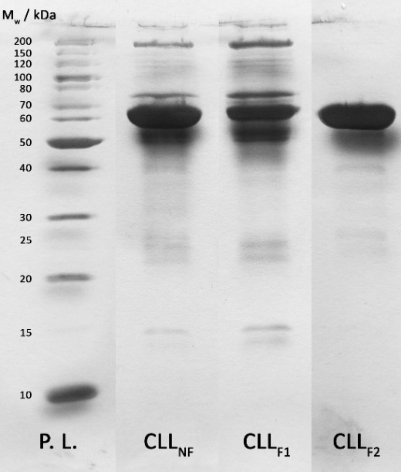

Figure 2. Thermograms of blood plasma from an individual with CLL (top). DSC thermogram of a non-fractionated blood plasma sample (full line) is compared to thermograms of flow-through (dotted line) and bound fraction (dashed line)obtained from HPLC fractionation. The right ΔC_{p} axis corresponds to the bound fraction. SDS-PAGE of blood plasma from an individual with CLL (bottom); P. L. — protein library, CLL_{NF} — non-fractionated blood plasma (1 mg/mL), CLL_{F1} — flow-through fraction (1 mg/mL), CLL_{F2} — bound fraction (0.8 mg/mL).

The obtained unfolding enthalpy of the flow-through fraction of CLL plasma was 117060 kJ/mol (Table 1), which is 22% lower than that of non-fractionated plasma. The thermogram of the bound fraction in Figure 2 shows a major exothermic effect above 82 °C due to protein aggregation. We hypothesize that this phenomenon is due to elution of HSA with HCOOH, even though this fraction was intercepted by high capacity buffer to neutralize acid. Very acidic conditions are non-physiological for HSA and can change its structure in a way that favors aggregation. Similar phenomena has been observed by other researchers.^{16,17} Together with the thermogram of the flow-through fraction, results of SDS-PAGE (Figure 2) show that fractionation of CLL plasma was successful. CLL_{F2} lane (bound fraction) displays an intensive band at 66 kDa, characteristic of HSA, no slower migrating bands and some low intensity bands in lower MW region that could correspond to heavy (~50 kDa) and light (~25 kDa) IgG chains. Results of flow-through fraction PAGE can be seen in CLL_{F1} lane. HSA band is less intensive but still present because in order to reduce the number of fractionations, high concentration of plasma with HSA concentration on the limit of binding capacity was injected on CIM αHSA column. Intensity of other bands is increased, suggesting that increasing the concentration of less abundant proteins was successful.

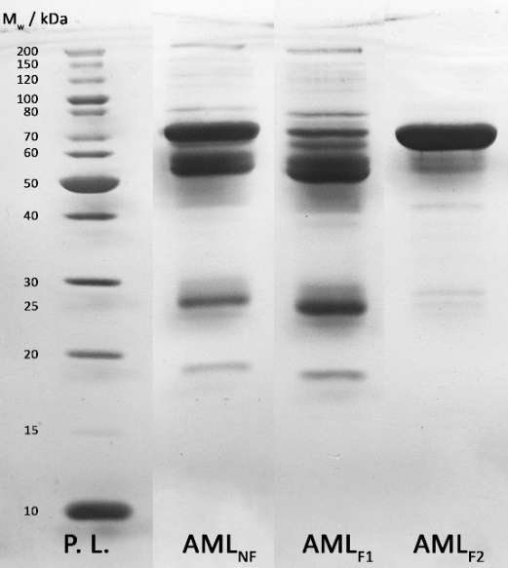

Figure 3. Thermograms of blood plasma from an individual with AML (top). DSC thermogram of a non-fractionated blood plasma sample (full line) is compared to thermograms of flow-through (dotted line) and bound fraction (dashed line)obtained from HPLC fractionation. The right ΔC_{p} axis corresponds to the bound fraction. SDS-PAGE of blood plasma from an individual with AML (bottom); P. L. — protein library, AML_{NF} — non-fractionated blood plasma (1 mg/mL), AML_{F1} — flow-through fraction (1 mg/mL), AML_{F2} — bound fraction (0.7 mg/mL).

The thermogram of the flow-through fraction of AML plasma (Figure 3) shows that depletion of HSA from blood plasma resulted in well-defined peak at 62 °C which in our opinion is a result of haptoglobin denaturation. Signals for other plasma proteins, such as fibrinogen at 53 °C and transferrin at 86 °C are also slightly amplified. The remaining peak between at 72 °C can be attributed to IgG denaturation. The obtained unfolding enthalpy for the flow-through fraction was 115060 kJ/mol (Table 1), which is approximately 27% lower than for non-fractionated AML plasma. Thermogram obtained from thermal denaturation of the bound fraction of AML plasma (Figure 3) displays an intensive endothermic peak, followed by a steep exothermic effect characteristic of protein aggregation. Results of SDS-PAGE of AML plasma (Figure 3) show an intensive HSA band in AML_{F2} lane, suggesting that we have successfully depleted HSA from the AML plasma. Some faster migrating bands corresponding to heavy (~50 kDa) and light (~25 kDa) IgG chains can also be seen in AML_{F2} lane. AML_{F1} lane corresponds to the flow-through fraction and contains a band at 66 kDa showing that not all of HSA was removed. The intensities of other bands are increased, proving that we have succeeded in increasing the relative concentration of other proteins.

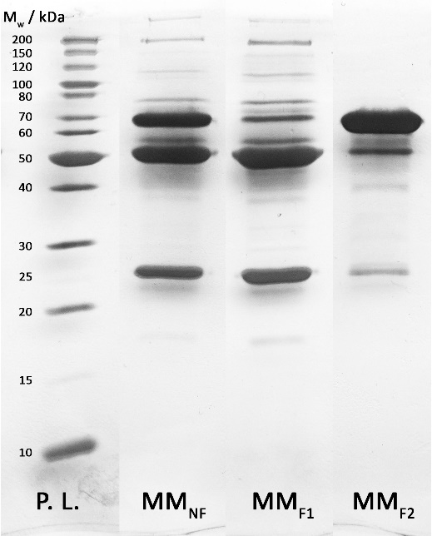

Figure 4. Thermograms of blood plasma from an individual with MM (top). DSC thermogram of a non-fractionated blood plasma sample (full line) is compared to thermograms of flow-through (dotted line) and bound fraction (dashed line)obtained from HPLC fractionation. The right ΔC_{p} axis corresponds to the bound fraction. SDS-PAGE of blood plasma from an individual with MM (bottom); P. L. — protein library, MM_{NF} — non-fractionated blood plasma (1 mg/mL), MM_{F1} — flow-through fraction (1 mg/mL), MM_{F2} — bound fraction (0.5 mg/mL).

When comparing thermograms of non-fractionated sample and flow-through fraction of the MM plasma (Figure 4), a distinct drop in signal intensity in the region characteristic of HSA unfolding is observed, suggesting that HSA depletion was successful. Consequentially contributions of other proteins are amplified, especially that for IgG at 82 °C. The denaturation enthalpy of the flow-through fraction was 170085 kJ/mol, which is only 7% lower than for non-fractionated MM plasma. Similarly, SDS-PAGE of MM flow-through fraction, MM_{F1}, shows decreased intensity of HSA band at 66 kDa and increased intensities of other bands. On the other hand SDS-PAGE of MM bound fraction, MM_{F2}, shows strong band, characteristic of HSA along with weaker bands representing heavy and light IgG chains. Comparison of Figures 2, 3 and 4 reveals that the intensities of weaker and faster migrating bands are strongest in the case of MM plasma. This could be a result of HSA-IgG complex formation, non-specific interactions or column degradation and should be further investigated. The stained gel (Figure 4) gives information not only about the effectiveness of MM plasma fractionation, but also of multiple myeloma signs. This is especially evident from several protein bands in MM_{NF} lane. A weak band, characteristic of HSA and abnormally intensive bands, characteristic of heavy and light IgG chains can be observed. Both phenomena are typical of multiple myeloma¹⁸ and it should be emphasized that MM plasma was obtain from patient with IgG clonality and light chain kappa restriction.

Conclusions
DSC provides a unique thermodynamic signature of the three examined diseases (chronic lymphocytic leukemia, multiple myeloma and acute myeloid leukemia), thus showing potential for plasma proteome investigation. IAC with the use of a CIM αHSA column enables amplification of less abundant plasma proteins, thus providing the tool to enhance the relative presence and/or influence of potential disease biomarkers. Amplification of plasma proteins in flow-through fractions was verified with SDS-PAGE and analyzed with DSC. The obtained results suggest that combination of DSC and IAC could be introduced as a possible novel and non-invasive diagnostic tool.

Acknowledgements
We acknowledge the financial support of the Slovenian Research Agency through Program Groups P1-0201 and P4-0121. We are also grateful to Iva Hafner Bratkovič for contributing important knowledge on making and staining SDS-PAGE gels.

References

- R. Mayeux, Neurotherapeutics, 2004, 1, 182-188.
http://dx.doi.org/10.1602/neurorx.1.2.182
- N. C. Garbett, J.J. Miller, A.B. Jenson, J. B. Chaires, Biophys. J., 2008, 94, 1377-1383.
http://dx.doi.org/10.1529/biophysj.107.119453
- P. Maurya, P. Meleady, P. Dowling, M. Clynes, Anticancer Res., 2007, 27, 1247-1256.
http://ar.iiarjournals.org/content/27/3A/1247.long
- N. C. Garbett, M. L. Merchant, C. W. Helm, A. B. Jenson, J. B. Klein, J. B. Chaires, PLoS One, 2014, 9, e84710, 1-12.
http://dx.doi.org/10.1371/journal.pone.0084710
- T. Čerk Petrič, P. Brne, B. Gabor, L. Govednik, M. Barut, A. Štrancar, L. Zupančič Kralj, J. Pharm. Biomed. Anal., 2007, 43, 243-249.
http://dx.doi.org/10.1016/j.jpba.2006.06.019
- C. Wu, J. Duan, T. Liu, R. D. Smith, W.-J. Qian, J. Chromatogr. B Analyt. Technol. Biomed. Life Sci., 2016, 1021, 57-68.
http://dx.doi.org/10.1016/j.jchromb.2016.01.015
- U. Černigoj, U. Vidic, B. Nemec, J. Gašperšič, J. Vidič, N. Lendero Krajnc, A. Štrancar, A. Podgornik, J. Chromatogr. A, 2016, 1464, 72-78.
http://dx.doi.org/10.1016/j.chroma.2016.08.014
- C. M. Stoscheck, Methods in Enzymol., 1990, 182, 50-69.
http://dx.doi.org/10.1016/0076-6879(90)82008-P
- I. A. Tarasova, A. A. Lobas, U. Černigoj, E. M. Solovyeva, B. Mahlberg, M. V. Ivanov, T. Panić-Janković, Z. Nagy, M. L. Pridatchenko, A. Pungor, B. Nemec, U. Vidic, J. Gašperšič, N. Lendero Krajnc, J. Vidič, M. V. Gorshkov, G. Mitulović, Electrophoresis, 2016, 37, 2322-2327.
http://dx.doi.org/10.1002/elps.201500489
- U. K. Laemmli, Nature, 1970, 227, 680-685.
http://dx.doi.org/10.1038/227680a0
- M. Chevallet, S. Luche, T. Rabilloud, Nat. Protoc., 2006, 1, 1852-1858.
http://dx.doi.org/10.1038/nprot.2006.288
- N. C. Garbett, M. L. Merchant, J. B. Chaires, J. B. Klein, Biochim. Biophys. Acta, 2013, 1830, 4675-4680.
http://dx.doi.org/10.1016/j.bbagen.2013.05.007
- A. Michnik, Z. Drzazga, K. Michalik, A. Barczyk, I. Santura, E. Sozańska, W. Pierzchała, J. Therm. Anal. Calorim., 2010, 102, 57-60.
http://dx.doi.org/10.1007/s10973-009-0602-6
- L. Kikalishvili, M. Ramishvili, G. Nemsadze, T. Lezhava, P. Khorava, M. Gorgoshidze, M. Kiladze, J. Monaselidze, J. Therm. Anal. Calorim., 2015, 120, 501-505.
http://dx.doi.org/10.1007/s10973-015-4426-2
- S. Todinova, S. Krumova, L. Gartcheva, C. Robeerst, S. G. Taneva, Anal. Chem., 2011, 83, 7992-7998.
http://dx.doi.org/10.1021/ac202055m
- G. A. Picó, Int. J. Biol. Macromol., 1997, 20, 63-73.
http://dx.doi.org/10.1016/S0141-8130(96)01153-1
- A. Kumar Shaw, S. Kumar Pal, J. Photoch. Photobio. B., 2008, 90, 69-77.
http://dx.doi.org/10.1016/j.jphotobiol.2007.11.003
- D. F. Keren: Protein Electrophoresis in Clinical Diagnosis, Hodder Arnold, London, Great Britain, 2003, pp. 63-108 and 151-168.
http://www.aun.edu.eg/molecular_biology/Protein%20workshop/&%20Protein%20Electrophoresis_clinical%20diagnosis.pdf

