SUPPORTING INFORMATION

Figure S1. Thermograms of flow-through (top) and bound (bottom) fractions of blood plasma from an individual with MM. Fractionation was performed twice to test robustness and reproducibility of our method. First (black line) and second (red line) fractionation yielded comparable thermograms.

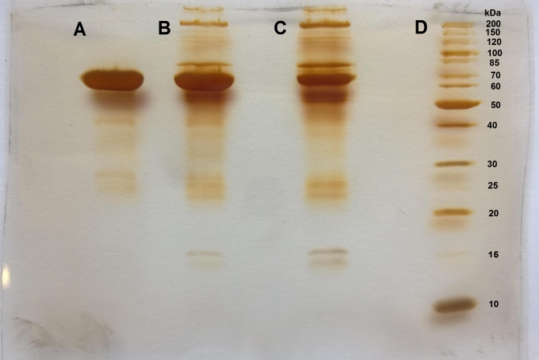
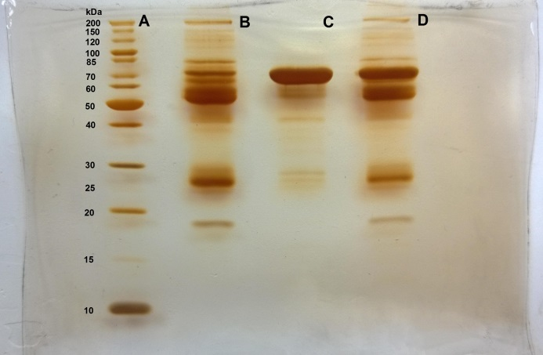
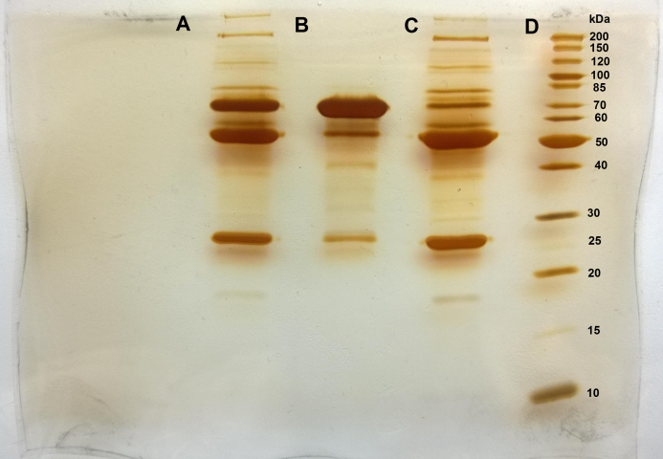

Figure S2. Raw images of our gels show results of SDS-PAGE of blood plasma from an individual with CLL (top), AML (middle) and MM (bottom)

