Modelling the correlation between molecular electrostatic potential and pKa on sets of carboxylic acids, phenols and anilines

Miha Virant ^{1,}*, Sara Drvarič Talian^{2,}*, Črtomir Podlipnik¹ and Barbara Hribar-Lee¹
¹Faculty of Chemistry and Chemical Technology, University of Ljubljana, Večna pot 113, SI-1000 Ljubljana, Slovenia.
²National Institute of Chemistry, Hajdrihova 19, SI-1000 Ljubljana, Slovenia.
*Corresponding authors: e-mail: miha.virant@fkkt.uni-lj.si, sara.drvarictalian@ki.si

For Cutting Edge 2017

Abstract
Calculations of molecular electrostatic potential were correlated with experimental pK_{a} values for different sets of acidic molecules (carboxylic acids, phenols and anilines) to obtain linear relationships of variable quality. A single tri-parameter model function was constructed to describe the pK_{a} dependence upon MEP maxima together with two automatically generated molecular descriptors, namely the counts of carboxylic acid and amine functional groups.

Keywords: molecular electrostatic potential, pKa, quantum mechanical calculations, multivariable linear regression.

Introduction
Any distribution of the electrical charge in a molecule creates an electrostatic potential V(r) at each point of the surrounding space r:¹
$$V\left(r\right)=\sum_{A}{\frac{z_{A}}{\left|R_{A}-r\right|}-\int{\frac{ρ\left(r^{'}\right)dr'}{\left|r^{'}-r\right|}}}$$

where z_{A} is a charge of a nucleus A located at R_{A}, and ρ(r) is the electronic density function of the molecule, that can be determined either computationally, or experimentally by diffraction methods.² This so-called molecular electrostatic potential (MEP) is a well-established tool for interpreting and predicting the molecular reactivity.²⁻⁵

One of the physico-chemical properties that has recently been shown to be correlated with the MEP is the pK_{a} value that describes the acid strength of certain organic acids.⁶⁻⁷ The correlation was established by comparing the calculated MEP values via different theoretical methods with the experimentally determined pK_{a} values for same sets of compounds. The success of the method consequently depends on the training set used in the program learning process, and the similarity of the compounds studied.⁷

A relatively good correlation between the maximum in MEP and the pK_{a} value was found for amines, anilines, carboxylic acids, alcohols, sulfonic acids and tioles.⁸ Further, a good correlation was established recently between pK_{a} and the most positive value of the MEP of the benzoic acids and phenols, and between the most negative value of MEP and the local ionization energies of these compounds.⁹

Since the knowledge of the pK_{a} values is vital for predicting the reactivity of the compound in question and is therefore of broad interest in drug design, toxicology studies, chemical synthesis etc., it is desirable to extend the current knowledge to other compounds.

In this paper, the correlation between pK_{a} values and MEP for carboxylic acids, phenols and anilines was tested and additional physico-chemical descriptors were introduced in regression model to improve the correlation.

Methods
Calculations of molecular electrostatic potential maxima (V_{max}) were executed using Spartan '14 (v. 1.1.4) software. Energy minimizations of equilibrium geometries were performed on sets of 39 aliphatic carboxylic acids, 17 mono substituted benzoic acids and 19 mono-substituted anilines and phenols.

The starting molecular configurations were formed using the Merck molecular force field (MMFF) optimization.¹⁰ Further, semi-empirical methods AM1, and PM6, ab initio Hartree-Fock method HF 6-31G*, and a density functional theory method B3LYP 6-31G* were used to calculate the MEP.¹¹

Several isoelectronic densities (0.2, 0.02, 0.002, and 0.0002) were examined for linear correlation between the maximum in MEP, V_{max}, and pK_{a} values obtained from the literature.^{12,13} The best correlation was obtained for isoelectronic value of 0.02, which was used in the further calculations.

The correlation between pK_{a}s and the obtained values for V_{max} was determined using the linear regression analysis.¹⁴ For molecules containing bromine atoms, MMFF optimization of molecular geometry was unsuccessful using PM6 method, so they were excluded from computational results in the aforementioned method sets.

To improve the correlation between pK_{a} and calculated descriptors from MEP, CANVAS’s ligfilter descriptors were included into the calculation of multiple linear regression analysis with CANVAS software from Schrödinger 2015 Suite. The model was constructed using V_{max} and two best suited ligfilter descriptors, which count the number of certain functional groups.

For validation of model group of 87 compounds were divided into two sets. The first one named training set was composed of 70 % randomly selected compounds which were used for building a model, and the second one (testing set) contained remaining 30 % compounds used for validation of the prediction capacity of the model.

The best subset of descriptors for construction of the model was selected with CANVAS’s simulated annealing¹⁵ algorithm with performing maximum of 1000 MC steps, initial and final temperature which corresponds to standard deviation of y being 0.5 and 0.05 respectively.

Results and discussion
The results for the correlation between V_{max} in MEP for the isoelectronic density 0.02 and pK_{a} for phenols (a), anilines (b), aliphatic (c), and benzoic acids (d) are given below. In subsection (e) the multivariable analysis is presented for the compounds studied.

a) The correlation between V_{max} and pK_{a} for the chosen set of mono-substituted phenols is shown in Figure 1. The results obtained with different methods are shown with different symbols/colors.
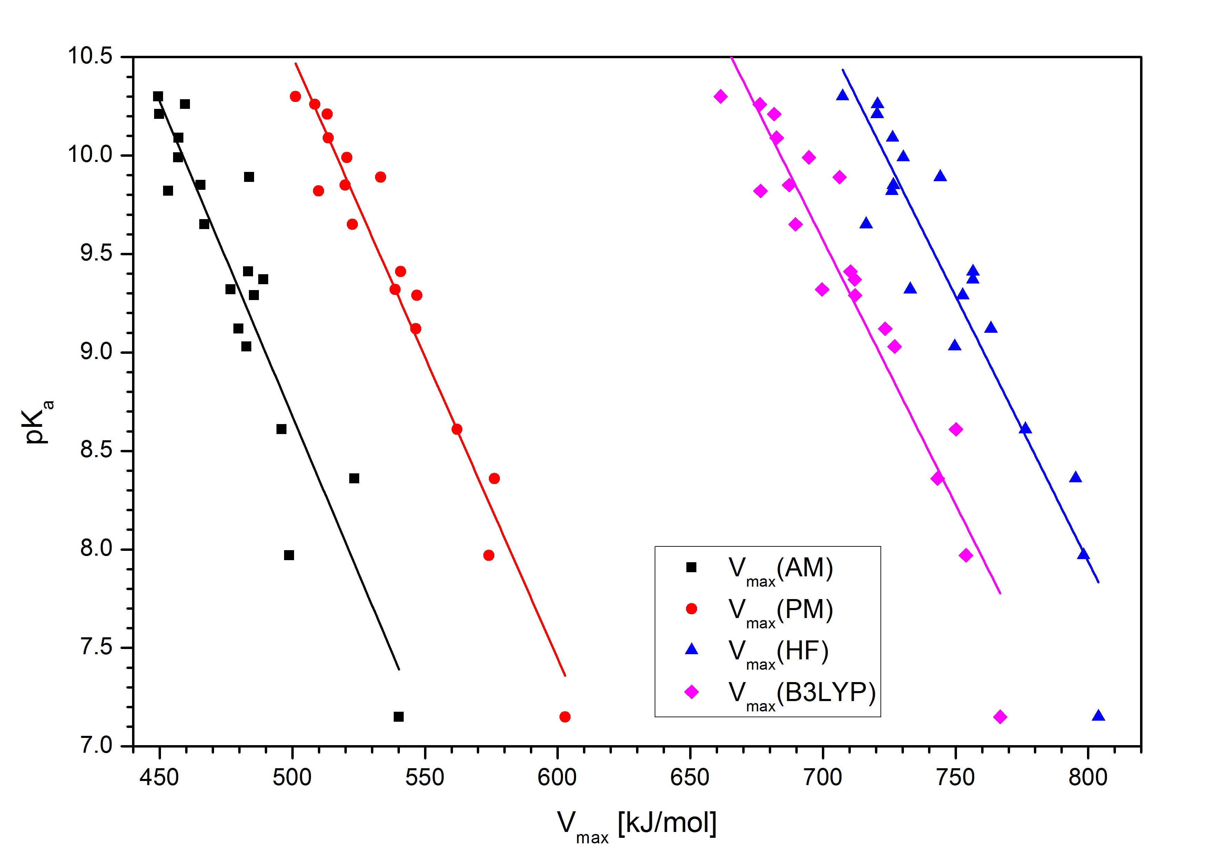
Figure 1. The correlation between the V_{max} calculated using different methods at IsoValue 0.02, and pK_{a} values^{12,13} of phenols.

Regardless of the method used for calculating the MEP, the correlation coefficient, R², is around 0.8. If we disregard the values for nitro phenols calculated via PM6 method, the slopes of the fitted curves are approximately the same, indicating that the results are not dependent on the method of calculation.

b) The results for the anilines are shown in Figure 2. For the determination of the correlation for the set of anilines, we modelled the V_{max} on protonated molecules (anilinium cations). As with the set of phenols, the value of R² being higher than 0.8 shows good correlation between calculated and experimental properties.
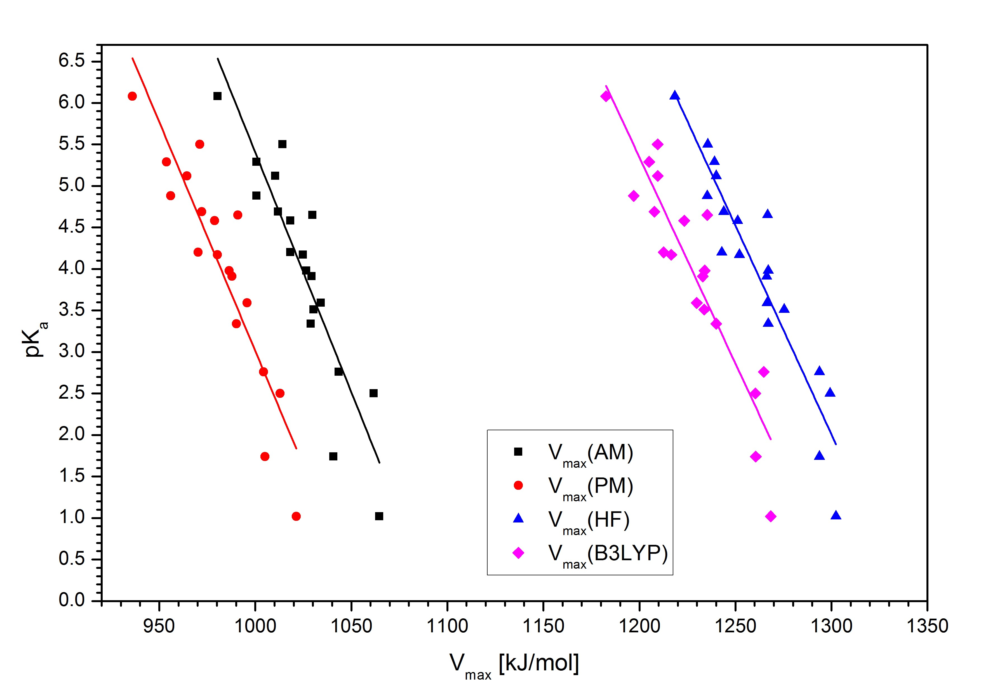
Figure 2. The correlation between the V_{max} calculated using different methods at IsoValue 0.02, and pK_{a} values^{12,13} of anilines.

c) In the case of aliphatic acids, much poorer correlation between V_{max} and pK_{a} was obtained (Figure 3). The obtained correlation coefficient R² ranged from 0.395 to 0.588, depending on the method of calculation, semi-empirical PM6 method having the lowest score. Poor correlations are most likely the consequence of structural diversity and larger pK_{a} range span.
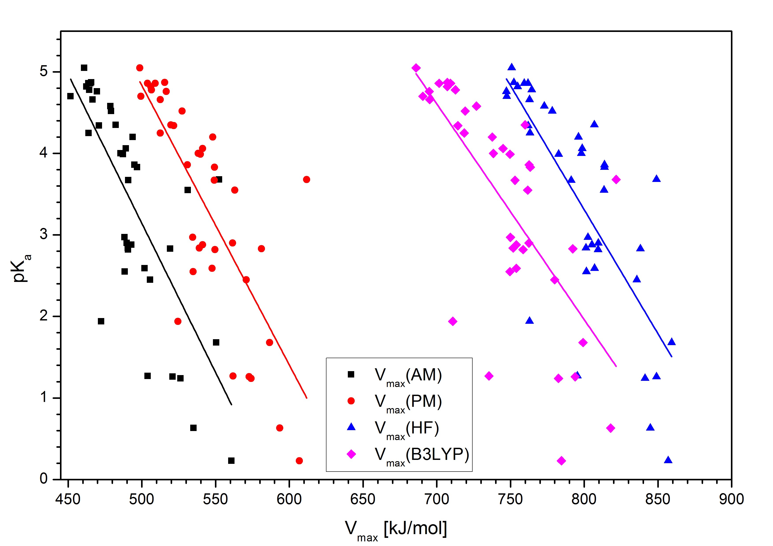
Figure 3. The correlation between the V_{max} calculated using different methods at IsoValue 0.02, and pK_{a} values^{12,13} of aliphatic acids.

d) The results for the correlation between V_{max} and pK_{a} for the benzoic acids studied is shown in Figure 4. As seen, the values of V_{max} and pK_{a} for the set of mono-substituted benzoic acids are poorly correlated. An evident deviation from linearity can be observed in values for methoxybenzoic and hydroxybenzoic acids. The large scatter in studied pK_{a} range suggests a non-linear response of the V_{max} to the substituent electronic effects.
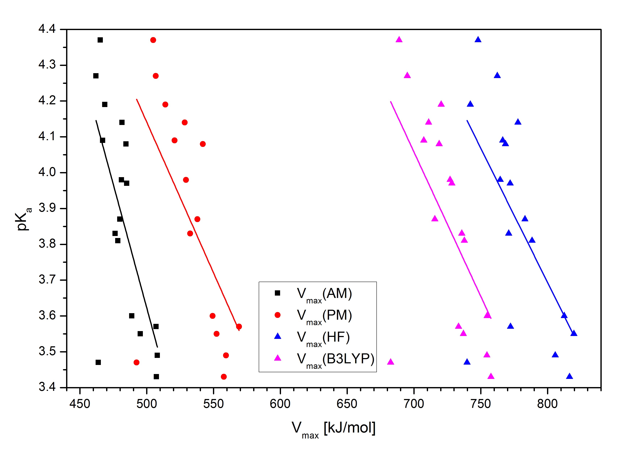
Figure 4. The correlation between the V_{max} calculated using different methods at IsoValue 0.02, and pK_{a} values^{12,13} of benzoic acids.

As evident from the Figure 5, obtained linear correlations for applied molecules can be classified into 3 groups. With incorporation of additional parameters, it should be possible to construct a single model to predict pK_{a} values for all 4 molecule sets.
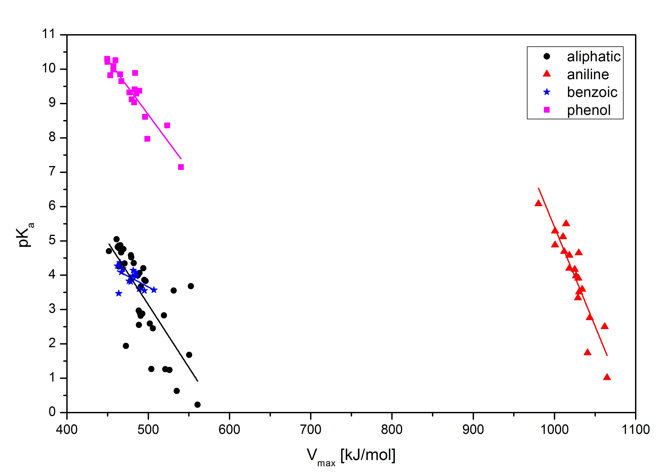
Figure 5. Experimental pK_{a} values^{12,13} as a function of V_{max}(AM1) for all molecule sets.

e) To improve the obtained correlations we made an attempt to include some software-generated descriptors into the multivariable analysis. Using the CANVAS, we determined ligfilter descriptors to be the parameters of choice. Inclusion of number of carboxylic acids or carboxylates (N_{COO}) and number of charged amine groups (N_{NH4+}) together with calculated V_{max} provides the possibility of unifying the correlation between chemical descriptors and pK_{a} for different types of molecules (Figure 6).
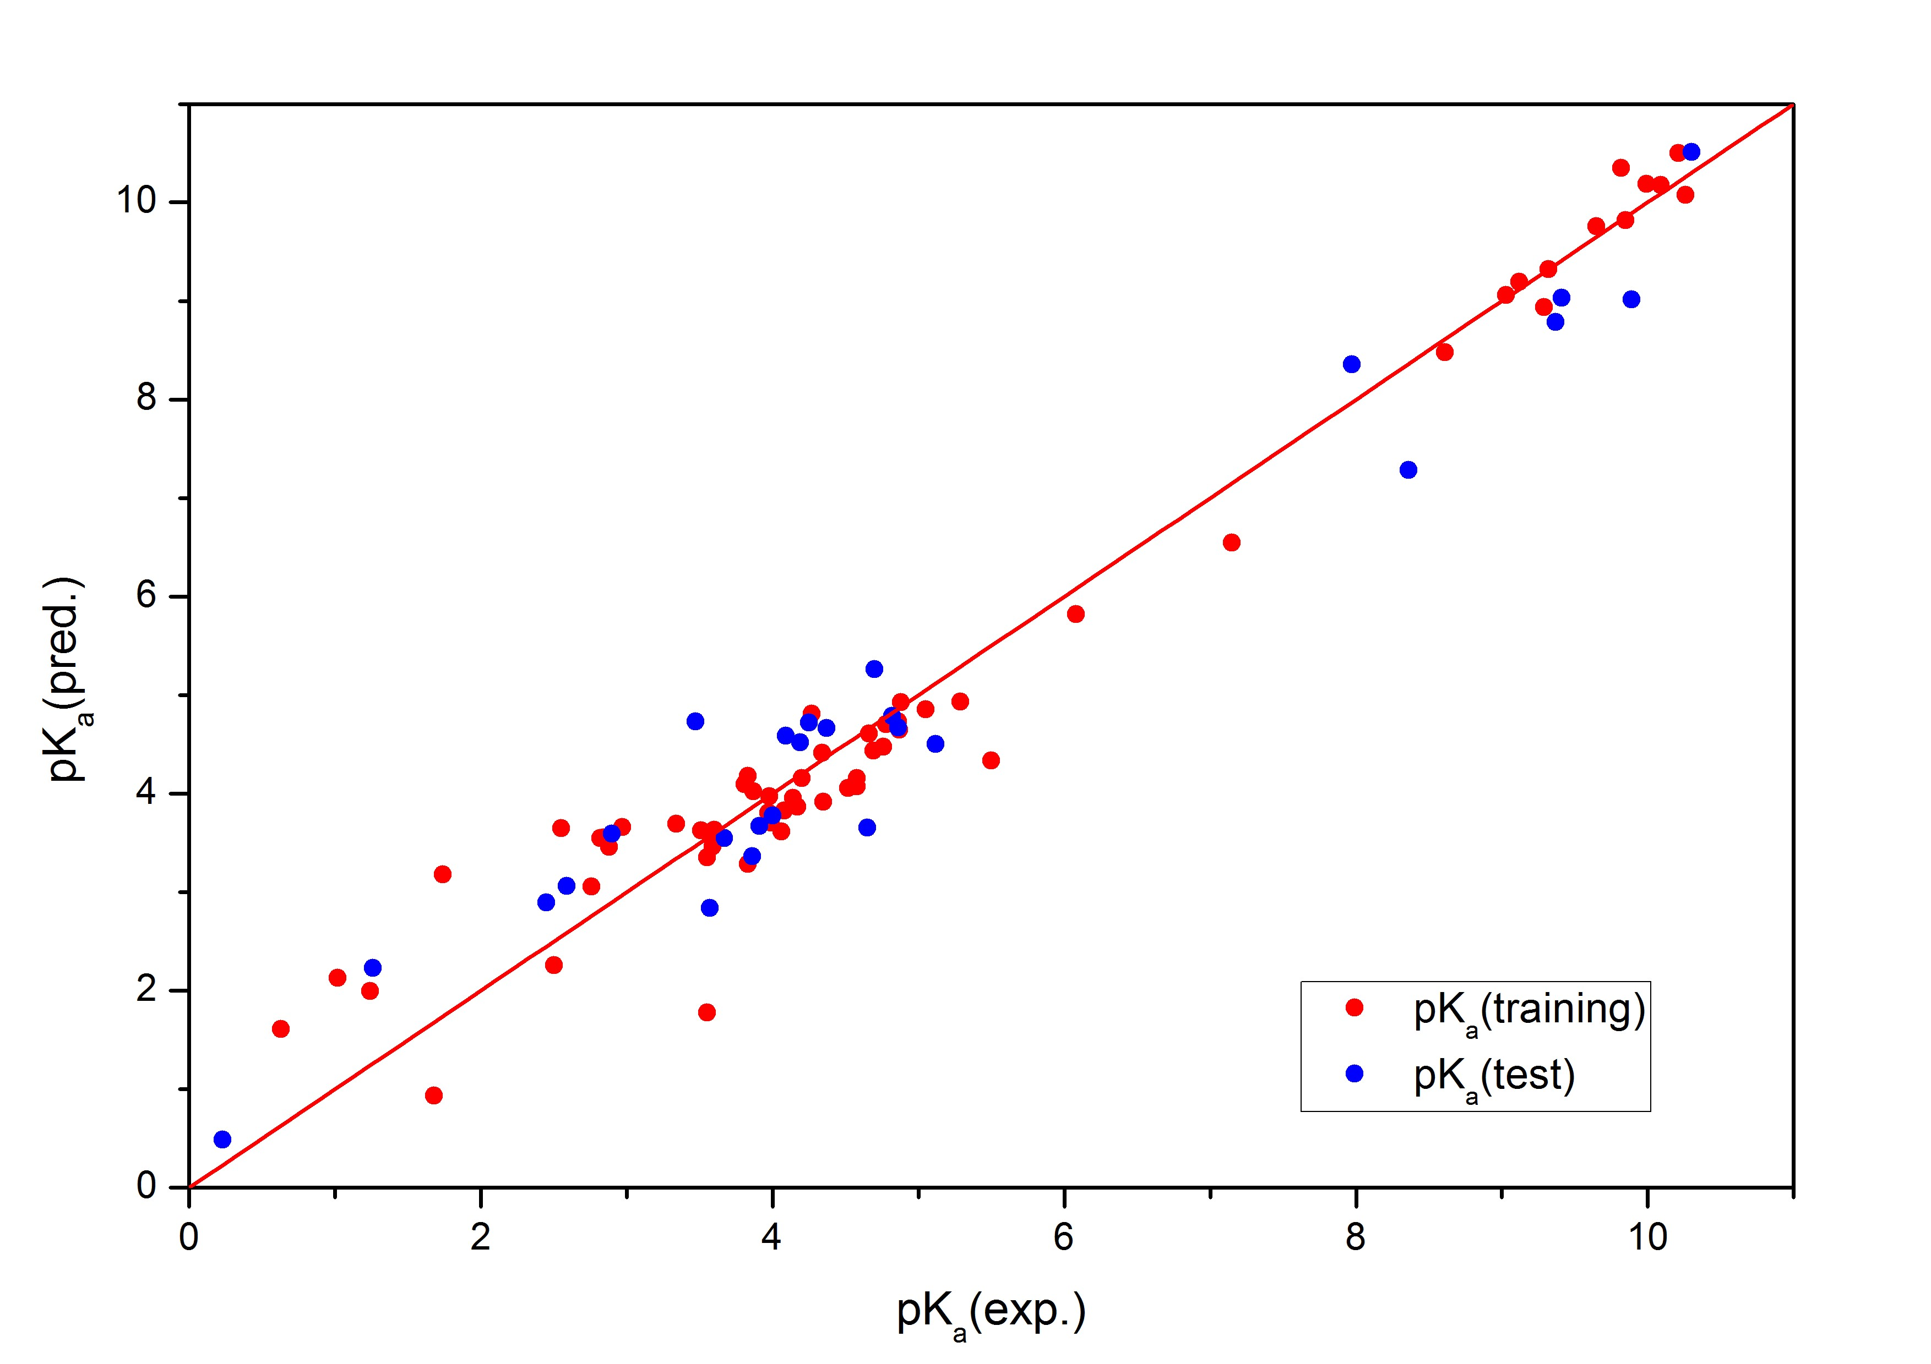
Figure 6. Predicted versus experimental pK_{a} values^{12,13} for training and testing sets of molecules.

Some deviations are present in the case of dicarboxylic aliphatic acids, so they were excluded from the set for model construction. Using a more complicated calculation method does not notably improve the correlation. R² has the same value (0.96) for the models with V_{max} from AM1, HF or B3LYP methods. A slight distinction between models can be seen from the quality of prediction for test set of molecules. Q² parameter for the models with V_{max} from AM1, HF or B3LYP methods has the values 0.95, 0.92 and 0.92 respectively. Calculated parameters and the equation of the model for the simplest computational method are in the Table 1.

Table 1. Coefficients of the model for pK_{a} prediction with V_{max}(AM1) and its statistical parameters.
model | coefficient | standard deviation |  | set of  compounds | validation  parameter
N₀ | 30.2 | ± 1.5 |  | set of  compounds | validation  parameter
V_{max}(AM1) | – 0.0438 | ± 0.0032 |  | training | R² = 0.96
N_{COO} | – 5.16 | ± 0.18 |  | testing | Q² = 0.95
N_{NH4+} | 18.5 | ± 1.7
$${pK}_{a}\left(pred.\right)= –0.0438 V_{max}-5.16 N_{COO}+18.5 N_{NH_{4}^{+}}+30.2$$

Conclusions
Good correlations were obtained between the maxima of molecular electrostatic potential and pK_{a} values for anilines and phenols. With the inclusion of certain physico-chemical descriptors, it was possible to unify the correlation between chemical descriptors and pK_{a} for different types of molecules with a single model function. The correlation is satisfying even with the simplest quantum mechanical calculation methods (semi-empirical method AM1).

References
1 | J. S. Murray, K. Sen (Eds.): Molecular electrostatic potentials: concepts and applications, Elsevier, Amsterdam, Netherlands, 1996.
2 | P. Politzer, D. G. Truhlar (Eds.): Chemical application of atomic and molecular electrostatic potentials, Plenum, New York, 1981.
3 | E. Scrocco, J. Tomasi, Adv. Quantum Chem. 1978, 11, 115–193.
4 | P. Sjoberg, P. Politzer, J. Phys. Chem. 1990, 94, 3959–3961.
5 | P. Politzer, P. R. Laurence, K. Jayasuriya, Environ. Health Persp. 1985, 61, 191–202.
6 | U. A. Chaudry, P. L. A. Popelier, J. Org. Chem. 2004, 69, 233–241.
7 | J. Cerar, Č. Podlipnik, Acta Chim. Slov. 2008, 55, 999–1008.
8 | S. Liu, L. G. Pedersen, J. Phys. Chem. A 2009, 113, 3648–3655.
9 | Y. Ma, K. C. Gross, C. A. Hollingswort–-239.
10 | T. A. Halgren, J. Comp. Chem. 1996, 17, 490–519.
11 | A. R. Leach: Molecular Modelling, principles and aplications; Pearson Education Limited, Essex, United Kingdom, 2001; pp 189–191.
12 | A. Albert, E. P. Serjeant: Ionization constants of acids and bases, Methuen, London, United Kingdom, 1962.
13 | D. D. Perrin, (Ed.): Dissociation constants of organic bases in aqueous solution, Butterworths, London, United Kingdom, 1965.
14 | W. H. Press, S. A. Teukolsky, W. T. Vetterling, B. P. Flannery: Numerical recipes in C, Cambridge Universitys Press, Cambridge, United Kingdom, 1992, pp 680–706.
15 | P. J. M. van Laarhoven, E. H. L. Aarts (Eds.): Simulated annealing: theory and application, Springer Science and Business Media. Dordrecht, Netherlands. 1987.

