Graphical Abstract

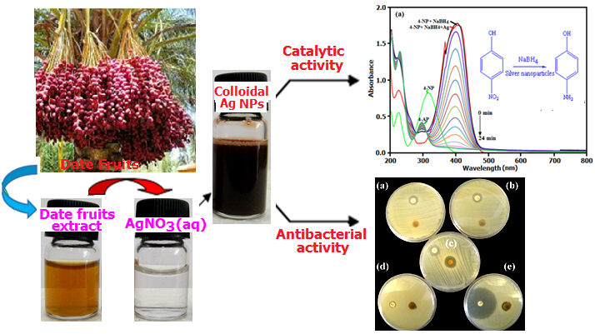 | Green Biosynthesis of Spherical Silver Nanoparticles by Using Date Palm (Phoenix Dactylifera) Fruit Extract and Study of Their Antibacterial and Catalytic Activities  Saeed Farhadi∗, Bahram Ajerloo, Abdelnassar Mohammadi

