Disintegrins from the venom of Vipera ammodytes ammodytes efficiently inhibit migration of breast cancer cells

Zorica Latinović^{a,b}, Adrijana Leonardiª, Toni Petanª, Margareta Žlajpahª and Igor Križaj^{a,c*}

ªDepartment of Molecular and Biomedical Sciences, Jožef Stefan Institute, Jamova cesta 39, Ljubljana, Slovenia;
^{b}Jožef Stefan International Postgraduate School, Jamova cesta 39, Ljubljana, Slovenia;
^{c}Faculty of Chemistry and Chemical Technology, Večna pot 113, University of Ljubljana, Ljubljana, Slovenia.

“For Cutting Edge 2017”

*Corresponding author: Department of Molecular and Biomedical Sciences, Jožef Stefan Institute, Jamova 39, 1000 Ljubljana, Slovenia.
E-mail address: igor.krizaj@ijs.si
Phone: +386 1 477 3626. Fax: +386 1 477 3984.

ABSTRACT

Integrins are plasma membrane proteins, dysfunction frequently result in cancer pathology, so they represent important targets of anti-tumor therapy. Snake venoms are known source of disintegrins (Dis), proteins that specifically bind integrins and thus interfere with their functions. In attempts to discover new molecules for treatment of breast cancer, the leading type of cancer in women, we isolated from the venom of the nose-horned viper a dimeric Dis (Vaa-Dis). By cell viability testing we demonstrated that 50 nM and higher concentrations of Vaa-Dis were are toxic to the highly invasive human breast adenocarcinoma cell line MDA-MB-231. Wound-healing assays revealed that one order of magnitude lower concentrations (2.5 nM) of Vaa-Dis efficiently inhibit MDA-MB-231 cell migration. This exposes a high anti-metastatic potential of Vaa-Dis, giving a perspective for further research and development of this natural snake venom protein towards a new drug candidate for breast cancer treatment.

Keywords: snake venom, disintegrin, integrin, cancer, metastasis, drug

- INTRODUCTION
Cancer, one of the deadliest diseases worldwide, is caused by inherited or acquired mutations of the genetic material. The main characteristics of cancer include sustaining proliferative signalling, evading growth suppressors, resisting cell death, enabling replicative immortality, inducing angiogenesis, and activating invasion and metastasis. Such properties enable cancer cells an unlimited growth and spreading, invasion through the organism and finally causing its death.¹ Prevention of metastatic growth is an efficient therapy in cancer control. The key roles in the process of migration and cell viability are played by transmembrane proteins called integrins.^{1,2}
Integrins are cell adhesion receptors on the cells’ surface that bind components of the extracellular matrix (ECM), various biological ligands and receptors on adjacent cells. They are heterodimeric proteins consisting of one α- and one ß-subunit. 18 different α-subunits and 8 ß- subunits are known, which have been found to appear in 24 different α-ß combinations, each of them possessing unique binding specificity.² Recent studies have exposed integrins as important factors in tumour cell survival, tumour growth and metastasis by establishing and breaking bonds between malignant cells and molecules in their surroundings. For this reason, integrins have become important targets of anti-tumour therapy.² Despite the fact that several therapeutics, integrin antagonists, have already been developed, a search for more efficient integrin-binding substances continues.^{2–4}
Snake venom (SV) proteins are broadly investigated as substances that can be used in diagnosis and treatment of human diseases. Among them, disintegrins (Dis) have been found to inhibit various cell functions by their interaction with different integrins, for example platelet aggregation, angiogenesis, tumour growth and metastasis.⁵ Dis are non-enzymatic cysteine-rich polypeptides. Their molecular mass ranges between 4 kDa and 15 kDa, they can be directly synthesized or formed by proteolysis of the P-II class metalloproteinases (MPs). SV Dis can be monomeric or dimeric, hetero- or homodimeric. In dimeric Dis, individual subunits are interconnected by disulphide bonds, which is crucial for stability and maintenance of a distinct globular structure. It also defines the configuration of the so called inhibitory loop, essential for the interaction with integrin receptor and, consequently, the biological activity.^{6,7}
In this work we focused on Dis proteins from the venom Vipera ammodytes ammodytes (Vaa-Dis). They were purified and biochemically characterized. Moreover, we investigated their influence on cell viability and in vitro migration in a model of highly invasive triple-negative breast cancer. The discovered potent ability to inhibit the migration of cancer cells qualifies Vaa-Dis as an original lead for the development of new anti-cancer drugs.

- MATERIAL AND METHODS

  - Purification of Vaa-Dis

Raw Vaa venom was obtained from the Institute of Immunology, Zagreb, Croatia. Lyophilized venom was stored at −20 °C and before use dissolved in 50 mM Tris, 2 mM CaCl₂, 300 mM NaCl, pH 7.0 (buffer A). 250 μl of the raw Vaa venom solution (16.67 mg) was applied on a Superdex 75 column 10/300 (GE Healthcare BioSciences AB, Sweden), equilibrated in buffer A and attached on a FPLC ÄKTA system (Amersham Biosciences, UK). Gel chromatography was performed at a constant flow rate of 0.5 ml/min. Concentration of proteins in the mobile phase was followed by measuring the absorbance at 280 nm (A₂₈₀). The B2 fraction was dialysed against 20 mM MES, 2 mM CaCl₂, pH 6.5 (buffer B) and further fractionated on a SP Sepharose Fast Flow column (GE Healthcare BioSciences AB, Sweden). Bound material was eluted by addition of 500 mM NaCl in buffer B. The material not retained by the cation-exchanger was collected and separated by reverse phase-high performance liquid chromatography (RP-HPLC) on a PLRP-S column (4.6 mm x 150 mm; 2.7 μm; 120 Å, Agilent Technologies, USA), equilibrated with 0.1% (v/v) trifluoroacetic acid (TFA) in water (solvent A), at a flow rate of 1 ml/min. The proteins were eluted from the column with a gradient of solvent B (90% (v/v) acetonitrile in 0.1% (v/v) TFA in water) as follows: 0–45% in 13 min and 45–55% in 10 min. A₂₁₅ was monitored to locate proteins in fractions, which were collected manually. Samples were dried using a vacuum concentrator SpeedVac (Savant, USA).

  - SDS-PAGE analysis

Venom samples were analysed using 15% (m/v) polyacrylamide gels in the presence of SDS (SDS-PAGE) under non-reducing and reducing conditions according to Laemmli.⁸ Proteins in gels were visualized by PageBlueTM (Thermo Scientific, USA) as instructed by the manufacturer. Molecular mass standards were from Fermentas (Lithuania).

  - N-terminal amino acid sequence analysis

Proteins were N-terminally sequenced by automated Edman degradation on a Procise 492A protein sequencing system (Applied Biosystems, USA).

  - Culturing of MDA-MB-231 cells

To carry out the migration assays the highly invasive breast cancer cell line MDA-MB-231 (ATCC, USA) was used. Cells were grown in RPMI-1640 medium (Invitrogen, USA) supplemented with 10% (v/v) fetal bovine serum (FBS) at 37°C in an atmosphere of 5% (v/v) CO₂. Adherent cell monolayers were routinely cultured in T25 and T75 tissue culture flasks (Corning, USA) and passaged in ratios of 1 : 3 to 1 : 4.

  - Cell viability testing

The in vitro cytotoxic potency of Vaa-Dis was evaluated using the PrestoBlueTM viability assay (Invitrogen, USA) essentially as described previously.⁹ Cells were trypsinized and counted by Trypan blue (Thermo Scientific, USA) exclusion assay¹⁰ using a hemocytometer (Fortuna, Germany). Cells were seeded in 96-well plates (TPP, Switzerland) at a density of 5000 cells/well in 100 μL RPMI-1640 medium and left to attach overnight. Cells were then treated with different concentrations of Vaa-Dis (0.005; 0.05; 0.5; 5; 50; 500 nM) for 0, 24, 48, and 72 h. After the treatment, 10 μL of PrestoBlueTM was added to each well, and the plates were incubated for 30 min at 37 °C. Cell supernatants were transferred to black microtiter plates (Corning, USA) and fluorescence was measured at an excitation of 560 nm and emission of 590 nm on an Infinite M1000 microplate reader (Tecan, Switzerland) to determine metabolic activity of the cells. Wells containing only the cell culturing medium and PrestoBlueTM were used as blank reference standards. Experiments were performed in triplicate. The normalization of cell viability was calculated as the ratio of sample absorbance to control absorbance (cells in media without Vaa-Dis).

  - Wound-healing assay

The wound-healing assay (WHA) was used to estimate the anti-migratory potency of Vaa-Dis. MDA-MB-231 cells were trypsinized, counted as specified above and plated in 48-well cell culture dishes (TPP, Switzerland) at a density of 2 × 10⁵ cells/well. Wounds (millimetre gaps) were then scratched in each cell monolayer using a pipette tip. Dead cells were removed by washing with D-PBS buffer and solutions of Vaa-Dis in RPMI-1640/10% FBS at different concentrations (2.5, 5.0, 7.5 and 15.0 nM) were added. Control samples contained only media. The influence of Vaa-Dis on cell migration was determined by observing the width of the gap under a CKX41 inverted microscope equipped with an E-450 camera (Olympus, Japan) after 1 h, 6 h, 12 h and 24 h of incubation. The gap was analysed using the ImageJ software (Softonic International S.A., Spain). The width of the gap was measured in three different wells for each concentration and incubation time.

- RESULTS AND DISCUSSION

Using gel-filtration chromatography we separated in the first step the raw venom of Vaa into seven fractions (A–F in Fig. 1A). The efficient inhibition of platelet aggregation induced by ADP or collagen by the gel filtration fraction B2 has been suggested to be due to the presence of Dis, which may obstruct this process by binding to α_{IIb}β₃ fibrinogen receptor.¹¹ For this reason, we decided to analyse the fraction B2 further and split it on a strong cation exchanger into a fraction retained by the exchanger (bound) and a flow-through fraction (unbound) (Fig. 1B). The latter was chromatographed on a RP-HPLC column. Vaa-Dis was found in a sharp peak eluting at 40% of solvent B (Fig. 1C). SDS-PAGE analysis of this peak under non-reducing conditions revealed only one protein band of about 17 kDa. Under reducing conditions the protein displayed a lower apparent molecular mass of about 13 kDa (Fig. 1D). This was expected as the usual structure of Viperidae Dis is a cystine-crosslinked dimer,^{6,8} which dissociates to monomers in the presence of reducing agents. The homogeneity of Vaa-Dis sample was inspected by N-terminal amino acid sequencing using Edman degradation. Two N-terminal sequences, NSANP and NSGNP, were obtained, both characteristic for Dis.¹² Considering also the SDS-PAGE analysis, this means that the Vaa-Dis sample did not contain any non-Dis protein. The heterogeneous N-terminal sequence of the sample indicates that Vaa-Dis is either a heterodimer or a mixture of two homodimeric Dis proteins. In support of the latter, Calvete et al. reported about VA6, a homodimeric Dis from the venom of Vipera ammodytes with the N-terminal sequence NSANP.¹² VA6 is an RGD sequence/motif-containing Dis.^{5,10} It has been demonstrated that such Dis efficiently bind to α_{IIb}β₃ receptor on platelets and in this way inhibit platelet aggregation.¹² Therefore, that explains the inhibition of ADP- and collagen-induced platelet aggregation by the Vaa venom gel filtration fraction B2.¹¹
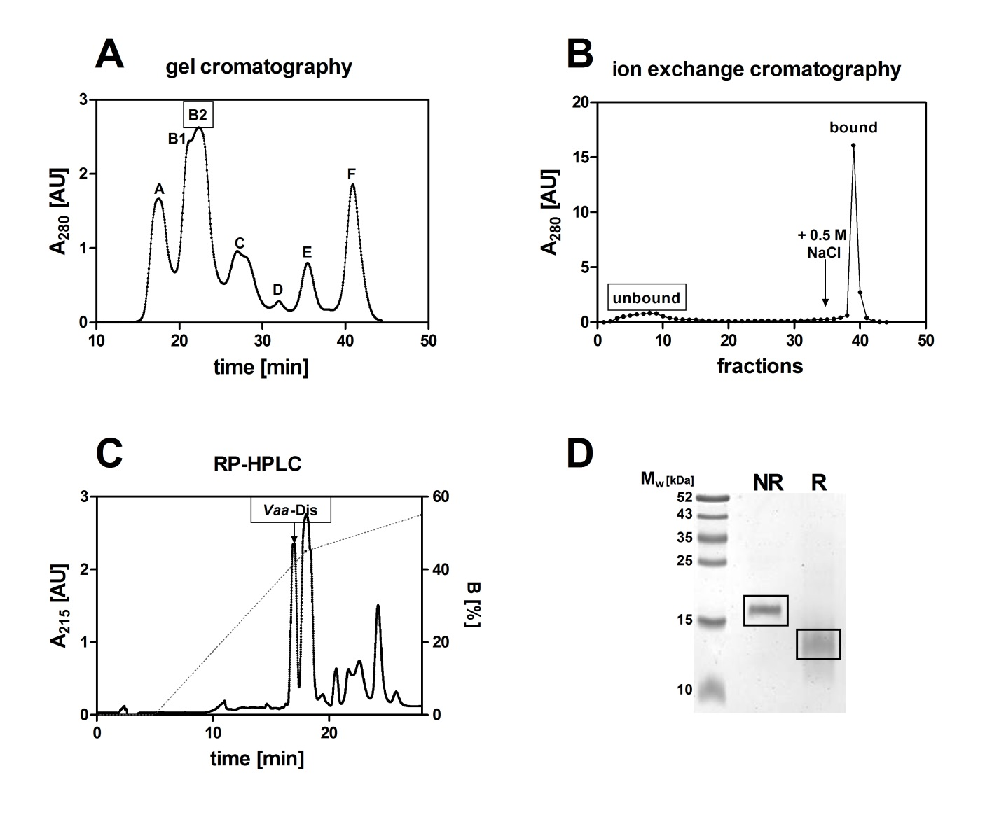
Fig. 1. Purification of Dis from the Vaa venom. (A) Using gel filtration on Superdex 75, the raw venom of Vaa was split to seven fractions. Presence of Dis in fraction B2 was indicated by its strong inhibition of platelet aggregation. ¹⁰ (B) Separation of the gel filtration fraction B2 on the SP Sepharose Fast Flow column to column-bound and unbound part. (C) RP-HPLC analysis of the proteins not retained by the SP Sepharose on the PLPR-S column. Vaa-Dis eluted from the column at 40% of solvent B (90% (v/v) acetonitrile in 0.1% (v/v) TFA in water). Dotted line designates the gradient, while full line the absorbance. (D). SDS-PAGE analysis of Vaa-Dis under non-reducing (NR) or reducing (R) conditions revealed the presence of only one protein band. The gel was stained by PageBlueTM.
Some RGD-containing Dis have been demonstrated to inhibit α_{v}ß₃ (vitronectin receptor)-mediated migration of endothelial and cancer cells – two examples of such SV Dis are triflavin and DisBa-01.¹³ As one of our main research topics is discovering new substances to oppose breast cancer, a major cause of death in women population worldwide,¹⁴ the possibility that Vaa-Dis also affects the migration of cancer cells directed our subsequent experiments. We study metastatic breast cancer on a model cell line, highly invasive human breast adenocarcinoma MDA-MB-231 cells. We found that Vaa-Dis is not cytotoxic to these cells at concentrations lower than 50 nM (Fig. 2A). At 50 nM and higher concentrations, Vaa-Dis induced a significant drop in cell viability, possibly by effecting proliferation and/or dying of the cells. Both processes are namely regulated via integrins,^{2,4} which are present in higher amounts in cancer cells than in the healthy cells.⁵ The level of expression of integrins α_{v}ß₃, α_{v}ß₅, α₅ß₁, α₆ß₄, α₄ß₁ and α_{v}ß₆ has been found in positive correlation with the ability of cells to migrate.¹³ In MDA-MB-231 cells the integrin α_{v}ß₅ and α_{v}ß₃ are particularly highly expressed.¹³ Drugs should not be toxic to healthy cells therefore the effect of Vaa-Dis on migration of cancer cell was evaluated at sub-cytotoxic concentrations of Vaa-Dis. As evident from the WHA results presented in Fig. 2B, Vaa-Dis significantly slowed down the in vitro migration of MDA-MB-231 cells already at a concentration of 2.5 nM, well below concentrations at which it induced cytotoxic effects (Fig. 2A).
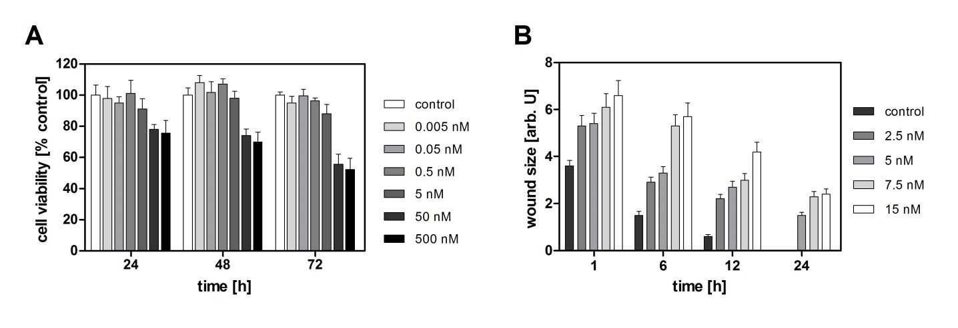
Fig. 2. Effects of Vaa-Dis on breast cancer cells. (A) As established by PrestoBlueTM cell viability testing, the cytotoxicity of Vaa-Dis for MDA-MB-231 cells is evident at 50 nM and higher concentrations. (B) The wound-healing assay on MDA-MB-231 cells was performed in the presence of Vaa-Dis at concentrations, which did not affect cell viability. Each result is an average of three independent experiments ± SEM. Units are arbitrary (arb. U).

- CONCLUSIONS

We have described the isolation and characterisation of novel Dis from the venom of Vaa. Due to a potent anti-migratory activity, Vaa-Dis is very promising for further research and development towards a new drug for breast cancer therapy.

- REFERENCES
1. D. Hanahan, R. A. Weinberg, Cell. 2011, 144, 646–674.
2. L. Seguin, J. S. Desgrosellier, S. M. Weis, D. A. Cheresh, Trends Cell Biol. 2015, 25, 234–40.
3. A. M. Alizadeh, S. Shiri, S. Farsinejad, Tumour Biol. 2014, 35, 8483–8523.
4. J. S. Desgrosellier, D. A. Cheresh, Nat. Rev. Cancer 2010, 10, 9–22.
5. J. K. Arruda Macêdo, J. W. Fox, M. de Souza Castro, Curr. Protein Pept. Sci. 2015, 16, 532–548.
6. J. J. Calvete, Toxicon 2013, 62, 40–49.
7. J. J. Calvete, L. Sanz, P. Cid, P. de la Torre, M. Flores-Díaz, M. C. Dos Santos, A. Borges, A. Bremo, Y. Angulo, B. Lomonte, A. Alape-Girón, J. M. Gutiérrez, J. Proteome Res. 2010, 9, 528–544.
8. U. K. Laemmli, Nature 1970, 227, 680–685.
9. A. Pucer, V. Brglez, C. Payré, J. Pungerčar, G. Lambeau, T. Petan, Mol. Cancer. 2013, 12, 111.
10. W. Strober, Curr. Protoc. Immunol. 2001, Appendix 3, Appendix 3B.
11. T. Sajevic, A. Leonardi, I. Krizaj, Toxin Rev. 2013, 9543, 1–4.
12. J. J. Calvete, M. P. Moreno-Murciano, R. D. G. Theakston, D. G. Kisiel, C. Marcinkiewicz, Biochem. J. 2003, 372, 725–734.
13. H. S. Selistre-de-Araujo, C. L. S. Pontes, C. F. Montenegro, A. C. B. M. Martin, Toxins (Basel), 2010, 2, 2606–2621.
14. R. D. Baird, C. Caldas, BMC Med. 2013, 11, 151.

