Synthesis and Structural Evaluation of 5-Methyl-6-acetyl Substituted Indole and Gramine

Lovel Kukuljan, Krištof Kranjc,* Franc Perdih*
Faculty of Chemistry and Chemical Technology, University of Ljubljana, Večna pot 113, SI-1000 Ljubljana, Slovenia
E-mail: franc.perdih@fkkt.uni-lj.si; kristof.kranjc@fkkt.uni-lj.si

Abstract
The synthesis and crystal structures of 1-(5-methyl-1H-indol-6-yl)ethan-1-one (7), C₁₁H₁₁NO, and 1-{3-[(dimethylamino)methyl]-5-methyl-1H-indol-6-yl}ethan-1-one (8), C₁₄H₁₈N₂O, are reported. The synthesis is based on the Diels–Alder cycloaddition of a substituted 2H-pyran-2-one derivative, followed by an acid-catalyzed cyclization and concomitant deprotection (the last two steps were carried out as a one-pot domino process) yielding substituted indole 7, which was further derivatized via Mannich reaction to the gramine derivative 8. The structure 7 has a single unique molecule in the asymmetric unit whereas the structure 8 contains four unique molecules in the asymmetric unit. Molecules 7 are linked via N–H···O hydrogen bonds between the secondary amine group and carbonyl moiety of the acetyl group of adjacent molecules, whereas molecules 8 are linked via N–H···N hydrogen bonds between the secondary and tertiary amine groups of adjacent molecules. Both structures are further stabilized by weak C–H···O, C–H···π and π···π interactions.

Keywords: Indoles, Gramines, Crystal structure, Hydrogen bonds, C–H···π interaction, π···π interaction

1. Introduction
Gramine, 3-(N,N-dimethylaminomethyl)indole, is a simple indole derivative with important functions in the plant world. The essential amino acid tryptophan and its derivatives are biosynthesized from gramine. Gramine was isolated for the first time from the giant cane (Arundo donax), has a role as an alkaloid in barley (Hordeum vulgare) and is of importance in many other plants.^{1,2}
Furthermore, gramine represents a valuable precursor for further derivatizations towards other targets, for example for the preparation of 1,3-disubstituted β-carbolines by the reaction of gramines with α-(alkylidenamino)nitriles in the presence of tributylphosphine³ and for the synthesis of the 2-prenyl tryptophan core of the tryprostatins A and B.⁴ For the quaternary gramine derivatives it was shown that they can be used as suitable sources of the 3-methylindole fragment in various diastereoselective alkylations, as recently described by Reinfelds et al.⁵ Gramine has also found utility as a part of N-substituted phosphines that were used as ligands in Suzuki–Miyaura coupling reactions of aryl halogenides, conducted at room temperature in a suitable ionic liquid, thus achieving increased yields in comparison with standard ligands containg amine groups.⁶
Gramine derivatives also possess various biological activites; recently it was found that a gramine derivative (i.e. N-[(1H-indol-3-yl)(pyridin-2-yl)methyl]benzo[d]thiazol-2-amine) having a pyridine and a benzothiazole moiety in its structure selectively inhibits human enterovirus 71 (EV71), a known agent of hand, foot and mouth disease in children associated with severe neurological problems, including death; on the other hand, the parent gramine does not inhibit EV71.⁷
The synthetic approach used toward gramine and its derivatives is most often Mannich reaction⁸ of the corresponding indoles: the position 3 of the indole framework (being the most nucleophilic) attacks an intermediate formed from formaldehyde and a secondary amine. The reaction can be accelerated by the application of suitable additives, Dai et al.⁹ have successfully applied zinc chloride among various other options. Such synthesis generally takes place at room temperature and is finished in a relatively short time (typically 90 min).
The scope of such reaction can be further broadened by the application of various aromatic aldehydes (instead of formaldehyde) and various heterocyclic compounds (instead of secondary amines) as demonstrated by Ke and co-workers.¹⁰ During their synthetic protocol there was no need to use any catalysts or solvents.
Analogues of gramine can be also prepared by the reaction between substituted 1,4-piperazines, 1H-indole and formaldehyde. With such an approach, Köksal Akkoç et al.¹¹ were able to synthesize compounds with increased cytotoxicity against human carcinoma cells compared with the other commercially available agents, such as the standard drug 5-fluorouracil.
Herein we present a straightforward approach towards a substituted gramine based on a Diels–Alder reaction between a corresponding 2H-pyran-2-one (acting as a diene) and a suitable dienophile (i.e. (Z)-1-methoxybut-1-en-3-yne) yielding a cycloadduct that is in the next step transformed into the desired indole, which is further derivatized via Mannich reaction to the substituted gramine.

2. Experimental
2.1. Materials and Measurements
Melting points were determined on a micro hot stage apparatus and are uncorrected. ¹H NMR spectra were recorded with a Bruker Avance DPX 300 spectrometer at 29 °C and 300 MHz using Me₄Si as an internal standard. IR spectra were obtained with a Bio-Rad FTS 3000MX as KBr pellets. MS spectra were recorded with a VG-Analytical AutoSpec Q instrument. Elemental analyses (C, H, N) were performed with a Perkin Elmer 2400 Series II CHNS/O Analyzer. TLC was carried out on Fluka silica-gel TLC-cards. All reagents and solvents were used as received from commercial suppliers.
Starting N-{5-acetyl-2-[(Z)-2-methoxyethenyl]-4-methylphenyl}benzamide (5) was prepared via Diels–Alder cycloaddition of (Z)-1-methoxybut-1-en-3-yne (4) on N-(5-acetyl-6-methyl-2-oxo-2H-pyran-3-yl)benzamide (3) as described previously.¹² Commercially is 4 available as a 50% methanol solution and has to be distilled under vacuum prior to use; the distillation of a mixture of 7 mL of commercial 4 and 5 mL of isopentanol at 360 mbar starts at 45 °C: the first fraction is methanol, the second (distilling at 90 °C) is pure 4 (a pale yellow liquid with a characteristic odour). Purified 4 has a limited shelf life even when stored in dark at –20 °C.

Synthesis of 1-(5-Methyl-1H-indol-6-yl)ethan-1-one (7)
To a solution of N-{5-acetyl-2-[(Z)-2-methoxyethenyl]-4-methylphenyl}benzamide (5) (0.309 g, 1 mmol) in acetonitrile (10 mL) hydrochloric acid (5%, 0.25 mL) was added. The mixture was stirred for 18 h at room temperature, thereafter neutralized with NaOH (0.113 g, 2.825 mmol dissolved in 4 mL of water). The resulting mixture was heated under reflux for 1 h, cooled to room temperature and extracted with EtOAc (2×20 mL). Combined organic phases were washed with water (3×10 mL), dried over anhydrous Na₂SO₄ and volatile components evaporated under reduced pressure yielding 0.148 g (86%) of the title product 7. M.p. 139–141 °C (EtOAc). IR (KBr) 3318, 1642, 1619, 1559, 1492, 1435, 1418, 1301 cm^{–1}. ¹H NMR (300 MHz, CDCl₃) δ 2.636 (s, 3H, Me), 2.639 (s, 3H, Me), 6.50 (m, 1H, 3-H), 7.34 (m, 1H, 2-H), 7.47 (s, 1H, 7-H), 7.84 (s, 1H, 4-H), 8.38 (s, 1H, NH). MS (ESI+) m/z 174 (MH⁺). Anal. calcd. for C₁₁H₁₁NO: C, 76.28; H, 6.40; N, 8.09. Found: C, 76.11; H, 6.11; N, 8.07.

Synthesis of 1-{3-[(Dimethylamino)methyl]-5-methyl-1H-indol-6-yl}ethan-1-one (8)
To a mixture of 1-(5-methyl-1H-indol-6-yl)ethan-1-one (7) (0.285 g, 1.646 mmol) and ethanol (6 mL) the following were added: 60% aqueous solution of dimethylamine (0.186 g, 1.5 eq.), anhydrous ZnCl₂ (0.339 g, 1.5 eq.) and 35% aqueous solution of formaldehyde (0.230 g, 1.5 eq.). The resulting suspension was stirred at room temperature for 3 h. Thereafter, aqueous NaOH (5%, 5 mL) was added to the reaction mixture and undissolved material was filtered off. The undisolved material was disposed, whereas the filtrate was extracted with EtOAc (2×10 mL). Combined organic phases were evaporated under reduced pressure, the remaining material was treated with water (3 mL) and aqueous HCl was added (5%, 2 mL). Thus precipitated unreacted indole was removed by filtration, the remaining clear filtrate was treated with aqueous NaOH (5%, 2 mL) causing new precipitate to appear. The resulting suspension was extracted with Et₂O (4×5 mL) and combined organic phases were dried over anhydrous MgSO₄. The solvent was left to evaporate and the yellow crystals formed were collected and re-crystallized from EtOAc affording 0.136 g (36%) of the title product 8. M.p. 126–128 °C (EtOAc). IR (KBr) 2789, 1669, 1620, 1467, 1449, 1356, 1241, 1203 cm^{–1}. ¹H NMR (300 MHz, CDCl₃) δ 2.29 (s, 6H, NMe₂), 2.59 (s, 3H, Me), 2.62 (s, 3H, Me), 3.61 (s, 2H, CH₂), 7.22 (m, 1H, 2-H), 7.49 (s, 1H, 7-H), 7.73 (s, 1H, 4-H), 8.88 (s, 1H, NH). MS (ESI+) m/z 231 (MH⁺). Anal. calcd. for C₁₄H₁₈N₂O: C, 73.01; H, 7.88; N, 12.16. Found: C, 73.16; H, 8.18; N, 12.21.

2.2. Crystallography
Single-crystal X-ray diffraction data were collected at room temperature on an Agilent Technologies SuperNova Dual diffractometer using Cu-Kα radiation (λ = 1.54184 Å). The data were processed by CrysAlis Pro.¹³ Structures were solved by direct methods implemented in Superflip¹⁴ and refined by a full-matrix least-squares procedure based on F² using SHELX2014.¹⁵ All non-hydrogen atoms were refined anisotropically. Hydrogen atoms were readily located in a difference Fourier maps and were subsequently treated as riding atoms in geometrically idealized positions, with C–H = 0.93 (aromatic), 0.97 (methylene) or 0.96 Å (CH₃), N–H = 0.86 Å and with U_{iso}(H) = kU_{eq}(C or N), where k = 1.5 for methyl groups, which were permitted to rotate but not to tilt, and 1.2 for all other H atoms. Crystallographic data are listed in Table 1.

Table 1. Crystal data and refinement parameters for the compounds 7 and 8.
Compound | 7 | 8
CCDC | 1503990 | 1503991
Molecular formula | C₁₁H₁₁NO | C₁₄H₁₈N₂O
Molecular weight | 173.21 | 230.30
Crystal system | Orthorhombic | Monoclinic
Space group | P c a 2₁ | P 2₁
Temperature (K) | 293(2) | 293(2)
a (Å) | 18.2632(7) | 9.0846(2)
b (Å) | 5.2027(2) | 21.4971(2)
c (Å) | 9.4496(3) | 13.0190(2)
α (°) | 90 | 90
β (°) | 90 | 90.106(2)
γ (°) | 90 | 90
V (Å³) | 897.88(6) | 2542.51(7)
Z | 4 | 8
D_{calc} (g cm^{–3}) | 1.281 | 1.203
Absorption coefficient (mm^{–1}) | 0.656 | 0.604
F(000) | 368 | 992
Crystal dimensions (mm) | 0.30 × 0.20 × 0.03 | 0.60 × 0.40 × 0.08
Reflections collected | 1994 | 49717
Independent reflections | 1280 [R_{int} = 0.0199] | 9657 [R_{int} = 0.0461]
Data / restraints / parameters | 1280 / 1 / 121 | 9657 / 1 / 630
R₁, wR₂ [I > 2σ(I)]ª | 0.0320, 0.0831 | 0.0467, 0.1403
R₁, wR₂ (all data)^{b} | 0.0361, 0.0885 | 0.0491, 0.1431
Goodness of fit on F², S^{c} | 1.142 | 1.047
Extinction coefficient | 0.0110(16) | 0.0038(4)
Largest diff. peak and hole (e Å^{–3}) | 0.124 and –0.096 | 0.265 and –0.155
ª R = ∑||F_{o}| – |F_{c}||/∑|F_{o}|. ^{b} wR₂ = {∑[w(F_{o}² – F_{c}²)²]/∑[w(F_{o}²)²]}^{1/2}. ^{c} S = {∑[(F_{o}² – F_{c}²)²]/(n/p)}^{1/2} where n is the number of reflections and p is the total number of parameters refined.

Table 2. Hydrogen bond and CH···π geometry of 7 and 8 (Å and °).
D–H···A | D–H (Å) | H···A (Å) | D···A (Å) | D–H···A (°) | Symmetry code
7
N1–H1···O1 | 0.86 | 2.04 | 2.893(3) | 174.2 | –x + ½, y + 1, z + ½
C11–H11C···O1 | 0.96 | 2.56 | 3.513(4) | 171.2 | x, y + 1, z
C9–H9A···Cg2 | 0.96 | 2.90 | 3.688(3) | 140 | x, y – 1, z
8
N1–H1···N4 | 0.86 | 2.10 | 2.936(4) | 165.1 | x – 1, y, z
N3–H3···N2 | 0.86 | 2.15 | 2.983(4) | 163.7 | x, y, z
N5–H5···N8 | 0.86 | 2.11 | 2.951(4) | 164.6 | x, y, z
N7–H7A···N6 | 0.86 | 2.14 | 2.978(4) | 164.4 | x + 1, y, z
C38–H38A···O1 | 0.96 | 2.58 | 3.392(5) | 142.6 | –x, y – ½, –z + 1
C42–H42A···O4 | 0.96 | 2.51 | 3.407(5) | 154.8 | –x + 1, y + ½, –z + 1
C56–H56B···O1 | 0.96 | 2.51 | 3.358(6) | 146.6 | –x + 1, y – ½, –z + 1
C1–H1A···Cg5 | 0.93 | 2.90 | 3.743(4) | 151 | x – 1, y, z
C15–H15···Cg2 | 0.93 | 2.88 | 3.715(4) | 150 | x, y, z
C29–H29···Cg11 | 0.93 | 2.81 | 3.668(4) | 154 | x, y, z
C43–H43···Cg8 | 0.93 | 2.82 | 3.680(4) | 154 | x + 1, y, z
Cg2, Cg5, Cg8 and Cg11 are C3–C8, C17–C22, C31–C36 and C45–C50 ring centroids.

3. Results and Discussion
3.1. Synthesis
The synthetic approach presented herein is based on our previous experience with Diels–Alder reactions of 2H-pyran-2-one derivatives (used as dienes) with various dienophiles.^{16–21} Here we applied (Z)-1-methoxybut-1-en-3-yne (4) as the dienophile cycloadding on 2H-pyran-2-one derivative 3 yielding a crucial intermediate 5, a substituted N-{2-[(Z)-2-methoxyethenyl]phenyl}benzamide (Scheme 1). This intermediate 5 has a strategically positioned methoxy group bound to the ethenyl fragment being in an ortho position to the benzamido group, therefore enabling a straightforward cyclization towards the indole ring (i.e. 6) already under mildly acidic conditions, as described previously.¹² However, an indole 6 obtained in such a way still contains an N-benzoyl protection group that needs to be removed to yield the indole 7. One possibility to achieve this could be the application of aqueous NaOH in a mixture of water and acetonitrile with gentle heating.²²

Scheme 1. Reaction sequence leading to the indole 7 and gramine 8.

On the other hand, our strategy was to combine both steps described above, i.e. the cyclization (5 → 6) and the removal of the N-benzoyl group (6 → 7) into a single step. Even though the first step needs acidic conditions and the second takes place in an alkaline solution, with a suitable choice of reaction parameters we were able to implement both transformations as a one-pot domino procedure. Primary cycloadduct 5, N-{2-[(Z)-2-methoxyethenyl]phenyl}benzamide derivative, was thus dissolved in acetonitrile, aqueous HCl was added and the mixture was stirred at room temperatue; thereafter enough aqueous NaOH was added to neutralize the excess HCl and to increase the pH to an appropriately alkaline value (pH approx. 10) for the deprotection to occur (upon gentle heating). Such approach to 7 shortens the synthetic pathway towards 7 and increases its final yield (86% yield after a one-pot procedure 5 → 7 vs. 71% combined yield over two separate steps).
The starting indole 7 was thereafter derivatized under standard Mannich reaction conditons (with formaldehyde and dimethylamine in ethanol as the solvent and with zinc chloride as the additive)⁸ to form the 6-acetyl-5-methylgramine derivative 8.
2H-Pyran-2-one derivatives 3, necessary for this synthetic approach, can be straightforwardly accessed via a one-pot synthesis starting from the simple commercially available precursors: a carbonyl compound 1 containing an activated CH₂ group (acetylacetone), a C₁-synthon such as N,N-dimethylformamide dimethyl acetal (DMFDMA) and hippuric acid (2) as an N-acylglycine derivative as previously described by Kepe and Kočevar.^{23–25} The synthesis takes place under heating (approx. 90 °C) in acetic anhydride (or in a mixture with acetic acid) as the solvent yielding desired substitued 3-benzoylamino-2H-pyran-2-ones 3.

3.2. Crystal Structures
The structure of 1-(5-methyl-1H-indol-6-yl)ethan-1-one, 7, has a single unique molecule in the asymmetric unit (Figure 1) whereas the structure of 1-{3-[(dimethylamino)methyl]-5-methyl-1H-indol-6-yl}ethan-1-one, 8, contains four unique molecules in the asymmetric unit (Figure 2). All the bond lengths of compounds 7 and 8 are within normal ranges.²⁶

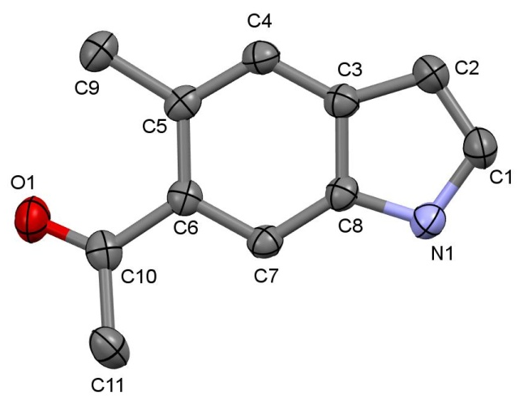
Figure 1. Atom numbering scheme and atom arrangement for 7. Probability ellipsoids are drawn at the 30% level. Hydrogen atoms have been omitted for clarity.

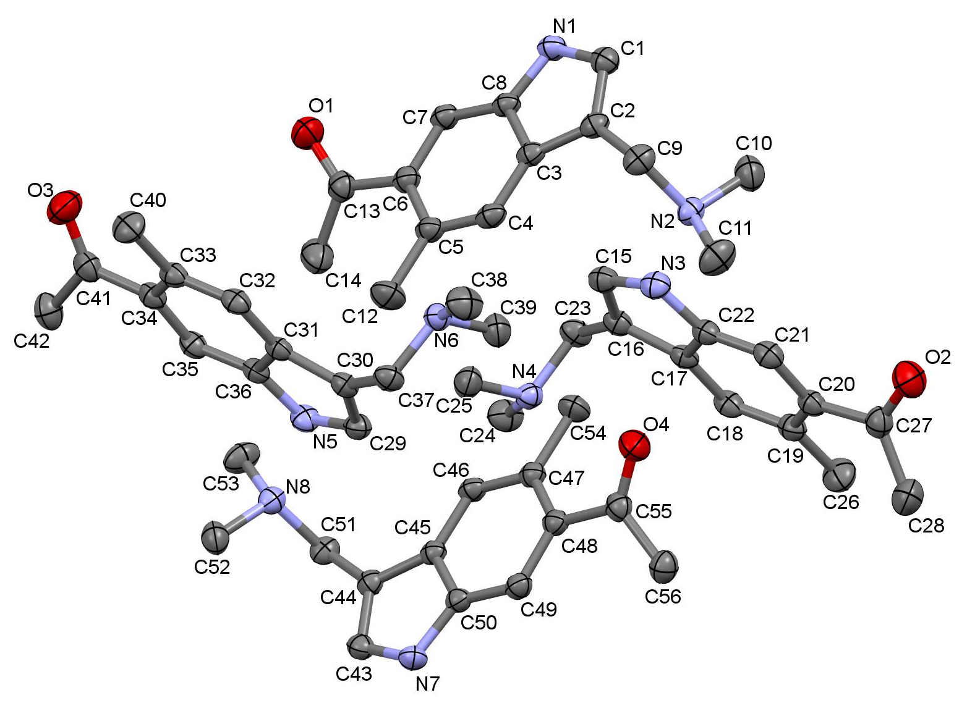
Figure 2. View of unique molecules in the asymmetric unit of 8 with the atom numbering scheme. Probability ellipsoids are drawn at the 30% level. Hydrogen atoms have been omitted for clarity.

In both compounds 7 and 8 the central indole ring is planar. The maximum deviation from the mean plane described by the ring atoms is +0.014(2) and –0.014(2) Å for the C8 and C6 atoms in 7 and in the range +0.019(4) to –0.019(3) Å for four unique molecules in 8. These values are similar to those observed in the analogous series of benzotriazoles.²⁷ The mean plane through the methylcarbonyl group (C6/C10/O1/C11) in 7 is inclined to the indole ring by 13.60(15)° while these angles in four unique molecules of 8 are 35.8(2)°, 36.3(2)°, 28.6(2)° and 32.59(19)°. Such angles in [1-methyl-2-(4-methylphenyl)-1H-indole-4,6-diyl]bis(phenylmethanone) are 22.46 and 32.54°,²⁸ while in N-{2-[6-benzoyl-5-methyl-1-(methylsulfonyl)-1H-indol-2-yl]-4-methylphenyl}methanesulfonamide this angle is much larger being 48.53°.²⁹ The dimethylamino group in 8 is just out of the plane of its attached indole ring as indicated by the C1–C2–C9–N2, C15–C16–C23–N4, C29–C30–C37–N6 and C43–C44–C51–N8 torsion angles of four crystallographically independent molecules in the range 95.0(4)–96.9(4)°. In N,N-dimethyl-1H-indole-3-methanamine,³⁰ 1-[1-(5-bromo-1H-indol-3-yl)ethyl]azepan-2-one monohydrate,³¹ [1-(di-t-butylphosphino)-1H-indol-3-yl]-N,N,N-trimethylmethanaminium iodide³² and N-[(5-bromo-1H-indol-3-yl)methyl]-N,N-dimethylammonium nitrate³³ equivalent torsion angles were found to be similar, with values between 92.42°and 103.70°.
In the crystal structure molecules of 7 are linked via N1–H1···O1(–x + ½, y + 1, z + ½) hydrogen bonding between the NH group of one molecule and carbonyl oxygen of the acetyl moiety of the adjacent molecule into an infinite chain generating the graph set motif C(6)³⁴ (Table 2, Figure 3). These chains are cross-linked into sheets by weak C11–H11C···O1(x, y + 1, z) hydrogen bonding between the hydrogen atom of the acetyl moiety of one molecule and carbonyl oxygen of the other molecule generating the graph set motif C(3). Furthermore, this 2D structure in 7 is stabilized by additional π···π interactions between the five membered pyrrole ring N1/C1–C3/C8 (centroid Cg1) and the six membered C3–C8 ring (centroid Cg2) of the other molecule, with a Cg1···Cg2(x, y + 1, z) centroid-to-centroid distance of 4.3536(16) Å, a dihedral angle between the rings of 0.91(14)°, a perpendicular distance from the centroid Cg1 to the plane of the other ring of 3.5530(12) Å and the angle between the intercentroid vector and the normal to the second ring of 35.30° (Figure 4). According to Janiak,³⁵ this interaction can be regarded as medium-to-weak, since strong interactions exhibit rather short centroid-to-centroid contacts (Cg···Cg < 3.8 Å), small slip angles (< 25°) and small vertical displacements (< 1.5 Å), which translate into a sizeable overlap of the aromatic planes. In comparison, medium-to-weak interactions exhibit rather long centroid-to-centroid distances (> 4.0 Å) together with large slip angles (> 30°) and large vertical displacements (> 2.0 Å).^{35–37} Additional weak C–H···π interactions between C9–H9A···Cg2(x, y – 1, z) with hydrogen-to-centroid distance 3.688(3) Å also stabilize the structure.

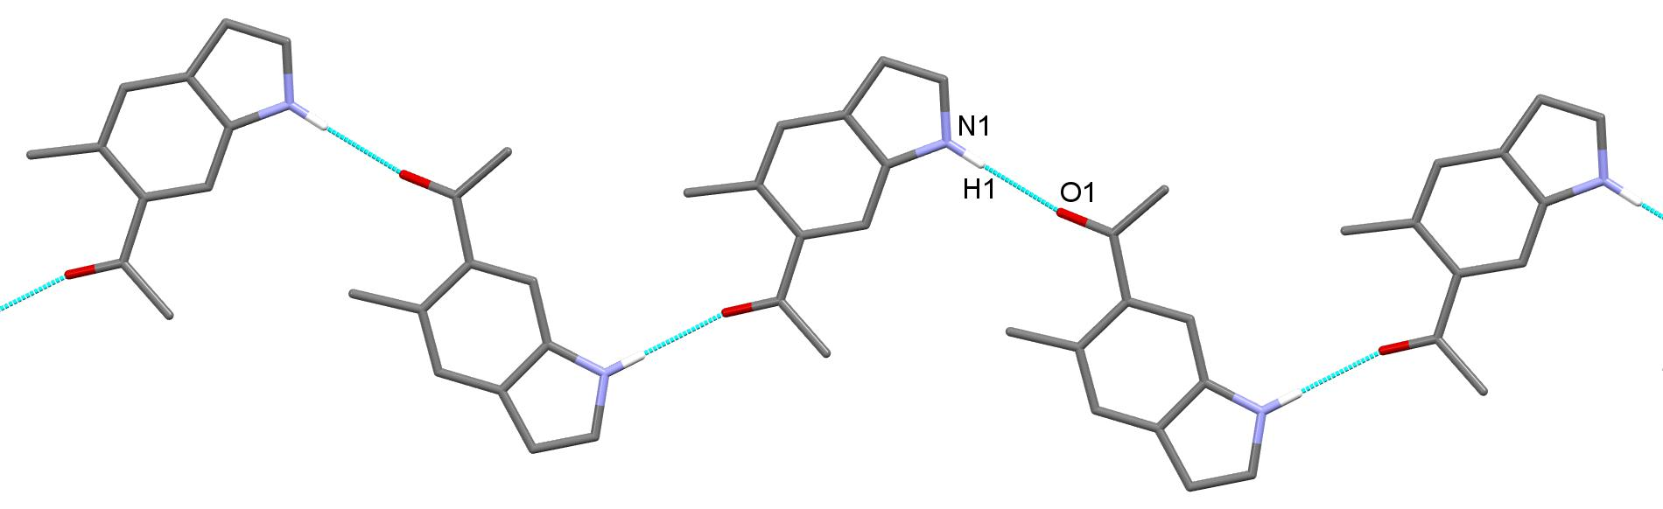
Figure 3. Chain formation via N–H···O hydrogen bonding with graph set motif C(6) in 7. Hydrogen atoms not involved in the motif shown have been omitted for clarity.

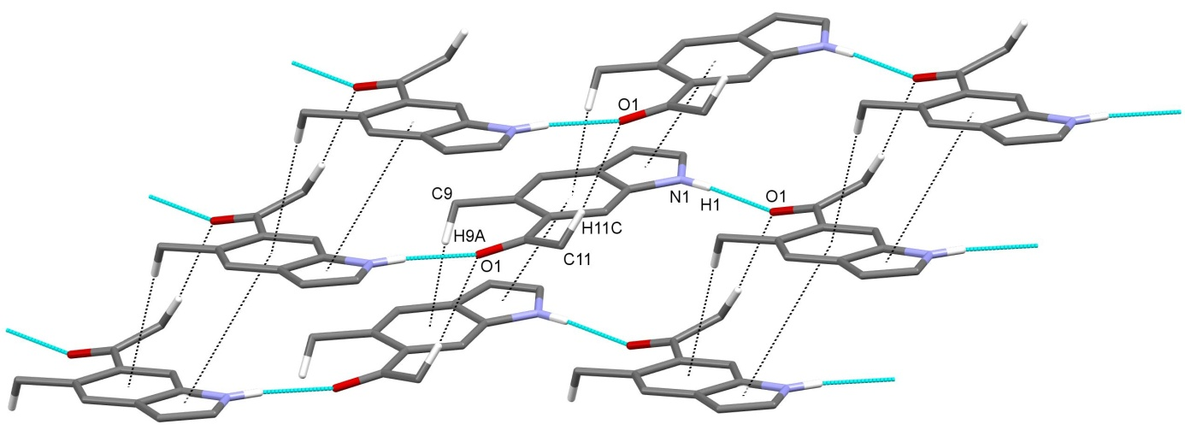
Figure 4. Sheet formation in 7 generated by N–H···O hydrogen bonding (blue dashed lines) and weak C–H···O, C–H···π and π···π interactions (dashed black lines). Hydrogen atoms not involved in the motif shown have been omitted for clarity.

In the crystal structure 8 four unique molecules are linked via N–H···N hydrogen bonding between the indole NH group of one molecule and the tertiary nitrogen atom of the dimethylamino group of the adjacent molecule into infinite zig-zag chains generating the graph set motif C(5). In each zig-zag chain two out of four unique molecules are involved. Chains are stabilized by weak C–H···π interactions between the CH group of the pyrrole moiety of one molecule and a six membered aromatic ring of the adjacent molecule (Table 2, Figure 5). Chains are cross-linked by weak C42–H42A···O4(–x + 1, y + ½, –z + 1) and C56–H56B···O1(–x + 1, y – ½, –z + 1) hydrogen bonding between methyl group of the acetyl moiety of one molecule and the carbonyl oxygen of the adjacent molecule together with weak C38–H38A···O1(–x, y – ½, –z + 1) hydrogen bonding between one methyl group of the dimethylamino moiety of one molecule and the carbonyl oxygen of the adjacent molecule (Table 2, Figure 6). In addition, supramolecular structure 8 is stabilized by medium strong π···π interactions between five membered pyrrole ring (Cg1, Cg4, Cg7 and Cg10) of one molecule and a six membered ring (Cg2, Cg5, Cg8 and Cg11) of the other molecule with an average centroid-to-centroid distance of 3.91 Å (Figure 7). For other data regarding π···π interactions, see Table 3.

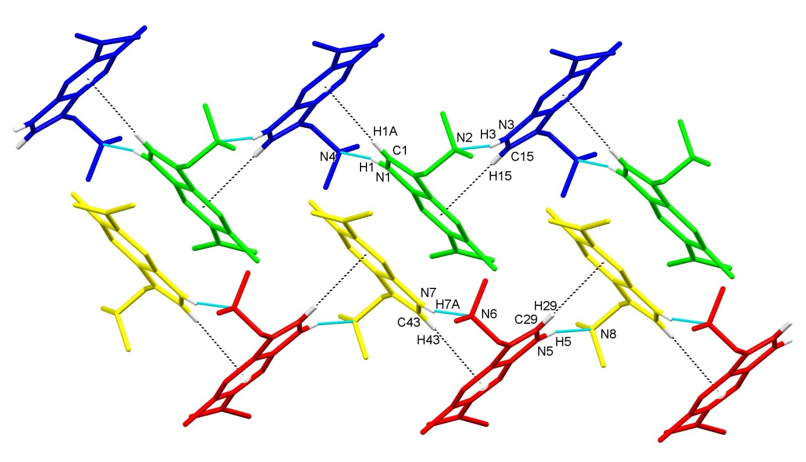
Figure 5. Formation of two chains in 8 by four unique molecules (color code: blue, green, red, yellow) generated by N–H···N hydrogen bonding (blue dashed lines) and C–H···π interactions (black dashed lines). Hydrogen atoms not involved in the motif shown have been omitted for clarity.

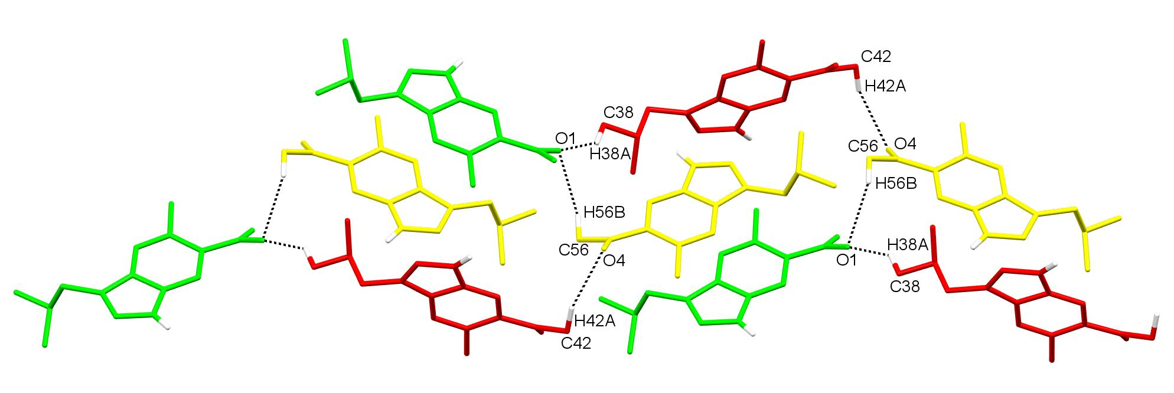
Figure 6. The arrangement of molecules of 8 formed by C42–H42A···O4, C56–H56B···O1 and C38–H38A···O1interactions (dashed lines). Hydrogen atoms not involved in the motif shown have been omitted for clarity.

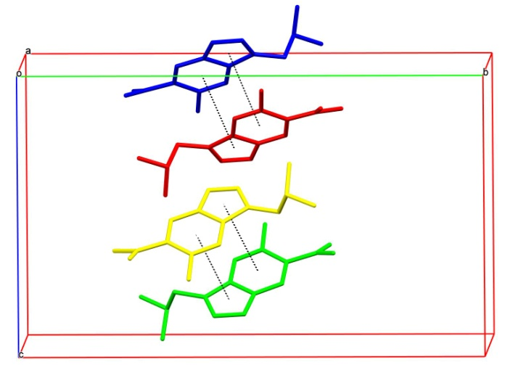
Figure 7. The formation of π···π interactions in 8 (dashed lines). Hydrogen atoms have been omitted for clarity.

Table 3. π···π interactions in 8.
Cg···Cg | CgI···CgJ (Å) | α (°) | β (°) | CgI-Perp (Å) | Symmetry code
Cg1···Cg11 | 3.927(2) | 2.13(18) | 22.93 | 3.5573(14) | x – 1, y, z
Cg2···Cg10 | 3.9126(19) | 1.52(17) | 24.59 | 3.5600(14) | x – 1, y, z
Cg4···Cg8 | 3.908(2) | 2.25(18) | 22.39 | –3.5523(14) | x, y, z + 1
Cg5···Cg7 | 3.9039(19) | 1.89(17) | 24.38 | –3.5460(14) | x, y, z + 1
CgI···CgJ, α, β and CgI-Perp are, respectively, the centroid-to-centroid distance between rings I and J (Å), the inter-ring dihedral angle (°), slip angle (°), and the perpendicular distance of CgI from ring J (Å). Ring centroids: Cg1 (N1/C1–C3/C8), Cg2 (C3–C8), Cg4 (N3/C15–C17/C22), Cg5 (C17–C22), Cg7 (N5/C29–C31/C36), Cg8 (C31–C36), Cg10 (N7/C43–C45/C50) and Cg11 (C45–C50).

4. Conclusion
With the Diels–Alder reaction between a substituted 2H-pyran-2-one and (Z)-1-methoxybut-1-en-3-yne as the dienophile we have prepared a cycloadduct that was in the next, one-pot domino process cyclized and deprotected into the desired 5-methyl-6-acetyl substituted indole and further derivatized via Mannich reaction to the 5-methyl-6-acetylgramine. Single-crystal X-ray diffraction analysis of both compounds provided a valuable insight into their molecular structures as well as the mode of packing and crystal architecture showing that in the indole derivative the molecules are linked via N–H···O hydrogen bonds between the secondary amine group and carbonyl moiety of the acetyl group of adjacent molecules, whereas the molecules of gramine are linked via N–H···N hydrogen bonds between the secondary and tertiary amine groups of adjacent molecules. In both structures weak C–H···O, C–H···π and π···π interactions were also observed.

5. Supplementary Material
Crystallographic data of 1 and 2 were deposited in the Cambridge Crystallographic Data Center under the number CCDC 1503990–1503991. CIF files containing complete information on the studied structures may be obtained free of charge from the Director, CCDC, 12 Union Road, Cambridge, CB2 1EZ, UK, fax +44-1223-336033; e-mail: data_request@ccdc.cam.ac.uk or from the following web site: www.ccdc.cam.ac.uk/data_request/cif.

6. Acknowledgement
The authors thank the Ministry of Education, Science and Sport of the Republic of Slovenia and the Slovenian Research Agency for financial support (grant Nos. P1-0230-0103 and P1-0230-0175). This work was also partially supported with infrastructure of the EN-FIST, Center of Excellence, Ljubljana, Slovenia.

7. References
[1] H. Matsuo, K. Taniguchi, T. Hiramoto, T. Yamada, Y. Ichinose, K. Toyoda, K. Takeda, T. Shiraishi, Plant. Cell. Physiol. 2001, 42, 1103–1111.
[2] B. B. Semenov, V. G. Granik, Khim. Farm. Zh. 2004, 38, 3–26.
[3] J. Letessier, H. Detert, K. Götz, T. Opatz, Synthesis 2012, 44, 747–754.
[4] T. Yamakawa, E. Ideue, Y. Iwaki, A. Sato, H. Tokuyama, J. Shimokawa, T. Fukuyama, Tetrahedron 2011, 67, 6547–6560.
[5] M. Reinfelds, K. Kalinins, D. Katkevica, R. Zemribo, M. Katkevics, Tetrahedron Lett. 2015, 56, 5882–5885.
[6] A. J. Keith, S. D. Kosik, L. M. V. Tillekeratne, M. R. Mason, Synlett 2014, 25, 977–982.
[7] Y. Wei, L. Shi, K. Wang, M. Liu, Q. Yang, Z. Yang, S. Ke, Molecules 2014, 19, 8949–8964.
[8] M. M. Heravi, V. Zadsirjan, Z. B. Savadjani, Curr. Org. Chem. 2014, 18, 2857–2891.
[9] H. G. Dai, J. T. Li, T. S. Li, Synth. Commun. 2006, 36, 1829–1835.
[10] S. Ke, L. Shi, X. Cao, Q. Yang, Y. Liang, Z. Yang, Eur. J. Med. Chem. 2012, 54, 248–254.
[11] M. Köksal Akkoç, M. Yarım Yüksel, İ. Durmaz, R. Çetin Atalay, Turk. J. Chem. 2012, 36, 515–525.
[12] K. Kranjc, M. Kočevar, Tetrahedron 2008, 64, 45–52.
[13] Agilent, CrysAlis PRO, Agilent Technologies, Yarnton, Oxfordshire, England, 2013.
[14] L. Palatinus, G. Chapuis, J. Appl. Cryst. 2007, 40, 786–790.
[15] G. M. Sheldrick, Acta Cryst. 2015, C71, 3–8.
[16] K. Kranjc, M. Kočevar, Arkivoc 2013, (i), 333–363.
[17] K. Kranjc, M. Kočevar, F. Perdih, Acta Cryst. 2011, C67, o201–o205.
[18] K. Kranjc, A. Juranovič, M. Kočevar, F. Perdih, J. Chem. Crystallogr. 2012, 42, 443–449.
[19] A. Juranovič, K. Kranjc, S. Polanc, F. Perdih, M. Kočevar, Monatsh. Chem. 2012, 143, 771–777.
[20] J. Suljagić, A. Juranovič, M. Krivec, K. Kranjc, M. Kočevar, J. Heterocycl. Chem. 2016, in press, doi: 10.1002/jhet.2603.
[21] K. Kranjc, M. Kočevar, New J. Chem. 2005, 29, 1027–1034.
[22] V. Lanke, K. R. Prabhu, Org. Lett. 2013, 15, 2818–2821.
[23] V. Kepe, M. Kočevar, S. Polanc, B. Verček, M. Tišler, Tetrahedron 1990, 46, 2081–2088.
[24] V. Kepe, M. Kočevar, S. Polanc, J. Heterocycl. Chem. 1996, 33, 1707–1710.
[25] V. Kepe, S. Polanc, M. Kočevar, Heterocycles 1998, 48, 671–678.
[26] F. H. Allen, O. Kennard, D. G. Watson, L. Brammer, A. G. Orpen, R. Taylor, J. Chem. Soc., Perkin Trans. II 1987, S1–S19.
[27] F. Odame, E. Hosten, R. Betz, K. Lobb, Z. R. Tshentu, Acta Chim. Slov. 2015, 62, 986–994.
[28] T. Guo, Q. Jiang, Z. Yu, Org. Chem. Front 2015, 2, 1361–1365.
[29] A. Nakhi, B. Prasad, U. Reddy, R. M. Rao, S. Sandra, R. Kapavarapu, D. Rambabu, G. R. Krishna, C. M. Reddy, K. Ravada, P. Misra, J. Iqbal, M. Pal, MedChemComm 2011, 2, 1006–1010.
[30] S. N. Golubev, Y. D. Kondrashev, J. Struct. Chem. 1984, 25, 467–470.
[31] R. Jiang, X.-J. Wu, X. Zhu, X.-P. Xu, S.-J. Ji, Eur. J. Org. Chem. 2010, 5946–5950.
[32] A. J. Keith, S. D. Kosik, L. M. V. Tillekeratne, M. R. Mason, Synlett 2014, 25, 977–982.
[33] Q. Wang, Z.-Y. Fu, X. Li, L.-M. Yu, Acta Cryst. 2011, E67, o1671.
[34] J. Bernstein, R. E. Davis, N. L. Shimoni, N.-L. Chang, Angew. Chem., Int. Ed. 1995, 34, 1555–1573.
[35] C. Janiak, J. Chem. Soc., Dalton Trans. 2000, 3885–3896.
[36] T. Dorn, C. Janiak, A.-K. Shandi, CrystEngComm 2005, 7, 633–641.
[37] X.-J. Yang, F. Drepper, B. Wu, W.-H. Sun, W. Haehnel, C. Janiak, Dalton Trans. 2005, 256–267.

Povzetek
Opisujemo sintezo in kristalno strukturo 1-(5-metil-1H-indol-6-il)etan-1-ona (7), C₁₁H₁₁NO, in 1-{3-[(dimetilamino)metil]-5-metil-1H-indol-6-il}etan-1-ona (8), C₁₄H₁₈N₂O. Sinteza temelji na Diels–Alderjevi cikloadiciji substituiranega 2H-piran-2-onskega derivata, ki ji sledi kislinsko katalizirana ciklizacija in odščita (zadnji stopnji sta bili izvedeni kot enolončni domino proces); tako nastali indol 7 smo dalje derivatizirali z Mannichovo reakcijo do graminskega derivata 8. Struktura 7 ima v asimetrični enoti eno samo molekulo, struktura 8 pa štiri. Molekule so v 7 povezane z N–H···O vodikovimi vezmi med sekundarno aminsko skupino ene molekule in karbonilnim delom acetilne skupine sosednje molekule. V strukturi 8 so molekule povezane preko N–H···N vodikovih vezi med sekundarno aminsko skupino ene molekule in terciarno aminsko skupino sosednje molekule. Obe strukturi sta dodatno stabilizirani s šibkimi C–H···O, C–H···π in π···π interakcijami.

Ključne besede: indoli, gramini, kristalna struktura, vodikove vezi, C–H···π interakcije, π···π interakcije

