Short communication
Evaluation of animal bone char as potential metal stabilization agent in metal contaminated soil
Evelin Gruden¹, Peter Bukovec¹ and Marija Zupančič^{1,*}
¹ Faculty of Chemistry and Chemical Technology, University of Ljubljana, Večna pot 113, SI 1000 Ljubljana, Slovenia.
* Corresponding author: E-mail: marija.zupancic@fkkt.uni-lj.si, Phone: +386 1 4798 531.
For Cutting Edge 2017

Abstract
The aim of this study was to evaluate the potential effect of animal bone char (ABC) addition on metal mobility in mine tailings. The mobility of metals after addition of ABC to tailings at four different application rates (0.6 g, 1.2 g, 1.8 g and 3.6 g ABC per 100 g of tailings) was evaluated by Toxicity Characteristic Leaching Procedure (TCLP) one step extraction. The obtained results indicated that the mobility of Pb, Cr and Cd gradually decreased with increasing quantity of added ABC. According to the TCLP, mobile concentrations of Pb in tailings exceeded threshold values for almost eight times. After ABC addition, Pb TCLP-extractable concentrations decreased from 39 mg L⁻¹ in tailings to lower than the TCLP limit values of 5 mg L⁻¹ at all ABC application rates, except in mixtures with the lowest addition of ABC. We concluded that ABC could be a successful metal stabilization agent for multi-metal contaminated soil, although attention should be paid at highly mobile As contaminated soil.
Keywords: Animal bone char; metal stabilization; phosphate; tailings

1. Introduction
The contamination of soil with Pb is an important ecological problem worldwide whereas mining is among the main sources of Pb contamination in mine areas.¹ Contaminated mine sites are poorly developed soils, depleted of organic matter and nutrients and are characterised by their excessive metal contents.² In the past, large amounts of mine wastes were dumped near the sites where they were produced and dispersed into nearby soils, crops and ecosystem.³⁻⁴ The accumulation of metals in soil may have serious consequences for animal and human health through the food chain, groundwater, plant growth and microorganism diversity.⁴⁻⁵
In situ chemical immobilization is a promising green and cost effective soil remediation technique where mobile metal chemical species are transformed into less mobile ones by adding different amendments.⁵⁻⁶ Phosphate amendments have been shown to be highly effective to reduce metal mobility and bioavailability. Many metals (Pb, Zn, Cd, Cu and others) can precipitate with phosphate sources as relatively insoluble metal phosphate species. Pb can be mainly converted into insoluble forms, such as pyromorphite (Pb₅(PO₄)₃OH).^{1, 7-8}
Animal bone char (ABC) is a granular material, rich of phosphates, that is produced by animal bone pyrolysis.⁹⁻¹⁰ It mainly contains about 70–76 % of biological, relatively crystalline calcium hydroxyapatite (Ca₅(PO₄)₃(OH)), 9–11 % of carbon and 7–9 % of CaCO₃.¹¹⁻¹² Few previous studies highlighted the potential use of ABC as a green and low–cost P–amendment for Pb and Zn immobilisation in contaminated soil.^{9, 13} However the use of ABC as a metal stabilization agents in multi-metal contaminated soil has rarely been reported.
In this research we investigated the use of ABC as metal immobilization agents and potential remediation solution for degraded metal contaminated area as mine tailings.

2. Experimental
In this study the mine tailings from Sasa zinc and lead mine in Macedonia were used as an example of metal contaminated poorly developed mine area soil. The tailings were previously air dried and analyzed for their physical and chemical properties. The tailings had a loamy sand (LS) texture (74.9 % sand, 17.4 % silt and 7.7 % clay). The principal crystalline tailings mineral phases were pyrite (FeS₂), quartz (SiO₂), epidote (Ca₂Al₂FeSi₃O₁₃H), clinochlore (Mg_{3.75}Fe²⁺_{1.25}Si₃Al₂O₁₀(OH)₈), cordierite (Na_{0.47}(Mg_{0.76}Fe_{1.1}Li_{0.14})(Al_{3.6}Be_{0.4})Si₅O₁₈(H₂O)_{0.8}), calcite (CaCO₃) and mica (K(Mg_{2.665}Li_{0.225}Na_{0.110})(Si_{3.312}Fe_{0.688}O₁₀)F₂). The total element concentration in tailings was determined as the content of elements soluble in aqua regia according to SIST ISO 11466:1996. The mobility of elements was evaluated according to the SIST EN 12457–4 one–stage batch test (water extraction, S/L = 1:10) and Toxicity Characteristic Leaching Procedure – TCLP.¹⁴ To classify and quantify the metal fractionation in tailings, the modified BCR sequential extraction procedure was conducted.¹⁵ Exchangeable fraction was evaluated on 1 g of tailings by extraction with 40 mL of 0.11 mol L⁻¹ acetic acid solution, reducible fraction with 40 mL of 0.5 mol L⁻¹ NH₂OH·HCl, oxidizable fraction with 10 mL of 30 % H₂O₂ and residual fraction with 6 mL of HCl, 2 mL of HNO₃ and 2 mL of HF.
The animal bone char (ABC) was air dried and powdered by planetary mill. The physicochemical properties of tailings and ABC are outlined in Table 1.

Table 1: Physicochemical properties of the mine tailings and ABC.
Tailings sample (T) |  | ABC sample
pH value (CaCl₂) | 7.46 ± 0.02 |  | pH value (CaCl₂) | 7.53 ± 0.04
Cation exchange capacity (cmol kg⁻¹) | 6.8 |  | Available P content (mg kg⁻¹) | 600 ± 15
Reduction potential (mV) | 392 |  | Total P content (%) | 15.5 ± 0.3
Total C content (%) | 0.78 |  | Total C content (%) | 9.51
Organic C content (%) | 0.19 |  | Total N content (%) | 0.64
Inorganic C content (%) | 0.59 |  | Total H content (%) | 0.94

To immobilize metals in contaminated soil sample, mixtures of tailings with ABC were prepared. ABC was added to tailings at four different application rates: 0.59 g, 1.19 g, 1.82 g and 3.64 g ABC per 100 g of tailings. To achieve sufficient homogenization, the mixtures were prepared as water suspensions, shaken by a mechanical shaker for 1 day and slowly air dried. All of the experiments were carried out in triplicate.
The Toxicity Characteristic Leaching Procedure (TCLP) was carried out to evaluate the metal stabilization efficiency of the ABC.¹⁴ 20 mL of 0.11 M acetic acid (pH = 2.83) were added to 1.000 ± 0.001 g of air-dried samples in 30 mL polypropylene centrifugation tubes. The samples were shaken by a mechanical shaker for 20 hours at 150 rpm. The extractants were separated from the solid residues by centrifugation at 2800 rpm for 15 min and filtered through a cellulose nitrate filter of 0.45 μm pore size (Sartorius, Germany).
The mobility of P in mixtures was evaluated by sodium hydrogen carbonate extraction of mixtures following by spectrometric determination of P according to SIST ISO 11263:1996. The absorbance measurements were carried out at 880 nm.
3. Results and Discussion
Total metal concentration, acetic acid and water extractable metal concentrations in tailings and the corresponding legislative limits are presented in Table 2.

Table 2: Total metal concentration (mg kg⁻¹), TCLP (mg L⁻¹) and water extractable (mg L⁻¹) metal concentrations in tailings with the corresponding legislative limits.
 | Cr | Co | Ni | Cu | Zn | As | Cd | Pb
Total metal concentration
Conc. (mg kg⁻¹) | 37 | 15 | 33 | 212 | 2423 | 93 | 12 | 3316
ªCritical level (mg kg⁻¹) | 380 | 240 | 210 | 300 | 720 | 55 | 12 | 530
TCLP
Conc. (mg L⁻¹) | 0.007 | 0.010 | 0.043 | 0.08 | 7 | 0.030 | 0.046 | 39
Regulatory levels (mg L⁻¹) | 5.0 | - | - | - | 250 | 5.0 | 1.0 | 5.0
Water extracts (S/L = 1:10)
Conc. (mg L⁻¹) | < 0.002 | < 0.002 | < 0.002 | < 0.002 | < 0.02 | < 0.002 | < 0.002 | 0.031
^{b}Limit value (mg L⁻¹) | 0.3 | - | 0.6 | 0.6 | 18 | 0.3 | 0.03 | 0.3
ª The critical legislative limits of dangerous substances in soil.¹⁶
^{b} The legislative limits for soil burdening with waste spreading.¹⁷

The total concentrations of Cu, Zn, As and Pb in tailings exceeded the critical limits of dangerous substances in the soil stated in Slovenian legislation,¹⁶ whereas the concentrations of metals in water extracts were far below the legal limits.¹⁷ The mobility of metals, evaluated by TCLP, was also quite low, except for Pb which acetic acid extractable concentrations exceed the TCLP regulatory limits by a factor of almost eight.
The partitioning of metals in tailings determined by modified BCR procedure is presented in Figure 1. Pb in tailings was mainly partitioned between exchangeable (29.7 %), residual (27.0 %) and oxidizable fraction (26.4 %). The highest proportion of Cr and As were found in the residual fraction, additionally Co, Ni, Cu, Zn and Cd were mainly partitioned in the residual and oxidizable fraction. Small amounts of metals in exchangeable form indicate that the mobility of metals was quite low, except for Pb, which is in agreement with our TCLP results.
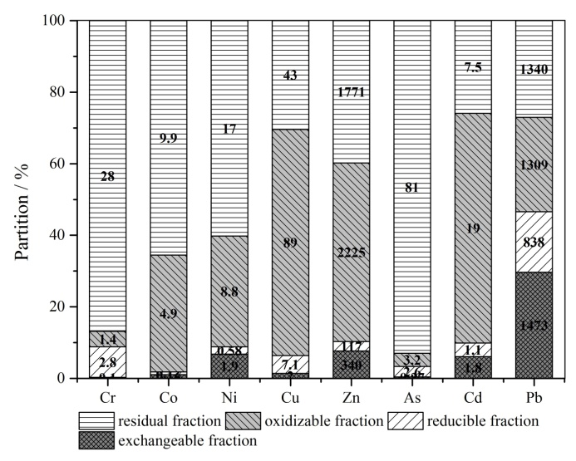
Fig. 1: Partitioning of metals in tailings, determined by modified BCR procedure (with corresponding concentration values in mg of metal per kg of tailings).

The change in pH values of soil is normally an important mechanism for metal stabilization.¹³ In this study the pH value of ABC was just slightly higher than the pH value of tailings. Therefore, the addition of ABC to tailings did not significantly change the pH of the mixtures (values between 7.44 and 7.56) and therefore have negligible influence on metal bioavailability reduction.
The stabilisation of specific elements in mixtures was estimated by comparing TCLP metal concentrations of mixtures to TCLP metal concentrations of tailings (Fig. 2).

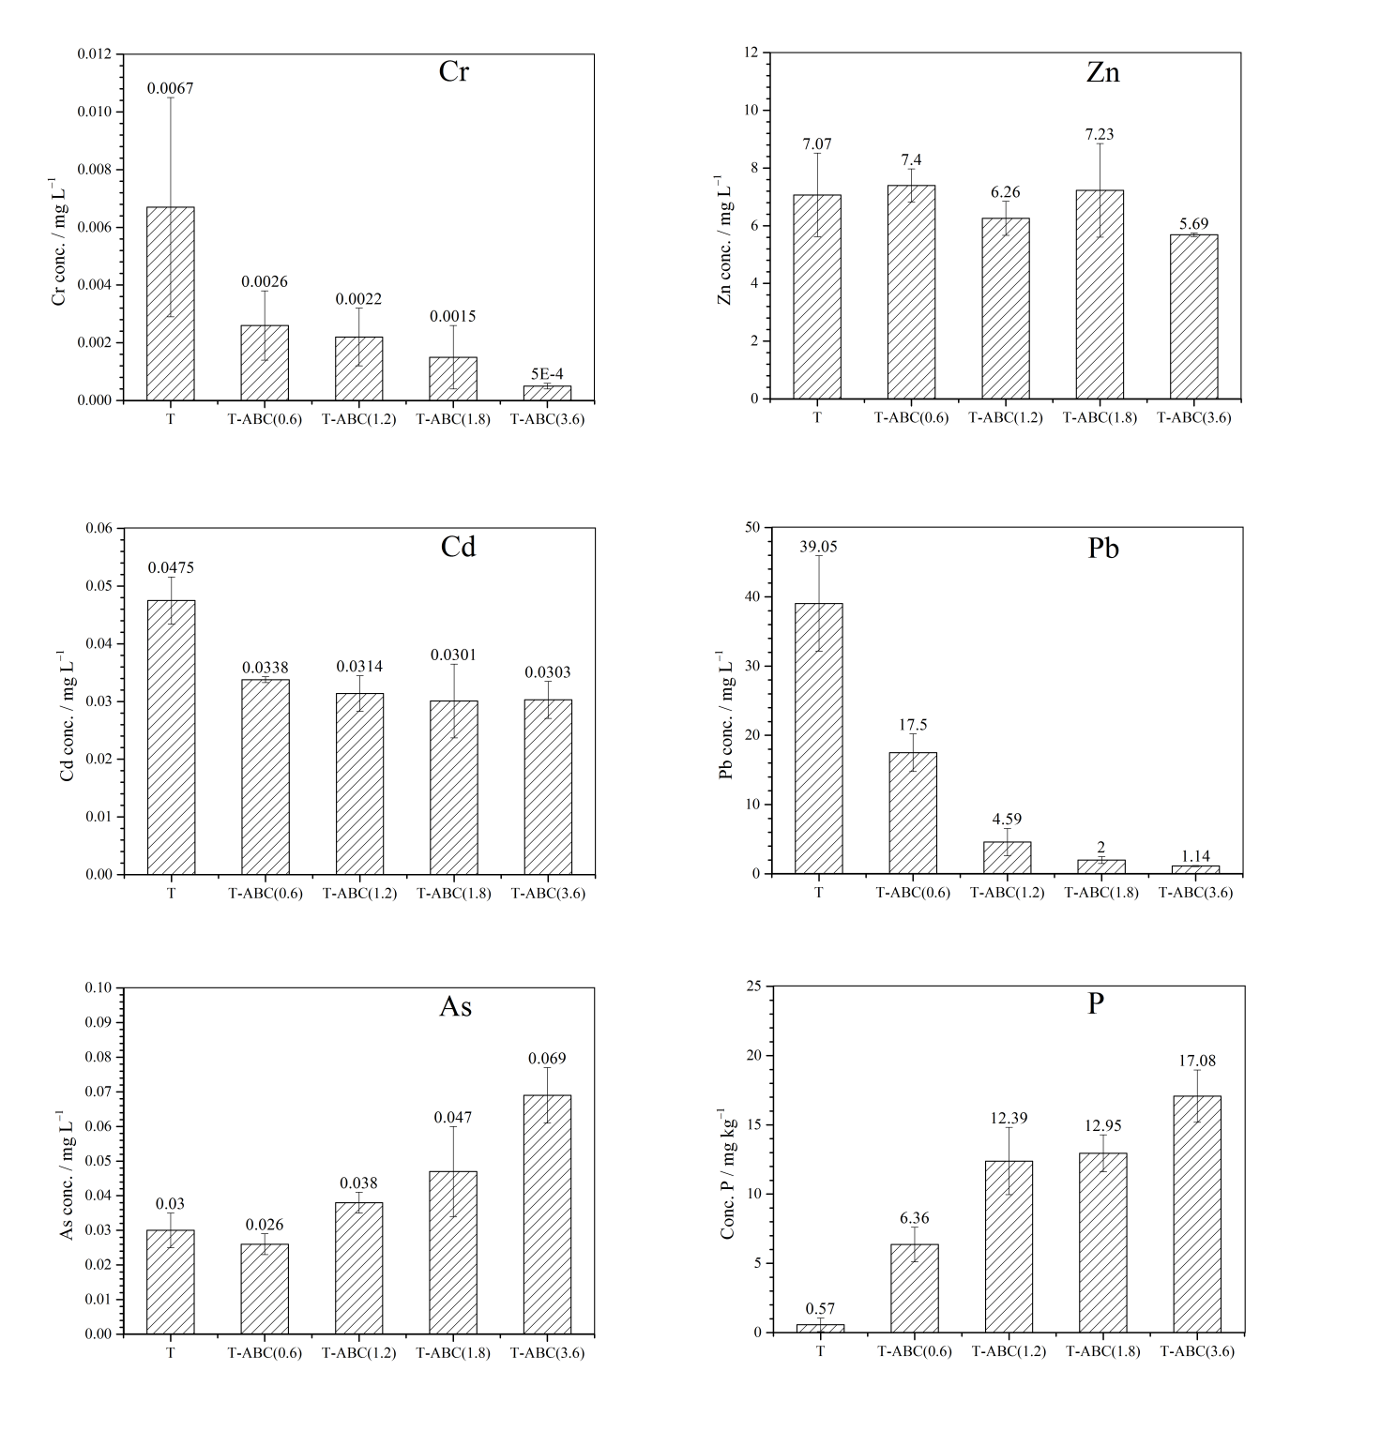
Fig. 2: TCLP concentrations of metals (in mg L⁻¹) and the mobility of P (in mg kg⁻¹) of the tailings and mixtures. Results are presented as the average of three replicates with standard deviations as the error bars.
The most efficient stabilization of metals was achieved for Pb. The addition of ABC at application rates of 0.6 %, 1.2 %, 1.8 % and 3.6 % decreased the mobility of Pb to 45 %, 12 %, 5 % and 3 % of the Pb mobility in tailings, respectively. Application of ABC at higher application rates was very effective in reducing the TCLP concentration of Pb to values lower than the USEPA toxic regulatory level (5 mg L⁻¹).¹⁴ Pb mobility reduction could be due to the formation of Pb hydroxyapatite-like minerals (Pb₁₀(PO₄)₆(OH)₂) by precipitation of Pb and P released from calcium hydroxyapatite.¹³ As shown in Fig. 2, the mobility of P gradually increases with respect to increasing application rate of ABC to tailing, but still remained at environmentally acceptable levels.
High metal stabilization efficiencies were also observed for Cr and Cd, respectively. Their mobility decreased down to 8 % (Cr) and 63 % (Cd) of original mobility in tailings. For both elements the increase in ABC addition resulted in increased stabilization efficiency. On the other hand, the effect of ABC on Zn mobility was quite small. A significant stabilization effect was observed only at the highest ABC application rates (80 % of Zn mobility in tailings), whereas at low application rates, the effect was even slightly destabilizing. As mentioned in literature, a possible removal mechanism for these three elements, besides metal phosphates precipitation, could be due to sorption mechanisms, like surface complexation and ion exchange.^{1, 9, 18}
Unlike other elements, the mobility of As increased 0.9, 1.3, 1.5 and 2.3 times in mixtures
T-ABC(0.6), T-ABC(1.2), T-ABC(1.8) and T-ABC(3.6), respectively. The highest TCLP concentrations of As was 0.069 mg L⁻¹ (1.39 mg kg⁻¹) and still remained well below the TCLP regulatory value of 5 mg L⁻¹. As(V) species at moderately acidic and neutral pH can be present as arsenate(V) oxyanions.¹⁹ Since the arsenate(V) is very similar to phosphate(V), competitive adsorption could occur and result as increased leaching of As.⁶

4. Conclusions
The addition of ABC to the studied multi-element contaminated mine tailings resulted in a considerable reduction of TCLP-extractable Pb, Cr and Cd in mixtures up to 3 %, 8 % and 63 % of concentrations in extracts of tailings, respectively. After the treatment, the concentration of acetic acid extractable Pb decreased below the regulatory level stated by TCLP. The addition of ABC gradually induced the desorption of the retained As in tailings and the increased concentration of mobile P in mixtures, but concentrations of As still remained far below TCLP threshold .
In summary, ABC amendments show promising results as metal-stabilization agents, especially for Pb immobilization. However, attention should be paid upon ABC amendments to highly mobile arsenic-metal polluted soil.
5. Acknowledgements
This research study was funded by financial support provided by the Ministry of Higher Education, Science and Technology (P1-0134) of the Republic of Slovenia.

6. References
1. I. R. Sneddon, M. Orueetxebarria, M. E. Hodson, P. F. Schofield, E. Valsami-Jones, Environ. Pollut. 2006, 144, 816-825. http://dx.doi.org/10.1016/j.envpol.2006.02.008
2. L. Beesley, O. S. Inneh, G. J. Norton, E. Moreno-Jimenez, T. Pardo, R. Clemente, J. J. C. Dawson, Environ. Pollut. 2014, 186, 195-202. http://dx.doi.org/10.1016/j.envpol.2013.11.026
3. G. Fellet, M. Marmiroli, L. Marchiol, Sci. Total Environ. 2014, 468-469, 598-608.
http://dx.doi.org/10.1016/j.scitotenv.2013.08.072
4. J. Pérez-Esteban, C. Escolástico, A. Masaguer, C. Vargas, A. Moliner, Chemosphere 2014, 103, 164-171. http://dx.doi.org/10.1016/j.chemosphere.2013.11.055
5. D. Houben, L. Evrard, P. Sonnet, Chemosphere 2013, 92, 1450-1457.
http://dx.doi.org/10.1016/j.chemosphere.2013.03.055
6. M. Zupančič, S. Lavrič, P. Bukovec, J. Environ. Monit. 2012, 14, 704-710.
http://dx.doi.org/10.1039/c2em10798h
7. I. R. Sneddon, M. Orueetxebarria, M. E. Hodson, P. F. Schofield, E. Valsami-Jones, Appl. Geochem. 2008, 23, 2414-2424. http://dx.doi.org/10.1016/j.apgeochem.2008.02.028
8. Z. Y. Huang, J. Li, Y. L. Cao, C. Cai, Z. Zhang, Geoderma 2016, 264, 126-131. http://dx.doi.org/10.1016/j.geoderma.2015.10.013
9. X. W. Hao, Y. Z. Huang, Y. S. Cui, Acta Ecol. Sin. 2010, 30, 118-122. http://dx.doi.org/10.1016/j.chnaes.2010.03.012
10. M. J. Zwetsloot, J. Lehmann, T. Bauerle, S. Vanek, R. Hestrin, Plant Soil 2016, Online First Articles, doi:10.1007/s11104-016-2905-2.
11. U. Iriarte-Velasco, J. L. Ayastuy, L. Zudaire, I. Sierra, Chem. Eng. J. 2014, 251, 217-227.
http://dx.doi.org/10.1016/j.cej.2014.04.048
12. J. C. Moreno-Piraján, R. Gómez-Cruz, V. S. García-Cuello, L. Giraldo, J. Anal. Appl. Pyrol. 2010, 89, 122-128. http://dx.doi.org/10.1016/j.jaap.2010.06.007
13. S. B. Chen, Y. G. Zhu, Y. B. Ma, G. McKay, Environ. Pollut. 2006, 139, 433-439.
http://dx.doi.org/10.1016/j.envpol.2005.06.007
14. USEPA, SW-846: Test Methods for Evaluating Solid Waste, Physical/Chemical Methods, Analytical Method 1311: Toxicity Characteristic Leaching Procedure, Washington, DC, 2008.
15. G. Rauret, J. F. Lopez-Sanchez, A. Sahuquillo, R. Rubio, C. Davidson, A. Ure, Ph. Quevauviller, J. Environ. Monit. 1999, 1, 57-61. http://dx.doi.org/10.1039/a807854h
16. Official Gazette of RS, Decree on the limit, warning and critical levels of hazardous substances in the soil, Nos. 68/96 and 41/04 - ZVO-1, 1996.
17. Official Gazette of RS, Decree on burdening the soil by waste, Nos. 34/08 and 61/11, 2008.
18. A. H. M. G. Hyder, S. A. Begum, N. O. Egiebor, J. Environ. Chem. Eng. 2015, 3, 1329-1336. http://dx.doi.org/10.1016/j.jece.2014.12.005
19. H. Jin, S. Capareda, Z. Chang, J. Gao, Y. Xu, J. Zhang, Bioresour. Technol. 2014, 169, 622-629. http://dx.doi.org/10.1016/j.biortech.2014.06.103

Povzetek
Namen našega raziskovalnega dela je bil proučiti vpliv dodatka biooglja, pripravljenega iz živalskih kosti (ABC), na mobilnost kovin v jalovinskem materialu. Jalovinskemu materialu smo dodali štiri različne deleže ABC (0.6 g, 1.2 g, 1.8 g in 3.6 g ABC na 100 g jalovine) in določili mobilnost kovin s pomočjo enostopenjske ekstrakcije z 0,11 M ocetno kislino (TCLP Toxicity Characteristic Leaching Procedure). Rezultati so pokazali, da se mobilnost Pb, Cr in Cd postopoma zmanjšuje z naraščajočo količino dodanega ABC. Pb je s stališča mejnih vrednosti, določenih s strani TCLP, predstavljal edini problematični element v vzorcu. Koncentracija Pb v ocetnokislinskih ekstraktih se je pri treh višjih dodatkih ABC zmanjšala z 39 mg L⁻¹ na vrednosti, ki so bile pod mejno vrednostjo TCLP testa (5 mg L⁻¹). Rezultati so pokazali uporabnost ABC kot učinkovitega stabilizacijskega sredstva za s kovinami onesnažena tla.

