Chemometric characterization of Slovenian red wines
Milena Ivanović¹, Anja Petek¹, Maša Islamčević Razboršek¹, Mitja Kolar²
¹University of Maribor, Faculty of Chemistry and Chemical Engineering, Smetanova ulica 17, 2000 Maribor
²University of Ljubljana, Faculty of Chemistry and Chemical Engineering, Večna pot 113, 1000 Ljubljana
*Corresponding author: E-mail: mitja.kolar@fkkt.uni-lj.si
Tel.: (+386)-1-4798-694

“For Cutting Edge 2017”
Abstract
Total phenolic (TPC), flavonoid (TFC) and tannin (TTC) contents, total SO₂, total acids, pH, and reducing sugars were measured in twenty five Slovenian red wines from three key wine producing regions: Podravje, Posavje and Primorska. The results were chemometrically analysed and the wines were classified according to region of origin and wine variety. Principal component analysis proved that TPC, TFC and TTC contents were primarily responsible for variation in the wines. Additionally, linear discriminant analysis (LDA) was performed and resulted in the satisfactory classification of samples by both wine variety and region.
Keywords: Slovenian red wines, quality parameters of wine, polyphenols, chemometric analysis.
- Introduction
Slovenia is a small European country with a long history of wine production in three key wine regions: Podravje (Drava Valley) in the east, Primorska (Littoral) in the west and Posavje (Lower Sava Valley) just south of the center. In Slovenia there are more than 28,000 wineries making between 80 and 90 million litres annually, of which 25% is red wine. Most of the red wine is produced in Primorska from three well-known grape varieties, Refošk, Teran and Merlot.
Wine is a complex matrix and its major components are water (81%), ethanol (between 11% and 15%) and sugars. Additionally it contains a wide range of organic and inorganic compounds, including polyphenols, different organic acids and nitrogenous compounds.¹ The concentration levels of these compounds are influenced by several oenological factors such as origin, grape variety, winemaking practices, ageing and vintage. Their quantitative determination in wines is of considerable importance, since it is known that they are responsible for the wine’s taste (polyphenols), colour (anthocyanins), and for beneficial health effects including antioxidant and anti-inflammatory activities.² Wine classification is a very important topic in order to detect possible frauds and to establish wine authenticity that is an important consideration in international markets.⁴ This process consists of building mathematical-statistical models based on quantitative and qualitative information about the natural constituents , like content of trace elements⁵, organic wine constituents such as volatile compounds⁶, sugars⁷, polyphenols⁸, anthocyanins⁹, etc.
Slovenian wine legislation¹⁰ prescribes that all wines should be submitted to chemical and sensoric-organoleptic analysis before being released to the market. After wines pass the tests, they are assigned a quality level according to the Zaščiteno geografsko poreklo (ZGP) which is similar to the European Union's QWPSR system (Quality Wines Produced in Specified Regions.)
In our previous paper¹¹, Slovenian red wines were characterized according to the phenolic acids content, and classified according to grape variety and Slovenian wine region. In the present study, several more variables were taken into account; total polyphenol content (TPC), condensed tannins content (TTC), flavonoids content (TFC), total reducing sugars, total acids content and total SO₂ content were determined in 25 Slovenian red wines. Additionally, the results obtained were used to build chemometric models for the classification of Slovenian red wines for different wine varieties from the three wine regions.
- Experimental
  - Chemicals and wine samples
Rutin, vanillin, gallic acid, Folin-Ciocalteu reagent and NaOH were supplied by Merck (Germany). Na₂CO₃, I₂ and KI were purchased from Sigma-Aldrich (Germany). AlCl₃ and H₂SO₄ were purchased from Fluka (USA) and methanol (MeOH) from JT Baker (Germany). CH₃COONa and HCl were supplied by Carlo Erba (Italy), CuSO₄ and KNaC₄H₄O₆ were purchased from Kemika (Croatia).
Twenty-five red wines from different Slovenian wineries and different varieties were purchased from local supermarkets. All the wine samples tested originated from four vintages (2011-2015). The wines were stored in a refrigerator at +4°C until analysed.
  - Instrumentation
Spectrophotometric measurements were carried out using a Cary 100 Varian UV/VIS spectrophotometer (USA). All titration determinations were performed on a Mettler Toledo T50 automatic titration system, using a DGi111-SC glass electrode and DMi140-SC platinum ring electrode. All samples were analysed in triplicate.

  - Analytical methods
    - Total polyphenols content (TPC)
Total polyphenol content (TPC) was determined according to the slightly modified standard spectrophotometric method described by Dewanto et al. ¹² The TPC was expressed as grams of gallic acid equivalents per litre (g GAE L⁻¹).
    - Total flavonoids content (TFC)
Similar to TPC the total flavonoids content (TFC) was measured spectrometric at 415 nm against a blank using UV-VIS spectrophotometer.¹² The TFC was expressed as grams of ruin per litre (g RUT L⁻¹).
    - Total condensed tannins content (TTC)
Condensed tannins were determined according to the methods described by Sun et al.¹³ The absorbance was measured at 500 nm against methanol as blank. The TTC was expressed as grams of catechin per litre (mg CAT L⁻¹).
    - Chemical parameters determined using an automatic titration system
For all other chemical parameters a Mettle Toledo T50 automatic titration system was used. Total SO₂ was determined according to the M564 method, total acids content to the M561 method, reducing sugars to the M566/567 methods, and M568 and pH to the M390 method.¹⁴
  - Statistical analysis
Microsoft Excel was used for the data preparation and result outputs. Statistical data treatment was performed using SPSS Statistics version 22.
- Results and discussion
The results of all analyses performed on selected Slovenian red wines are listed in the supplementary material (Table 1). The TPC determined by the Folin-Ciocalteu method ranged from 1.24 to 4.01 g GAE L⁻¹. These values are in general accordance with results determined for Croatian, Italian, Slovakian, Austrian and Romanian red wines.¹⁵⁻²⁰ In the literature, relatively little information about TFC in red wines was found.^{20,21} When we compared our results with literature data we found that Slovenian red wines are a very rich source of flavonoids; by applying colorimetric method using rutin as a standard, TFC was determined in the range of 0.05 to 0.38 g RUT L⁻¹. TTCs were determined in the concentration range of 0.37-1.92 g CAT L⁻¹, where the lowest average TTC was determined in the Modra Frankinja variety. These results are in accordance with those of other authors.²² The highest concentration was determined in the Modri Pinot variety from the Primorska wine region. For comparison, red wines from Romania can contain 0.63-2.34 g of tannins L⁻¹ (as catechin equivalents).²⁰
Wines can be classified according to sugar content as dry (up to 9 g L⁻¹), semi-dry (up to 12 g L⁻¹), semi-sweet (up to 50 g L⁻¹) and sweet (above 50 g L⁻¹).¹⁰ From these categories we concluded that all of the wines tested belong to the group of dry wines, as they contain from 2 to 8 g L⁻¹ of reducing sugars, in accordance with the bottle declarations. The total acid content in red wines can be from 3.5 to 10 g L⁻¹ ¹⁰, and all our results are in this range. According to the literature¹⁰, total SO₂ must not exceed 160 mg L⁻¹ for a wine with reducing sugars content below 5 g L⁻¹, and not exceed 210 mg L⁻¹ for red wines with reducing sugars content above 5 g L⁻¹. Increased contents of total SO₂ were found in just two samples, marked as RW22 and RW25, of the Modri Pinot and Modra Frankinja varieties, respectively. pH values were not significantly different from wine to wine, as they were in the range of 3.37 to 3.98 and are comparable with results reported by other authors.²³
  - Statistical analysis
Exploratory data analysis was performed using the SPSS program. In the first step of the statistical evaluation, the Kolmogorov-Smirnov test (with a significance level of 0.05) was used. This test reveals whether the original data set is normally distributed (TPC, TFC, TTC, reducing sugars, total SO₂, total acids content and pH) or not. If not, the data was transformed to obtain normal distribution. In this way the prepared data were used for further analyses.

3.3.1. Principal component analysis (PCA)
The parametric Pearson correlation test (with significance levels 0.01 and 0.05) was used to determine any inter-relation between two variables. Statistically significant positive correlations at the confidence level 0.01 were found between the following parameters: TPC and TFC (0.721), TPC and TTC (0.897), TPC and reducing sugars (0.617) and TTC and reducing sugars (0.580). Positive correlations at the confidence level 0.05 were found between TFC and TTC (0.494) and between TFC and reducing sugars (0.489). Negative correlation at the confidence level of 0.05 was found between pH and total acids (-0.401): higher acid contents lead to lower pH values.
Before applying PCA modelling, Grubb’s test was applied in order to detect outliers. Outliers were detected in datasets of TFC, reducing sugars, pH and total SO₂, and were discarded from the PCA analysis. For the obtained Factor Analysis results, for the creation of a PCA model based on wine regions only three statistical important variables were taken into account: TPC, TFC and TTC. As can be seen in the plot of scores in Figure 1, PC1 is well discriminated between Primorska (group 1) and Podravje (group 2) wines. The wines from the Posavje region (group 3) were positioned in the middle; some samples were dispersed into group 2. The first two PCs explained 96% of the total variance between wine regions of the samples analysed. The highest percentage of phenolic compounds (TPC, TFC and TTC) were found in wine samples from the Primorska region (Figure 1).
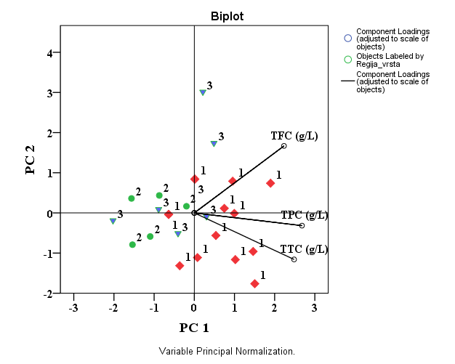
Figure 1. PCA bi-plot in the plane PC2 vs. PC1. The objects are labelled by Slovenian wine regions. The first principal component (PC1) explained 78% of the variation between the samples, and the second (PC2) explained 18% of the variation. PC1 and PC2 values separate samples according to TPC and TFC, respectively.
3.3.2. Linear discriminant analysis (LDA)
For LDA classification of samples from the three wine regions, the next parameters selected were TFC, TTC and reducing sugars. The graphical output of classification is shown in Figure 2. The classification rates for the categories mentioned were acceptably good; overall correct classification ratio was 80% for the training set and almost 70% for the validation set.
LDA was also used to categorize wine samples for the Cabernet, Refošk, Modra Frankinja and Modri Pinot varieties employing optimally selected variables: TFC, TTC and total acids content; the results are presented in Figure 3. Classification ratio was 90% for the training set, and 80% for the validation set. Using the afore-mentioned descriptors, the Refošk variety is distinguished from the other classes, and formed a group in the positive part of DF 1. This analysis showed a strong similarity between wine varieties Modri Pinot and Modra Frankinja, and together they form a group in the negative part of DF 1. The similarity between these two varieties, according to some other parameters, was also shown.²⁴ LDA analysis resulted in apt classification of samples according to both regions and varieties.
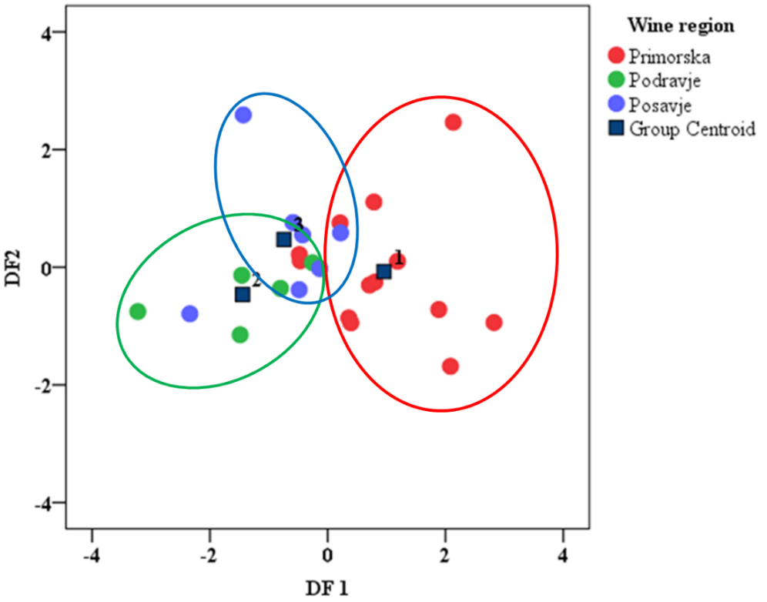
Figure 2. Graphic output of LDA in the plane of the first two discriminant functions. Classification according to Slovenian wine regions.
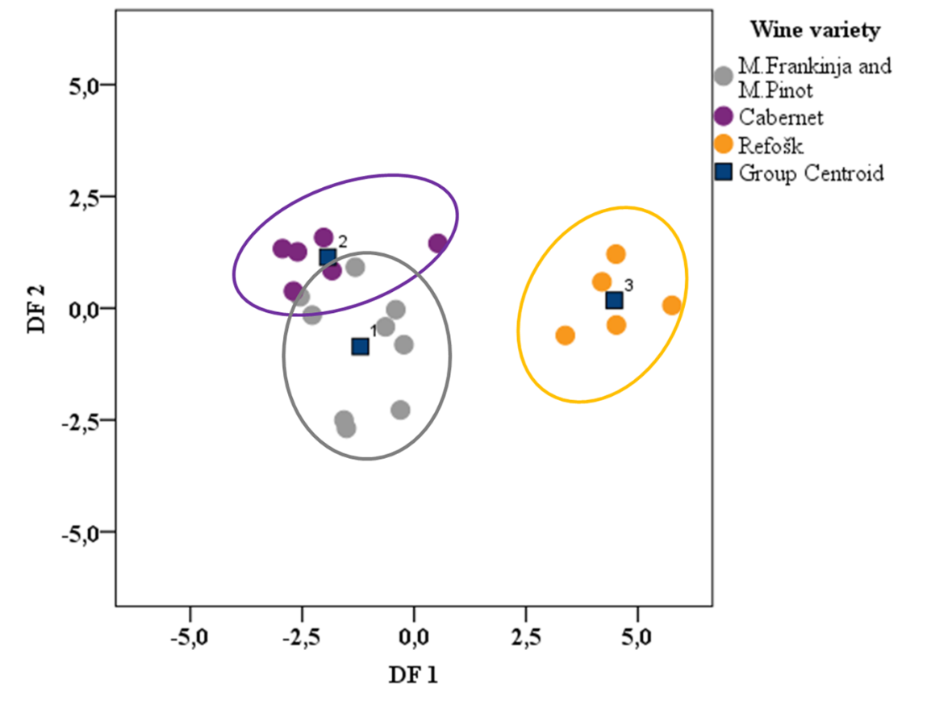

Figure 3. Graphic output of LDA in the plane of the first two discriminant functions. Classification according to varieties.

- Conclusions
This paper is one of a few studies on systematic chemical characterization of the most well-known Slovenian red wines. The results showed that Slovenian red wines are very rich source of health beneficial compounds, especially flavonoids. The results obtained were chemometrically processed, and wines classified according to region and grape variety. The analysis demonstrates the usefulness of variable selection and also suggests the application of a developed model for wine classification according to several parameters such as vintage, winemaking practices and alcohol content. It can also be used as a model for the routine classification and quality control of imported wines.
- References
- S. Moncayo, J. D. Rosales, R. Izquierdo-Hornillos, J. Anzano, J. O. Caceres, Talanta 2016, 158, 185–191.
- F. Mattivi, C. Zulian, G. Nicolini, L. Valenti, Ann. N. Y. Acad. Sci. 2002, 957, 37-56.
- D. Serrano-Lourido, J. Saurina, S. Hernández-Cassou, A. Checa, Food Chem. 2012, 135, 1425–1431.
- R. Garrido-Delgado, L. Arce, A.V. Guamán, A. Pardo, S. Marco, M. Valcárcel, Talanta. 2011, 84, 471–479.
- I. Geana, A. Iordache, R. Ionete, A. Marinescu, A. Ranca, M. Culea, Food Chem. 2013, 138, 1125–1134.
- B. T. Weldegergis, A. de Villiers, A. M. Crouch, Food Chem. 2011, 128, 1100–1109.
- A. Caligiani, D. Acquotti, G. Palla, V. Bocchi, Anal. Chim. Acta. 2007, 585, 110–119.
- L. Jaitz, K. Siegl, R. Eder, G. Rak, L. Abranko, G. Koellensperger, S. Hann, Food Chem. 2010, 122, 366–372.
- A. de De Villiers, G. Vanhoenacker, P. Majek, P. Sandra, J. Chromatogr. A. 2004, 1054, 195–204.
- Zakon o vinu (Slovenian wine laws), Uradni list Republike Slovenije. 2006, https://www.uradni-list.si/1/content?id=75822
- M. Ivanović, M. I. Razboršek, M. Kolar, Acta Chim. Slo. 2016, 63, In Press.
- X. Dewanto, K. Wu, K. Adom, R. H. Liu, J. Agric. Food Chem. 2002, 50, 3010-3014.
- B. Sun, J. M. Richardo-Da-Silva, I. Spranger, J. Agric. Food Chem. 1998, 46, 4267-4274.
- http://www.mt.com/es/en/home/applications/Application_Browse_Laboratory_Analytics/Application_fam_browse_main.html.
- M. Šeruga, I. Novak, L. Jakobek, Food Chem. 2011, 124, 1208-12016.
- V. Katalinić, M. Miloš, D. Modun, I. Musić, M. Boban, Food Chem. 2004, 86, 593–600.
- J. Piljac, S. Martinez, T. Stipčević, Z. Petrović, M. Metikoš-Huković, Am. J. Enol. Vitic. 2004, 55, 417–422.
- D. Di Majo, M. La Guardia, S. Giammanco, L. La Neve, M. Giammanco, Food Chem. 2008, 111, 45–49.
- A. Staško, V. Brezova, M. Mazur, M. Čertik, M. Kalinak, G. Gescheidt, LWT- Food Sci. Technol. 2008, 41, 2126–2135.
- A. Hosu, V. M. Cristea, C. Cimpoiu, Food Chem. 2014, 150, 113-118.
- L. M. Magalhaes, M. Ines, G. S. Almedia, L. Barreiros, S. Reis, M. A. Segundo, Food Anal. Meth. 2012, 5, 530-539.
- J. F. Harbertson, R. E. Hodgins, L. N. Thurston, L. J. Schaffer, M. S. Reid, J. L. Landon, C. F. Ross, D. O. Adams, Am J Enol Vitic. 2008, 59, 210-214.
- E. Buyuktuncel, E. Porgah, C. Colak, Food and Nut. Sci. 2014, 5, 1660-1667.
- Projekt »Modra frankinja - žametno vino Posavja« http://www.modra-frankinja.com/upload/urejevalnik/datoteke/2014_11_27_Strategija-trzenja-vina-modra-frankinja_FINAL.pdf
Acknowledgments
The authors would like to thank dr. Roman Kranvogl for his helpful comments regarding chemometric interpretation.
Povzetek
Vsebnost skupnih fenolov (TPC), flavonoidov (TFC) in taninov (TTC), kakor tudi skupni SO₂, skupne kisline, pH, reducirajoči sladkorji so bili določeni v petindvajsetih slovenskih rdečih vinih iz treh ključnih vinorodnih pokrajin: Podravja, Posavja in Primorske. Vsi pridobljeni rezultati so bili znotraj sprejemljivega območja skladno s slovenskim zakonom o kvaliteti vin. Rezultati so bili kemometrično ovrednoteni, vina pa razvrščena glede na vinorodne dežele in sorte grozdja. Metoda glavnih osi je pokazala, da so vsebnosti TPC, TFC in TTC v prvi vrsti odgovorne za razliko med vini. Z rezultati linearne diskriminantne analize pa smo ugotovili, da so analizirani parametri odvisni tako od sorte vina kot tudi od pokrajine oziroma vinorodnega območja.

