Infrared spectroscopy the work-horse for analysis of co-processed ibuprofen and magnesium trisilicate: co-milling vs. co-freeze drying

Manoj Acharya, Satyaki Mishra, Rudra N. Sahoo, Subrata Mallick*

Faculty of Pharmaceutical Sciences, Siksha ‘O’ Anusandhan University, Kalinganagar,
Khandagiri Square, Bhubaneswar, OR, India.

-----------------------------------------------------------------------------------------------------------
*Correspondence to: Subrata Mallick (E-mail: subratamallick@soauniversity.ac.in;
s_mallickin@yahoo.com; profsmallick@gmail.com)
Fax: +91-674-2386271; Tel: +91-674-2386209

Abstract
Infrared spectroscopy has been explored for analysis of co-processed ibuprofen and magnesium trisilicate. SEM and DSC have been monitored for examining interaction study. FTIR spectroscopy of co-processed formulations described acid–base reaction between the carboxylic acid containing ibuprofen to a significant extent. Dissolution of drug has been increased greatly after co-processing in comparison to crystalline ibuprofen. Increased absorbance of carboxylate peak accompanied by a consistently reduced absorbance of the carbonyl acid peak was evident, and the absorbance of carboxylate peak was rather more in freeze-dried sample compared to milled product. Intermolecular hydrogen bonding between ibuprofen and magnesium trisilicate in the co-processed material has been suggested. Inhibition of crystal growth morphology has been noticed in the photomicrographs of both the co-processed materials. DSC report has shown absence or significantly decreased melting endotherm representing almost complete amorphization of ibuprofen. Freeze-dried samples have improved drug dissolution more significantly compared to ball-milled samples.

Keywords: Infrared spectroscopy; co-milling; co-freeze drying; scanning electron microscopy; differential scanning calorimetry.

Introduction
Magnesium trisilicate is a compound of magnesium oxide and silicon dioxide with varying proportions of water (USP 28). As per PhEur 2005 magnesium trisilicate corresponds to the approximate Empirical Formula Mg₂Si₃O₈,xH₂O. The Structural Formula is 2MgO,3SiO₂,xH₂O. Magnesium trisilicate is used as a glidant in oral pharmaceutical formulations and food products. It is also used therapeutically as an antacid in the treatment of peptic ulcers. Via a neutralization reaction it increases the pH of gastric juice. After precipitation colloidal silica can coat gastrointestinal mucosa which can confer further protection. Magnesium trisilicate is also a solid adsorbent and could be utilized to improve the dissolution of poorly soluble drugs.^{1,2}
Ibuprofen, the most commonly prescribed NSAIDs³ is known to induce injury of the gastrointestinal tract and cause changes in the permeability and structural properties of the membrane.^{4,5} Indigestion, heartburn, or gastroesophageal reflux can sometimes be symptoms of more serious conditions such as stomach ulcers or stomach cancer and doctor consultation is necessary before taking magnesium trisilicate when an individual is taking a non-steroidal anti-inflammatory drug. Magnesium trisilicate interacts with a number of drugs and alter their absorption, thereby reducing their effectiveness.⁶⁻¹⁰ Enteric coatings designed to prevent the dissolution in the stomach may also be damaged by magnesium trisilicate.
Solid-dispersion granules of a poorly water-soluble drug containing microporous magnesium aluminosilicate (Neusilin) prepared by hot-melt granulation technique has shown improved dissolution of drug.^{11,12} The solid dispersion granules of BAY 12-9566 containing Neusilin were successfully compressed into tablets and increased dissolution. Mixtures of ibuprofen and porous adsorbents have shown considerably higher dissolution compared to the pure drug.¹³ The hydrogen-bonding potential of silanol groups on the surface of Neusilin brought about the increase in the drug dissolution rate.
Ball milling is a powerful tool for particle size reduction and processing in the pharmaceutical and non-pharmaceutical industries.¹⁴ It is also a device for effecting chemical reactions by mechanical energy in dry-state and at ambient temperatures.^{15,16} Ball milling presents a greener route for many processes compared to the use of microwave and ultrasound as energy sources. Impact and attrition during ball milling can bring about changes in the crystal structure of the drug and can induce amorphization¹⁷⁻²² and improve bioavailability.²³ Freeze drying is a standard process used to stabilize, store or increase the shelf life of drug products and other biologicals in the pharmaceutical industries. Physical structure may be retained and the material can be preserved for storage or transport.²⁴
In the present study co-processing of ibuprofen and magnesium trisilicate has been undertaken by milling together in the dry-state and freeze-drying after aqueous state kneading. FTIR spectroscopy was monitored to identify the mechanism of interaction²⁵⁻²⁷ of the carboxylic acid-containing drug ibuprofen with magnesium trisilicate. Infrared spectroscopy is a workhorse technique for pharmaceutical analysis in recent years. Infrared spectrum represents the molecular absorption and transmission, creating a molecular fingerprint of the sample. It corresponds to the frequencies of vibrations between the bonds of the atoms. Material is a unique combination of atoms and no two compounds produce the exactly same infrared spectrum. Changes in the frequency and shape of ibuprofen bands could be detected for the analysis of possible redistribution of electronic density in the structure of ibuprofen molecule. The interaction study has also been monitored by scanning electron microscopy and differential scanning calorimetry (DSC). Afterward, in-vitro drug release from the formulated co-processed powder was carried out to assure about the biological availability of the drug.²⁸ The detailed infrared spectroscopy of this type of interaction after co-processing by dry-state milling, and aqueous state equilibration and freeze drying has rarely been reported earlier. Nokhodchi et al.,²⁹ crystallized ibuprofen in presence of starch derivatives for improved pharmaceutical performance and found no significant change in FTIR spectroscopy and concluded that there is no change in molecular level of ibuprofen. Ibuprofen solid dispersions prepared using polyethylene glycol 4000 have shown no significant change in FT-IR spectra.²⁷
Experimental
Materials
Ibuprofen was obtained from Tejani Life care, Cuttack, India and magnesium trisilicate (USP 28) was purchased from Burgoyne & Co, India (not less than 20% of magnesium oxide and not less than 45 % of silicon dioxide; loss on ignition 17.0-34.0%). All other chemicals used were of analytical reagent grade.

Co-processing of ibuprofen and magnesium trisilicate
Crystalline powder of ibuprofen and magnesium trisilicate powder were mixed for approximately 5 minutes by simple blending process using mortar and spatula at laboratory ambient condition in the dry-state (∼30 °C; ∼60 % RH) without trituration. Ibuprofen and magnesium trisilicate (physical mixtures) weight ratios were maintained as per formulation and left for immediate use in the co-process of dry-state ball-milling and, aqueous state kneading and freeze-drying.
Dry-state ball-milling
The powder mixture of ibuprofen and magnesium trisilicate in the weight ratios was placed into a cylindrical vessel of ball mill (Swastik Electric and Scientific Work, India) and 1 h period of constant milling was performed in the dry-state at lab ambient condition of ~30 °C, ~60 % RH. Significant increase in temperature of the milled material has not been detected at the end of the co-process. Ball charged in the vessel allowed smooth cascading motion, and significant attrition and impact during dry-state milling while operating the mill at 100 rpm for 1 h.
Aqueous state kneading and freeze-drying
Aqueous state kneading was performed by adding small amount of water in the physical powder mixtures of ibuprofen and magnesium trisilicate and left for a period of about 12 h at ambient conditions for equilibration. The kneaded samples were freeze-dried (Lark, Penguin Classic Plus, India) for 10-12 hours for effective drying. The pressure during freeze-drying was adjusted to 15–20 Pa while temperature maintained approximately at −40 °C. The freeze-dried samples were preserved in the desiccator till further analysis.
The ball-milled and freeze-dried samples were left at ambient condition (∼60% RH, ∼30 °C) for few hours and dried in an incubator (Labotech, India) at 50 °C. The powder materials were passed through mesh 44 (opening ~350 μm) and assayed for drug content determination from the absorbance measured at 222 nm (λ_{max}) in the UV visible Spectrophotometer (Jasco-V630 UV Spectrophotometer Spectrometer, Software: Spectra Manager) using standard calibration curve of ibuprofen.
Ibuprofen–magnesium trisilicate interaction study
FTIR spectra of pure crystalline ibuprofen and co-processed powder samples were performed for a comparative study between co-milling and co-freeze drying interaction. All the samples were mixed thoroughly with potassium bromide in the ratio of 1:100. KBr discs were prepared by compressing the powders at a pressure of 6 tonnes for 10 min in a Hydraulic pellet press (Technosearch Instruments, Maharashtra, India) and scans were collected (Table 1).

Table 1 FTIR information

[Detailed Information] |  | [Measurement Information]
Data array type | Linear data array | Model Name | FT/IR-4100typeA
Horizontal axis | Wavenumber [cm⁻¹] | Serial Number | B131661016
Vertical axis | %T | Light Source | Standard
Start | 399.193 cm⁻¹ | Detector | TGS
End | 4000.6 cm⁻¹ | Accumulation | 80
Data interval | 0.964233 cm⁻¹ | Resolution | 4 cm⁻¹
Data points | 3736 | Zero Filling | On
 |  | Apodization | Cosine
 |  | Aperture | Auto (7.1 mm)
 |  | Scanning Speed | Auto (2 mm/sec)
 |  | Filter | Auto (30000 Hz)

Surface morphology and thermal analysis of the particle
Surface morphology and crystalline nature of the particulate samples were investigated using Scanning electron microscope (Instrument JSM-6390, Jeol, Tokyo, Japan). The powder samples were dried and sputtered with gold and scanned at room temperature using an accelerated voltage of 10 kV (Wd 19 and Spot_Size 48). Thermal behavior of the powder samples was characterized using a Differential scanning calorimeter (DSC, Universal V4.2E TA Instruments). Samples approximately 5–6 mg were weighed accurately and put into crimped aluminum pans with a pin hole in the lid. All samples were heated at a heating rate of 10 °C/min in an atmosphere of nitrogen gas purge at 50 ml/min from 30 and 300 °C.
Dissolution studies
Powdered samples containing 10 mg equivalent of ibuprofen were dispersed in 900 ml of distilled water and dissolution was carried out using USP XXIV type II dissolution apparatus (Electrolab, dissolution tester USP TDT 06L, India) at a temperature of 37 ± 0.2˚C and paddle rotation set at 100 rpm. Ibuprofen concentration was determined by UV absorption at 222 nm. Aliquots were withdrawn at appropriate time intervals of 5, 10, 15, 30, 60, 90 and 120 min, and replaced with a fresh dissolution medium. After proper rinsing of the cuvette and filtration of the aliquot through a 0.45 μm membrane filter, absorbance was recorded using the UV-Visible Spectro photometer. Standard calibration curve was used for calculating the respective concentration and the data were utilized to estimate cumulative percent drug release. Cumulative percent drug release was reported as the mean of not less than three determinations.
Results and discussion
Crystalline ibuprofen was co-processed with magnesium trisilicate in the dry-state by constant milling for 1 h period at lab ambient condition of ~30 °C. Aqueous state co-processing was also performed by kneading with water and freeze-drying at 15–20 Pa pressure and maintained temperature at −40 °C. These types of dry-process and wet-process could be analogous to the commonly followed processes in the tablet granulation department of pharmaceutical industries. These processes are effective, simple and scalable for interaction study. Due to presence of varying amount of bound moisture in native magnesium trisilicate the co-milled materials became moisty in nature and needed drying. Instant character of the freeze-dried samples is to absorb moisture like a sponge when left at ambient condition of ∼60 % RH and 30 °C for few hours and drying in an incubator at 50 °C becomes necessary. The co-processed dried and equilibrated powder materials were passed through mesh of opening ~350 μm and assayed for actual drug content determination. Ibuprofen–magnesium trisilicate interaction study has been characterized by FTIR, and the usefulness of this powerful technique has been supported by scanning electron microscopy and differential scanning calorimetry as described below. Drug release from the formulated dosage form is important and ultimately related to the bioavailability of the drug. Dissolution of ibuprofen from the co-processed material has also been described below. Formulation detail and code of ibuprofen samples co-processed with magnesium trisilicate has been mentioned in Table 2.

Table 2 Formulation code of ibuprofen samples co-processed with magnesium trisilicate

Formulation code | Drug: MTS ratio | Co-processing | Ibuprofen assay (%)
IB | -- | -- | --
IB₃M₁B | 3: 1 | Dry-state Ball-milling for one hour | 71.61±5.1
IB₂M₁B | 2: 1 | Dry-state Ball-milling for one hour | 68.65±4.6
IB₁M₁B | 1:1 | Dry-state Ball-milling for one hour | 46.09±3.5
IB₁M₂B | 1: 2 | Dry-state Ball-milling for one hour | 37.54±2.8
IB₃M₁F | 3: 1 | Aqueous state equilibration and freeze-drying | 74.11±3.2
IB₂M₁F | 2: 1 | Aqueous state equilibration and freeze-drying | 68.55±3.8
IB₁M₁F | 1:1 | Aqueous state equilibration and freeze-drying | 48.65±2.4
IB₁M₂F | 1: 2 | Aqueous state equilibration and freeze-drying | 30.54±2.1
Ibuprofen = IB, Magnesium trisilicate = MTS,

FTIR Analysis
Spectral data of FTIR band assignments of ibuprofen and co-processed samples are tabulated in Table 3. The very strong band at 2958 cm⁻¹ in the FTIR spectrum of ibuprofen is assigned to CH₃ asymmetric stretching.³⁰ Ibuprofen has also shown the presence of free acid carbonyl peak at 1722 cm⁻¹ with high intensity,^{27,31} but became very weak when co-milled in the dry-state as well as co-freeze-dried after aqueous state kneading and equilibration with magnesium trisilicate (Fig. 1a,b). As the magnesium trisilicate (2MgO,3SiO₂,xH₂O) contains magnesium oxide (not less than 20 % of magnesium oxide as per USP 28) and the acidic nature of the carboxylic acid group of ibuprofen, the possibility of an acid–base interaction between the drug and MgO of magnesium trisilicate was explored. Also, very high intensity peak of ibuprofen at 1230 cm⁻¹ was due to C-C stretching³² became gradually medium, weak, very weak and absent as the magnesium trisilicate amount increased in both the co-processed materials IB₃M₁F to IB₁M₂F and IB₃M₁B to IB₁M₂B. A strong band noticed at 779 cm⁻¹ in ibuprofen was due to CH₂ rocking vibration and the intensity observed to be weaker and weaker after co-processing.^{33,34} CH₂ asymmetric stretching vibration (3094 cm⁻¹ and 2868 cm⁻¹) and CH₂ inplane rocking vibration (522 cm⁻¹) were also detected in pure ibuprofen and found weaker and absent when co-milled and freeze dried after co-kneading. CH₂ asymmetric stretching vibration (3094 cm⁻¹ and 2868 cm⁻¹), CH₃ asymmetric deformation (1462 cm⁻¹), CH₃ rocking of strong intensity (935 cm⁻¹), and CH₂ inplane rocking vibration (522 cm⁻¹) were also detected in pure ibuprofen. Poor band

Table 3 Spectral data of FTIR of ibuprofen and co-processed samples

Band | Tentative assignments | Wavenumber (cm⁻¹)
Band | Tentative assignments | Ibuprofen | MTS | IB₃M₁F | IB₂M₁F | IB₁M₁F | IB₁M₂F | IB₃M₁B | IB₂M₁B | IB₁M₁B | IB₁M₂B
1 | OH stretching | absent | 3200- 3550 bb | 3200- 3550 bb | 3200- 3550 bb | 3200- 3550 bb | 3200- 3550 bb | 3200- 3550 bb | 3200- 3550 bb | 3200- 3550 bb | 3200- 3550 bb
2 | CH2 asym str | 3094 m | -- | absent | absent | absent | absent | 3096 w | 3096 w | absent | absent
3 | CH3 asym str | 2958 vs | -- | 2955 vs | 2955 vs | 2954 vs | 2954 vs | 2955 vs | 2955 vs | 2954 vs | 2953 vs
4 | CH2 sym str | 2868 m | -- | 2868 m | 2868 m | 2868 m | 2868 m | 2869 m | 2869 m | 2869 m | 2869 m
5 | O-H…O valance str combination | 2729 m | -- | 2729 aa | 2729 aa | 2729 aa | 2729 aa | 2730 w | 2730 w | 2730 vw | Absent
6 | O-H…O valance str combination | 2630 m | -- | Absent | Absent | Absent | Absent | 2631 vw | 2632 vw | Absent | Absent
7 | C=O str | 1722 vs | -- | 1720 vw | 1720 vw | 1720 vw | Absent | 1720 m | 1720 m | 1720 w | Absent
8 | carboxylate stretching mode | Absent | -- | 1600-1650 m | 1600-1650 m | 1600-1650 m | 1600-1650 s | 1600-1650 w | 1600-1650 w | 1600-1650 m | 1600-1650 s
9 | aromatic C=C str | 1507 s | -- | 1512 vw | 1511 vw | 1512 vvw | 1512 vvw | 1509 m | 1508 m | 1511 vw | 1511 vw
10 | CH3 asym deformation, CH2 scissoring | 1462 s | -- | 1462 vw | 1463 vw | 1463 vw | 1463 vw | 1462 m | 1462 m | 1463 vw | 1464 vw
11 | CH-CO deformation | 1420 s | -- | 1421 vw | 1421 vw | 1421 vw | 1415 vw | 1420 m | 1420 m | 1421 vw | 1421 vw
12 | CH3 sym str | 1380 s | -- | 1383 vvw | 1382 vvw | 1382 vvw | 1384 vvw | 1380 w | 1381 w | 1380 vw | 1381 vvw
13 | OH in plane deformation | 1321 s | -- | 1322 vw | 1321 vw | 1322 vw | 1322 vvw | 1321 m | 1321 w | 1322 vw | 1325 vvw
14 | =C-H in plane deformation | 1268 s | -- | 1268 vw | 1268 vw | 1268 vw | 1268 vvw | 1263 m | 1269 w | 1269 vw | 1268 vvw
15 | C…C str | 1230 vs | -- | 1231 vw | 1231 vw | 1230 vw | 1230 vvw | 1231 m | 1231 w | 1232 vw | 1232 vvw
16 | C-O str | 1183 s | -- | 1183 vw | 1184 vw | 1183 vw | 1183 vvw | 1184 m | 1184 w | 1185 vw | 1185 vvw
17 | =C-H in plane deformation | 1122 w | -- | merger | merger | merger | merger | merger | merger | merger | merger
18 | =C-H in plane deformation | 1067 m | -- | merger | merger | merger | merger | merger | merger | merger | merger
19 | Si-O-Si  asym str | Absent | 1027 bb | ∼1027 mbb | ∼1027 mbb | ∼1027 bb | ∼1027 bb | ∼1027 mbb | ∼1027 mbb | ∼1027 bb | ∼1027 bb
20 | C-H in plane deformation | 1008 m | -- | merger | merger | merger | merger | merger | merger | merger | merger
21 | C-O-C str | 970 m | -- | 970 w | 970 vw | 970 vvw | 970 vvw | 970 w | 970 w | 970 vw | 970 vvw
22 | CH3 rocking vibration | 935 s | -- | 948 vw | 948 vw | 948 vvw | absent | 935 w | 936 w | 936 vw | 936 vvw
23 | C-H out of plane vibration | 866 s | -- | 866 vw | 866 vw | 866 vvw | absent | 866 w | 866 w | 866 vw | 865 vw
24 | CH2 rocking | 779 s | -- | 780 w | 780 w | 780 vw | 780 vvw | 779 w | 779 w | 780 vw | 780 vvw
25 | C=C ring str, C...C skeletal vibration | 746 w | -- | 746 vw | 746 vw | 746 vw | 746 vvw | 746 vw | 746 vw | 746 vvw | 746 vvw
26 | C-H out of plane deformation | 668 s | -- | 669 vvw | 669 vvw | 669 vvw | 669 vvw | 668 m | 668 w | 669 vw | 669 vvw
27 | C-H in plane ring deformation | 636 w | -- | 636 vvw | 636 vvw | 635 vvw | 635 vvw | 636 w | 636 w | 636 vw | 636 vvw
28 | C...C deformation | 588 m | -- | 588 vvw | 588 vvw | 588 vvw | 588 vvw | 588 m | 588 w | 588 vw | 588 vvw
29 | CH2 in plane rocking | 522 m | -- | 522 vvw | 522 vvw | 522 vvw | 522 vvw | 522 m | 522 w | 522 vvw | 522 vvw
30 | CH2/CH3 deformation vibration | 479 vw | -- | 472 vw | 462 vw | 464 vw | 461 vw | 461 vw | 464 vw | 462 vw | 462 vw
31 | O-Si-O bending | Absent | 471 bb | 464 m | 461 m | 463 bb | 463 bb | 464 m | 464 m | 464 bb | 464 bb
32 | C=C-C ring asym bending | 421 w | -- | 420 aa | 421 aa | 421 aa | 421 aa | 420 vvw | 421 vvw | 421 vvw | 421 vvw

(s- strong; bb- broad band; mbb- medium broad band; w- weak; sym-symmetrical; asym-asymmetrical; str-stretching; m- medium; vs- very strong; vw – very weak; vvw – very very weak; aa- almost absent.)

(a)
Figure 1 (contd.)

(b)

Figure 1 FTIR spectroscopy of co-processed ibuprofen and magnesium trisilicate after dry-state ball-milling (a) MTS, IB, IB3M1F, IB2M1F, IB1M1F, and IB1M2F; and aqueous state equilibration and freeze-drying (b) IB, IB3M1B, IB2M1B, IB1M1B, and IB1M2B.

performance was perceived in the co-processed formulations. C-O stretching (1183 cm⁻¹), CH₂ scissoring vibration (1462 cm⁻¹) and CH-CO deformation (1420 cm⁻¹) contributed their presence strongly in ibuprofen alone and weakly in the co-processed powder. An acid–base reaction between the carboxylic acid containing ibuprofen and MgO containing MTS in presence of moisture can describe the changes in the FTIR spectra of co-processed formulations. The reaction has been facilitated in presence of water when co-freeze-dried after aqueous state kneading and equilibration with magnesium trisilicate and also co-milled in the dry-state containing varying proportions of water in the MTS compound. Carboxylate ion shows peak in the range of 1600-1650 cm⁻¹ in the FTIR spectrum and this change was detected as a function of IB/MTS ratio. A reduction in absorbance of the carbonyl acid peak accompanied by a corresponding increase in the absorbance of carboxylate peak was prominent and the absorbance of carboxylate peak was relatively more in freeze-dried product compared to milled product. A large broad band between 3550 to 3200 cm⁻¹ ascribed to the presence of the O-H stretching frequency of silanol group bonded to the inorganic structure of MTS (containing SiO₂), and also hydrogen bonds between adsorbed water and silanol.^{25,35} This large broad band is absent in ibuprofen pure drug but consistently maintained in all the co-processed materials could be due to intermolecular hydrogen bonding. The band related to the silanol (Si-O-Si) asymmetric stretching was found at 1027 cm⁻¹ with high intensity in MTS and also in the co-processed formulations. Silanol asymmetric stretching intensity increased with the amount of MTS in the formulation. Another peak at 471 cm⁻¹ in MTS due to O-Si-O bending³⁶ prominently observed in the formulations. The small changes in the band intensity, band orientation and overlapping indicated only van der Waals or dipole-dipole interactions between ibuprofen and magnesium trisilicate molecules.
Characterization by scanning electron microscopy and differential scanning calorimetry
Scanning electron microscopy is a powerful tool to study the inhibition of crystal growth morphology. Fig. 2 shows distinctive plate like layers due to the crystalline nature in the initial samples of pure ibuprofen. Physical mixture of drug and magnesium trisilicate in 1:1 ratio (IB₁M₁pm) shows the presence of ibuprofen crystal geometry very clearly with slightly damaged morphology. Markedly reduced particle size has been noticed not only in the co-milled materials but also in the freeze-dried formulations after aqueous state kneading and co-processing. Crystal geometry of ibuprofen has been significantly disappeared in both the co-processed materials.

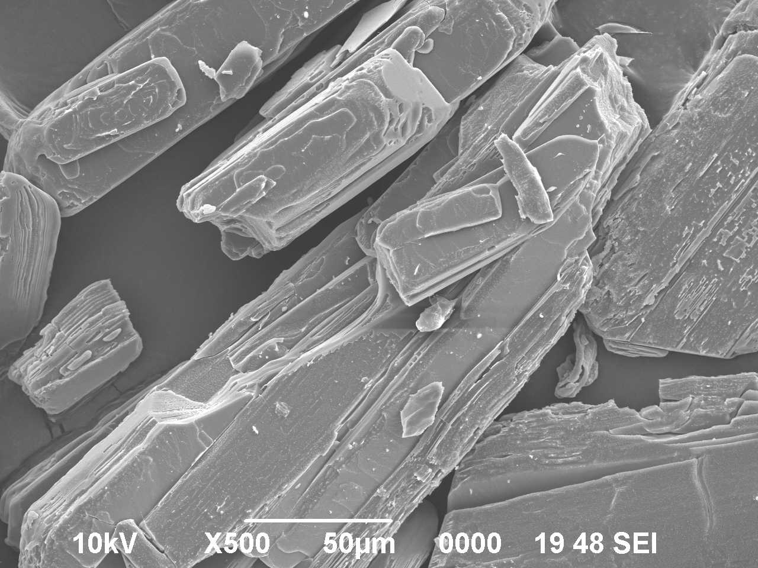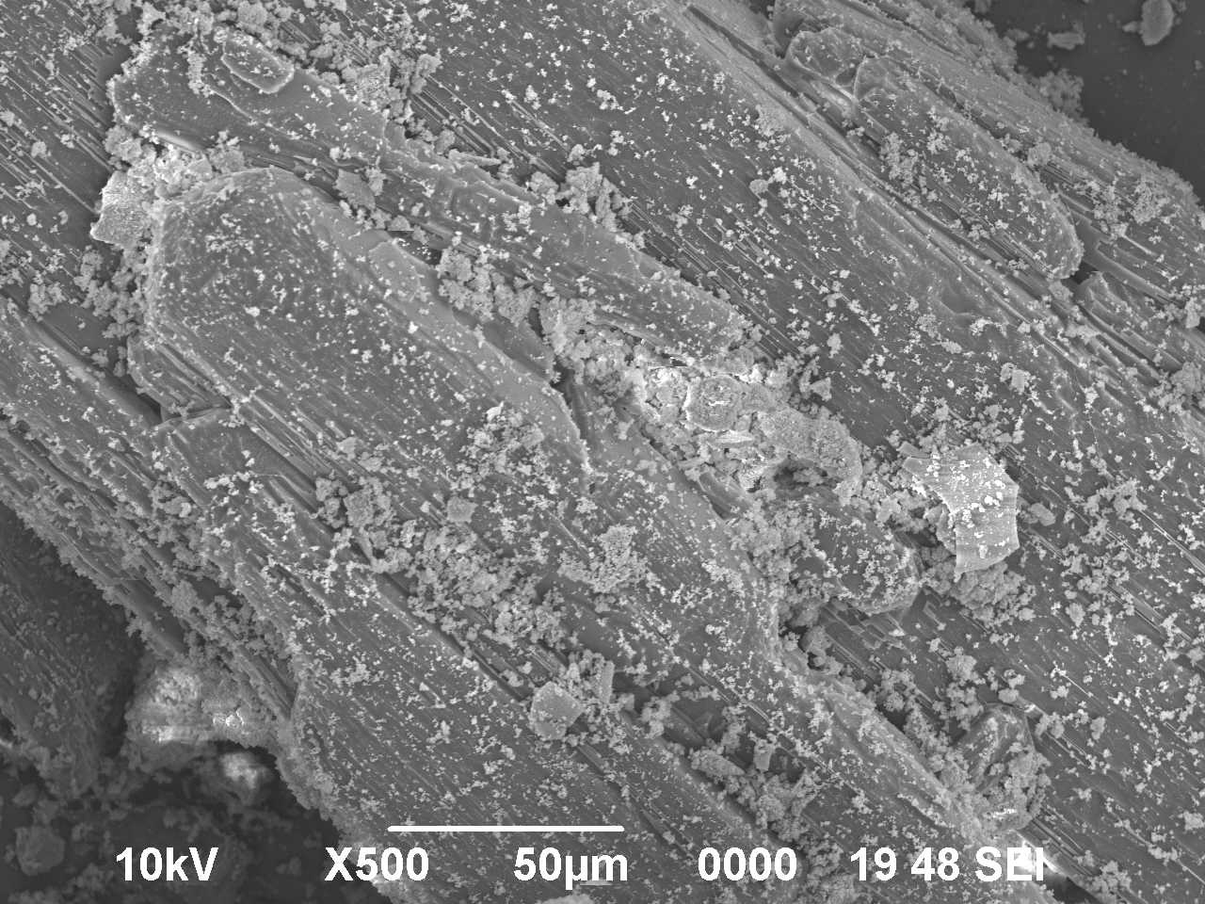
b
a

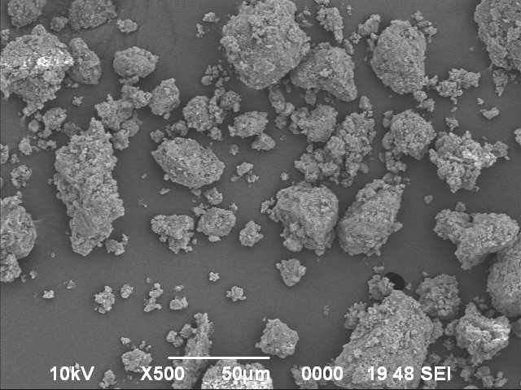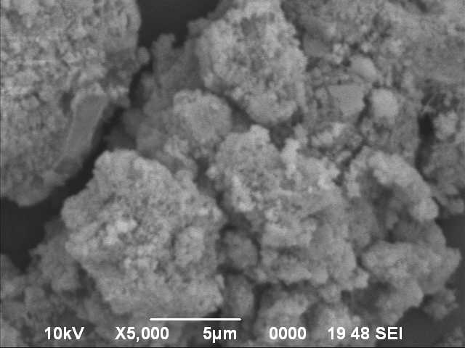
d
c

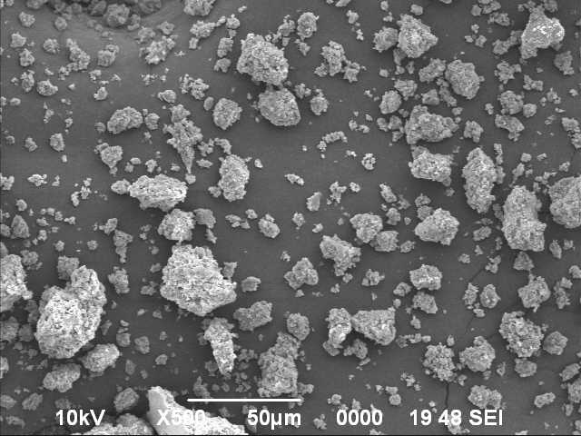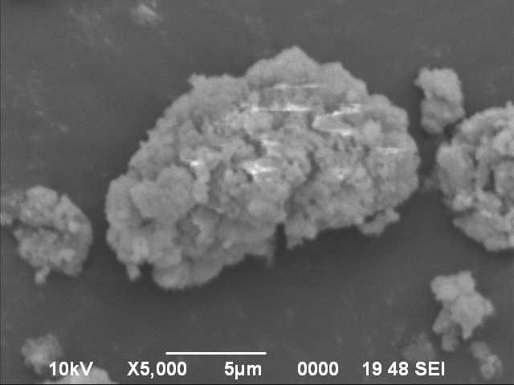
f
e

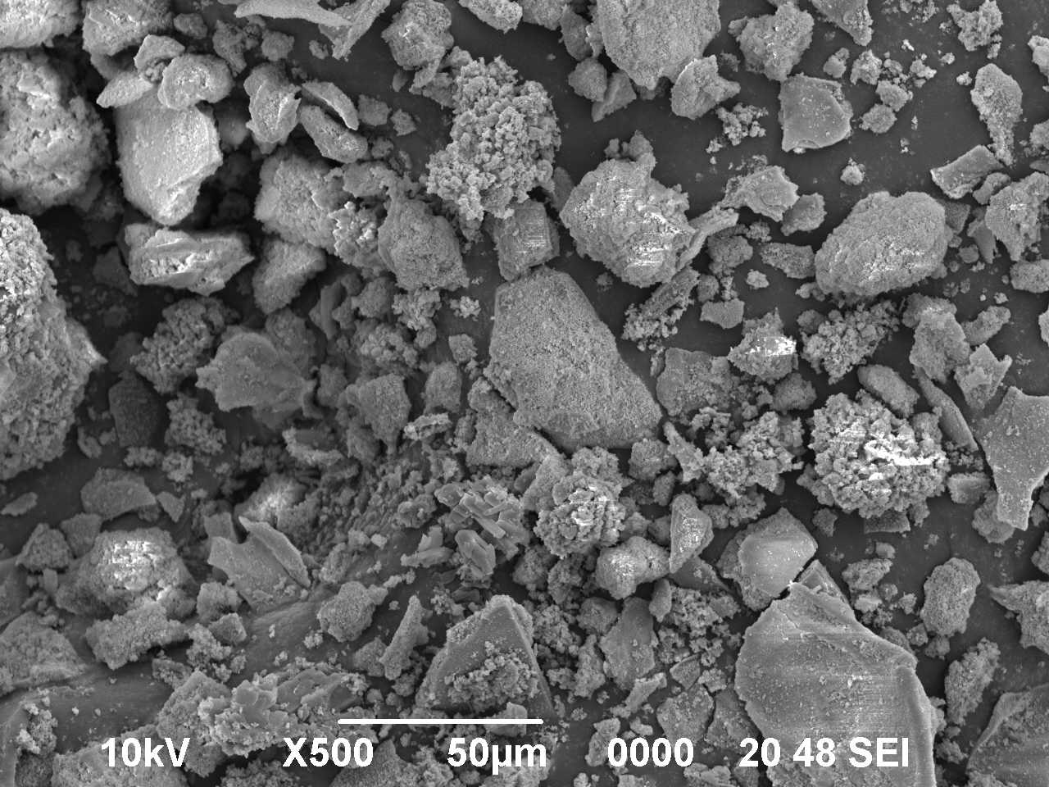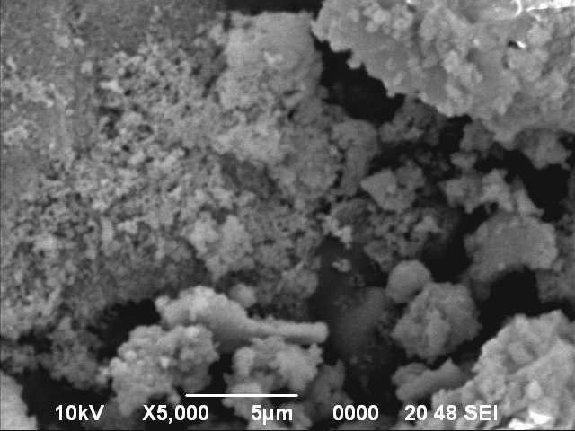
g
h

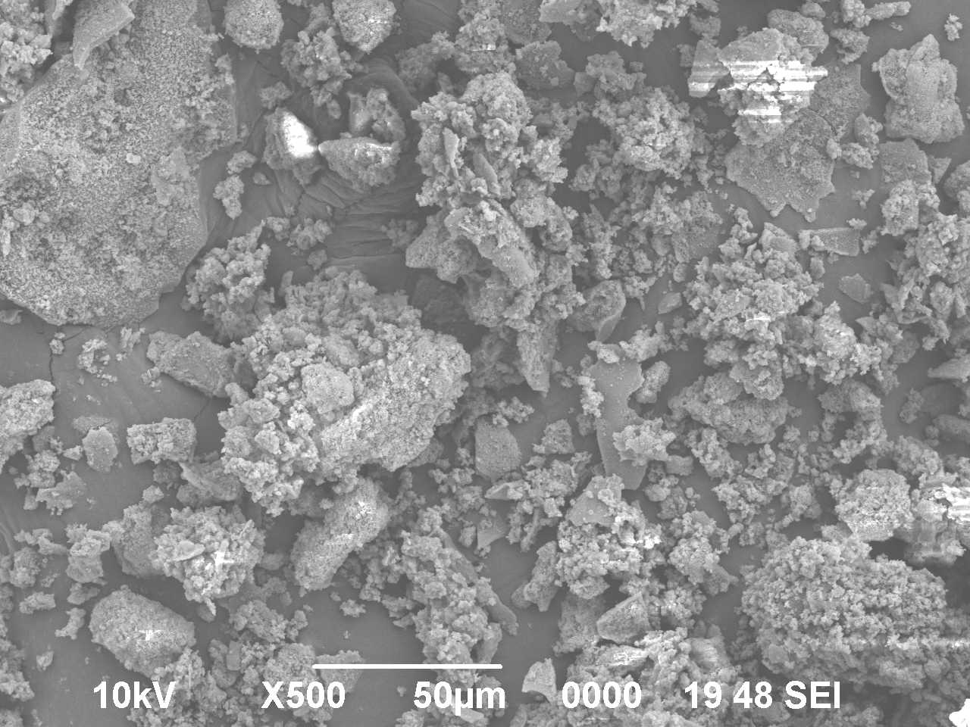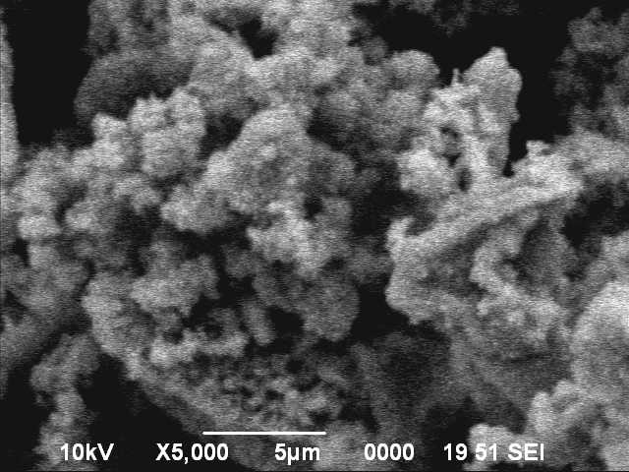
j
i

Figure 2 (a) Ibuprofen pure, (b) IB₁M₁pm, (c) IB₁M₁B (X500), (d) IB₁M₁B (X5000), (e) IB₁M₂B (X500), (f) IB₁M₂B (X5000), (g) IB₁M₁F (X500), (h) IB₁M₁F (X5000), (i) IB₁M₂F (1:2)F(X500), and (j) IB₁M₂F (X5000).

Sub-micron and nano-crystalline agglomeration were observed particularly in the milled material whereas, freeze-dried materials have shown porous bed of irregular nanoparticles developing grain boundaries in the crystal structure indicating loss of crystal geometry. These grain boundaries supposed to disrupt the motion of dislocations and reduce the crystallite size of ibuprofen in the co-processed powder.³⁷
Differential scanning calorimetry is frequently used in pharmaceutical research as an analytical tool for the identification and interaction study of active drug after co-processing with other pharmaceutical compounds.³⁸⁻⁴³ It can explain the miscibility/incompatibility with its effects on thermal stability, yielding results promptly and efficiently.⁴⁴ Thermograms after differential scanning calorimetry of pure ibuprofen and co-processed powder samples are presented in Fig 3. Ibuprofen has shown the melting endotherm at 76.7 °C which is approximately similar to the literature value.³³ With the increase of MTS amount in the co-processed material melting temperature and enthalpy (data not mentioned) have been decreased markedly signifying the material is made up of a number of smaller crystals or crystallites, and paracrystalline phases. Melting endotherm of IB₁M₂B and IB₁M₂F has been disappeared indicating an almost amorphous structure where the atomic position is limited to short range order only. Amorphous phase of ibuprofen could be possible to produce by solid state co-milling with kaolin.³¹ The interaction between ibuprofen and the porous silica adsorbents indicated a significant loss of crystallinity of ibuprofen by the DSC studies.¹³

Figure 3 Differential scanning calorimetry of co-processed ibuprofen and magnesium trisilicate after dry-state ball-milling, and aqueous state equilibration and freeze-drying

Dissolution of ibuprofen
In-vitro drug release profiles of the co-processed material up to 120 min have been depicted in the Fig. 4a,b. The powder materials have shown significantly improved dissolution of drug after co-processing. Crystalline ibuprofen exhibited only 52.89 % dissolution whereas, dry-state co-milling of ibuprofen and magnesium trisilicate has improved dissolution to a great extent (77.98 to 85.84 %). Formulated powder samples of aqueous state co-processing and freeze-drying of ibuprofen and magnesium trisilicate have presented relatively more improved drug release (84.87 to 100.29 %). Percentage release of ibuprofen increased gradually with the gradual increase in magnesium trisilicate proportion in the freeze-dried samples. Mixtures of ibuprofen and magnesium trisilicate have presented substantially higher dissolution compared to the pure drug. Magnesium oxide (MgO) in magnesium trisilicate and carboxylic acid containing ibuprofen brought about the acid–base reaction and the hydrogen-bonding potential of silanol groups of SiO₂ in the surface of magnesium trisilicate facilitated collectively the increase in the drug dissolution rate. Dissolution of nimesulide from pharmaceutical formulations exhibited better dissolution when the formulations contain micronized nimesulide crystals and medium become alkaline rather than acidic.²⁸ Increased proportion of magnesium trisilicate in the mixture might have consumed the carboxylic acid containing ibuprofen and more of hydrogen-bonding potential of silanol groups can describe the increased release of ibuprofen of the co-processed formulations. Otsuka et al. have been able to transform the crystalline polymorphs of indomethacin to amorphous states during milling which had 60 % higher dissolution than the crystalline state.²⁰ The increased dissolution of drug from solid dispersions possibly be related to the decreased drug crystallinity or effective wetting of the reduced drug particles.⁴⁵⁻⁴⁸ Co-processing of ibuprofen with magnesium trisilicate for enhanced dissolution possibly be a promising approach for improvement of ibuprofen bioavailability.⁴⁷

(a)

(b)

Figure 4 Dissolution profiles of co-processed ibuprofen and magnesium trisilicate: (a) dry-state ball-milling samples; (b) freeze-dried samples after aqueous state equilibration.

Conclusions
Crystalline ibuprofen co-processed with magnesium trisilicate in the dry-state by constant milling, and in the aqueous state equilibration and freeze-drying has been analyzed by infrared spectroscopy. Changes in the frequency and shape of ibuprofen bands after co-processing have been detected for the analysis of redistribution of electronic density in the structure of ibuprofen molecule. Changes in the FTIR spectroscopy of co-processed formulations can describe acid–base reaction between the carboxylic acid containing ibuprofen and MgO of magnesium trisilicate (2MgO,3SiO2,xH2O). Varying proportions of water in the magnesium trisilicate facilitated the reaction in the dry-state milling rather gently while, aqueous state equilibration and freeze-drying brought about the reaction considerably. Reduced absorbance of the carbonyl acid peak accompanied by a consistently increase in the absorbance of carboxylate peak was prominently visible and the absorbance of carboxylate peak was rather more in freeze-dried product compared to milled sample. O-H stretching frequency of silanol group due to the presence of SiO₂ in the structure of MTS and the hydrogen bonds between adsorbed water and silanol attributed a large broad band between 3550 to 3200 cm⁻¹ in all the co-processed materials and not in ibuprofen pure drug spectrum. That is the indication of intermolecular hydrogen bonding between ibuprofen and magnesium trisilicate in the co-processed material. Scanning electron microscopy revealed the inhibition of crystal growth morphology in both the co-processed materials. Milled material has shown sub-micron and nano-crystalline accumulation but, porous bed of irregular nanoparticles with developing grain boundaries was observed in the crystal structure of the freeze-dried samples. Missing of melting endotherm in the DSC report of IB₁M₂B and IB₁M₂F signified almost complete amorphization of ibuprofen. Significantly decreased melting temperature and enthalpy of ibuprofen in the other co-processed materials indicated inhibition of crystal growth to a great extent. Significantly increased dissolution of drug has been noticed after co-processing compared to crystalline ibuprofen alone. Freeze-dried process presented relatively more enhanced drug dissolution compared to ball-milled samples.
Acknowledgments
The authors are very much grateful to Prof. Manoj Ranjan Nayak, President, Siksha O Anusandhan University for his inspiration and facilities.
Conflict of Interest
None
References
- F. Carli, E. Chiellini, Pharmaceutical composition comprising a water/oil/water double microemulsion incorporated in a solid support. 2004, Google Patents.
- X. Pan, The application of porous adsorbents to increase the dissolution rate of low solubility drugs, dissertation. 2002, University of Maryland.
- R. Jones, Am. J. Med. 2001, 110, S4–S7.
- L. M. Lichtenberger, Y. Zhou, E. J. Dial, R. M. Raphael, J. Pharm. Pharmacol. 2006, 58, 1421–1428.
- C. S. Levin, J. Kundu B. G. Janesko, G. E. Scuseria, R. M. Raphael, N. J. Halas, J. Phys. Chem. B. 2008, 112, 14168–14175.
- D. M. Moss, M. Siccardi, D. J. Back, A. Owen, J. Antimicrob. Chemother. 2013, 68, 1627–1634.
- V. F. Naggar, S. A. Khalil, M. W. Gouda, J. Pharm. Sci. 1978, 67, 1029-1030.
- V. F. Naggar, S. A. Khalil, Clin. Pharmacol. Ther. 1979, 25, 857-863.
- V. F. Naggar, S. A. Khalil, Pharmazie. 1980, 35, 412-416.
- S. A. Babhair, M. Tariq, Res. Commun. Chem. Pathol. Pharmacol. 1983, 40, 165-168.
- M. K. Gupta, D. Goldman, R. H. Bogner, Y-C. Tseng, Pharm. Dev. Technol. 2001, 6, 563–572.
- M. K. Gupta, R. H. Bogner, D. Goldman, Y-C. Tseng, Pharm. Dev. Technol. 2002, 7, 103–112.
- S. Madieh, M. Simone, W. Wilson, D. Mehra, L. Augsburger, J. Pharm. Sci. 2007, 96, 851–863.
- M. Mihelcic, A. S. Vuk, D. Vrhovsek, F. Svegl, M. Hajzeri, B. Orel, Acta Chim. Slov. 2014, 61, 517–529.
- T. Friscic, in: A. Stolle, B. Ranu (Ed.): Ball Milling Towards Green Synthesis: Applications, Projects, Challenges, Royal Society of Chemistry, Thomas Graham House, Cambridge, UK, 2015, pp. 151-189.
- Y. Liu, X. Wang, H. Liu, Z. Dong, S. Li, H. Gea, M.Yan, RSC Adv. 2015, 5, 60460-60466.
- G. Buckton, A. Choularton, A. E. Beezer, S. M. Chatham, Int. J. Pharm. 1988, 47, 121–128.
- S. Kitamura, A. Miyamae, S. Koda, Y. Morimoto, Int. J. Pharm. 1989, 56, 125–134.
- M. Otsuka, T. Ofusa, Y. Matsuda, Colloids Surf. B: Biointerf. 1999, 13, 263–273.
- M. Otsuka, T. Matsumoto, N. Kaneniwa, Chem. Pharm. Bull. 1986, 34, 1784–1793.
- B. Karolewicz, A. Górniak, A. Owczarek, E. ŻurawskaPłaksej, A. Piwowar, J. Pluta, J. Therm. Anal. Cal. 2014, 115, 2487-2493.
- H. Al-Hamidi, K. Asare-Addo, S. Desai, M. Kitson, A. Nokhodchi, Drug Dev Ind Pharm. 2015, 41, 1682-1692.
- E. Klosinska-Szmurlo, M. Grudzien, K. Betlejewska-Kielak, F. Plucinski, J. Biernacka, A. P. Mazurek, Acta Chim. Slov. 2014, 61, 827–834.
- M. J. Pikal, in: J. C. May, L. Rey, (Ed.): Freeze-Drying/Lyophilization of Pharmaceutical & Biological Products, 2004, Marcel Dekker, Inc. New York, U.S.A.
- A. O. Jorgetto, S. P. Pereira, R. I. V. da Silva, M. J. Saeki, M. A. U. Martines, V. A. Pedrosa1, G. R. de Castro, Acta Chim. Slov. 2015, 62, 111–121.
- A. Górniak, B. Karolewicz, H Czapor-Irzabek, O. Gładysz, Farmacia, 2016, 64, 244-251.
- M. Newa, K. H. Bhandari, D. X. Li, J. O. Kim, D. S. Yoo, J. A. Kim, B. K. Yoo, J. S. Woo, H. G. Choi, C. S. Yong, Biol. Pharm. Bull. 2008, 31, 939–945.
- B. Tubic, A. Uzunovic, S. Pilipovic, Z. Gagic, Acta Chim. Slov. 2016, 63, 193–199.
- A. Nokhodchi, A. Homayouni, R. Araya, W. Kaialy, W. Obeidat, K. Asare-Addo, RSC Adv. 2015, 5, 46119-46131. DOI: 10.1039/C5RA06183K
- R. M. Silverstein, G. C. Bassler, T. C. Morrill, in: J. Stiefel (Ed.): Infrared spectroscopy: Spectrometric identification of organic compounds, John Wiley and Sons, Singapore, 1991, pp. 91–164.
- S. Mallick, S. Pattnaik, K. Swain, P. K. De, A. Saha, G. Ghoshal, A. Mondal, Eur J Pharm Biopharm. 2008, 68, 346–351.
- S. G. Kazarian, G. G. Martirosyan, Int J Pharm. 2002, 232, 81–90.
- A. Nokhodchi, O. Amire, M. Jelvehgari, Daru 2010, 18, 74-83.
- S. R. Matkovic, G. M. Valle, L. E. Briand, Latin Am Appl Res. 2005, 35, 189-195.
- E. DeOliveira, J. D. Torres, C. C. Silva, A. A. M. Luz, P. Bakuzis, A. G. S. Prado, J Braz Chem Soc. 2006, 17, 994-999.
- A. Carreno, E. Schott, X. Zarate, R. Arratia-Perez, J. C. VegaDe, M. Mardones, J. M. Manriquez, I. Chavez, J. Chil. Chem. Soc. 2011, 56, 692-696.
- P. R. Cantwell, M. Tang, S. J. Dillon, J. Luo, G. S. Rohrer, M. P. Harmer, Acta Mater. 2014, 62, 1–48.
- S. Mallick, Indian J Pharm Sci. 2004, 2, 142-147.
- S. Pattnaik, K. Swain, S. Mallick, Z. Lin, Int J Pharm. 2011, 406, 106-110.
- R. Mohapatra, S. Mallick, A. Nanda, R. N. Sahoo, A. Pramanik, A. Bose, D. Das, L. Pattnaik, RSC Adv. 2016, 6, 31976–31987.
- B. Tita, T. Jurca, G. Rusu, G. Bandur, D. Tita, Rev Chim (Bucharest). 2013, 64, 1089-1095.
- B. Tita, E. Marian, G. Rusu, G. Bandur, D. Tita, Rev Chim (Bucharest). 2013, 64, 1390-1394.
- B. Panda, A. S. Parihar, S. Mallick, Int J Biol Macromol. 2014, 67, 295-302.
- K. Klimova, J. Leitner, Thermochim Acta., 2012, 550, 59-64.
- M. Newa, K. H. Bhandari, D. H. Oh, Y. R. Kim, J. H. Sung, J. O. Kim, J. S. Woo, H. G. Choi, C. S. Yong, Arch. Pharm. Res. 2008, 31, 1497-1507. doi: 10.1007/s12272-001-2136-8.
- H. H. Baek, D. H. Kim, S. Y. Kwon, S. J. Rho, D. W. Kim, H. G. Choi, Y. R. Kim, C. S. Yong, Arch. Pharm. Res. 2012, 35, 683-689. doi: 10.1007/s12272-012-0412-4.
- B. Karolewicz, M. Gajda, A. Owczarek, J. Pluta, A. Górniak, Trop. J. Pharm. Res. 2014, 13, 1225-1232.
- B. Karolewicz, M. Gajda, A. Owczarek, J. Pluta, A. Górniak, Pharmazie, 2014, 69, 589-594.

Figure captions

Figure 1 FTIR spectroscopy of co-processed ibuprofen and magnesium trisilicate after dry-state ball-milling (a) MTS, IB, IB₃M₁F, IB₂M₁F, IB₁M₁F, and IB₁M₂F; and aqueous state equilibration and freeze-drying (b) IB, IB₃M₁B, IB₂M₁B, IB₁M₁B, and IB₁M₂B.

Figure 2 Scanning electron microscopy of co-processed ibuprofen and magnesium trisilicate after dry-state ball-milling, and aqueous state equilibration and freeze-drying: (a) Ibuprofen pure (× 500), (b) IB₁M₁pm (× 500), (c) IB₁M₁B (× 500), (d) IB₁M₁B (× 5000), (e) IB₁M₂B (× 500), (f) IB₁M₂B (× 5000), (g) IB₁M₁F (× 500), (h) IB₁M₁F (× 5000), (i) IB₁M₂F (× 500), and (j) IB₁M₂F (× 5000).

Figure 3 Differential scanning calorimetry of co-processed ibuprofen and magnesium trisilicate after dry-state ball-milling, and aqueous state equilibration and freeze-drying

Figure 4 Dissolution profiles of co-processed ibuprofen and magnesium trisilicate: (a) dry-state ball-milling samples; (b) freeze-dried samples after aqueous state equilibration.

