Volatile Organic Compounds Removal from Gas Streams by Adsorption onto Natural Clay and Zeolite
Hicham ZAITAN¹*, Elham F. MOHAMED², Héctor VALDÉS³, Mustapfa NAWDALI⁴, Salah RAFQAH⁵, Marie Hélène MANERO⁶

¹Laboratoire de Chimie de la Matière Condensée, Faculté des Sciences et Techniques, Université Sidi Mohamed Ben Abdellah, Fès, Maroc.
²Air Pollution Department, Environmental Research Division, National Research Centre, 33 EL Bohouth St., Dokki, Giza, Egypt.
³Laboratorio de Tecnologías Limpias (F. Ingeniería), Universidad Católica de la Santísima Concepción, Alonso de Ribera 2850, Concepción, Chile
⁴Laboratoire de Chimie de la Matière Condensée, Faculté Polydisciplinaire de Taza, Université Sidi Mohamed Ben Abdellah, Taza, Maroc
⁵Laboratoire de Chimie Analytique et Moléculaire, Faculté Polydisciplinaire, Safi, Université Cadi Ayyad, Marrakech, Maroc.
⁶Université de Toulouse, INPT, UPS, Laboratoire de Génie Chimique, 4, Allée Emile Monso, F-31030 Toulouse, France

*Corresponding author. Tel: +212- 535611686; Fax.: +212- 535608214. E-mail: hicham.zaitan@usmba.ac.ma (Hicham Zaitan)

Abstract
A great number of pollution problems come as a result of the emission of Volatile Organic Compounds (VOCs) into the environment and their control becomes a serious challenge for the global chemical industry. Adsorption is a widely used technique for the removal of VOCs due to its high efficiency, low cost, and convenient operation. In this study, the feasibility to use a natural clay, collected from the Fez region, as adsorbent material to control VOCs emissions is evaluated. Fez natural clay is characterised by different physical-chemical methods and adsorptive interaction features between VOCs and natural clay are identified. Toluene (T), methanol (M) and benzaldehyde (B) are used here as representatives of three different kinds of VOCs. Adsorption isotherms onto natural clay and zeolite are obtained at room temperature. According to Langmuir model data, maximum adsorption capacities (q_{m}) of Fez natural clay and zeolite toward methanol, toluene and benzaldehyde at 300 K are 8, 0.91 and 3.1 mmol g⁻¹, and 15, 1.91 and 13.9 mmol g⁻¹ respectively. The enthalpy of adsorption of toluene onto Fez natural clay was found to be -54 kJ mol⁻¹, which indicated that a physical adsorption takes place. An increase on temperature reduces the adsorption capacity of natural clay toward VOCs. Experimental results show that natural clay could be used as a potential adsorbent for VOC removal, at lower cost.

Keywords: Adsorption; Air pollution control; Zeolite; Natural clay; VOCs.

- Introduction
Various industrial processes are the main sources of volatile organic compounds (VOCs) that contribute to air pollution issues.¹⁻³ VOCs are critical toxic substances that may cause harmful effects on human health when are emitted into the environment.⁴ Additionally, they have adverse environmental effects on vegetation and various kinds of materials.⁵ Toluene, methanol, xylene, acetaldehyde and benzaldehyde are the most commonly used aromatic solvents in a great variety of industrial applications. The reduction of VOCs from gas waste streams to acceptable levels is a serious challenge for the global chemical industry.
There are several available techniques for VOCs control.⁶⁻¹¹ Adsorption is the most preferred method for the removal of VOCs from polluted air. Moreover, adsorption is a very effective treatment method to use at low concentration levels of VOCs.¹²⁻¹³ Activated carbons and zeolites have been widely used as Adsorbents in many environmental applications.¹⁴⁻²⁰ On the one hand, the use of activated carbons as adsorbents is restricted due to its high operating costs and safety issues. Activated carbon regeneration requires high temperature and normally during this step about 10–15% of activated carbon is lost.²¹ On the other hand, synthetic zeolites have high acquisition cost with an average of 10 fold more expensive than activated carbons and they are usually sensitive to the presence of humidity.²² In this perspective, it would be of a great economic relevance developing cheap adsorbents able to replace commercially available activated carbons and zeolites.²³⁻²⁵

On this context, natural clays appear as interest natural adsorbents to clean polluted air, since their application could result in a cost-effective process for VOCs removal.²⁶ Natural clays are quite abundant in Morocco and their low acquisition costs are likely to become an strong adsorbent candidate for the removal of VOCs from air. The study presented here aims to evaluate the feasibility to use locally available clay normally used in the ceramic industry of the city of Fez, as adsorptive material for the elimination of VOCs from waste gaseous streams. In particular, clay adsorption capacity toward different target VOCs are evaluated. Additionally, adsorption capacity of Fez clay is compared to a commercial zeolite (Faujasite Y). Moreover, the influence of surface properties of both materials on the adsorption capacity is discussed.

Material and methods

2.1 Materials
Natural clay was obtained from deposits located in the vicinity of Fez city, Morocco (denoted here as FS) and was used without any previous activation. A commercial dealuminated faujasite Y zeolite (Fau Y) was supplied by TOSOH Corporation (360HUD3C) (Tokyo, Japan) in the form of pellets (Ø = 3 mm). Natural clay and Fau Y zeolite were dried in air at 383 K for 24 h and stored in a dessicator until further use. Physical and chemical surface properties of natural clay and Fau Y zeolite are listed in Table 1.
Methanol (M), toluene (T) and benzaldehyde (B) are used in this study as target VOCs, representatives of families of alcohols, aldehydes and aromatic organic compounds, respectively. They were supplied in liquid phase by Sigma-Aldrich (Sigma-Aldrich Chimie S.a.r.l., Lyon, France), all of them with a purity > 99%.
Table 1. Physical–chemical properties of FS natural clay and Fau Y zeolite

Property | FS natural clay | Faujasite Y zeolite
Origin | Fez area (Morocco) | Tosoh Corp. 360HUD3C (Japan)
Crystalline framework | -- | α-cages
Pore diameters (Ǻ) | 8 | 7.4 (aperture) – 13 (cage Ø)
SiO₂/Al₂O₃ (mol mol⁻¹) | 5.71 | 13.7
Binder clay (m %) | -- | 25%
Total pore volume V_{T} (cm³ g⁻¹) | 0.029 | 0.4
Specific surface area S_{BET} (m² g⁻¹) | 28.94 | 550
Apparent density (g dm⁻³) | 700 | 460
Granular diameter (mm) | 0.5 | 3
Material colour | Grey | White
Dominant clay mineral | Kaolinite | --

2.2 Characterisation of Clay Sample
The surface area and pore volume of the FS natural clay were measured by Micromeritics ASAP 2010 instrument using nitrogen adsorption at 77 K after out degassing the clayn natural at 383K in a vacuum of <10⁻⁵ Torr to ensure a dry clean surface, free of loosely held adsorbed species.
The percentages of sand, silt and clay in the FS clay sample were measured on bulk sediment, using a laser diffraction particle analyser. Samples were dispersed in 100 cm³ of deionised water and disaggregated under stirring and ultrasonic waves.²⁷
Mineralogical composition of natural clay was determined by X-ray diffraction analysis (XRD) using a Philips goniometer, X'Pert PRO, equipped with Kα radiation of copper. Different phases were identified using database of the International Centre for Diffrac tion Data (ICDD). Elemental composition of the clay sample was identified by X-ray fluorescence (XRF) using a Bruker S4 Pioneer spectrometer. Particle size distribution was determined using a laser diffraction particle analyser. Total organic matter content was quantified by measurements of loss on ignition. Atterberg limit of raw clay was also established.
Scanning electron microscopy assays (SEM) were conducted with a QUANTA-200 scanning electron microscope (Philips). Accelerating voltages were measured between 1 and 30 kV with increments of 1kV. Scanning electron microscope provides a surface image with a resolution of a few tens of nm. This technique gives information about solid surface morphology (size, shape and pore distribution).
Thermogravimetric analyses (TGA) were carried out in a thermobalance apparatus (Seteram TGA-92). FS natural clay sample (0.0165 g), was heated up to 1273 K (heating rate of 10 K min⁻¹) under air flow (30 cm³ min⁻¹) and the change in sample weight in relation to change in temperature was registered (TG curve).
FTIR spectra were measured by the VERTEX70 spectrometer in the range 4000 to 400 cm⁻¹ with a resolution of 4 cm⁻¹ in order to investigate the surface characteristics of FS natural clay.
2.3 Adsorption Isotherms
VOCs adsorption isotherms were performed using the bottle point method, as described elsewhere.²⁸ Figure 1 shows a schematic representation of the experimental system used to determine the adsorption performance. Adsorbent samples (FS natural clay or FAU Y zeolite) were introduced into the angled tube (0.5 g) of the batch glass contactor (1.1 dm³). Then, a known volume of liquid VOC was injected through a septum into each adsorption chamber at 300 K and 101 kPa, leading to a desired initial VOC concentration after its complete evaporation. Adsorption chambers were stirred until equilibrium was reached (ca. 2 h).
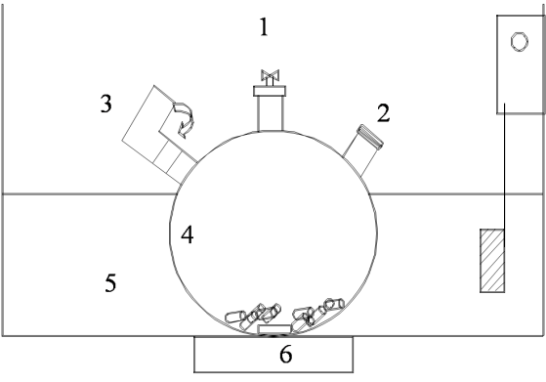
Figure 1. Experimental device for adsorption isotherm determination: (1) valve for gas sampling, (2) liquid injection septum, (3) angled tube containing the adsorbent, (4) bottle contactor, (5) thermostatic bath and (6) stirring system.

Finally, gas samples were taken from each bottle and analysed by gas chromatography (Varian CP-3800 GC, Varian Inc., USA). The total amount of adsorbed VOC per gram of adsorbent at equilibrium, q_{e} (mol kg⁻¹), was calculated from a mass balance in each isotherm batch adsorption chamber, as follows:
q_{e} = V (C₀ – C_{e})/M (1)
where C₀ and C_{e} (mol m⁻³) are gas phase concentration of the selected VOCs at the beginning and at equilibrium, respectively. M (g) is the mass of adsorbent sample used in each batch adsorption chamber, and V (1.1 ×10⁻³ m³) stands for the total volume of the adsorption chamber.

3. Results and discussion
3.1 Characterisation of Clay Sample
Fig. 2 and Table 2 summarise the textural properties of the sample measured by the physical adsorption of N₂ at 77K. The FS natural clay shown type IV isotherm according to the IUPAC classification. The initial part of the Type IV isotherm (P<0.4), corresponding to the monolayer region, was scarcely visible, which could be ascribed to physique adsorption at the surface of the adsorbent. In a high relative pressure range, the isotherm show a clear hysteresis loop associated with capillary condensation taking place in mesopores structures²⁶, formed between the elementary clay particles named tactoids.
Figure 2. N₂ isotherm of FS clay

As shown in Table 2, BET surface area of the FS clay is 28.94 m²/g with an average pore diameter ranging from 2.064 nm.

Table 2: Textural parameters of FS natural clay
Solid | Clay Natural
S_{BET} (m² g⁻¹) | 28.94
Vª_{t} (cm³ g⁻¹) | 0.030
V^{b}_{meso} (cm³ g⁻¹) | 0.025
S^{c}_{ext} (m² g⁻¹) | 20.10
S^{d}_{mic equi} (m² g⁻¹) | 8.84
Ve_{mic} (cm³ g⁻¹) | 0.005
D^{f}_{p} (nm) | 2.064
ª Total pore volume, ^{b} Mesoporous volume, ^{c} External specific surface, ^{d} Specific micropore surface area, ^{e} Microporous volume, ^{f} pore diameter
Particle size distribution analysis shows that FS natural clay is a smooth solid material composed by 1 % of sand (ranged between 0.08-2 mm), 49% of silt (ranged 2-80 µm) and 50% of clay (< 2 µm). A high clay content is normally related to material plasticity; however organic matter content and other parameters are also involved. A more detailed evaluation of clay plasticity was conducted using the Atterberg Limits.^{29,30} Results evidence a liquid limit (LL) of 56%, a plastic limit (PL) of 20%, and a plasticity index (PI) of 36%. Additionally, chemical analysis shows that FS contains 14.29 % of carbonates (expressed as CaCO₃) and only a 3% of organic matter.

Fig. 3 shows the mineralogical composition of FS natural clay. Results reveal a complex heterogeneous structure of FS natural clay, corresponding to quartz (Q) and calcite (C). Semi-quantitative analyses indicate that natural clay is mainly composed by smectite (35%), kaolinite (25%), illite (20%), chlorite (10%) and inter-stratified minerals (10%).
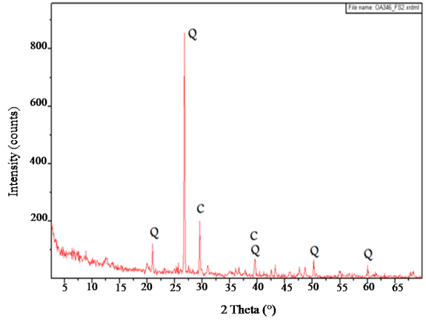
Figure 3. X-ray diffraction of FS natural clay (Q: Quartz, C: Calcite)
XRF results (see Table 3) indicate that FS natural clay is mainly composed of SiO₂, Al₂O₃ CaO, and Fe₂O₃; with a SiO₂/Al₂O₃ of 3.4 and trace amount of other oxides such as MgO, K₂O, Na₂O, P₂O₅, TiO₂. FAU zeolite is composed of SiO₂ and Al₂O₃ followed by K₂O, Fe₂O₃, MgO and Na₂O, with a SiO₂/Al₂O₃ of 1.8.

Table 3. Chemical composition of raw FS natural clay and Fau Y zeolite (m%) determined by XRF.
 | FS natural clay | Fau Y
SiO₂ | 41.28 | 28.0
Al₂O₃ | 12.29 | 16.0
Fe₂O₃ | 4.13 | 1.0
MgO | 2.80 | 0.6
K₂O | 1.74 | 5.6
CaO | 14.23 | --
Na₂O | 1.03 | 0.45
TiO₂ | 0.63 | --
P₂O₅ | 0.64 | --
LOI* | 21.23 | --
* L.O.I: loss on ignition.

Fig. 4 displays SEM images of FS natural clay and Fau Y zeolite. Micrographics show an overall homogeneity of texture and regular shapes with high particle densification.
On one hand, FS natural clay presents a regular porous structure (see Fig. 4-A1 and 4-A2), without the presence of cracks or holes. However, some quartz grains are presented (≤10 μm). Inter-particle/agglomerate void spaces are also displayed that could contribute to natural clay porosity. On the other hand, in the Fau Y zeolite image (see Fig. 4-B1 and 4-B2) crystal shapes can be visualised. Coarse particles are also observed in Fau Y zeolite, with the presence of void spaces that could contribute to the porosity of Fau Y zeolite.
A1 | B1
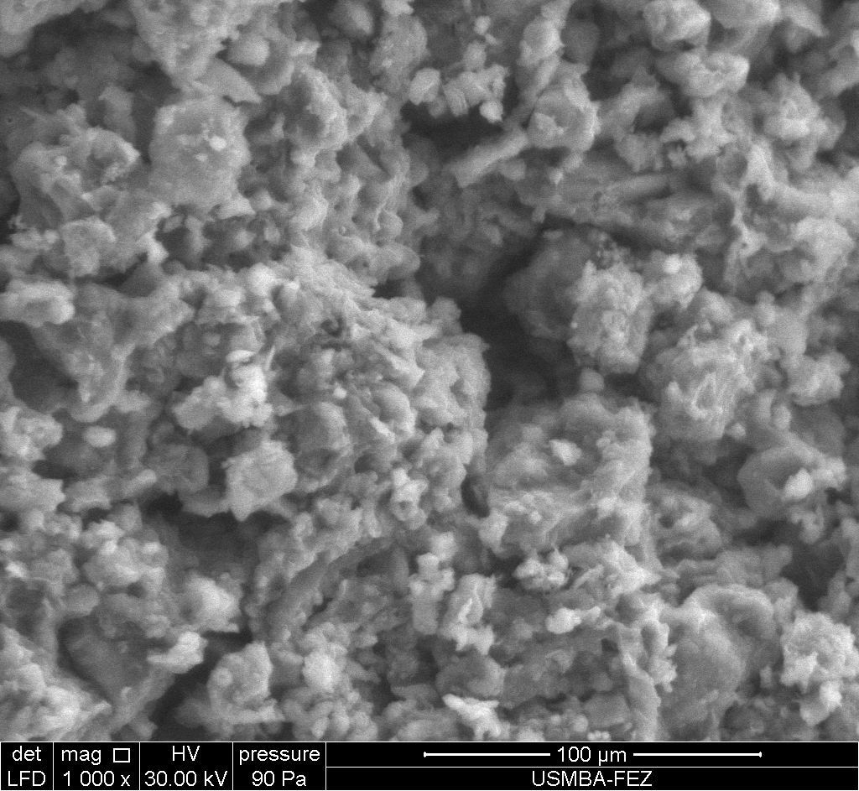 | 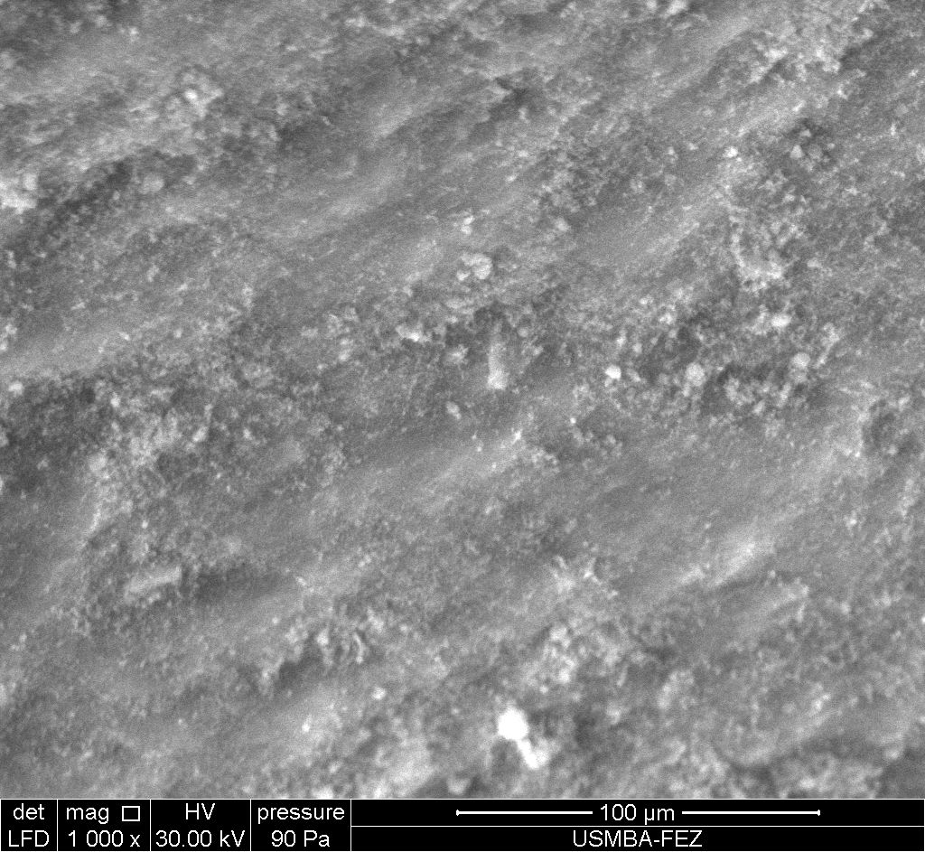
A2 | B2
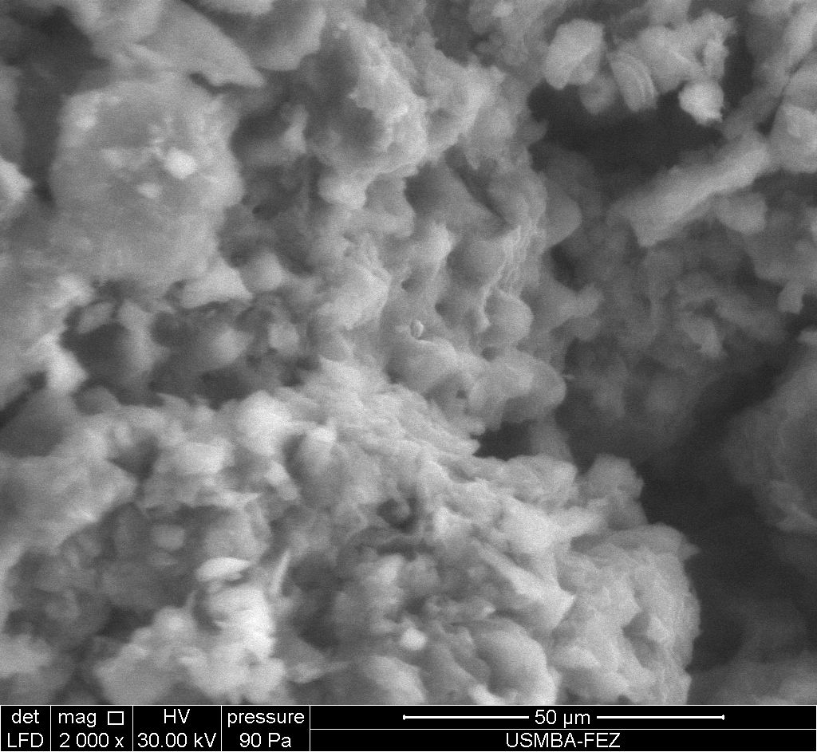 | 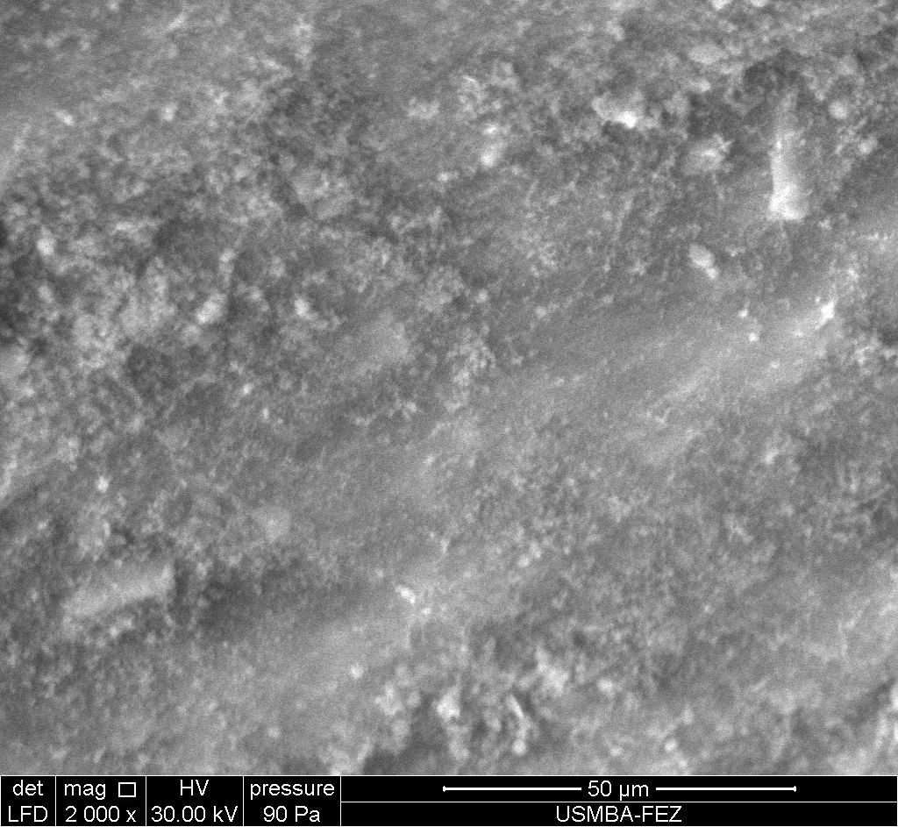
Figure 4. SEM pictures of the FS natural clay (A1-A2) and Fau Y zeolite (B1-B2).

Fig. 5 illustrates the results of thermogravimetric analyses (TGA) conducted on FS natural clay sample. TG curve shows the change in sample weight, and DTG curve displays derivative weight loss, as a function of temperature. FS sample has a total weight loss about 21.24% between 373 and 1273 K. The first registered weight loss (until 273 K) corresponds to the desorption of undissociated water. The second loss of weight occurs at 852K and could correspond to water removal from the clay mineral composition.³¹ The weight loss that takes place at 1136 K could be related to calcite CaCO₃ decomposition.³²
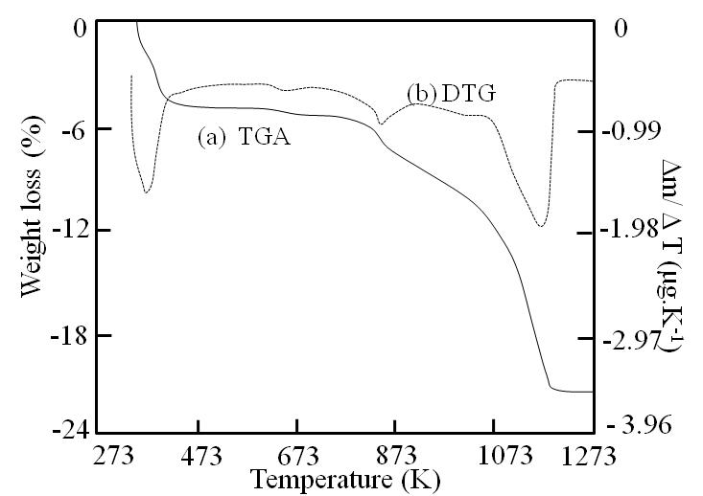
Figure 5. Thermogravimetric analysis (TGA) of FS natural clay

Infrared spectrum of FS natural clay is shown in Fig. 6 and indicates the presence of absorption bands corresponding to Si–O, Al–O, Mg-O, Fe-O and Ca–O vibrations (3622, 3399, 1635, 1421, 996, 872, 727, 530, and 450 cm^{−1.}, respectively). The presence of calcium could be associated with carbonates species (stretching bands near 1421 and 872 cm⁻¹)^{33,34} which are apparently related with the existence of calcite, in agreement with those results obtained by XRD and thermogravimetric analysis. Stretching vibrations of the surface hydroxyl groups (Si–Si–OH, or Al–Al–OH coupled by A1MgOH) are found at 3622 cm⁻¹. Vibrations at 1635 cm⁻¹ is attributable to the bending of adsorbed water between the layers. Moreover, absorption bands at 996, 530 and 450 cm⁻¹ could arise due to stretching and bending vibrations of SiO₄²⁻ tetrahedral.³⁵ In the low frequency range (1200–650 cm⁻¹), maximum absorption of silicate minerals was observed at 996 cm⁻¹ while bands at 530 and 450 cm⁻¹ could be to Al–O–Si and Si–O–Si bending vibrations, respectively.
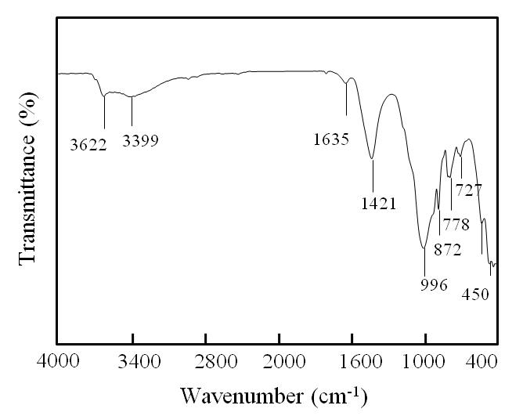
Figure 6. Infrared spectra of FS natural clay

3.2 Adsorption Capacities of FS Natural Clay and Fau Y Zeolite Towards VOCs
Fig. 7 displays adsorption equilibrium data of selected VOCs (benzaldehyde, methanol, and toluene) at 300 K onto FS natural clay and Fau Y zeolite samples, after the outgassing step at 383 K for 24 h. Adsorption equilibrium data are reported as mol of adsorbed VOC per mass of solid [mol_{adsorbed VOC}⋅g _{solid}⁻¹]. Experimental adsorption data fit to Lagmuir adsorption isotherm model very well.³⁶

${\text{q}}_{\text{e}}\text{=}\frac{\text{K }{{\text{C}}_{\text{VOC}}\text{q}}_{\text{m}}}{\text{(1+K }{\text{C}}_{\text{VOC}}\text{)}}$ (2)

where q_{e} is the amount of adsorbed VOC (benzaldehyde, methanol, or toluene) on the natural clay FS or Fau Y zeolite at equilibrium [mol g⁻¹], C_{VOC} is the concentration of the selected VOC (benzaldehyde, methanol, or toluene) at the equilibrium (mol m⁻³), q_{m} is the maximum adsorption capacity [mol g⁻¹], and K is the adsorption equilibrium constant or Langmuir constant [m³ mol⁻¹]. Langmuir sorption model has been applied to VOC adsorption on synthetic zeolites.^{28,37}
The maximum adsorption capacity, q_{m}, and the adsorption equilibrium constant, K, are determined from the intercept and the slope of the linearised form of Langmuir plot. The values of different parameters of the Langmuir adsorption model at 300 K together with the correlation factor, R², for the selected VOC on natural clay and Faujasite Y zeolite samples are summarised in Table 4. Additionally, the maximum adsorption capacity is also expressed in mmol m⁻², corresponding to monolayer coverage and it is here defined as S_{t}.
As it can be seen in Fig. 7 and as expected, the adsorption capacities of FS natural clay and Fau Y zeolite, increase as the concentration of VOCs increases.³⁵
Figure. 7. Comparison of adsorption capacities toward different VOCs (benzaldehyde, methanol, and toluene) of (▲) FS natural clay and (•) Fau Y zeolite, (-) represents the fit to Langmuir adsorption model.

Results indicate that FS natural clay has lower uptake capacity toward all VOCs assessed here. The greatest adsorption capacity of Fau Y zeolite could be due to its large specific surface area (S_{BET}) and total pore volume.

Table 4. Adsorption equilibrium constants of adsorbed VOCs onto FS natural clay and Fau Y zeolite obtained by the Langmuir adsorption model at 300K.

VOCs | Sample | Langmuir
VOCs | Sample | q_{m}  [mmol g⁻¹] | S_{t}  [mmol m⁻²] | K  [m³ mol⁻¹] | R²
Methanol | FS natural clay | 8 | 0.254 | 0.852 | 0.99
Methanol | Fau Y zeolite | 15 | 0.027 | 0.811 | 0.98
Toluene | FS natural clay | 0.91 | 0.029 | 0.889 | 0.98
Toluene | Fau Y zeolite | 1.91 | 0.003 | 1.456 | 0.97
Benzaldehyde | FS natural clay | 3.1 | 0.098 | 0.450 | 0.97
Benzaldehyde | Fau Y zeolite | 13.9 | 0.025 | 0.604 | 0.95

Results listed in Table 4 shows that FS natural clay has higher adsorption affinity toward aliphatic hydrocarbons (methanol 8 mmol g⁻¹) than for aromatic compounds (toluene 0.91 mmol g⁻¹). These results could be attributed to the pore size of the FS natural clay in relation to the kinetic diameters of the VOCs (4 Å for methanol and 5.8 Å for toluene).
Maximum adsorption capacities of FS natural clay, q_{m}, at 300 K led to the following adsorption order: methanol (8 mmol g⁻¹)> benzaldehyde (3.1 mmol g⁻¹) > toluene (0.91 mmol g⁻¹). Fau Y zeolite shows the highest affinity toward methanol adsorption (15 mmol g⁻¹) followed by benzaldehyde (13.9 mmol g⁻¹) and toluene (1.91 mmol g⁻¹). These results are in agreement with those obtained by SEM analysis where Fau Y zeolite shows a higher developed microporous structure, than FS natural clay (see Fig. 4).
Non-aromatic molecule such as methanol with small kinetic diameter¹⁶ around 4 Å can be easily adsorbed into the FS natural clay; whereas aromatic molecules (toluene and benzaldehyde) with relatively larger kinetic diameters in the range of 5.8 - 6.8 Å have difficulty being adsorbed due to their larger sizes.³⁹⁻⁴¹ For Fau Y zeolite, with a mesoporous structure, largest molecules (benzaldehyde and toluene) can easily be adsorbed.^{42, 43} In addition, Si/Al ratio is another important parameter that affects adsorption capacity of adsorbents.^{44,45} Fau Y zeolite has higher Si/Al ratio than FS natural clay. This parameter may also explain the higher adsorption capacity of Fau Y zeolite as compared to FS natural clay. Munthali et al.⁴⁶ has reported that zeolites with higher negative charge density had greater selectivity for H⁺. On the other hand, the degree of hydrophobicity is normally dependent on the Si/Al ratio.⁴⁷ Fau Y zeolite with high specific surface area (S_{BET}) making zeolite as an effective sorbent for pollution control purposes, especially for the removal of VOCs from waste gas streams.

Table 5. Comparison of adsorption capacities toward benzaldehyde (B), methanol (M), or toluene (T) of FS natural clay and some other adsorbents reported in the literature.
Adsorbent | VOCs | Temperature (K) | Adsorption capacity (mmol/g) | References
FS natural clay | T | 300 | 0.91 | Present work
Fau Y | T | 300 | 1.99 | Present work
ZSM-5 | T | 300 | 0.93 | 37
MS13X | T | 300 | 3.7 | 40
MOF-177 | T | 298 | 6.35 | 17
NaY | T | 300 | 1.36 | 48
ZnY | T | 300 | 1.25 | 48
NiY | T | 300 | 3.59 | 48
AgY | T | 300 | 3.65 | 48
ZSM-5 sorbents | T | 299 | 1.55-1.57 | 49
HMOR | T | 298 | 2-3 | 41
Raw clay | T | 298 | 0.016 | 50
DDMA–clay | T | 298 | 0.02 | 50
porous clay heterostructures (PCH) | T | 298 | 1.53 | 51
FS natural clay | M | 300 | 8 | Present work
SAPO-34 | M | 300 | 15 | 52
ZSM-5 sorbents (HZSM or NaZSM-5/180) | M | 299 | 0.83-1.1 | 49
Faujasite StY₂-L | M | 299 | 2.21 | 49
Faujasite SiCl₄Y₂-L | M | 299 | 1.57 | 49
HMOR | M | 299 | 3.08 | 49
MCM-41 | M | 299 | 11-21 | 53
Zeolite (HY901, MS13X) | M | 298 | 10-12 | 41
Activated carbon | B | 303 | 0.79 | 54

As a way of comparison, Table 5 lists the amount of adsorbed VOCs (benzaldehyde, methanol, or toluene) at the equilibrium onto FS natural clay (present work) and from literature references using different adsorbents under similar conditions. As it can be seen, adsorption capacities of natural clay toward benzaldehyde, methanol, and toluene are of the same order of those observed values using other porous adsorbents such as zeolites.
3.3 Effect of Temperature
As a way of illustration, Fig. 8 shows the effect of temperature on the adsorption of toluene onto FS natural clay. As it can be seen the adsorption capacity of FS natural clay toward toluene progressively decreases when temperature raises from 300 to 323K. Toluene adsorption is reduced around a 40% with the increase on temperature, suggesting that the adsorption of VOCs onto FS natural clay is an exothermic process. Similarly, Moghadam et al.⁴⁸ have observed that toluene adsorption onto Glycyrrhiza glabra root is reduced with the increase of temperature.
Figure. 8. Effect of temperature on the adsorption capacity of FS natural clay toward toluene.

Adsorption enthalpy is estimated using Van’t Hoff method, relating the changes in the adsorption equilibrium constant, K, with the change in temperature, T, as described by equation (3):

$\text{lnK=-}\left(\frac{\text{∆H}}{\text{RT}}\right)\text{+}\left(\frac{\text{∆S}}{\text{R}}\right)$ (3)

where ∆H is the adsorption enthalpy (kJ mol⁻¹), ∆S is the entropy change (kJ mol⁻¹K⁻¹), T is the absolute temperature (K) and R is the gas constant (0.008314 kJ mol⁻¹K⁻¹). Thus, ∆H is estimated from the slope of the linear van’t Hoff plot.
The obtained negative value of ∆H (-54 kJ mol⁻¹) confirms the exothermic nature of toluene adsorption onto FS natural clay. Generally, physisorption has characteristic values between -20 and -60 kJ mol⁻¹; whereas chemisorption has a range of -80 to -400 kJ mol⁻¹.⁵⁵ It should be noticed that the adsorption enthalpy value obtained here is 1.38 times the value of toluene evaporation heat (39.2 kJ mol⁻¹).⁵⁶ It could be concluded that toluene adsorption on FS clay is mainly a physical process. In fact, the low heat of adsorption may be considered as advantage in a procedure that includes a desorption/regeneration step of the adsorbent and VOC recovery.

3.4 Analysis of Adsorbent Costs
In this section a preliminary analysis of operating cost related to the use of FS natural clay and Fau Y zeolite for the removal of VOCs is conducted. As it can be seen in Table 4, the maximum adsorption capacity of Fau Y zeolite at 300 K, is almost 2 to 4 times higher than the values of FS natural clay. This means that FS natural clay in order to have an equivalent adsorption capacity to Fau Y zeolite, it is necessary to use a mass of FS natural clay 2 - 4.5 times higher than that required mass of Fau Y zeolite.
Nevertheless, the adsorber size will be smaller in case of using FS natural clay than the required size for Fau Y zeolite, due to the difference on apparent density of both materials (700 g dm⁻³ for FS natural clay and 460 g dm⁻³ for Fau Y zeolite). Therefore, the use of FS natural clay instead of Fau Y zeolite might help greatly in the reduction of adsorbent bed size. This is considered to be a significant advantage of FS natural clay over other adsorbents, showing its potential interest for capturing toluene and other VOCs normally present in industrial emissions. If it is considered an estimated average price of FS natural clay to be around US$ 0.02 kg⁻¹, it will yield an additional advantage in terms of operating cost, being 500 times lower than those values obtained when Fau Y zeolite is used (US$ 10 kg⁻¹). Thus, natural clay is likely to become a strong adsorbent candidate for VOC removal.

4 Conclusions
Adsorption capacity results of FS natural clay toward methanol, toluene and benzaldehyde as representatives VOCs suggest that FS natural clay could be applicable for controlling the emissions of VOCs from industrial processes and indoor environments. Although, commercial Fau Y zeolite shows a higher adsorption capacity for all the VOCs used in this study, FS natural clay is more abundant and its low acquisition cost makes it an efficient and economic natural adsorbent for the removal of VOCs from contaminated gaseous streams. Hence, natural clay could be effectively applied as an alternative low cost adsorbent to remove toxic organic pollutants from waste gas streams. Natural clay collected from Fez area has a great potential for air purification control.

5. Acknowledgements
Authors gratefully acknowledge the Centre National pour la Recherche Scientifique et Technique of Morocco (CNRST), the Centre national de la recherche scientifique of France (CNRS) with the Project (CNRST/CNRS No. SPI 05/13), Embassy of France in Egypt, French Institute in Cairo EGYPT, Comisión Nacional de Investigación Científica y Tecnológica of Chile (CONICYT) and Fondo Nacional de Desarrollo Científico y Tecnológico of Chile (FONDECYT) with the Project (CONICYT/FONDECYT Grant No. 1130560), for their financial support.

6. References
1. F. Khan, A. Ghoshal, J. Loss. Prev. Proc. Ind. 2000, 13(6), 527–545.
http://dx.doi.org/10.1016/S0950-4230(00)00007-3
2. T. Ohura, T. Amagai, X.Y. Shen, S. Li, P. Zhang, L.Z. Zhu, Atmos. Environ. 2009, 43, 6352–6359.
http://dx.doi.org/10.1016/j.atmosenv.2009.09.022
3. B. Guieysse, C. Hort, V. Platel, R. Munoz, M. Ondarts, S. Revah, Biotechnol. Adv. 2008, 26, 398–410.
http://dx.doi.org/10.1016/j.biotechadv.2008.03.005
4. H. Wang, L. Nie, J. Li, Y. Wang, G. Wang, J. Wang , Z. Hao, Chin. Sci. Bull. 2013, 58(7), 724−730.
http://dx.doi.org/10.1007/s11434-012-5345-2
5. A.J. Cohen, Environ. Health. Perspect. 2000, 108, 743–750.
6. M. Kampa, E. Castanas, Environ. Pollut. 2008, 151, 362-367.
http://dx.doi.org/10.1016/j.envpol.2007.06.012
7. I. Faisal, V.K. Khan, J. Loss. Prev. Process. Ind. 2000, 13, 527–545.
http://dx.doi.org/10.1016/S0950-4230(00)00007-3
8. V.R. Choudhary, K. Mantri, Langmuir, 2000, 16(17), 7031–7037.
http://dx.doi.org/10.1021/la991714u
9. A.K. Boulamanti, C.A. Korologos, C.J. Philippopoulos, Atmos. Environ. 2008, 42, 7844-7850.
http://dx.doi.org/10.1016/j.atmosenv.2008.07.016
10. P. Monneyron, M-H. Manero, J.S. Pic, Can. J. Chem. Eng. 2007, 85, 326-332.
http://dx.doi.org/10.1002/cjce.5450850307
11. E.N. Ruddy, L.A. Carroll, Chem. Eng. Prog. 1993, 89(7), 28–35.
12. A.K. Ghoshal, S.D. Manjare, J. Loss. Prev. Process. Ind. 2002, 15(6), 413–421.
http://dx.doi.org/10.1016/S0950-4230(02)00042-6
13. H. Zaitan, H. Valdés, Removal of volatile organic compounds (VOCs) using adsorption Process onto Natural Clays, in: K. Chetehouna, Volatile Organic Compounds: Emission, Pollution and Control, New York: Nova Publishers, 2014. p. 169-207.
14. V.K. Gupta, N. Verma, Chem. Eng. Sci. 2002, 57, 2679–2696.
http://dx.doi.org/10.1016/S0009-2509(02)00158-6
15. X. Li, Z. Li, L. Luo, Chin. J. Chem. Eng. 2008, 16(2), 203-208.
http://dx.doi.org/10.1016/S1004-9541(08)60063-4
16. J. Pires, A. Carvalho, M.B. Carvalho, Microporous Mesoporous Mater. 2001, 43, 277–287.
http://dx.doi.org/10.1016/S1387-1811(01)00207-4
17. L. Chu, S. Deng, R. Zhao, Z. Zhang, C. Li, X. Kang, RSC Adv. 2015, 5, 102625-102632.
http://dx.doi.org/ 10.1039/C5RA22597C
18. T. El Brihi, J.N. Jaubert, D. Barth, L. Perrin, Environ. Technol. 2003, 24(10), 1201-1210.
http://dx.doi.org/10.1080/09593330309385662
19. P. Le Cloirec, Chin. J. Chem. Eng. 2012, 20,461-468.
http://dx.doi:10.1016/S1004-9541(11)60207-3
20. H.F. Cheng, M. Reinhard, Environ. Sci. Technol. 2006, 40, 7694–7701.
http://dx.doi.org/10.1021/es060886s
21. E. Mohamed, C. Andriantsiferana, A. Wilhelm, H. Delmas, Environ. Technol. 2011, 32, 1325-1336.
http://dx.doi.org/10.1080/09593330.2010.536783
22. X. Tao, T. Yang, T. Chang, T. Chung, J. Environ. Eng. 2004, 130, 1210-1216.
http://dx.doi.org/10.1061/(ASCE)0733-9372(2004)130:10(1210))
23. M.W. Ackley, S.U. Rege, H. Saxena, Microporous Mesoporous Mater. 2003, 61, 25–42.
http://dx.doi:10.1016/S1387-1811(03)00353-6
24. C. Julcour, C. Andriantsiferana, N. Krou, C. Ayral, E. Mohamed, A. Wilhelm, H. Delmas, L. Le Coq, C. Gerente, K.M. Smith, S.Pullket, G.D. Fowler, N.J. Graham, J. Environ. Manag. 2010, 91(12), 2432-2439.
http://dx.doi.org/10.1016/j.jenvman.2010.06.008
25. J. F. Vivo-Vilches, A.F. Pérez-Cadenas, F. Carrasco-Marín, F.J. Maldonado-Hóda, J. Environ. Chem. Eng. 2015, 3, 2662-2669.
http://dx.doi.org/10.1016/j.jece.2015.09.027
26. H. Zaitan, D. Bianchi, O. Achak, T. Chafik, J. Hazard. Mater. 2008, 153, 852–859.
http://dx.doi.org/10.1016/j.jhazmat.2007.09.070
27. S. Bertrand, F. Charlet, E. Chapron, N. Fagel, M. Batist, Palaeogeogr. Palaeoclimatol. Palaeoecol. 2008, 259, 301-322.
http://dx.doi.org/10.1016/j.palaeo.2007.10.013
28. S. Brosillon, M. H . Manero, J. Foussard, Environ. Sci. Technol. 2001, 35, 3571–3575.
http://dx.doi.org/10.1021/es010017x
29. A. Atterberg, Die Plastizität der Tone., Internationale Mitteilungen für Bodenkunde, 1911, 1, 10–43.
30. F.A. Andrade, H. A. Al-Qureshi, D. Hotza, Appl. Clay. Sci. 2011, 51, 1–7.
http://dx.doi.org/10.1016/j.clay.2010.10.028
31. F. Ayari, E. Srasra, M. Trabelsi-Ayadi, Desalination 2005,185, 391–397.
http://dx.doi.org/10.1016/j.desal.2005.04.046
32. M. V. Kök, Energy Sources 2002, 24(10), 899–907.
http://dx.doi.org/10.1080/00908310290086833
33. N. V. Vagenas, A. Gatsouli, C. G. Kontoyannis, Talanta 2003, 59, 831-836.
http://dx.doi.org/10.1016/S0039-9140(02)00638-0
34. A. Sdiri, T. Higashi, T. Hatta, F. Jamoussi, N. Tase, Environ. Earth. Sci. 2010, 61(6), 1275-1287.
http://dx.doi.org/10.1007/s12665-010-0450-5
35. V. C. Farmer, The layer silicates, in: V.C. Farmer (Ed.), The Infrared Spectra of Minerals, Mineralogical Society, London, 1974.
36. I. Langmuir, J. Am. Chem. Soc., 1918, 40(9), 1361–1403.
http://dx.doi.org/10.1021/ja02242a004
37. H. Zaitan, M.H. Manero, H. Valdés, J. Environ. Sci. 2016, 41, 59–68
http://dx.doi.org/10.1016/j.jes.2015.05.021
38. J. Ruiz, R. Bilbao, M.B. Murillo, Environ. Sci. Technol. 1998, 32, 1079-1084.
http://dx.doi.org/10.1021/es9704996
39. E.G. Derouane, Stud. Surf. Sci. Catal., 1980, 5, 5–18.
http://dx.doi.org/10.1016/S0167-2991(08)64860-0
40. Y.H. Ma, T.D. Tang, L.B. Sand, L.Y. Hou, Stud. Surf. Sci. Catal. 1986, 28, 531- 538.
http://dx.doi.org/10.1016/S0167-2991(09)60916-2
41. K.J. Kim, H.G. Ahn, Microporous Mesoporous Mater, 2012, 152, 78–83.
http://dx.doi.org/10.1016/j.micromeso.2011.11.051
42. K. Chae, Y. Siberio-Pérez, J. Kim, Y. Go, M. Eddaoudi, J. Matzger, M. O'Keeffe, M. Yaghi, Nature, 2003, 427, 523-527.
http://dx.doi.org/10.1038/nature02311
43. F. Qian, B. Li, Y. Hu, G. Niu, Y. Zhang, C. Renchao, T. Yi, D. Su, A. Asiri, D. Zhao, Chem-A Eur. J. 2012, 18, 931–939.
http://dx.doi.org/10.1002/chem.201102505
44. P. Harben, The industrial minerals handybook. 4th ed., Industrial minerals information 11 Ltd., London, 2002
45. A.M. Ziyath, P. Mahbub, A. Goonetilleke, M.O. Adebajo, S. Kokot, A. Oloyede, J. Water Resource Prot. 2011, 3, 758-767.
http://dx.doi.org/10.4236/jwarp.2011.310086
46. M. Munthali, M. Elsheikh, E. Johan, N. Matsue, Molecules, 2014, 19, 20468-20481.
http://dx.doi.org/10.3390/molecules191220468
47. M. Oliveira, A. Miranda, C. Barbosa, C. Cavalcante, D. Azevedo, E. Castellon, Fuel, 2009, 88, 1885-1892.
http://dx.doi.org/10.1016/j.fuel.2009.04.011
48. F. Mohammadi-Moghadam, M.M. Amin, M. Khiadani, F. Momenbeik, H. Nourmoradi, M.S. Hatamipour, J. Environ. and Public Health, 2013, 2013, 1-7.
http://dx.doi.org/10.1155/2013/986083
49. C.K.W. Meininghaus, R. Prins, Microporous and Mesoporous Mater. 2000, 35–36, 349–365.
http://dx.doi.org/10.1016/S1387-1811(99)00233-4
50. I. Jarraya, S. Fourmentin, M. Benzina, S. Bouaziz, Chem. Geology, 2010, 275, 1-8.
http://dx.org/10.1016/j.chemgeo.2010.04.004
51. F. Qu, L. Zhu, K. Yang, J. Hazard. Mater. 2009, 170, 7-12.
http://dx.doi.org/10.1016/j.jhazmat.2009.05.027
52. Y. Kobayashi, Y. Li, Y. Wang, D. Wang, Chin. J. Cat. 2013, 34, 2192–2199.
http://dx.doi.org/ 10.1016/S1872-2067(12)60676-7
53. M.M.M. Ribeiro Carrott, A.J.E. Candeias, P.J.M. Carrott, P.I. Ravikovitch, A.V. Neimark, A.D. Sequeira, Microporous and Mesoporous Mater. 2001, 47, 323-337.
http://dx.doi.org/10.1016/S1387-1811(01)00394-8
54. R.K. Rajoriya, B. Prasad, I.M. Mishra, K.L. Wasewar, Chem. Biochem. Eng. Q. 2007, 21(3), 219–226.
55. Y. Yu, Y. Zhuang, Z.H. Wang, J. Colloid. Interface. Sci. 2001, 242(2), 288-293.
http://dx.doi.org/10.1006/jcis.2001.7780
56. D.D. Do, Adsorption Analysis: Equilibria and Kinetics. London: Imperial College Press, 1998.

