Determination of the activity signature of key carbohydrate metabolism enzymes in grapevine

Elizabeth Dunn Covington,¹ Thomas Roitsch^{2,3} and Marina Dermastia^{1*}

¹National Institute of Biology, Večna pot 111, SI-1000 Ljubljana, Slovenia
²Department of Plant and Environmental Sciences, Copenhagen Plant Science Centre, University of Copenhagen, Højbakkegård Allé 13, 2630 Taastrup, Denmark
³Global Change Research Centre, Czech Globe AS CR, v.v.i., Drásov 470, Cz-664 24 Drásov, Czech Republic

* Corresponding author: E-mail: marina.dermastia@nib.si

Abstract

The following protocol for activity assays for enzymes of primary carbohydrate metabolism, while based on our recently published one for quantitative measurement of activities using coupled spectrophotometric assays in a 96-well format, is tailored to the complexities of tannin-rich extracts from grapevine leaf. As a case study we applied the protocol to grapevine leaf samples infected with 'Candidatus Phytoplasma solani'. This plant pathogenic bacteria causes the most widespread grapevine yellows disease in Europe, Bois noir, and is known to alter carbohydrate metabolism in grapevine. The described adaptations may be useful for determination of metabolic fingerprints for physiological phenotyping of other plant species with inherently high levels of phenolic compounds.

Keywords: AGPase, carbohydrates, invertases, sucrose synthase, panel of enzyme activity assays, phytoplasma.

- Introduction

Carbohydrates are the main energy and carbon source for all organisms, and in plants are also important signaling factors.¹ Therefore, proper regulation of their production, distribution, and allocation is essential for both plant development and plant responses to pathogens and abiotic stresses. Significant changes in carbohydrate metabolism are associated with development of disease symptoms on grapevine infected with phytoplasmas.^{2,3,4} Phytoplasmas are plant pathogenic bacteria belonging to the Mollicutes class.^{5,6,7} They are cell wall-free, and the smallest bacteria in both cell and genome size. In plants, they exclusively inhabit nutrient-rich phloem, which is part of the vascular tissues and responsible for transport of assimilates from source to sink tissues and organs. Phytoplasmas are the causal agents of important crop and fruit tree diseases, including grapevine diseases.⁸ The changes of carbohydrate metabolism in phytoplasma-infected grapevine have been detected mainly as increased expression of genes encoding the key enzymes associated with carbohydrate production. However, the resulting enzyme activities are affected by a complex interplay of transcriptional, post-transcriptional, and post-translational regulatory mechanisms. Consequently, often no direct correlation between mRNA and protein levels can be found, due to the rate of protein translation, the stability/degradation of proteins, and the regulation of enzyme activity by substrates, products, protein interactions, and protein modifications. Along with other nonbiased approaches, such as hormone signatures,⁹ enzyme activity signatures are important parts of a multidimensional phenomics approach to understanding plant physiological responses to external fluctuations.¹⁰ Enzyme activities appear to be robust markers¹⁰ and are not necessarily correlated with metabolites.¹¹ Information about the abundance and biological activities of proteins is essential to reveal how genes affect phenotypes,¹² such as the altered carbohydrate metabolism of phytoplasma-infected plants.

We have recently developed a universal protein extraction and fractionation method that can be applied to a wide variety of plant species and organs to obtain extracts for determining activities for key enzymes involved in carbohydrate metabolism. These published semi-high-throughput spectrophotometric assays for determination of primary carbohydrate metabolism enzymes from a single extraction¹³ failed when applied to grapevine leaves, probably due to interfering substances in the extracts. In the present work we have adapted our general assays for application in uninfected grapevine samples and those infected with the most widespread grapevine phytoplasma in Europe, ‘Candidatus Phytoplasma solani’.¹⁴

- Experimental

Whole asymptomatic grapevine leaves and those with symptoms of infection with ‘Ca. P. solani’ were sampled in a production vineyard of grapevine (Vitis vinifera L.) cv. ‘Chardonnay’ in the south-western part of Slovenia (45°58′ N, 13°32′ E). Each leaf was tested for ‘Ca. P. solani’ presence according to the detection system developed by Hren et al.¹⁵

Protocols were established for measuring the enzyme activities of ADP-glucose pyrophosphorylase (AGPase), which is a rate-limiting enzyme in starch biosynthesis;¹⁶ sucrose synthase (SuSy), which catalyzes sucrose breakdown to UDP-glucose and fructose in planta;¹⁷ and three invertase isoenzymes – cytoplasmic invertase with a neutral pH optimum (cytINV), acid-insoluble bound to the cell wall (cwINV), and acid-soluble localized in the vacuole (vacINV). The workflow for measuring the enzyme activities of AGPase, SuSy, cytINV, cwINV and vacINV is depicted in the assays’ scheme (Figure 1). Major changes to the original protocols¹³ were required, and these are detailed in the Results and Discussion section.

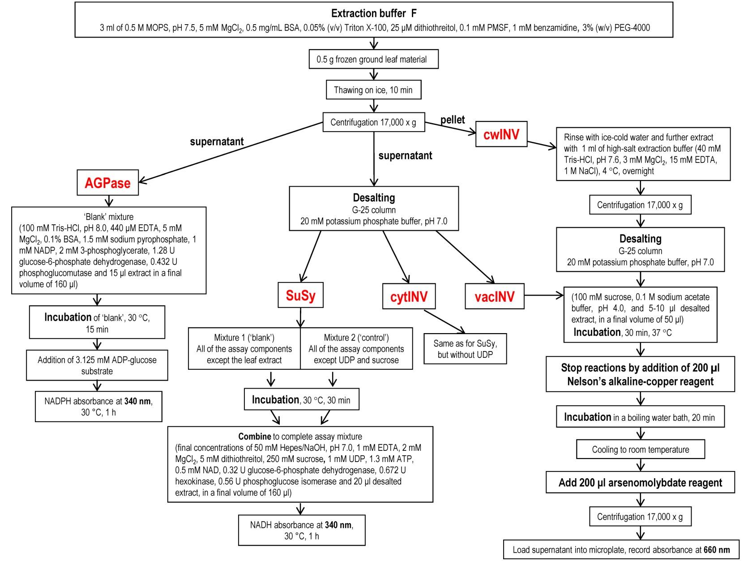

Figure 1. The workflow for measuring enzyme activities of AGPase, SuSy, cytINV, cwINV and vacINV.

- Results and Discussion

Although the method we established to determine an activity signature for key enzymes of carbohydrate metabolism performed well with various monocot and dicot model and crop plants¹³ and proved to be useful for physiological phenotyping,¹⁰ we encountered a number of difficulties in applying the “universal” extraction protocol to grapevine. The most likely reason is the endogenous high level of phenolic and anthocyanin compounds present in grapevine, which further increases during phytoplasma infection.^{18,19} By reacting indiscriminately, these compounds both inactivate enzymes and interfere with detection techniques.^{20,21} Control measures include polymeric reagents that are added to extraction buffers in order to bind secondary compounds released by cell lysis.

Adaptation of the extraction protocol for grapevine
Polyvinylpolypyrrolidone (PVPP) is frequently added to plant extracts to adsorb phenolics and has the advantage that it is insoluble, allowing it and adsorbed phenolics to be removed from the extract prior to analysis. However, when PVPP was added to grapevine leaf extracts, even at high concentrations (2-30% w/v), no invertase activity could be detected (Table 1). Additionally, when crude grapevine extract made with PVPP was added to the AGPase assay solution, a thick precipitate formed, preventing spectrophotometric measurement of AGPase activity. Past enzyme studies from grapevine leaf have instead used polyethylene glycol 4000 (PEG-4000) to bind phenolics.²²⁻²⁶ When varying concentrations of PEG-4000 were added to extraction buffer, the highest invertase activity was observed with 3% (w/v) PEG-4000 (Table 1).

Table 1. Specific activity (nkat/g FW) of vacINV in extraction buffer A (see Table 2) supplemented with the indicated phenolic-binding agent. All percentages are w/v.

 | 2% PVPP | 10% PVPP | 30% PVPP | 1% PEG-4000 | 3% PEG-4000 | 6% PEG-4000
Activity | 0 | 0 | 0 | 3.28 | 3.83 | 2.43

Four previously reported extraction buffers, including Jammer’s extraction buffer B¹³ and three buffers used in grapevine enzyme studies,^{15,17,19} were tested in parallel for highest activities (see recipes in Table 2). Because activity of maize SuSy requires magnesium sulfate in extraction buffer,²⁵ buffers were tested with and without added Mg if it was not included in the published recipe. For ease of comparison, the protease inhibitors PMSF and benzamidine were added to all extraction buffers. Additionally, 3% (w/v) PEG-4000 was used to adsorb polyphenols in all extraction buffers. Extraction buffer F, based on that of Takayanagi,²⁷ gave the highest activity for all enzymes except cwINV (Figure 2), perhaps due to the additional phenol-binding capacity of bovine serum albumin (BSA).

Table 2. Extraction buffers tested for enzyme assays, modified from the indicated references.
Buffer | Composition | Reference
A | 40 mM Tris-HCl, pH 7.6; 1 mM EDTA; 14 mM 2-mercaptoethanol; 0.1 mM PMSF; 1 mM benzamidine; 3% (w/v) PEG-4000 | 13
B | 40 mM Tris-HCl, pH 7.6; 1 mM EDTA; 14 mM 2-mercaptoethanol; 10 mM MgSO₄; 0.1 mM PMSF; 1 mM benzamidine; 3% (w/v) PEG-4000 | 13
C | 250 mM MES-NaOH, pH 6.3; 20 mM cysteine-HCl; 3 mM EDTA; 20 mM DTT; 0.1 mM PMSF; 1 mM benzamidine; 3% (w/v) PEG-4000 | 23
D | 250 mM MES-NaOH, pH 6.3; 20 mM cysteine-HCl; 3 mM EDTA; 20 mM DTT; 10 mM MgSO₄; 0.1 mM PMSF; 1 mM benzamidine; 3% (w/v) PEG-4000 | 23
E | 100 mM Tris-HCl, pH 7.4; 100 mM cysteine; 10 mM MgSO₄; 0.1 mM PMSF; 1 mM benzamidine; 3% (w/v) PEG-4000 | 25
F | 0.5 M MOPS, pH 7.5; 5 mM MgCl₂; 0.5 mg/ml BSA; 0.05% Triton X-100; 25 μM DTT; 0.1 mM PMSF; 1 mM benzamidine; 3% (w/v) PEG-4000 | 27
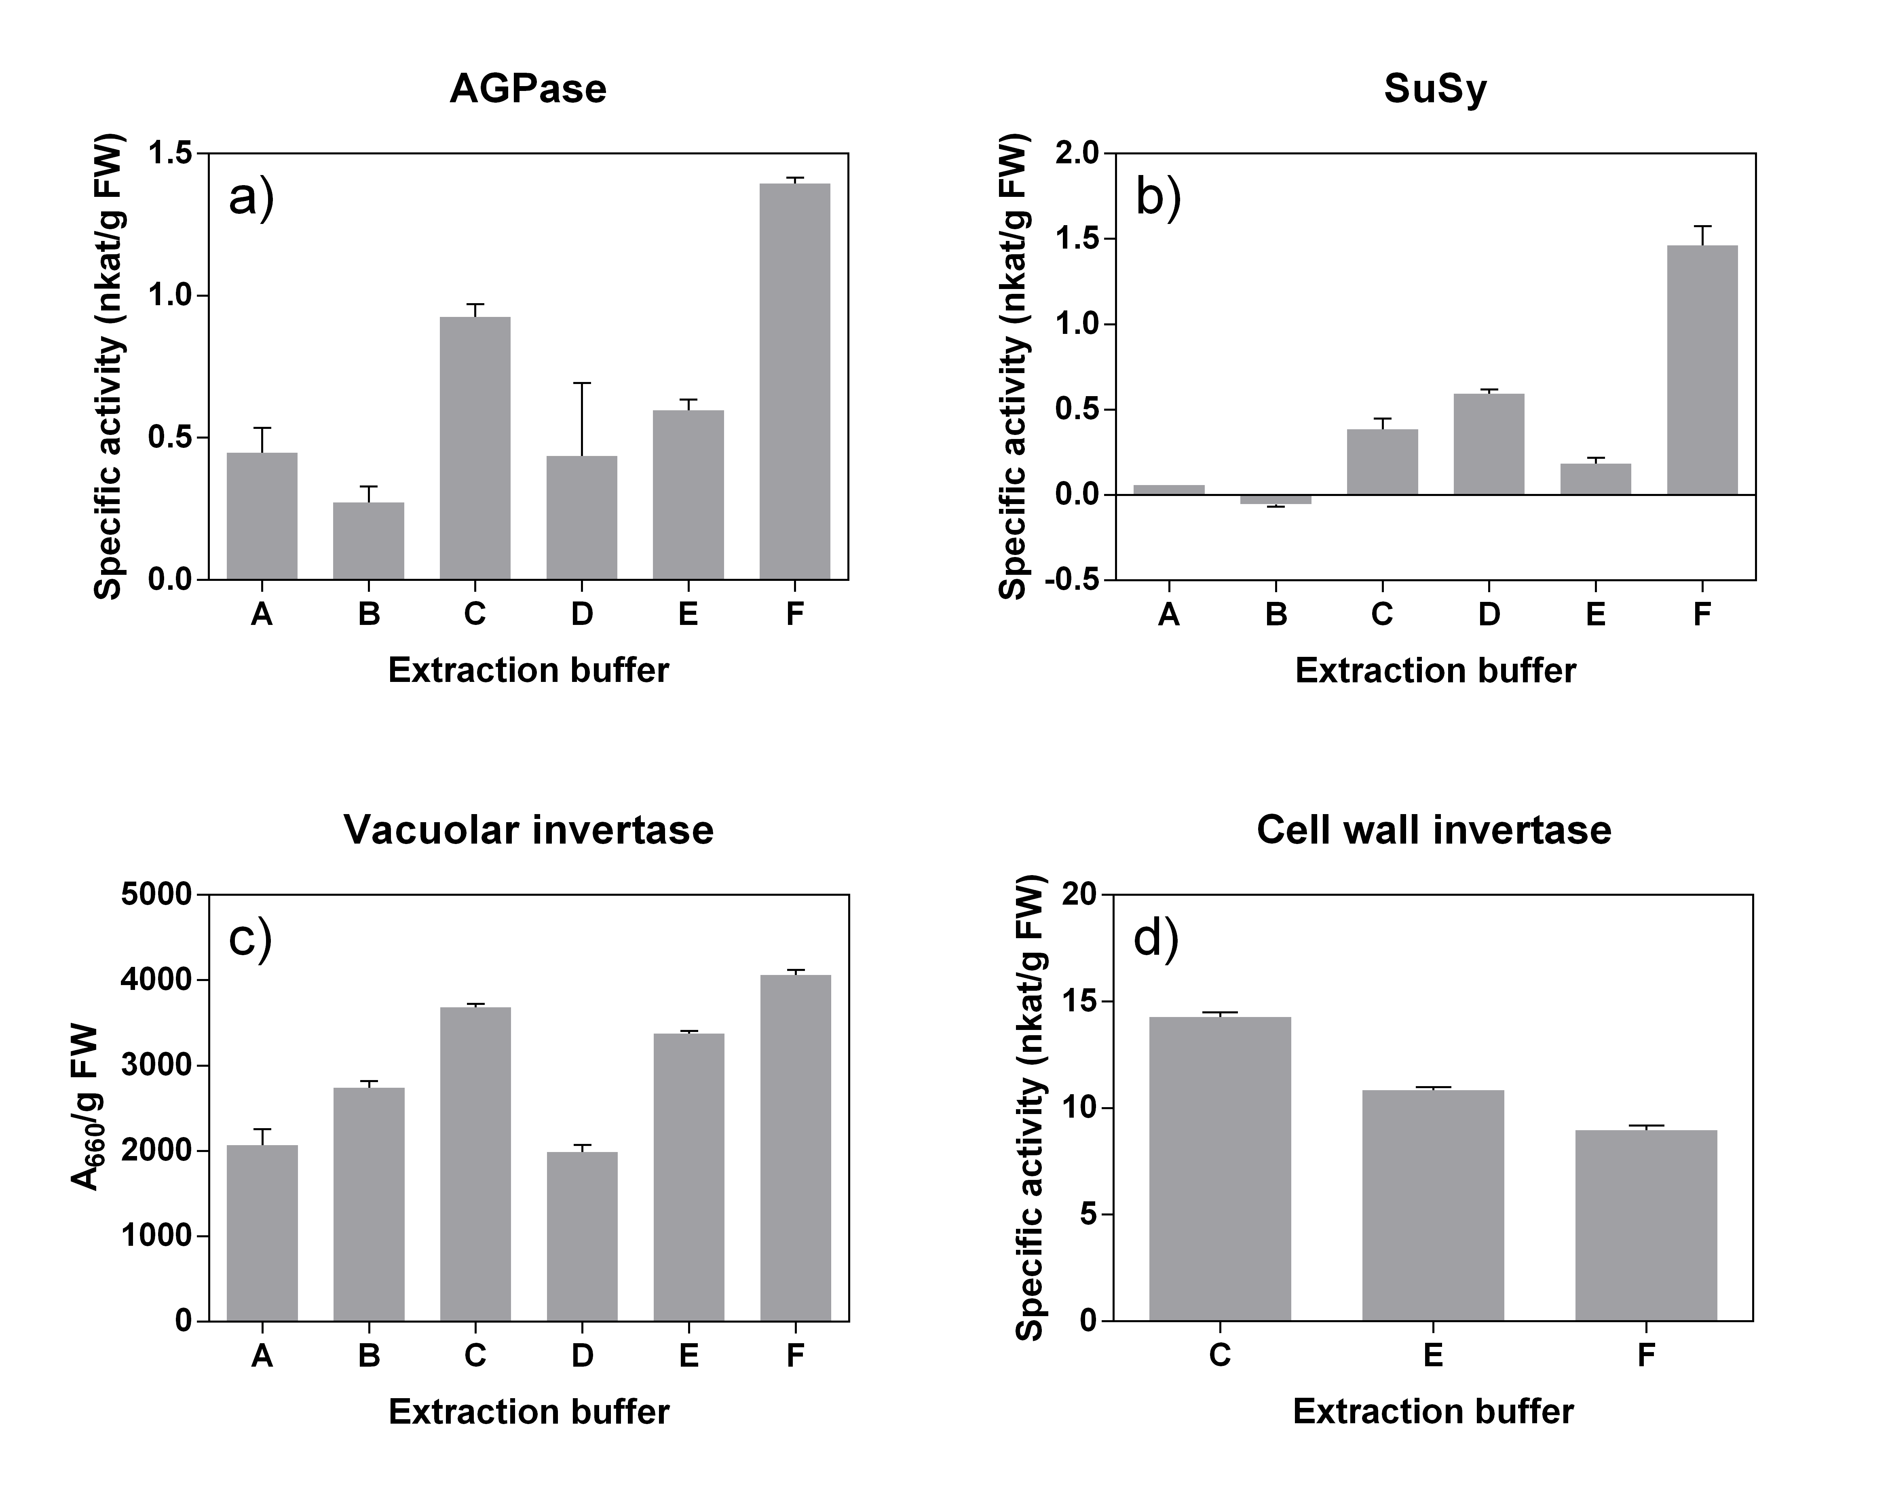
Figure 2. Enzyme activity of AGPase (a), SuSy (b), vacINV (c), and cwINV (d) obtained from various extraction buffers. Bars represent mean of three technical replicates. Error bars represent standard error of the mean (s.e.m.). Because the vacINV experiment lacked an appropriate standard curve, results are presented as absorbance values at 660 nm rather than as reducing sugar concentrations.

High concentrations of endogenous substrates for SuSy and invertase necessitated desalting of crude extracts prior to enzyme assay. Desalting further serves to remove reducing agents and secondary compounds that may inhibit activity of invertase. Grapevine SuSy activity was greatly diminished when crude extracts were dialyzed overnight (0.21 nkat/g FW) as compared to column desalting (1.47 nkat/g FW). Additionally, grapevine extracts lost most SuSy activity if extracts were frozen (data not shown). Therefore, cleared extracts were desalted over a Sephadex G-25 column, and SuSy activity was assayed immediately. The final extraction protocol allowed measurement of five key enzymes of carbohydrate metabolism from a single extraction. AGPase, SuSy, and cytINV were assayed immediately on the day of enzyme extraction, while vacINV and cwINV could be assayed from frozen extracts at a later date.

Adaptation of enzyme activity assays for grapevine samples
Enzyme assay methods also had to be altered for grapevine leaf samples. The SuSy and AGPase assay conditions of Jammer et al.¹³ worked adequately for grapevine extracts with only slight modification. Both assays required pre-incubation for 15-30 minutes to allow run-down of background activity. In the case of SuSy, blank and control mixtures were separately pre-incubated to allow run-down of blank reactions due to extract and of control reactions due to contaminating sugars in the sucrose substrate.

Invertase assay proved more problematic in grapevine. The ABTS (2,2′-azino-bis(3-ethylbenzothiazoline-6-sulfonic acid)) used for glucose detection,¹³ reacts with phenolic compounds,²⁸ and substrate-free blanks spiked with known concentrations of glucose reported inaccurate glucose levels when measured with the glucose oxidase/peroxidase/ABTS method. A commercial glucose determination kit (Megazyme) also gave inaccurate measures; invertase continued to cleave sucrose at a slow rate after detection buffer was added, causing slow color development over a time course of hours rather than minutes. Therefore, we used the Nelson-Somogyi method^{29,30} to determine the reducing sugar products of the invertase reaction. This method had the advantage of quickly halting the invertase reaction at the end of incubation when samples were immersed in a boiling water bath, and tests of samples spiked with glucose gave values accurate within 8%.

Other adaptations to the invertase assay included increasing the substrate concentration from 10 mM to 100 mM because the reported K_{M} of grapevine vacINV is around 3-10 mM sucrose.³¹⁻³³ VacINV activity was higher at pH 4.0 than pH 4.5 (7.8 nkat/g FW vs. 5.1 nkat/g FW; see also ²³). Finally, the reaction progress was followed and found to be linear for at least 1 hour (Figure 3). For efficiency of measurement, therefore, the length of the assay incubation was reduced to 30 minutes, well within the linear portion of the reaction.

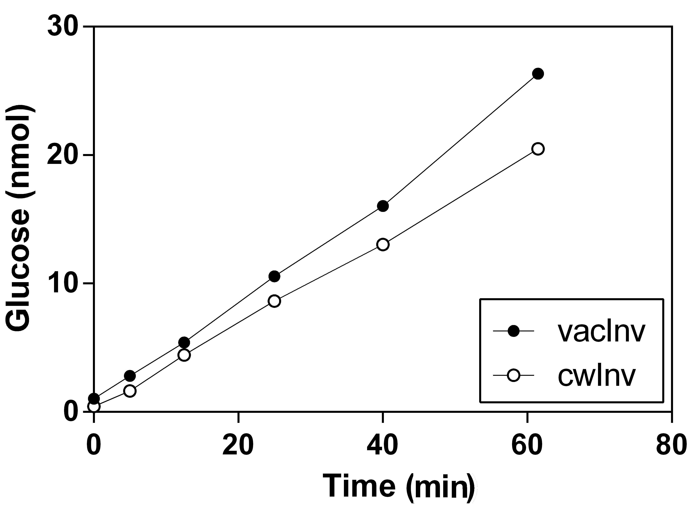
Figure 3. Time course of invertase reaction. Assays of vacINV and cwINV were allowed to proceed for 1 hour. Samples were removed at the indicated time points and glucose accumulation immediately measured.

Case study: Effect of infection of grapevine leaves by phytoplasma ‘Ca. P. solani’
The developed protocol was tested on uninfected grapevine leaves and leaves infected with ‘Ca. P. solani’ (Figure 4). The results show high activity of vacINV, which was higher, although not significantly (p=0.07), in infected samples. The amount of transcript of VvINV2 encoding vacINV is increased in infected leaf veins.² Activity of SuSy significantly increased (from 0.10 to 0.53 nkat/g FW), in correlation with the gene expression of VvSuSy² and similar observations from grapevine infected with another taxonomically unrelated phytoplasma (Prezelj et al., submitted), suggesting a specific role of SuSy in phytoplasma-infected grapevines.

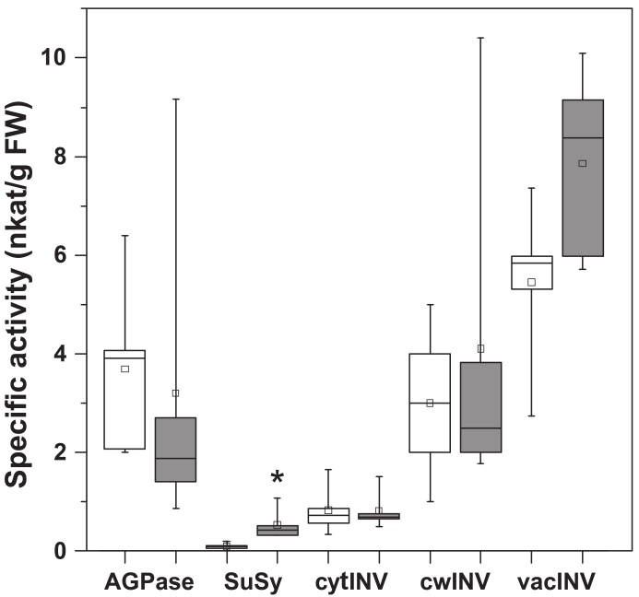
Figure 4. Box plot of the specific activities of AGPase, SuSy, cytINV, cwINV and vacINV in whole-leaf samples of uninfected (white boxes) and ‘Ca. P. solani’-infected (grey boxes) grapevines. Line across the box, median; square, mean; box, 25th and 75th percentiles; whiskers, minimum and maximum values. *, p<0.05 (Student’s t-tests). N=5 for all enzymes.

In sum, the altered protocol, while based heavily on that of Jammer et al.,¹³ is tailored to the complexities of tannin-rich extracts from grapevine leaf. The described adaptations may be useful for other plant species with inherently high levels of phenolic compounds or tissues that are enriched in phenolics due to exogenous factors or expression of specific transgenes.²¹ This protocol provides a valuable platform for advanced metabolic fingerprinting of grapevine to complement determination of metabolites^{34,35,36} and will help narrow the knowledge gap regarding phenotypic plasticity in environment and agricultural management practice.¹⁰

Acknowledgement: This work was supported by Javni sklad RS za razvoj kadrov in štipendije, visiting fellowship to EC, ARRS program P4-0165 and the Ministry of Education, Youth and Sports of CR within the National Sustainability Program I (NPU I), grant number LO1415 to TR.

- References

1. N. G. Halford, T. Y. Curtis, N. Muttucumaru, J. Postles, et al., Ann. Appl. Biol. 2011, 158, 1-25.
2. M. Hren, P. Nikolić, A. Rotter, A. Blejec, et al., BMC Genomics 2009, 10, 460-476.
3. S. Santi, F. De Marco, R. Polizzotto, S. Grisan, et al., Frontiers Plant Sci. 2013, 4, 171.
4. L. Landi, L., G. Romanazzi, J. Agr. Food Chem. 2011, 59, 6628-6637.
5. C. Marcone, Ann. Appl. Biol. 2014, 165, 199–221.
6. K. Maejima, K. Oshima, S. Namba, J. Gen. Plant Pathol. 2014, 80, 210-221.
7. Y. Zhao, R. Davis, W. Wei, I. Lee, Int. J. Syst. Evol. Micr. 2015, 65, 1075-1082. 8. P. G. Weintraub, P. Jones (Eds.), Phytoplasmas: Genomes, Plant Hosts and Vectors. CAB International North America, Cambridge, Massachusetts, 2010.
9. D. K. Großkinsky, A. Albacete, A. Jammer, P. Krbez, et al., Mol. Plant. 2014, 7, 1053-1056.
10. D. K. Großkinsky, J. Svensgaard, S. Christensen, T. Roitsch, J. Exp. Bot. 2015, 66, 5429-5440.
11. R. Sulpice, S. Trenkamp, M. Steinfath, B. Usadel, et al., Plant Cell. 2010, 22, 2872-2893.
12. M. Stitt, Y. Gibon, Trends Plant Sci. 2014, 19, 256-265.
13. A. Jammer, A. Gasperl, N. Luschin-Ebengreuth, E. Heyneke, et al., J. Exp. Bot. 2015, 66, 5531-5542.
14. F. Quaglino, Y. Zhao, P. Casati, D. Bulgari, et al., Int. J. Syst. Evol. Microbiol. 2013, 63, 2879-2894.
15. M. Hren, J. Boben, A. Rotter, P. Kralj, et al., Plant Pathol. 2007, 56, 785-796.
16. M. A. Ballicora, A. A. Iglesias, J. Preiss, Photosynth. Res. 2004, 79, 1-24.
17. K. Koch, Curr. Opin. Plant Biol. 2004, 7, 235-246.
18. P. Margaria P, A. Ferrandino, P. Caciagli, O. Kedrina, et al., Plant Cell Environ.
2014, 37, 2183-2200.
19. D. Rusjan, R. Veberič, R., M.,Mikulič-Petkovšek, M., Eur. J. Plant Pathol. 2012, 133, 965–974.
20. W. D. Loomis, Methods Enzymol. 1974, 31, 528-544.
21. A. Guivarc’h, J. Rembur, M. Goetz, T. Roitsch, et al., J. Exp. Bot. 2002, 53, 621-629.
22. J. J. Hunter, R. Skrivan, H. P. Ruffner, Vitis. 1994, 33, 189-195.
23. H. P. Ruffner, S. Adler, D. M. Rast, Phytochemistry. 1990, 29, 2083-2086.
24. C. Davies, S. P. Robinson, Plant Physiol. 1996, 111, 275-283.
25. W. Claussen, B. R. Loveys, J. S. Hawker, Physiol. Plant. 1985, 65, 275-280.
26. W. J. S. Downton, J. S. Hawker, Phytochemistry. 1973, 12, 1557-1563.
27. T. Takayanagi, K. Yokotsuka, Am. J. Enol. Vitic. 1997, 48, 403-407.
28. R. B. Walker, J. D. Everette, J. Agric. Food Chem. 2009, 57, 1156-1161.
29. N. Nelson, J. Biol. Chem. 1944, 153, 375-380.
30. M. Somogyi, J. Biol. Chem. 1952, 195, 19-23.
31. K. Nakanishi, W. Wu, K. Yokotsuka, J. Ferment. Bioeng. 1991, 71, 66-68.
32. Q.-H. Pan, P. Cao, C.-Q. Duan, Aust. J. Grape Wine Res. 2009, 15, 9-17.
33. W. Porntaveewat, T. Takayanagi, K. Yokotsuka, J. Ferment. Bioeng. 1994, 78, 288-292.
34. Z. W. Dai, C. Léon, R. Feil, J. Lunn, et al., J. Exp. Bot. 2013, 5, 1345-1355.
35. M. Griesser, N. C. Lawo, S. Crespo-Martinez, K. Schoedl-Hummel, et al., Plant Sci. 2015, 234, 38-49.
36. N. Prezelj, L. Fragner, W. Weckwerth, M. Dermastia, Mitteilungen Klosterneuburg 2016, 66, 74-78.

