SUPPORTING INFORMATION
Figure S1. FT-IR Spectrum of [Cu₃(µ₂-Cl)₂Cl₄(1-Vim)₆]
Figure S2. Electronic Spectrum of [Cu₃(µ₂-Cl)₂Cl₄(1-Vim)₆]

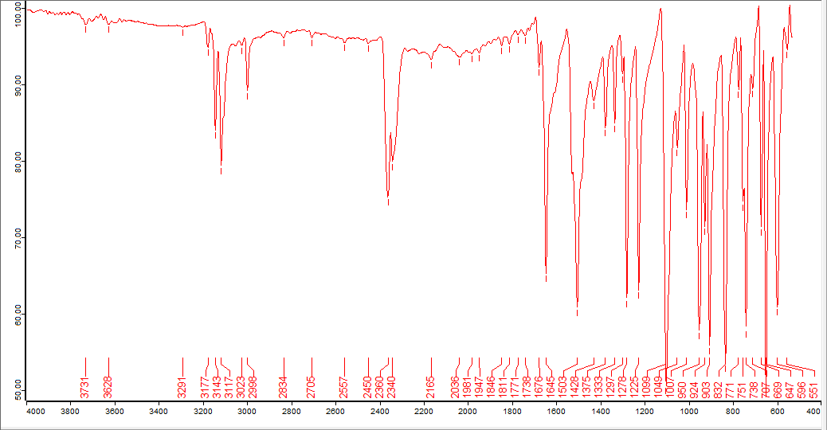
Figure S1. FT-IR Spectrum of [Cu₃(µ₂-Cl)₂Cl₄(1-Vim)₆]

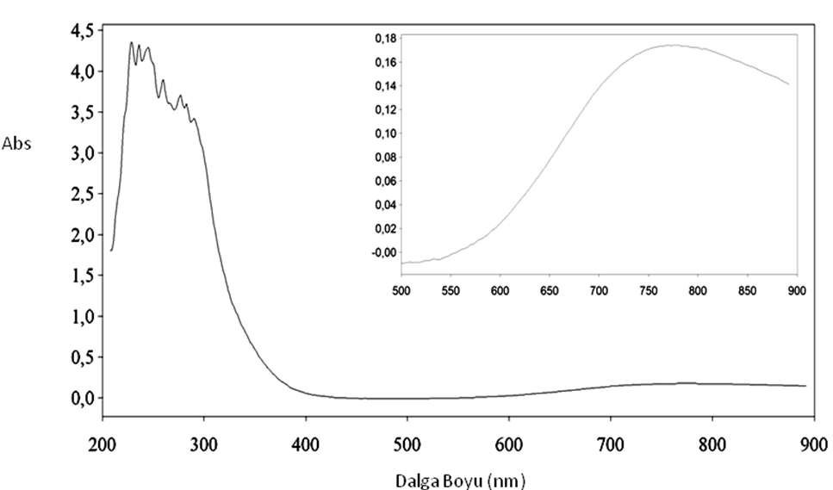
Figure S2. Electronic Spectrum of [Cu₃(µ₂-Cl)₂Cl₄(2-Vim)₆]

