Oxidation of ruthenium and iridium metal by XeF₂ and crystal structure determination of [Xe₂F₃][RuF₆]∙XeF₂ and [Xe₂F₃][MF₆] (M = Ru, Ir)

Melita Tramšek*, Evgeny Goreshnik, Gašper Tavčar,
Jožef Stefan Institute, Jamova 39, SI-1000 Ljubljana, Slovenia
*Corresponding author E-mail: melita.tramsek@ijs.si, Tel.: +386 1 477 3301

Abstract
Salts containing [Xe₂F₃]⁺ cations and [MF₆]⁻ anions (M = Ru, Ir) were synthesized by the oxidation of metal with excess of XeF₂ in anhydrous hydrogen fluoride (aHF) as a solvent. Single crystals of [Xe₂F₃][RuF₆]∙XeF₂, [Xe₂F₃][RuF₆] and [Xe₂F₃][IrF₆] were grown by slow evaporation of the solvent. [Xe₂F₃][RuF₆]∙XeF₂ crystallizes in a triclinic P-1 space group (a = 8.3362(1) Å, b = 8.8197(2) Å, c = 9.3026(4) Å; α = 68.27(1) °, β = 63.45(1) °, γ = 82.02 °, V = 568.09(9) Å³ (Z = 2)). Discrete [Xe₂F₃]⁺, XeF₂ and [RuF₆]⁻ units are found in the asymmetric unit. [Xe₂F₃][RuF₆] and [Xe₂F₃][IrF₆] compounds are isostructural and crystalize in a monoclinic C/c space group (a = 14.481(3) Å (Ru); 14.544(3) Å (Ir); b = 8.0837(8) Å (Ru), 8.0808(7) Å (Ir), c = 10.952(2) Å (Ru), 11.014(2) Å (Ir); β = 136.825(6) ° (Ru), 139.954(7) °,V = 877.2(3) Å³ (Ru), 883.6(3) Å³ (Ir); Z = 4). The asymmetric unit in the [Xe₂F₃][MF₆] (M = Ru, Ir) consists of one [Xe₂F₃]⁺ and one [MF₆]⁻ unit.

Keywords: noble gas fluorides, ruthenium, iridium, crystal structure

1. Introduction

XeF₂ is the most stable and easily handled noble gas fluoride and therefore its chemistry is very extensive. Basic information about XeF₂, its properties and possibilities that it offers can be found in review paper and book and the references listed therein. , One of its unexpected and interesting abilities is also binding to metal centres in order to form coordination compounds. A large variety of such compounds has been found in previous years. The formation of XeF₂ adducts with main-group and transition-metal Lewis acidic pentafluoridometalates -MF₅ is known for decades. So far three types of the compounds were found: 2XeF₂∙MF₅, XeF₂∙MF₅ and XeF₂∙(MF₅)₂. The degree of ionic character in these compounds varies depending on the Lewis acidity of the respective pentafluoride. Compounds were mainly characterized by vibrational spectroscopy and can be written as salts [Xe₂F₃][MF₆], [XeF][MF₆] and [XeF][M₂F₁₁], especially in the case of reactions with strong Lewis acids (for example AsF₅, SbF₅, BiF₅...). The formation of 2:1 compounds was found in the cases where M was As, Sb, Bi, Ta, Ru, Os and Ir. , , , From this type of compounds (2:1 composition) [Xe₂F₃][MF₆] (M = As, Sb) , were also structurally characterized. The compounds with composition 1:1 (XeF⁺MF₆⁻) and 1:2 (XeF⁺M₂F₁₁⁻) were obtained for the most of the MF₅ mentioned above. Some of them were structurally characterized: [XeF][MF₆] (M = As, Sb, Bi, Ru and Ir) , , , and [XeF][M₂F₁₁] (M = Sb, Bi)¹¹. One of the latest structurally determined case is also and [XeF][IrSbF₁₁] with two different metals in the anion.¹³ [Xe₂F₃]⁺ and [XeF]⁺ cations were recently found with nonoctahedral anion in the xenon(II) polyfluoridotitanates(IV): [Xe₂F₃][Ti₈F₃₃] and [XeF]₂[Ti₉F₃₈].
The present study reports about the synthesis and structural characterization of three noble gas salts containing [Xe₂F₃]⁺ cation: [Xe₂F₃][RuF₆]∙XeF₂, [Xe₂F₃][RuF₆] and [Xe₂F₃][IrF₆].

2. Experimental
2.1. General Experimental Procedure and Reagents
Volatile materials (anhydrous HF, F₂) were handled in an all PTFE vacuum line equipped with PTFE (polytetrafluoroethylene) valves. The manipulations of the non-volatile materials were carried out in a glove-box (M. Braun). The residual water in the atmosphere within the glove-box never exceeded 1 ppm. The reactions were carried out in FEP (tetrafluoroethylene-hexafluoropropylene; Polytetra GmbH, Germany) reaction vessels (height 250–300 mm with inner diameter 15.5 mm and outer diameter 18.75 mm) equipped with PTFE valves and PTFE coated stirring bars. T-shaped reaction vessels from PTFE were used for the crystallization process. Prior to their use all reaction vessels were passivated with elemental fluorine. Fluorine was used as supplied (Solvay Fluor and Derivate GmbH, Germany). Anhydrous HF (Linde, 99.995 %) was treated with K₂NiF₆ (Advance Research Chemicals, Inc.) for several hours prior to use. XeF₂ was synthesized by photochemical reaction between Xe and F₂. Caution: aHF, F₂ and XeF₂ must be handled in a well-ventilated fume hood, and protective clothing must be worn at all times.

2.2. Synthesis and characterization procedures
Synthetic procedures for ruthenium and iridium compounds were the same. Metal powder (Ru: 0.215 g, 2.13 mmol, Ir: 0,430 g, 2.2 mmol) was added into reaction vessel inside the glove-box. The aHF was condensed into the reaction vessel at -196 °C at the vacuum line. Large excess of XeF₂ (mole ratio M: XeF₂ was approximately 1:10) was weighted into another reaction vessel inside the glove-box. Anhydrous HF was added to the XeF₂ and reaction vessel was slowly warmed up to room temperature. XeF₂ solution was then poured into cold reaction vessel (-196 °C) with suspension of the metal powder (Ru, Ir) and left to slowly warm up to room temperature. The solution turned green immediately in the case of ruthenium but the reaction with iridium proceeded at room temperature for several days (light gray solid product). Products of the oxidation were isolated by removal of aHF and excessive XeF₂ under dynamic vacuum at room temperature. Several crystallization experiments were performed. In some cases the product of the oxidation of the metal with XeF₂ was dissolved in aHF in a wider arm of the T-shaped crystallization vessel, while in the other additional XeF₂ was added. Solution was then poured into narrow arm of the crystallization vessel and left to crystallize by a small temperature gradient used for slow evaporation of aHF.
The Raman spectra were recorded at room temperature with a Horiba Jobin Yvon LabRam-HR spectrometer equipped with an Olympus BXFM-ILHS microscope and CCD detector. The samples were excited by the 632.8 nm emission line of a He−Ne laser. Samples for measurement were transferred into the quartz capillary inside glove-box.
The crystallographic parameters and summaries of data collection for all compounds are presented in Table 1. Single-crystal data were collected on a Rigaku AFC7 diffractometer using graphite monochromatized MoKα radiation at 200 K. Crystals were immersed into perfuorinated oil in glove-box and further on selected under the microscope. An empirical multi-scan absorption correction was applied. All structures were solved by direct methods using SIR-92 and SHELXS-97 programs (teXan crystallographic software package of Molecular Structure Corporation ) and refined with SHELXL-97 software, implemented in program package WinGX . Full–matrix least–squares refinements based on F² were carried out for the positional and thermal parameters for all non-hydrogen atoms. The figures were prepared using DIAMOND 3.1 software. Further details of the crystal-structure investigation may be obtained from the Fachinformationszentrum Karlsruhe, 76344 Eggenstein-Leopoldshafen, Germany, on quoting the depository number: CSD-430805 for [Xe₂F₃][RuF₆], CSD-430806 for [Xe₂F₃][IrF₆] and CSD-430807 for [Xe₂F₃][RuF₆]∙XeF₂ respectively.

3. Results and Discussion
Oxidation power of XeF₂ was used in order to prepare previously mentioned Ru(V) and Ir(V) compounds. XeF₂ dissolved in anhydrous hydrogen fluoride (aHF) was also used as selective inorganic fluorinating reagent for oxidation and fluorination of Ir and RuF₃ almost three decades ago with final products being IrF₅ and RuF₅. Metal ruthenium was oxidized rapidly with vigorous reaction being observed during the warming of the reaction vessel from -196 °C to room temperature. A clear, slightly green solution was obtained. We used slightly modified procedure for preparation of ruthenium compound ([Xe₂F₃][MF₆]∙XeF₂). The product was further used for the synthesis of [Ba(XeF₂)₅][RuF₆]₂. The same reaction with iridium proceeded for several weeks. The colour of the solution was red-brown at the beginning and after several days became slightly yellow with some grey precipitate – same as the solid product after the isolation. Grey solid obtained by the oxidation of Ir metal with XeF₂ was re-dissolved in aHF and clear slightly green solution was obtained. Products of the reactions were also monitored by Raman spectroscopy, which shows (Figure 1) that in both cases the compound with composition [Xe₂F₃][MF₆]∙nXeF₂ (M = Ru, Ir, n is aprox. 1 according to the mass balance of the reaction) were obtained. Alternative method used for the preparation of related compounds with Ru(V) (KRuF₆, LiRuF₆ ) and Ir(V) (KIrF₆, LiIrF₆) with alkaline metals is room temperature oxidation with elemental fluorine in the presence of Lewis base (KF) in aHF. One of the recently published ways to prepare soluble iridium compounds, which seems to be important for modern “urban mining”, is also reaction of the metal with tetrafluorobromates (MBrF₄; M = K, Rb, Cs).
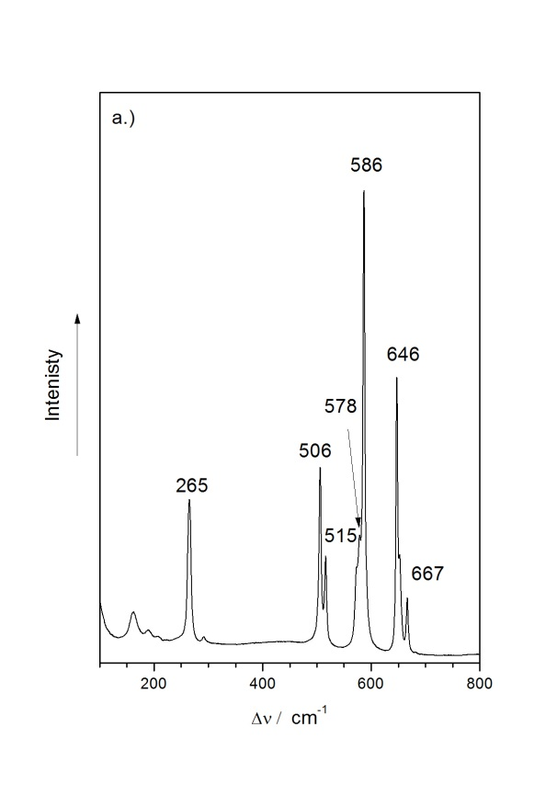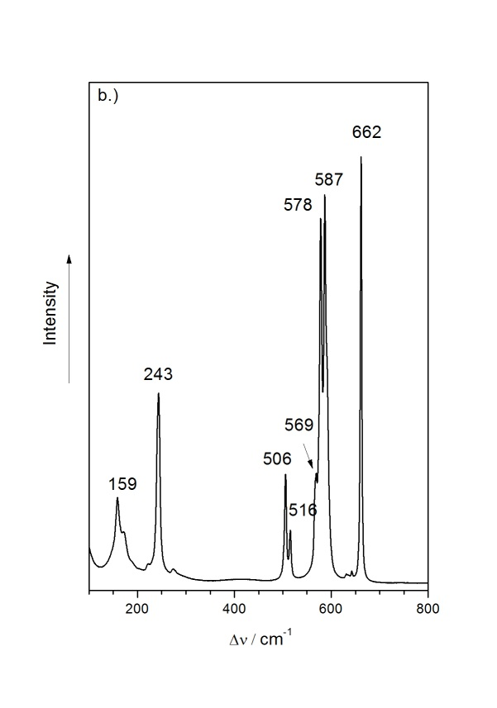
Figure 1. Raman spectra of [Xe₂F₃][RuF₆]∙XeF₂ (a) and [Xe₂F₃][IrF₆]∙XeF₂ (b)

For solid XeF₂ the band at 497 cm⁻¹ is characteristic. The bands at 506 cm⁻¹, 515 cm⁻¹ in ruthenium compound and 506 cm⁻¹ and 516 cm⁻¹ in iridium compound can be attributed to the XeF₂ weakly associated with [Xe₂F₃]⁺ cations and [MF₆]⁻ anions in the [Xe₂F₃][MF₆]∙XeF₂ product. Similar positions and assignments of this bands were observed in some other cases in the system XeF₂-MF₅ (M = Sb, Ta, Nb). The weakly associated XeF₂ was found in the melt of the compounds. “Free” XeF₂ was also found in the compounds XeF₂∙XeF₆∙AsF₅ and XeF₂∙2(XeF₆)∙2(AsF₅), where the Raman bands depend on the interaction of the so called “free” XeF₂ molecule with cations and anions and consequential distortion of its shape. “Free” XeF₂ in XeF₂∙2(XeF₆)∙2(AsF₅) compound is probably in completely symmetric environment, therefore the band assigned to it coincides with the symmetric stretching frequency in molecular XeF₂ (497 cm⁻¹). On the other hand Raman spectrum of XeF₂∙XeF₆∙AsF₅ doesn’t show symmetric vibration of molecular XeF₂ but two bands at 557 cm⁻¹ and 429 cm⁻¹ which represent distorted XeF₂ molecule meaning that XeF₂ in such compound can be far from “free”. Linear distortion of XeF₂ was found also in the Raman spectrum of XeF₂∙[XeF₅][RuF₆]. Bands at 578 cm⁻¹ and 586 cm⁻¹ in the ruthenium compound and bands at 578 cm⁻¹ and 587 cm⁻¹ in iridium compound can be confidently assigned to the Xe-F_{t} stretch vibrations of [Xe₂F₃]⁺ cation. They are in the region that is characteristic for such vibrations (from ca. 575 cm⁻¹ to 600 cm⁻¹). The bands at 646 cm⁻¹, 667 cm⁻¹ and 265 cm⁻¹ for ruthenium compound and 662 cm⁻¹ and 243 cm⁻¹ for iridium can be assigned to the vibration of [MF₆]⁻ anions. Products with additional XeF₂ are not stable under dynamic vacuum at room temperature. They release XeF₂, which leads to the formation of the [Xe₂F₃][MF₆] and further on to the [XeF][MF₆] (M = Ru, Ir) compounds. Raman analysis of the slow removal of XeF₂ under dynamic vacuum in the case of ruthenium is shown in Figure 2. In the spectrum shown on the Figure 2a (black colour) all three phases can be found: [Xe₂F₃][RuF₆]∙XeF₂, [Xe₂F₃][RuF₆] and [XeF][RuF₆]. With the release of the XeF₂, phases [Xe₂F₃][RuF₆] and [XeF][RuF₆] are found (Figure 2b (blue colour). Prolonged pumping on the vacuum system (overnight) ended up with [XeF][RuF₆] as the only product. Position and the intensities of the bands for [Xe₂F₃][RuF₆] and [XeF][RuF₆] are in the agreement with those published previously. ⁴

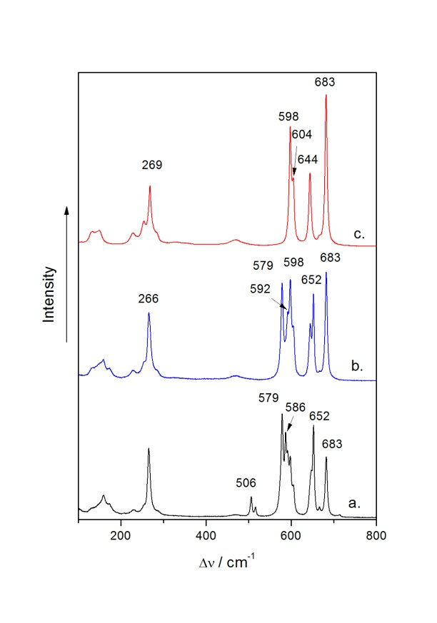
Figure 2: Raman spectra of the reaction mixture during the isolation of ruthenium compound on the vacuum system.

3.1 Crystal structure determination of [Xe₂F₃][RuF₆]∙XeF₂ and [Xe₂F₃][MF₆] (M = Ru, Ir)
Three compounds in this system were structurally characterized. Summary of crystal data and refinement results for [Xe₂F₃][RuF₆]∙XeF₂ and [Xe₂F₃][MF₆] (M = Ru, Ir) are presented in Table 1 and selected distances and angles are found in Table 2. Several unsuccessful attempts were made in order to prepare suitable single crystals of the [Xe₂F₃][IrF₆]∙XeF₂. So far we were only able to resolve structure of [Xe₂F₃][IrF₆].

Table 1. Crystal data and structure refinement for [Xe₂F₃][RuF₆]∙XeF₂ and Xe₂F₃MF₆ (M = Ru, Ir)
 | [Xe₂F₃][RuF₆]∙XeF₂ | [Xe₂F₃][RuF₆] | [Xe₂F₃][IrF₆]
Empirical formula | RuXe₃F₁₁ | RuXe₂F₉ | IrXe₂F₉
Formula weight | 703.94 | 534.67 | 625.8
Wavelength, MoKα | 0.71069 Å | 0.71069 Å | 0.71069 Å
Crystal system,  Space group | triclinic  P-1 | monoclinic  C/c | monoclinic  C/c
Temperature, K | 200 | 200 | 200
Unit cell dimensions
a, Å | 8.3362(1) | 14.481(3) | 14.544(3)
b, Å | 8.8197(2) | 8.0837(8) | 8.0808(7)
c, Å | 9.3026(4) | 10.952(2) | 11.014(2)
α, ° | 68.27(1) | 90 | 90
β, ° | 63.45(1) | 136.825(6) | 136.954(7)
γ, ° | 82.02(2) | 90 | 90
V, Å³ | 568.09(9) | 877.2(3) | 883.6(3)
Z | 2 | 4 | 4
Calculated density, g/cm³ | 4.115 | 4.048 | 4.704
Absorption coeff., mm⁻¹ | 10.289 | 9.477 | 22.745
F(000) | 610 | 932 | 1064
Crystal size, mm | 0.08x0.06x0.04 | 0.1x0.1x0.08 | 0.1x0.07x0.05
Colour | colourless | colourless | colourless
Theta range for data collection, deg | 2.487 - 28.6986 | 3.2522- 28.5637 | 3.1256 - 27.9323
Limiting indices | -8 ≤ h ≤ 11, -10 ≤ k ≤ 11,  -11 ≤ l ≤ 12 | -18 ≤ h ≤ 16, -10 ≤ k ≤ 10,  -8 ≤ l ≤ 14 | -18 ≤ h ≤ 17, -6 ≤ k ≤ 10,  -6 ≤ l ≤ 14
Refinement method | Full-matrix least-squares on F² | Full-matrix least-squares on F² | Full-matrix least-squares on F²
Measured reflections | 2259 | 1174 | 1129
Used in refinement | 1837 | 890 | 1074
Free parameters | 137 | 111 | 111
Goodness-of-fit on F² | 1.134 | 1.134 | 1.067
R indices | R₁ =0.0608  wR₁ = 0.1775 | R₁ =0.0371  wR₁ = 0.0849 | R₁ =0.0382  wR₁ = 0.0963
Largest diff. peak and hole, e Å⁻³ | 1.758 and -3.063 | 1.579 and -1.236 | 1.699 and -2.329

The structure of [Xe₂F₃][RuF₆]∙XeF₂ compound consists of discrete [Xe₂F₃]⁺, XeF₂ and [RuF₆]⁻ units (Figure 3). XeF₂ molecules and [Xe₂F₃]⁺ cations are oriented roughly perpendicularly to each other. When viewed towards (-3 -4 3) direction alternating cationic and anionic layers could be marked out. Anions are separated by XeF₂ molecules (Figure 4). The compound is structurally related to [Kr₂F₃][SbF₆]∙KrF₂ in which the crystal packing consists of alternating cation and equally populated anion/KrF₂ layers.
XeF₂ molecules are slightly asymmetrical with distances being 1.980(7) Å and 1.992(7) Å and angle F10−Xe−F11 of 178.9(4) °. [Xe₂F₃]⁺ cation exhibit planar, V shape configuration with nearly symmetrical Xe−F_{t} bonds (2.139(7) Å, 2.152(7) Å) and Xe−F_{b}−Xe angle of 154.3(4) °. The [RuF₆]⁻ anions are slightly distorted octahedra with Ru–F bond distances in the range from 1.834(8) to 1.861(7) Å.
Table 2. Selected distances (Å) and angles (°) in [Xe₂F₃][RuF₆]∙XeF₂, [Xe₂F₃][MF₆] (M = Ru, Ir)
 | [Xe₂F₃][RuF₆]∙XeF₂ | [Xe₂F₃][RuF₆] | [Xe₂F₃][IrF₆]
Xe1−F1 | 2.139(7) | 2.09(1) | 2.12(2)
Xe2−F1 | 2.152(7) | 2.17(1) | 2.15(2)
Xe1−F2 | 1.913(8) | 1.90(2) | 1.88(2)
Xe2−F3 | 1.919(6) | 1.92(2) | 1.96(2)
Xe3−F10 | 1.980(7)
Xe3−F11 | 1.992(7)
Xe1−F1−Xe2 | 154.3(4) | 161.5(5) | 161.3(8)
F10−Xe3−F11 | 178.9(4)

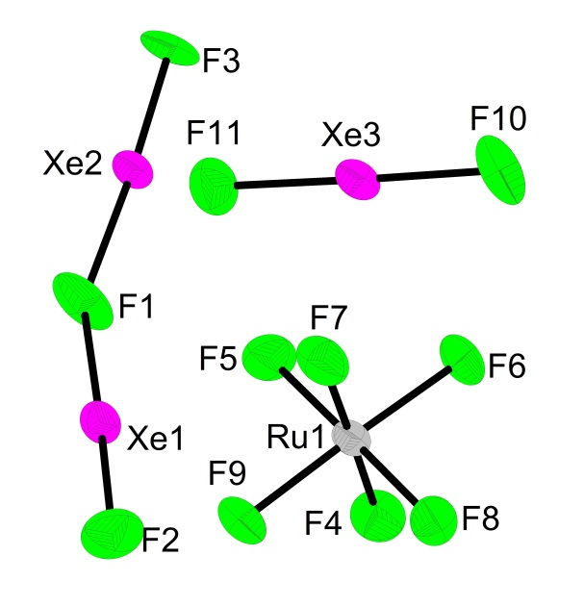
Figure 3. Asymmetric unit in [Xe₂F₃][RuF₆]∙XeF₂ with thermal ellipsoids drawn at 50 % probability level.

Xe centres from both XeF₂ and [Xe₂F₃]⁺ moieties interact with fluorine atoms from another structural units. The shortest F9···Xe2^{iii} and F9···Xe1 distances of 3.190(7) and 3.216(7) Å respectively correspond to slightly elongated Ru1−F9 bond (1.861(7) Å). There are four XeF₂ molecules bound to one anion via Xe···F contacts of 3.301(7) - 3.373(7) Å.
Weak Xe···F(Xe) and Xe···F(Ru) interactions connect above mentioned units into three-dimensional network (Figure 4) if contacts shorter than 3.4 Å are taken into consideration. The Xe−F bond lengths in XeF₂ molecules demonstrate weak asymmetry. Such a difference possibly relates to a formation of different Xe−F···Xe contacts. The shorter Xe3−F10 bond of 1.980(7) Å corresponds to an appearance of F10···Xe1^{i} and F10···Xe2^{ii} contacts of 3.156(7) and 3.298(8) Å respectively. Opposite F11 atom (Xe3−F11 1.992(7) Å) forms the only one F11···Xe2 contact of 3.169(8) Å. All three Xe atoms bound to XeF₂ molecule belong to three different [Xe₂F₃]⁺ units.
Terminal F2 and F3 atoms from each [Xe₂F₃]⁺ also form longer contacts with Xe centers from other cations. These contacts are slightly longer than those in the case of XeF₂···Xe₂F₃⁺ interaction (3.219(7) - 3.278(8) Å correspondingly)

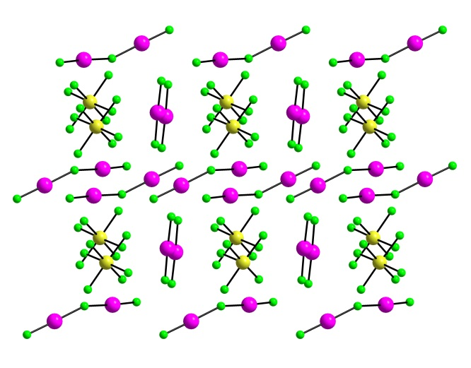
Figure 4. Packing of the asymmetric units in the structure of [Xe₂F₃][RuF₆]∙XeF₂

Compounds [Xe₂F₃][MF₆]∙(M = Ru, Ir) are both isostructural with monoclinic [Xe₂F₃][SbF₆] ⁹. Asymmetrical unit in both cases consists of one [Xe₂F₃]⁺ cation and one [MF₆]⁻ anion (Figure 5). In both cases several Xe∙∙∙F contacts in the range above 3 Å can be found. The position of the asymmetrical units down b-axis is presented in Figure 6. More open structure of the Xe₂F₃⁺ cation is found in the case of [Xe₂F₃][MF₆] (M = Ru, Ir) compared to the [Xe₂F₃][RuF₆]∙XeF₂. (Xe∙∙∙F_{b}∙∙∙Xe) angles, which are 161.5(5) ° in ruthenium compound and 161.3(8) ° in iridium compound, are in agreement with those in isostructural monoclinic [Xe₂F₃][SbF₆] (Xe∙∙∙F_{b}∙∙∙Xe = 160.3 °). Bridging angle of Xe∙∙∙F_{b}∙∙∙Xe in [Xe₂F₃]⁺ cations vary from 139.8 ° (trigonal [Xe₂F₃][AsF₆] ⁹) to the widest one being 164.3 ° ([Xe₂F₃][Ti₈F₃₃] ¹⁴).
Strong dependence of the Xe···F_{b}···Xe bridge angle on the crystal packing and on the nature of the counter anion was demonstrated in previous study. Calculation (Christiansen-Ermler ECP) in the same study also predicted non-linear structure of the [Xe₂F₃]⁺ cation with a bridging angle of 168 °. ⁹
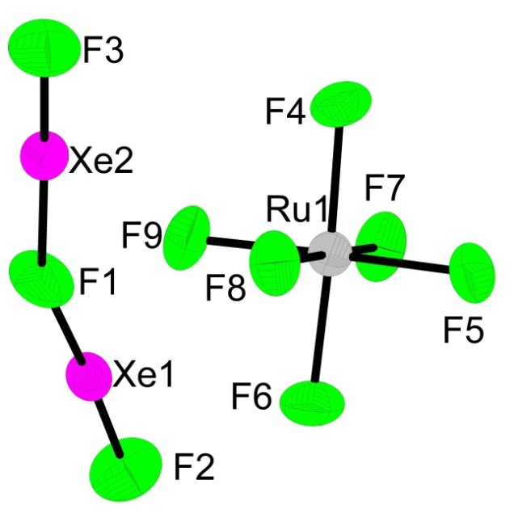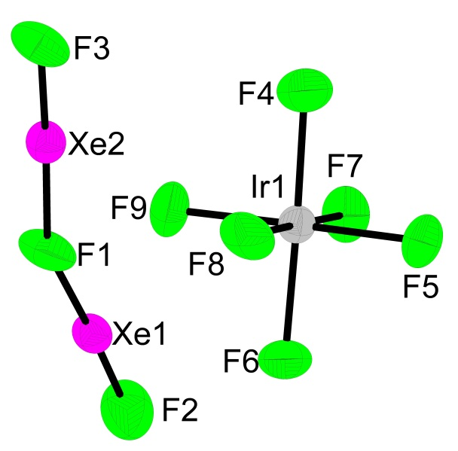
Figure 5. Asymmetric units in [Xe₂F₃][RuF₆] and [Xe₂F₃][IrF₆] with thermal ellipsoids drawn at 50 % probability level.

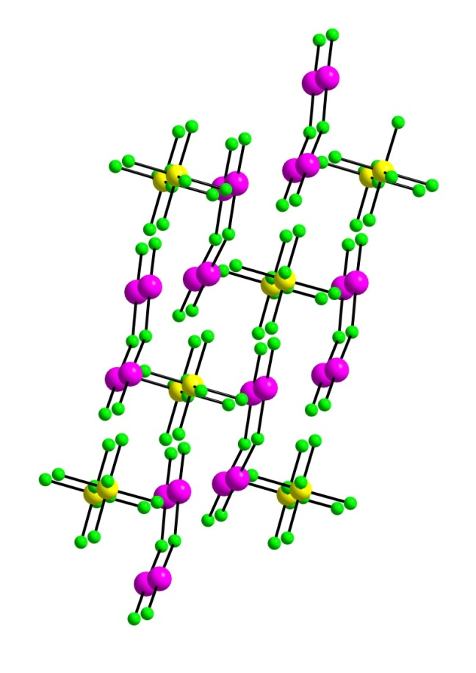
Figure 6. Packing in the crystal structure of [Xe₂F₃][RuF₆] viewed along b-axis

4. Conclusions
The oxidizing power of XeF₂ was demonstrated by oxidation of ruthenium and iridium metal in aHF as a solvent. Products of the oxidation belong to the family of noble gas compounds with [Xe₂F₃]⁺ cations. Salt with composition [Xe₂F₃][RuF₆]∙XeF₂ was structurally characterized. The synthesis and characterization with Raman spectroscopy of the new salt [Xe₂F₃][IrF₆]∙XeF₂ are also reported. Single crystal structures of [Xe₂F₃][RuF₆] and [Xe₂F₃][IrF₆] were determined.

5. Acknowledgement
The authors gratefully acknowledge the Slovenian Research Agency (ARRS) for financial support of the Research Program P1-0045 (Inorganic Chemistry and Technology).

6. References:

. M Tramšek, B. Žemva, Acta Chim. Slov. 2006, 53, 105-116.
. J. Reedjik, K. Poeppelmeier (Ed.): Comperhensive Inorganic Chemistry II, Elsevier, Oxford, 2013, D. S. Brock, G. J. Schrobilgen, B. Žemva, Vol. 1, pp755-822
. M. Tramšek, G. Tavčar, J. Fluorine Chem. 2015, 174, 14-21.
. F. O. Sladky, P.A. Bulliner, N. Bartlett, J. Chem. Soc. 1969, 2179-2188.
. B. Frlec, J.H. Holloway, J. Chem. Soc. 1975, 535-540.
. R. J. Gillespie, D. Martin, G. J. Schrobilgen, J. Chem. Soc. Dalton 1980, 1898-1903.
. J. H. Holloway, J.G, Knowles, J. Chem. Soc. 1969, 756-761.
. N. Bartlett, B. G. DeBoer, F. J. Hollander, F. O. Sladky, D. H. Templeton, A. Zalkin, Inorg. Chem. 1974, 13, 780-785.
. B. A. Fir, M. Gerken, B. E. Pointner, H. P. A. Mercier, D. A. Dixon, G. J. Schrobilgen, J. Fluorine Chem. 2000, 105, 159-167.
. A. Zalkin, D. L. Ward, R. N. Biagoni, D. H. Tempelton, N. Bartlett, Inorg. Chem. 1978, 17, 1318-1322.
. Elliot H. St. A., Lehman J. F. Mercier H. P. A., Jenkins H. D. B., Schrobilgen G. J. , Inorg. Chem. 2010, 49, 8504-8523.
. N. Bartlett, M. Gennis, B. K. Morrell, A. Zalkin, Inorg. Chem. 1973, 12, 1717-1721.
. F. Tamadon, S. Seidel, K. Seppelt, Acta Chim. Slov. 2013, 60, 491-494.
. K. Radan, E. Goreshnik, B. Žemva, Agew. Chem. Int. Ed. 2014, 53, 13715-13719
. R. N. Grimes (Ed.). Inorganic Syntheses, John Wiley, New York, 1992, A. Šmalc, K. Lutar, Vol. 29, pp. 1-4.
. A. Altomare, M. Cascarano, M., C. Giacovazzo, A. Guagliardi, J. Appl. Cryst. 1993, 26, 343-350.
. Molecular Structure Corporation. (1997-1999), teXsan for Windows, Single Crystal Structure Analysis Software. Version 1.06, MSC, 9009 New Trails Drive, The Woodlands, TX 77381, USA.
. G. M. Sheldrick, Acta Cryst. 2008, A64, 112-122.
. L. J.Farrugia, J. Appl. Cryst. 1999, 32, 837-838.
. DIAMOND v3.1, Crystal Impact GbR, Bonn, Germany, 2004-2005
. R. C. Burns, I. D. MacLeod, T. A. O'Donnell, T. E. Peel, K. A. Philips, A. B. Waugh, J. Inorg. Nucl. Chem. 1977, 39, 1737-1739.
. T. Bunič, M. Tramšek, E. Goreshnik, B. Žemva, Collect. Czech. Chem. Commun. 2008, 73, 1645-1654.
. G. Lucier, S. H. Elder, L. Chacón, N Bartlett, Eur. J. Solid State Inorg. Chem. 1969, 33, 809-820.
. G. Tavčar, B. Žemva, Inorg. Chem. 2013, 52, 4139-4323.
. S. Ivlev, P. Woidy, F. Kraus, I. Gerin, R. Ostvald, Eur. J. Inorg. Chem. 2013, 4984-4987.
. P. A. Agron, G. M. Begun, H. A. Levy, A. A. Mason, C. G. Jones, D. F. Smith, Science 1963, 139, 842-844.
. B. Frlec, J. H. Holloway, J. Inorg. Nucl. Chem. Supplement 1 1976, 28, 167-171.
. N. Bartlett, M. Wechsberg, Z. anorg. Allg. Chem. 1971, 385, 5-17.
. B. Žemva, L. Golič, J. Slivnik, Vestn. Slov. Kem. Druš. 1983, 30, 365-376.
. Lehman J. F., Dixon D. A., Schrobilgen G. J., Inorg. Chem. 2001, 40, 3002-3017. Povzetek: Z oksidacijo kovine s presežnim XeF₂ v brezvodnem vodikovem fluoridu (aHF) kot topilu smo pripravili spojine s kationi [Xe₂F₃]⁺ in anioni [MF₆]⁻ (M = Ru, Ir). Kristale [Xe₂F₃][RuF₆]∙XeF₂, [Xe₂F₃][RuF₆] in [Xe₂F₃][IrF₆], ki so bili primerni za rentgensko strukturno analizo, smo pripravili s počasnim izhlapevanjem topila. [Xe₂F₃][RuF₆]∙XeF₂ kristalizira v triklinskem kristalnem sistemu, prostorska skupina P-1 (a = 8.3362(1) Å, b = 8.8197(2) Å, c = 9.3026(4) Å; α = 68.27(1) °, β = 63,45(1) °, γ = 82.02 °, V = 568.09(9) Å³ (Z = 2)). V asimetrični enoti spojine se nahajajo [Xe₂F₃]⁺, XeF₂ in [RuF₆]⁻. Spojini [Xe₂F₃][RuF₆] in [Xe₂F₃][IrF₆] sta izostrukturni in kristalizirata v monoklinskem kristalnem sistemu, prostorska skupine C/c (a = 14.481(3) Å (Ru); 14.544(3) Å (Ir); b = 8.0837(8) Å (Ru), 8.0808(7) Å (Ir), c = 10.952(2) Å (Ru), 11.014(2) Å (Ir); β = 136.825(6) ° (Ru), 139.954(7) °,V = 877.2(3) Å³ (Ru), 883.6(3) Å³ (Ir); Z = 4). Asimetrični enota [Xe₂F₃][MF₆] (M = Ru, Ir) je sestavljena iz [Xe₂F₃]⁺ in [MF₆]⁻ ionov. Graphical Abstract 