The interaction of acrolein with pristine and N-doped TiO₂ anatase nanoparticles: A DFT study
Amirali Abbasi ^{a, b, c*}, Jaber Jahanbin Sardroodi ^{a, b, c}
a. Molecular Simulation laboratory (MSL), Azarbaijan Shahid Madani University, Tabriz, Iran
b. Computational Nanomaterials Research Group (CNRG), Azarbaijan Shahid Madani University, Tabriz, Iran
c. Department of Chemistry, Faculty of Basic Sciences, Azarbaijan Shahid Madani University, Tabriz, Iran
* Corresponding Author, Tel: +98-412-432-7541; Email: a_abbasi@azaruniv.edu

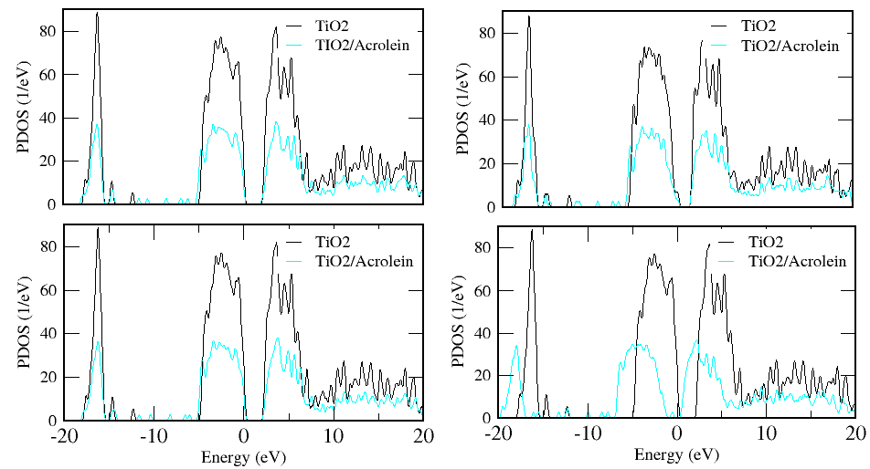
d
c
b
a

Figure S1. Density of states for the adsorption of a C₃H₄O molecule on the TiO₂ anatase nanoparticles, a: Complex A1; b: Complex A2; c: Complex A3 and d: Complex A4.

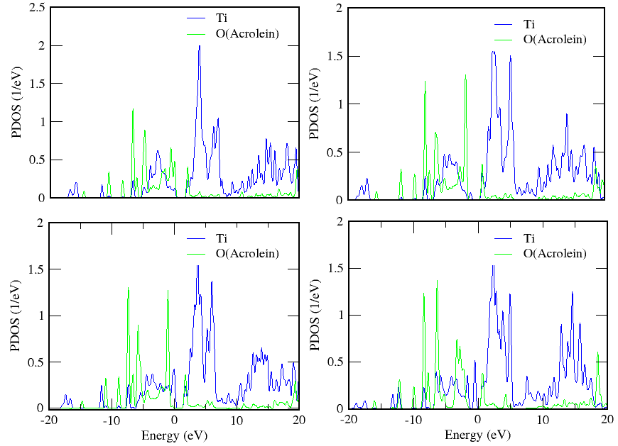
d
c
b
a

Figure S2. PDOS for the adsorption of C₃H₄O molecule on the N-doped nanoparticles, a: Complex A6; b: Complex A7; c: Complex A8; d: Complex A9.

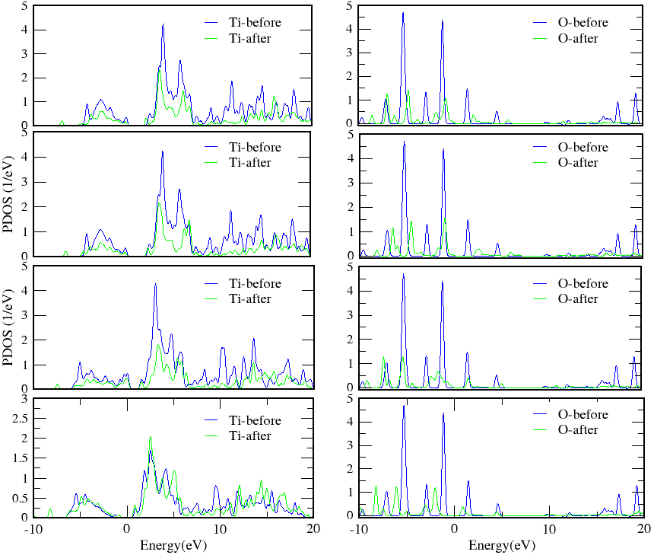
Figure S3. PDOS for the adsorption of C₃H₄O molecule on the N-doped nanoparticles, a: Complex A1; b: Complex A2; c: Complex A3; d: Complex A4; e: Complex A1; f: Complex A2; g: Complex A3; h: Complex A4.
h
g
f
e
d
c
b
a

