TOC：

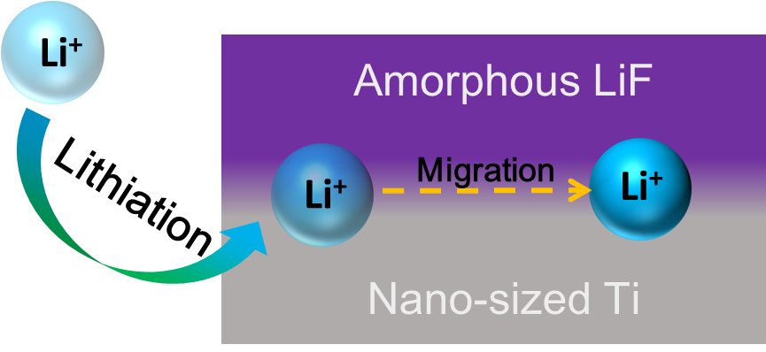

Graphic abstract:

LiF/Ti nanocomposite after electrochemical or chemical lithiation show much enhanced ionic conductivity due to diffusion behavior of external lithium along phase boundary between LiF and Ti.

Highlight of this manuscript

- A LiF-Ti nanocomposite thin film is deposited by co-sputtering method.
- Lithium is “injected” into the LiF/Ti film by electrochemical lithiation and chemical lithiation.
- LiF/Ti film with external lithium shows much enhanced ionic and electronic conductivity.
- Phase boundary between LiF and Ti can be fast ionic diffusion channels .

