Graphical Abstract

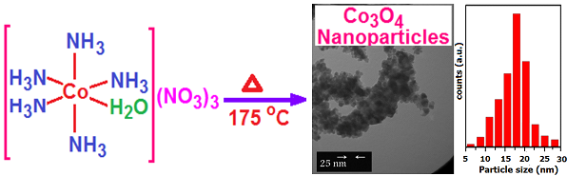 | Characterization of Cobalt Oxide Nanoparticles Prepared by the Thermal Decomposition of [Co(NH₃)₅(H₂O)](NO₃)₃ Complex and Study of Their Photocatalytic Activity  Saeed Farhadi, Masoumeh Javanmard, Gholamali Nadri

