Characterization of Cobalt Oxide Nanoparticles Prepared by the Thermal Decomposition
of [Co(NH₃)₅(H₂O)](NO₃)₃ Complex and Study of Their Photocatalytic Activity

Saeed Farhadi* and Gholamali Nadri
Department of Chemistry, Lorestan University, Khoramabad 68135-465, Iran
*Corresponding author: E-mail: sfarhadi1348@yahoo.com
Tel.: +98 06633120611, fax: +98 06633120618

Abstract
In this work, thermal decomposition of the [Co(NH₃)₅(H₂O)](NO₃)₃ complex was investigated under solid state conditions. The obtained results showed that this complex was easily decomposed into the Co₃O₄ nanoparticles at low temperature (175 °C) without using expensive and toxic solvents or complicated equipment. The product was identified by X-ray diffraction (XRD), Fourier transform infrared spectroscopy (FT-IR), transmission electron microscopy (TEM) and energy-dispersive X-ray spectroscopy (EDS). Optical and magnetic properties of the products were studied by UV-visible spectroscopy and a vibrating sample magnetometer (VSM), respectively. FT-IR, XRD and EDS analyses confirmed the formation of highly pure spinel-type Co₃O₄ phase with cubic structure. SEM and TEM images showed that Co₃O₄ nanoparticles have a sphere-like morphology with an average size of 10-30 nm. The optical spectrum of each Co₃O₄ product revealed the presence of two band gaps in the range of 2-3.5 eV, which in turn confirmed the semiconducting properties. The magnetic measurement showed a weak ferromagnetic order at room temperature. Photocatalytic degradation of methylene blue (MB) demonstrated that the as-prepared Co₃O₄ nanoparticles show good photocatalytic effect under visible-light irradiation.

Keywords: Co₃O₄ nanoparticles, Thermal decomposition, pentamminecobalt(III) complexes, Ferromagnetic order, Photocatalytic degradation.
_____________________________________________________________________________
1. Introduction
Metal oxides nanoparticles represent a new class of important materials that are increasingly being developed for use in research and health-related applications. They are interesting not only for their wide variety of physical and chemical properties, but also for their wide variety of potential applications.¹ In particular, Co₃O₄ semiconductor is a versatile material that has achievable applications in gas sensors,^{2,3} heterogeneous catalysts,⁴⁻⁶ electrochemical devices,⁷ Li-ion batteries,⁸⁻¹¹ magnetic materials^{12,13} and photocatalysts.^{14,15} In recent years, the increasing interest has been focused on the synthesis of Co₃O₄ nanostructures because of the influences of particle size on their properties and applications.¹⁶⁻²⁶ Various wet-chemical methods such as hydro-/solvothermal method,^{27,28} combustion method,²⁹⁻³¹ microwave heating,³²⁻³⁴ sol–gel process,³⁵ spray pyrolysis,³⁶ sonochemical method,³⁷ co-precipitation,³⁸ ionic liquid-assisted method,³⁹ polyol method⁴⁰ and a non-aqueous route⁴¹ have been reported to synthesize Co₃O₄ nanostructures. Nevertheless, most of these methods involve complex processes, high calcination temperatures, and expensive and toxic precursors. In addition to these, they are either time consuming or require expensive instruments.
One of the simplest and lowest cost techniques to prepare metal oxides nanostructures is the solid-state thermal decomposition of molecular precursors at low temperature. This promising technique offers several unique advantages and significant merits over other methods including easy workup, short reaction time, and the preparation of various inorganic nanomaterials with unique sizes, specific shapes and with narrow size distribution.⁴²⁻⁴⁶ In this context, several precursors including CoC₂O₄.2H₂O,⁴⁷ [Co(Pht)(H₂O)]_{n} polymer,⁴⁸ Co(salophen),⁴⁹ Co(C₆H₅COO)(N₂H₄)₂,⁵⁰ [Co(NH₃)₅(CO₃)](NO₃)₂,⁵¹ [Co^{III}(NH₃)₆](NO₃)₃,⁵² and [Co(NH₃)₆]₂(C₂O₄)₃·4H₂O⁵³ have been used to synthesize Co₃O₄ nanostructures via the thermal decomposition route. However, the development of simple and new methods for obtaining precursor of Co₃O₄ for thermal decomposition is still of great significance for the synthesis of Co₃O₄ nanoparticles at low temperature.
In the present work, we wish to report on the direct thermolysis of an energetic pentamminecobalt(III) complex, [Co(NH₃)₅(H₂O)](NO₃)₃, which led to the synthesis of Co₃O₄ nanoparticles at low temperature without needs expensive and toxic solvents or complicated equipment. The obtained product from the decomposition of [Co(NH₃)₅(H₂O)](NO₃)₃ complex was characterized by X-ray diffraction (XRD), Fourier transform infrared spectroscopy (FT-IR), scanning electron microscopy (SEM), energy-dispersive X-ray spectroscopy (EDS), transmission electron microscopy (TEM), UV-visible spectroscopy, and magnetic measurement. The method is a fast, mild, energy-efficient and environmentally friendly route to produce Co₃O₄ nanoparticles in only one step.

2. Experimental
2. 1. Preparation of Co₃O₄ Nanoparticles
The precursor complex, Co(NH₃)₅(H₂O)](NO₃)₃, was synthesized according to the literature method.⁵⁴ In order to prepare Co₃O₄ nanoparticles, an appropriate amount (2 g) of the [Co(NH₃)₅(H₂O)](NO₃)₃ powder was loaded into a porcelain crucible and was then transferred into a muffle furnace. The sample was heated at a rate of 10 °C min⁻¹ from room temperature to 150 °C in air atmosphere and was maintained at this temperature for 1 h. Similar experiment was performed for the sample calcined at 175 °C. The decomposition product of the complex was collected for characterization.

2. 2. Methods of Characterization
The composition and phase purity of the products were characterized on a Rigaku D/max C III X-ray diffractometer using Ni-filtered Cu Ka radiation (λ = 1.5406 Å). XRD patterns were recorded in the 2θ range of 10°–80° with a scanning step of 0.02°. To investigate chemical bonding of the products, infrared spectra were recorded on the diluted samples in KBr pellets using a Schimadzu 160 FT–IR spectrophotometer within the region of 4000–400 cm⁻¹. The optical absorption spectrum was recorded on a Shimadzu 1650PC UV–vis spectrophotometer in a wavelength range of 200-700 nm at room temperature. The samples for UV-vis studies were well dispersed in distilled water to form a homogeneous suspension by sonication for 30 min. The morphology and particle size distribution of the as-prepared products were observed with a transmission electron microscope (TEM, Philips CM10) and equipped with an energy dispersive X-ray spectroscopy. For the TEM measurements, the powders were ultrasonicated in ethanol and a drop of the suspension was dried on a carbon-coated microgrid. The magnetic properties of Co₃O₄ nanoparticles were measured using a vibrating sample magnetometer (VSM, Iran Meghnatis Daghigh Kavir Company).

2.3. Photocatalytic Tests
50 ml of 25 mg/L methylene blue (MB) aqueous solution was used for the photocatalytic experiment. 30 mg of the Co₃O₄ nanotubes were added to MB aqueous solution and stirred with a magnetic stirrer in the dark for 30 min to establish adsorption-desorption equilibrium between the solution and catalyst before exposures to the irradiation from the 400 W high-pressure Mercury lamp (λ≥420 nm). After adding 2 mL 30% H₂O₂ to the suspension, the lamp was turned on. Samples were taken out and the changes of MB concentration were monitored using a UV-vis spectrometer. At regular time intervals, 5 ml MB aqueous solution was taken out from the reactor vessel and centrifuged to separate the solution and the suspended catalyst. The UV–vis adsorption spectrum of the filtered solution was measured in the range 400-800 nm. The degradation degree of MB in the aqueous solution was estimated by the absorbance measurements at about 665 nm. All the aqueous samples were at natural pH and all experiments were carried out at room temperature.

3. Results and Discussion
3. 1. Characterization of Co₃O₄ Nanoparticles
Firstly, the FT-IR spectra of the [Co(NH₃)₅(H₂O)](NO₃)₃ complex and its decomposition products at selected temperature were investigated. As shown in Figure 1 (curve a), the FT-IR spectrum of the complex shows the characteristic bands of the NH₃ and NO₃ groups ligands at about 3500-3000, 1600-1500, 1450-1250, 1050 and 650 cm⁻¹.⁵⁵ For the sample calcined at 150 °C (Figure 1, curve b), most of the bands associated with the complex disappeared and two characteristic bands of the spinel-type Co₃O₄ structure at about 660 and 560 cm⁻¹ are observed. The former band is characteristic of Co³⁺–O vibration in an octahedral site, and the later one is attributable to the Co²⁺–O vibration in a tetrahedral site of the Co₃O₄ lattice.³² As can be seen in Figure 1 (curve c), the sample decomposed at 175 °C only two characteristic bands of the Co₃O₄ phase appeared, which confirm the complete decomposition of these complexes to pure Co₃O₄ phase as indicated by the XRD results (discussed below).

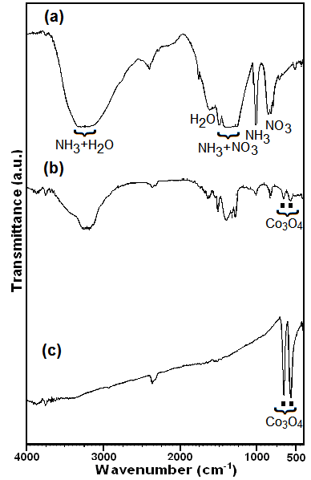
Figure 1. FT-IR spectra of (a) [Co(NH₃)₅(H₂O)](NO₃)₃ complex and its decomposition product at (b) 150 °C and (c) 175 °C.

Figure 2 shows the XRD patterns of the samples calcined at 150 and 175 °C. The XRD pattern of sample decomposed at 150 °C in Figure 3(a) exhibits weak diffraction peaks with 2θ values at 19.50°, 31.37°, 37.02°, 39.10°, 44.97°, 55.84°, 59.58°, 65.44° and 77.65°. These diffraction peaks can be indexed to the crystalline cubic phase Co₃O₄ with lattice constant of a = 8.076 Å and a space group of Fd3m, which are in agreement with the reported values (JCPDS Card No. 76-1802). This result confirms that the Co₃O₄ phase started to appear at 150 °C, as indicated by the FT-IR result. As can be seen in Figure 2(b), the intensity of the characteristic peaks of the Co₃O₄ phase markedly increases with increasing the decomposition temperature to 175 °C. This finding confirms that complex was completely decomposed to the Co₃O₄ phase at 175 °C. The XRD pattern of the sample reveals only the diffraction peaks attributable to the Co₃O₄ with cubic phase. Diffraction peaks related to the impurities were not observed in the patterns, confirming the high purity of the synthesized products. Furthermore, the diffraction peaks are markedly broadened due to the small size effect of the particles. The average sizes of the Co₃O₄ particles was calculated by the Debye–Scherrer equation:⁶⁴ D_{XRD} = 0.9λ/(βcosθ) where D_{XRD} is the average crystalline size, λ is the wavelength of CuKα, β is the full width at half maximum (FWHM) of the diffraction peak and θ is the Bragg's angle. For two samples, the average size of the nanopartricles calculated using the most intense peak (101) at 2θ = 36.26° is approximately 20 nm. This value is in accordance with TEM observations (discussed below).
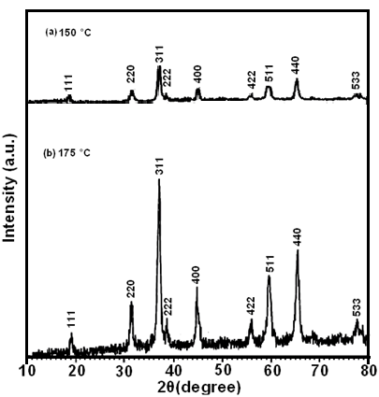

Figure 2. The XRD patterns for the decomposition products of [Co(NH₃)₅(H₂O)](NO₃)₃ complex at (a) 150 °C and (b) 175 °C.

Figure 3 shows the Raman spectrum of the Co₃O₄ nanoparticles prepared at 175 °C. Four obvious peaks located at around 467, 593, 610, and 675 cm⁻¹, corresponding to four Raman-active modes (E_{g}, 2F_{2g} and A_{1g},) of the Co₃O₄ phase. The Raman shifts are consistent with those of pure crystalline Co₃O₄, indicating that the Co₃O₄ nanoparticles have a similar crystal structure of the bulk Co₃O₄.⁴⁵ This result further confirms the formation of highly pure Co₃O₄ nanoparticles. Based on FT-IR, XRD and Raman results, we suggest the thermal decomposition reaction of the title complex is as follows:
3[Co(NH₃)₅(NO₃)](NO₃)₂(s) → Co₃O₄(s) + 2NH₃(g) + 19.5H₂O + 9.25N₂ + 1.5NO + N₂O

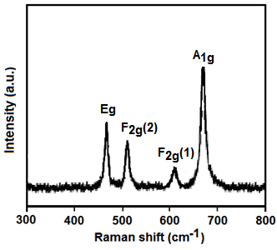
Figure 3. Raman spectrum of the Co₃O₄ nanoparticles

The morphology of Co₃O₄ nanoparticles was investigated by SEM. Figure 4 shows the SEM image of the as-prepared Co₃O₄ nanoparticles. From the SEM image, it is clearly evident that the product consists of extremely fine particles with sphere-like morphology. It seems that the nanoparticles are size-homogeneous and appreciably aggregated as clusters due to the extremely small dimensions and high surface energy of the obtained nanoparticles.

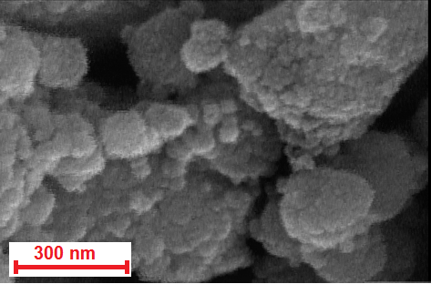
Figure 4. SEM image of the Co₃O₄ nanoparticles.

The TEM images of sample were obtained and are shown in Figure 5. The TEM sample was prepared by dispersing the powder in ethanol by ultrasonic vibration. From the scale on the images, it is concluded that the size of the Co₃O₄ nanoparticles is approximately in the range of 10 to 25 nm. Average grain-size obtained from TEM image is approximately 17.5 nm. This is consistent with the average particle size obtained from the XRD data. Such consistency implies that the formed nanoparticles are a single-phase. Although it is difficult to define a shape, the morphology of the particles seemed to be approximately spherical.

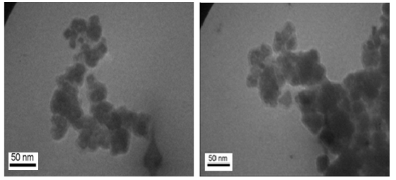
Figure 5. TEM images of the Co₃O₄ nanoparticles

The chemical purity and stoichiometry of the product were also examined by EDX analysis. Figure 6 shows the EDX spectrum of the Co₃O₄ nanoparticles prepared via the decomposition of [Co(NH₃)₅(H₂O)](NO₃)₃ at 175. Only oxygen and cobalt elements existed in the product. The atomic percentages of Co and O were found to be 43.14% and 56.86%, respectively, which is near to the theoretical ratiabove, above,o (3:4) of Co₃O₄. The Au peaks at about 2.2 and 9.75 keV correspond to the TEM holding grid. No other elements can be detected, indicating the high purity of the Co₃O₄ nanoparticles.
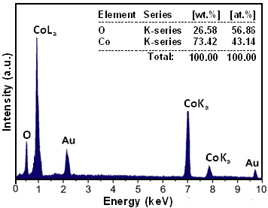
Figure 6. EDX spectrum of the Co₃O₄ nanoparticles.

To determine the magnetic properties, the hysteresis loop of the Co₃O₄ nanoparticles was measured at room temperature. As shown in Figure 7, the magnetization is approximately linear with the field and it does not attain the saturation even at the applied field of 8.5 kOe. As shown in the inset of Figure 7, a tiny hysteresis loop can be observed with a coercivity of about 135 Oe which is characteristic of weak ferromagnetic behaviour, although bulk Co₃O₄ has antiferromagnetic nature. This behavior is similar to that of Co₃O₄ NPs obtained by solvothermal process⁵⁶ and may be explained by uncompensated surface spins and/or finite size effects of the Co₃O₄ nanoparticles.⁵⁷
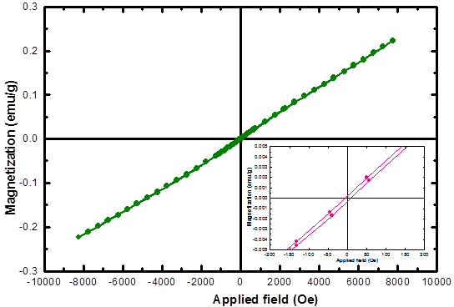
Figure 7. (a) Magnetization curve as a function of applied magnetic field for Co₃O₄ nanoparticles at room temperature, and (b) the expansion of magnetization vs. field near the lower applied field.

Optical absorption properties of the as-prepared Co₃O₄ nanoparticles were investigated at room temperature by UV–vis spectroscopy. As can be seen in Figure 8, the product two absorption bands appear in the wavelength ranges of 200–350 and 380–600 nm. As has been reported in the literatures,^{16,30} these bands can be assigned to the O²⁻→Co²⁺ and O²⁻→Co³⁺ charge transfer processes, respectively. Co₃O₄ is a p-type semiconductor and its band gap, E_{g}, can be determined by the following equation:
(Ahv)^{n} = K(hv-E_{g})
Where hv is the photon energy (in eV), A is the absorption coefficient, K is a constant relative to the material. The plot of (αhv)² versus hv is shown in the insets of Figure 8. The value of hv extrapolated to (αhv)²= 0 gives an absorption band gap energy (E_{g}). The absorption bands in Figure 8 give two E_{g} values of 3.45 and 2.20 eV for the sample which are blue-shifted relative to reported values for the bulk sample (2.19 and 1.48 eV, respectively).⁵⁸ The increase in the band gaps of the Co₃O₄ nanoparticles may ascribe to the quantum confinement effects of particles.

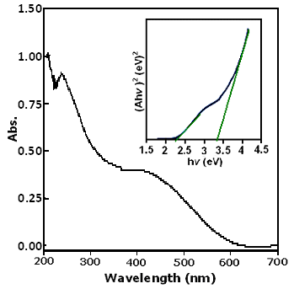
Figure 8. UV-Vis spectrum and (Ahv)²-hv curve (inset) of the Co₃O₄ nanoparticles.

3.2. Photocatalytic activity of the Co₃O₄ nanoparticles
The photocatalytic activity of the as-synthesized Co₃O₄ nanoparticles for the degradation of organic dye such as methylene blue (MB) has been performed under visible light irradiation at room temperature. The UV–vis spectra of MB aqueous solution in the presence of Co₃O₄ nanoparticles photocatalyst and H₂O₂ under visible light irradiation (λ > 420 nm) over various time intervals are shown in Figure 9. MB dye has a characteristic absorption peak at about 662 nm, which obviously decreases with the increase of irradiation time due to the continuous photocatalytic degradation of MB molecules in the system. After 150 min irradiation, the absorbance of the MB aqueous solution reaches to less than 0.01, indicating the complete degradation of MB. Therefore, the photocatalytic experiments show that the as-prepared Co₃O₄ nanoparticles have much high visible-light photocatalytic activity.
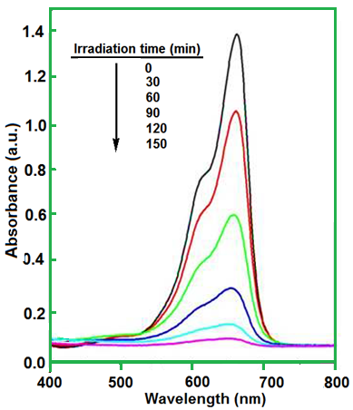

Figure 9. Evolution of UV–vis absorption spectrum of methylene blue (MB) under irradiation at different times using Co₃O₄ nanoparticles in the presence of H₂O₂.

Figure 10 shows the degradation rate of MB dye at different exposure times in the presence Co₃O₄ catalyst. C₀ is the concentration of dye after the adsorption–desorption equilibrium is reached but before irradiation, and C is the concentration of dye after different visible light irradiation times. As can be seen in Figure 10, in the absence of Co₃O₄ nearly 15% of the MB molecules are degraded by H₂O₂ after irradiation for 150 min (curve a). The degradation rate of MB molecules is significantly enhanced when Co₃O₄ is added to the adsorption–desorption equilibrium (curve b). Nearly 100% of MB is degraded by Co₃O₄ nanoparticles in the presence of H₂O₂ after irradiation for 150 min. These results can be possibly attributed to the remarkable function of Co₃O₄ nanoparticles, which serve as generator of hydroxyl radicals (.OH) via photoelectrochemical decomposition of H₂O₂ under visible light irradiation. Therefore, the as-synthesized Co₃O₄ nanoparticles are an excellent photocatalyst in the presence of H₂O₂ under visible light irradiation to degrade organic dyes.

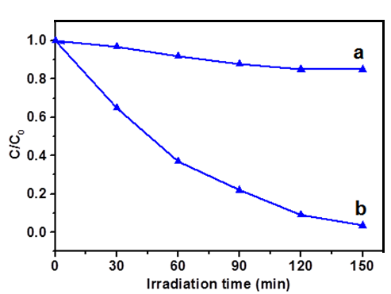
Figure 10. Photocatalytic degradation of MB in the presence of : (a)
H₂O₂ and (b) Co₃O₄ + H₂O₂.

Based on the above results, a possible photocatalytic mechanism of Co₃O₄ nanoparticles has been proposed as follows: Upon irradiation with visible light, Co₃O₄ nanoparticles particles undergo charge separation, electrons in the valence band (e⁻_{VB}) of Co₃O₄ can be excited to its conduction band (CB), causing the generation of holes in the valance band (h⁺_{VB}) simultaneously (reaction (1)). Then, the e⁻_{VB} can activate the H₂O₂ to generate the OH. and OH⁻ (reaction (2)). Thus, the OH. generated from reaction (2) is the main factor for photodegradation of the dye.
Co₃O₄ + hv → e⁻_{VB} + h⁺_{CB} (1)
H₂O₂ + e⁻_{VB} → .OH + OH⁻ (2)
MB + .OH → degradation products (CO₂, H₂O, NO₃, etc) (3)

4. Conclusions
In conclusion, Co₃O₄ nanoparticles with an average particle size of 19 nm have been successfully prepared via thermal decomposition of the [Co(NH₃)₅(H₂O)](NO₃)₃ at 175 °C. Co₃O₄ nanoparticles are formed from this complex via a redox reaction between NH₃ and the NO₃⁻ ions. This method yields sphere-like Co₃O₄ nanoparticles with a narrow size distribution and weak ferromagnetic behavior. The estimated optical absorption band gaps of the Co₃O₄ nanoparticles are relatively blue-shifted, compared with the values for the bulk sample. The as-prepared Co₃O₄ nanoparticles exhibit excellent photocatalytic activity for the degradation of MB dye in the presence of H₂O₂ under visible light irradiation.

5. Acknowledgements
The authors are grateful to the Lorestan University Research Council and Iran Nanotechnology Initiative Council (INIC) for financial support.

6. References
1. K. J. Klabunde, R. M. Richards, Nanoscale Materials in Chemistry, 2nd edn. Wiley, New York, 2012.
2. W. Y. Li, L. N. Xu, J. Chen, Adv. Funct. Mater. 2005, 15, 851–857.
3. R. Wu, J. Wu, M. Yu, T. Tsai, C. Yeh, Sens. Actu. B: Chem. 2008, 131, 306–312.
4. A. Askarinejad, M. Bagherzadeh, A. Morsali, Appl. Surface Sci. 2010, 256, 6678–6682.
5. T. E. Davies, T. Garcia, B. Solsona, S. H. Taylor, Chem. Commun. 2006, 32, 3417–3419.
6. V. R. Mate, M. Shirai, C. V. Rode, Catal. Commun. 2013, 33, 66-69.
7. T. Maruyama, S. Arai, J. Electrochem. Soc. 1996, 143, 1383-1386
8. N. Du, H. Zhang, B. D. Chen, J. B. Wu, X. Y. Ma, Z. H. Liu, Y. Q. Zhang, D.R. Yang, X.H. Huang, J. P. Tu, Adv. Mater. 2007, 19, 4505–4509.
9. X. W. Lou, D. Deng, J. Y. Lee, L. A. Archer, Adv. Mater. 2008, 20, 258–262.
10. S. L. Chou, J. Z. Wang, H. K. Liu, S. X. Dou, J. Power Sources 2008, 182, 359–364.
11. Y.G. Li, B. Tan, Y.Y. Wu, Nano Lett. 2008, 8, 265–270.
12. R. M. Wang, C. M. Liu, H. Z. Zhang, C. P. Chen, L. Guo, H. B. Xu, S. H. Yang, Appl. Phys. Lett. 2004, 85, 2080–2082.
13. S. A. Makhlouf, J. Magn. Magn. Mater. 2002, 246, 184–190.
14. X. Lou, J. Han, W. Chu, X. Wang, Q. Cheng, Mater. Sci. Eng. B 2007, 137, 268–271.
15. T. Warang, N. Patel, A. Santini, N. Bazzanella, A. Kale, A. Miotello, Appl. Catal. A: Gen. 2012, 423– 424, 21– 27.
16. L. Sun, H. Li, L. Ren, C. Hu, Solid State Sci. 2009, 11, 108–112.
17. Y. Chen, Y. Zhang, S. Fu, Mater. Lett. 2007, 61, 701–705.
18. T. Lai, Y. Lai, C. Lee, Y. Shu, C. Wang, Catal. Today 2008, 131, 105–110.
19. W. W. Wang, Y. J. Zhu, Mater. Res. Bull. 2005, 40, 1929–1935.
20. L. Li, Y. Chu, Y. Liu, J. L. Song, D. Wang, X.W. Du, Mater. Lett. 2008, 62, 1507–1510.
21. J. Du, L. Chai, G. Wang, K. Li, Y. Qian, Aust. J. Chem. 2008, 61, 153–158.
22. R. M. Wang, C. M. Liu, H. Z. Zhang, C. P. Chen, L. Guo, H. B. Xu, S. H. Yang, Appl. Phys. Lett. 2004, 85, 2080–2082.
23. Y. Li, J. Zhao, Y. Dan, D. Ma, Y. Zhao, S. Hou, H. Lin, Z. Wang, Chem. Eng. J. 2011, 166, 428–434.
24. H. Sun, M. Ahmad, J. Zhu, Electrochim. Acta 2013, 89, 199– 205.
25. M. Ren, S. Yuan, L. Su, Z. Zhou, Solid State Sci. 2012, 14, 451–455.
26. L. X. Yang, Y.J. Zhu, L. Li, L, Zhang, H. Tong, W. W. Wang, Eur. J. Inorg. Chem. 2006, 23, 4787–4792.
27. J. Ma, S. Zhang, W. Liu, Y. Zhao, J. Alloys Compd. 2010, 490, 647–651.
28. E. Lester, G. Aksomaityte, J. Li, S. Gomez, Prog. Cryst. Growth Charact. Mater. 2012, 58, 3–13.
29. J. Jiu, Y. Ge, X. Li, X, L. Nie, Mater. Lett. 2002, 54, 260–263.
30. F. Gu, C. Li, Y. Hu, L. Zhang, J. Cryst. Growth 2007, 304, 369–373.
31. M.C. Gardey-Merin, O. M. Palermo, R. Belda, M. E. Fernández de Rapp, G. E.Lascalea, P. G. Vázquez, Proced. Mater. Sci. 2012, 1, 588 – 593.
32. L. H. Ai, J. Jiang, Powder Tech. 2009, 195, 11–14.
33. L. Li, J. Ren, Mater. Res. Bull. 2006, 41, 2286–2290.
34. A. S. Bhatt, D. K. Bhat, C. W. Tai, M. S. Mater. Chem. Phys. 2011, 125, 347–350.
35. M. E. Baydi, G. Poillerat, J. L. Rehspringer, J. L. Gautier, J. F. Koenig, P. Chartier, J. Solid State Chem. 1994, 109, 281–288.
36. D. Y. Kim, S. H. Ju, H. Y. Koo, S. K. Hong, Y. C. Kangf, J. Alloys Compd. 2006, 417, 254–258.
37. R. V. Kumar, Y. Diamant, A. Gedanken, Chem. Mater. 2000, 12, 2301–2305.
38. K. Sinko, G. Szabo, M. Zrinyi, J. Nanosci. Nanotechnol. 2011, 11, 1–9.
39. D. Zou, C. Xu, H. Luo, L. Wang, T. Ying, Mater. Lett. 2008, 62, 1976–1978.
40. J. Jiang, L. Li, Mater. Lett. 2007, 6, 4894–4896.
41. S. Fan, X. Liu, Y. Li, E. Yan, C. Wang, J. Liu, Y. Zhang, Mater. Lett. 2013, 91, 291–293
42. E. Traversa, M. Sakamoto, Y. Sadaoka, Part. Sci. Technol. 1998, 16, 185–214.
43. S. Farhadi, N. Rashidi, Polyhedron 2010, 29, 2959-2965.
44. S. Farhadi, Z. Roostaei-Zaniyani, Polyhedron 2011, 30, 1244–1249.
45. M. Salavati-Niasari, F. Davar, Mater. Lett. 2009, 63, 441–443.
46. M. Y. Masoomi, A. Morsali, Coord. Chem. Rev. 2012, 256, 2921-2943.
47. L. Ren, P. Wang, Y. Han, C. Hu, B. Wei, Mater. Phys. Lett. 2009, 476, 78–83.
48. F. Mohandes, F. Davar, M. Salavati-Niasari, J. Magn. Magn. Mater. 2010, 322, 872–877.
49. M. Salavati-Niasari A. Khansari, F. Davar, Inorg. Chim. Acta 2009, 362, 4937–4942.
50. K. Thangavelu, K. Parameswari, K. Kuppusamy, Y. Haldorai, Y, Mater. Lett. 2011, 65, 1482–1484
51. S. Farhadi, J. Safabakhsh, J. Alloys Compd. 2012, 515,180–185.
52. S. Farhadi, K. Pourzare, Mater. Res. Bull. 2012, 47, 1550–1556.
53. S. Farhadi, K. Pourzare, Polyhedron 2014, 67, 104–110.
54. G. Schlesssinger, Inorg. Synth. 1960, 4, 189–191.
55. H. P. Klug, L. E. Alexander, X-ray Diffraction Procedures, second ed., Wiley, New York, 1964.
56. K. Nakamoto, Infrared and Raman Spectra of Inorganic and Coordination Compounds, Part B: Applications in Coordination, Organometallic, and Bioinorganic Chemistry, sixth ed., Wiley, New York, 2009.
57. Y. Qi, Y. Zhao, Z. Wu, Mater. Chem. Phys. 2008, 110, 457–462.
58. X. P. Shen, H. J. Miao, H. Zhao, Z. Xu, Appl. Phys. A: Mater. Sci. Process 2008, 91, 47–51.

