Effect of process parameters on the physicochemical properties of nano- and micrometric zinc oxide

Jolanta PULIT-PROCIAKª, Marcin BANACHª

ªCracow University of Technology, Faculty of Chemical Engineering and Technology, 24 Warszawska St., 31-155 Cracow, Poland

corresponding author: Jolanta PULIT-PROCIAK,
e-mail: jolantapulit@indy.chemia.pk.edu.pl, Cracow University of Technology, Faculty of Chemical Engineering and Technology, 24 Warszawska St., 31-155 Cracow, Poland, tel. +48 12 628 20 92, fax. +48 12 628 20 35

ABSTRACT
The paper presents a method of obtaining zinc oxide nano- and microparticles. In these studies microwave reactor and laboratory pressure reactor were used. Since microwave radiation accelerates proceeding of reactions, this way was found to be an effective method in the process of obtaining fine nanocrystallines of zinc oxide. The size of prepared particles did not exceed 500 nm.

KEYWORDS: zinc oxide, nanoparticles, green chemistry

Introduction
Metal oxides occurring in nanometric scale are characterized by more valuable properties comparing to the characteristics of the same macro-scale-materials. Such structures may be defined by ratio of surface area to their mass. This value is large enough so that other material properties are determined by surface properties. Due to their larger ratio of surface area to volume, they exhibit a higher chemical activity. Increased chemical activity of such materials may be explained by analyzing their structure. The size of the nanoparticles surface area increases significantly with decreasing their size. Small nanoparticle with a diameter of 1 nm has 100% of atoms disposed on its surface, while the particle with diameter of 10 nm has only 15% of surface atoms. Therefore, smaller particles are more chemically reactive.¹
Zinc oxide is known primarily for its bleaching properties. It is used as inorganic pigment,^{2,3} catalyst^{4,5} as well as sunglasses or wood coating material. Thanks to the fact that it is transparent for visible wavelength range of sunlight nanosized zinc oxide may be used as a blocker of harmful ultraviolet irradiation.^{6,7} In addition, zinc oxide nanoparticles have antibacterial and wound-healing properties.^{8,9} Thanks to their biocidal properties they found application for example in the production of antimicrobial textiles.¹⁰ Since zinc oxide has valuable electrical, optielectronic and photochemical properties, it has been also used in electrotechnique.¹¹
There are many methods for the preparation of zinc oxide in the nanocrystalline form. Nawaz and colleagues have described a synthesizing of zinc nanooxide by wet chemical method using zinc nitrate, sodium hydroxide and starch which served as stabilizing agent. Obtained product exhibited antibacterial properties.¹² Parashar synthesized nanometric zinc oxide by mixing an organic solution of a zinc precursor with an alcoholic base solution and adding acetone in order to precipitate a milky white zinc oxide.¹³ Nanometric zinc oxide may be also synthesized by metallurgical and mechanochemical processes, controlled precipitation method as well as by sol-gel, solvothermal and hydrothermal methods.¹⁴ Ohara and colleagues obtained highly crystalline zinc oxide nanoparticles by the way of supercritical water hydrothermal synthesis.¹⁵
In this paper studies on obtaining zinc oxide nano- and microparticles in a field of microwave radiation and in the laboratory pressure reactor have been described. The aim of the work was to also compare the physicochemical properties of obtained products.

Experimental
Materials
Zinc nitrate hexahydrate (≥99.0%) was used as zinc precursor. Sodium hydroxide (≥98%) served as precipitating substance. Both chemicals were obtained from Sigma Aldrich. Solutions were prepared in deionized water.

Methods
The first phase of studies was common for both types of processes. It concerned the precipitation of zinc hydroxide by adding an aqueous solution of sodium hydroxide to an aqueous solution of zinc nitrate. The process runs at room temperature under continuous stirring. Sodium hydroxide was used in a stoichiometric amount. Accurate amounts of substrates used are presented in Table 1.

Table 1. Substrates used in the precipitation process
Reagent | Molar concentration, c [mol/dm³] | Volume, V [cm³]
Zn(NO)₃ | 0,1 | 25
NaOH | 2,0 | 2,5

In a further step, a dehydration process occurred. In order to accelerate that process, zinc hydroxide suspension was subjected to elevated temperature and pressure treatment. It was expected that the acceleration of dehydration process by applying elevated heat and pressure, promotes the formation of smaller crystallites of zinc oxide so that their size would be in the nanometric range. For this purpose, the suspension was transferred to a microwave reactor or laboratory pressure reactor.

Processes carried out in a microwave reactor
The use of polar solvent (water) in the field of microwave radiation is possible to efficiently transfer the heat in a short time in the whole volume of the reaction mixture, which accelerates the process of dehydration. Dehydration processes carried out in a microwave reactor were varied directly through selection of different temperature-pressure conditions. In fact, these parameters were determined by specific values of microwave power and the residence time of the sample in the microwave field. Microwave power and residence time were independent parameters, which took three levels of volatility. Process parameters are given in Table 2. In the studies a microwave reactor Magnum II from Ertec Poland was used.

Table 2. Parameters of dehydration processes carried out in microwave reactor
Sample | Input variables |  | Temperature achieved [°C] | Pressure achieved [bar] | d_{med} [nm] (based on SEM) | d_{med} [nm] (based on Scherrer eq.)
Sample | Microwave power [%] | Residence time [min]
M1 | 70 | 3 | 100 | 9 | 20-200 | 31
M2 | 70 | 5 | 160 | 15 | 10-200 | 31
M3 | 70 | 7 | 200 | 26 | 20-200 | 30
M4 | 85 | 3 | 100 | 11 | 50-300 | 27
M5 | 85 | 5 | 180 | 25 | 100-200 | 28
M6 | 85 | 7 | 230 | 39 | 40-250 | 22
M7 | 100 | 3 | 110 | 14 | 40-200 | 28
M8 | 100 | 5 | 200 | 39 | 80-200 | 30
M9 | 100 | 7 | 240 | 39 | 60-250 | 30

Processes carried out in a laboratory pressure reactor
Parameters of processes carried out in the laboratory pressure reactor were chosen arbitrarily, on the basis of preliminary studies. Their exact values are presented in Table 3.

Table 3. Parameters of dehydration processes carried out in laboratory pressure reactor
Sample | Input variables |  | Pressure achieved [bar] | d_{med} [nm] (based on SEM) | d_{med} [nm] (based on Scherrer eq.)
Sample | Temperature [°C] | Process time [min] | Pressure achieved [bar] | d_{med} [nm] (based on SEM) | d_{med} [nm] (based on Scherrer eq.)
R1 | 120 | 30 | 1 | 200-400 | 32
R2 | 160 | 30 | 4 | 50-400 | 30
R3 | 200 | 30 | 14 | 30-200 | 30

Obtained suspensions were filtered on Buchner funnel using Whatman filters (d=0.45 µm) and washed with 160 cm³ of deionized water so as sodium nitrate would be removed. Solids were dried in air-dryer at 50ºC within 2 hours. Obtained products were analyzed by instrumental techniques. In the course of scanning electron microscopy a determination of the shape and indirect determination of zinc oxide particles size was possible. The study was carried out using 1430 VP microscope from LEO Electron Microscopy Ltd. In order to reveal the crystal structure, the sample was subjected to X-ray analysis conducted on X-ray diffractometer X’Pert PW 1752/00 from Philips. In order to detect vibrations characteristic of zinc oxide, samples were subjected to Fourier transform infrared spectroscopy. For this purpose spectrophotometer Nicolet 380 from Nicolet was used.

Results and Discussion
Preparation of zinc oxide proceeds according to the following equations:

Scanning electron microscopy
Figure 1 presents SEM photomicrographs of obtained products.
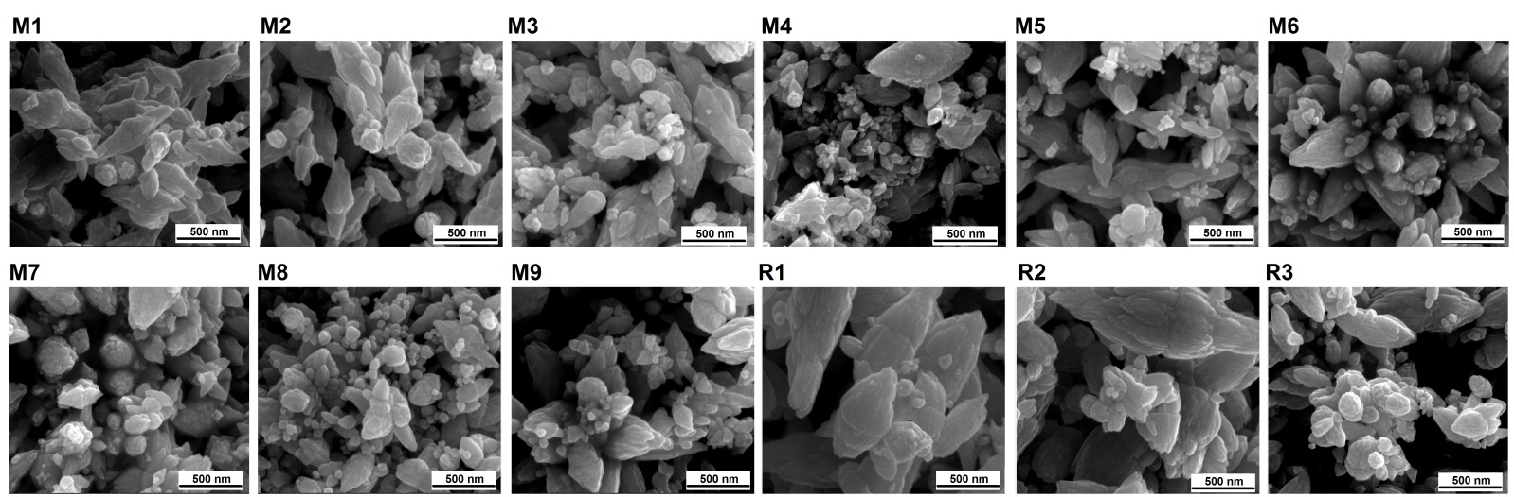
Fig. 1. Photomicrographs of obtained products

Based on obtained photomicrographs the shape of products may be defined as flower-like particles. It may be concluded that shape the size of particles depend on the conditions of their preparation. Comparing both reactors, it has been found out that the greater degree of variation in particles shape was reached when microwave reactor was used. Despite a greater diversity of shape and size of products obtained in the microwave radiation field, the particles size was ranged from 20 to 200 nm, while the particles obtained in the laboratory pressure reactor were larger – their medium diameter was in the range from 30 to 400 nm. Moreover, the influence of temperature on the minimum size difference between the largest and smallest particles is perceptible. Higher temperature determines lower size variation. It favours obtaining larger number of particles which are characterised by more homogenous size. On the other hand, the mean particle size is dependent mostly on the dehydration time. Larger particles are obtained when the reaction time is elongated. It may be caused by progressive agglomeration which occurs as time progresses.

X-ray analysis
Results of X-ray analysis are presented in Figure 2.
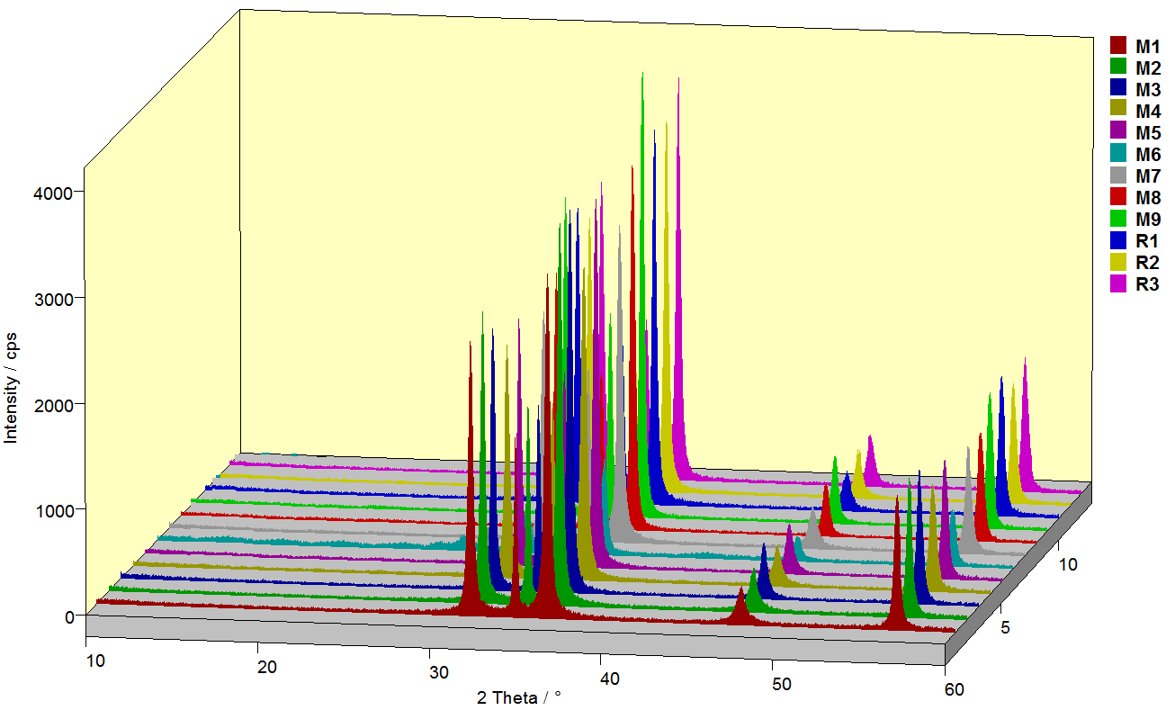
Fig. 2. XRD diffractogram of all samples

The resulting diffractogram indicates the receipt of zinc oxide. Peaks occurring in the area of 32°, 34° and 36° of 2θ diffraction angle correspond to strong Bragg reflection. The incidence of these peaks is characteristic for zinc oxide. Other reflections were not detected, which indicates high purity of samples. Peak intensity provides high crystallinity of products and their width reflects small size of crystallites. The size of crystallites was also calculated based on Scherrer equation:

,
where
K - dimensionless shape factor (K=0,9)
λ - X-ray wavelength [nm]
β - full width of peak at half maximum
Θ - Bragg angle

Values of calculated crystallites size are given in Tables 2 and 3. It should be noted that these size values concern the size of individual crystallites, which may consist the structure of nano- and microparticles that are characterized by larger sizes.

Fourier transform infrared spectroscopy
Figure 3 presents typical FT-IR spectra of zinc oxide. During the FT-IR analysis a distinct characteristic absorption band at 440 cm⁻¹ has been revealed. This band may be assigned to stretching vibrations of Zn‒O. Other bands are derived from water present in products (stretching vibrations of O‒H at 3400 cm⁻¹) and Zn‒OH at 880 cm⁻¹.
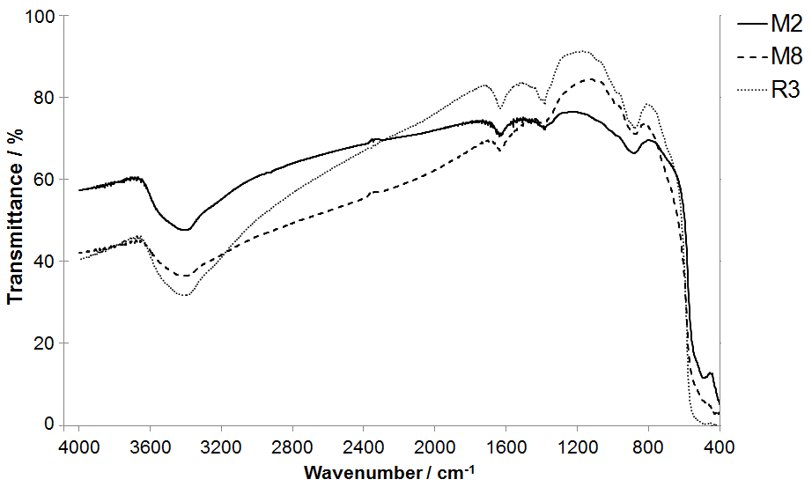
Fig. 3. FT-IR spectrum of obtained samples

Conclusions
The results indicate the qualitative uniformity of products which were obtained both under microwave irradiation and in the laboratory pressure reactor. However, particles are distinguished by their varied shape and size. In general, they have lower average size in the case of obtaining them under microwave radiation. In addition, processes occur more efficiently when using microwave radiation. Products obtained in the course of hydrothermal synthesis within 5 min are characterized by physicochemical properties which are similar to properties of products obtained in a laboratory pressure reactor within 30 min.

Acknowledgements
This work is a part of the project Synthesis and Application of Innovative Nanomaterials with Antimicrobial Properties supported by National Centre for Research and Development under the Project LIDER/03/146/L-3/11/NCBR/2012 for the period of 2012–2015.

References
- C. Rao, G. Lulkarni, P. Thomas, P. Edwards, Chem. Eur. J. 2002, 8, 29-35.
- M. M. Mikhailov, V. V. Neshchimenko, S. He, C. Li, J. Spacecraft. Rockets. 2011, 48, 891-896.
- C. Li, V. V. Neshchimenko, M. M. Mikhailov, International Journal of Chemical, Nuclear, Metallurgical and Materials Engineering, 2014, 8, 388-392.
- M. S. Spencer, Top. Catal. 1999, 8, 259-266.
- W. A. Lazier, H. Adkins, J. Am. Chem. Soc. 1925, 47, 1719-1722.
- L. O. Upton, R. W. Young, Neutral glasses and method of making the same,
US Patent Number 3,010,836 A, date of patent November 28, 1961.
- V. H. Batdorf, T. R. Anderson, Ultra violet light protective coating, CA Patent Number 2,202,587 C, date of patent October 30, 2012.
- A. A. Tayel, W. F. El-Tras, S. Moussa, A. F. El-Baz, H. Mahrous, M. F. Salem, L. Brimer, J. Food Safety. 2011, 31, 211-218.
- J. W. Wang, A. Cao, Y. Jiang, X. Zhang, J. H. Liu, Y. Liu, W. Hang, ACS Appl. Mater. Interfaces. 2014, 6, 2791-2798.
- R. Rajendran, C. Balakumar, H. A. M. Ahammed, S. Jayakumar, K. Vaideki, E. M. Rajesh, Int. J. Eng. Sci. Technol. 2010, 2, 202-208.
- S. Kumar, P. Venkateswarlu, V. R. Rao, G. N. Rao, Int. Nano. Lett. 2013, 3, 30-35.
- H. R. Nawaz, B. A. Solangi, B. Zehra, U. Nadeem, Can. J. Sci. Ind. Res. 2011, 2, 164-170.
- S. Parashar, Process for the preparation of nano zinc oxide particles,
US Patent Number 20,110,002,970 A1, date of patent January 6, 2011.
- A. Kołodziejczak-Radzimska, T. Jesionowski, Materials. 2014, 7, 2833-2881.
- S. Ohara, T. Mousavand, M. Umetsu, S. Takami, T. Adschiri, in: M. Nakahara (Ed.), Hydrothermal synthesis of fine zinc oxide nano-particles under supercritical conditions: 14th International Conference on the Properties of Water and Steam, 2004, Kyoto, Japan, Maruzen Tokyo, 2004, pp. 280-283.

