Supporting information

Ionic Liquid-Assisted Synthesis of Nanostructured ZnFe₂O₄ Particles as Anode Material for Lithium Ion Batteries:
Performance Evaulation with Special Emphasis on Metal Dissolution
Haiping Jia, Richard Kloepsch, Xin He, Marco Evertz, Sascha, Nowak, Jie Li, Martin Winter, Tobias Placke

Experimental details for Si, Sn and Ge materials and electrodes for metal ion dissolution studies:
For the metal ion dissolution commercial silicon (Nanostructured & Amorphous Materials, Inc.; primary particle size: 50-70 nm), tin (US Research Nanomaterials, Inc.; primary particle size: 60-80 nm) and germanium (SkySpring Nanomaterials, primary particle size: 70-120 nm) were used. These materials were studied without further carbon coating or surface modification. In each case, composite electrodes were prepared using a composition of 80 wt.% active material, 10 wt.% of conductive carbon black agent C-nergy Super C65 (Imerys Graphite & Carbon) and 10 wt.% of sodium-carboxymethyl cellulose (Na-CMC, Walocel CRT 2000 PA 12) as binder. The electrode preparation process and cell preparation followed as described for ZnFe₂O₄-based electrodes.

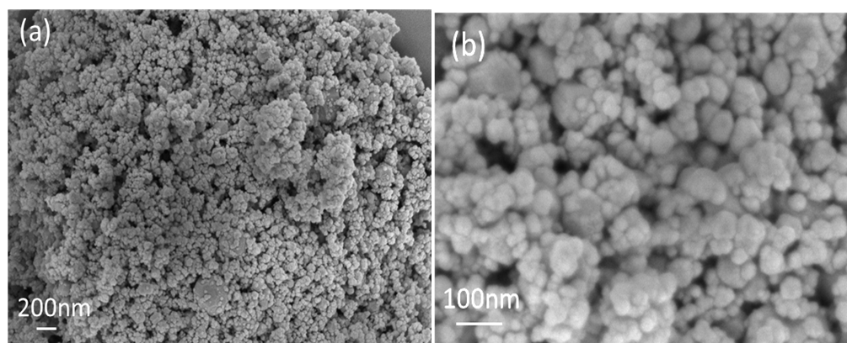
Figure S1. SEM images of commercial ZnFe₂O₄ particles.

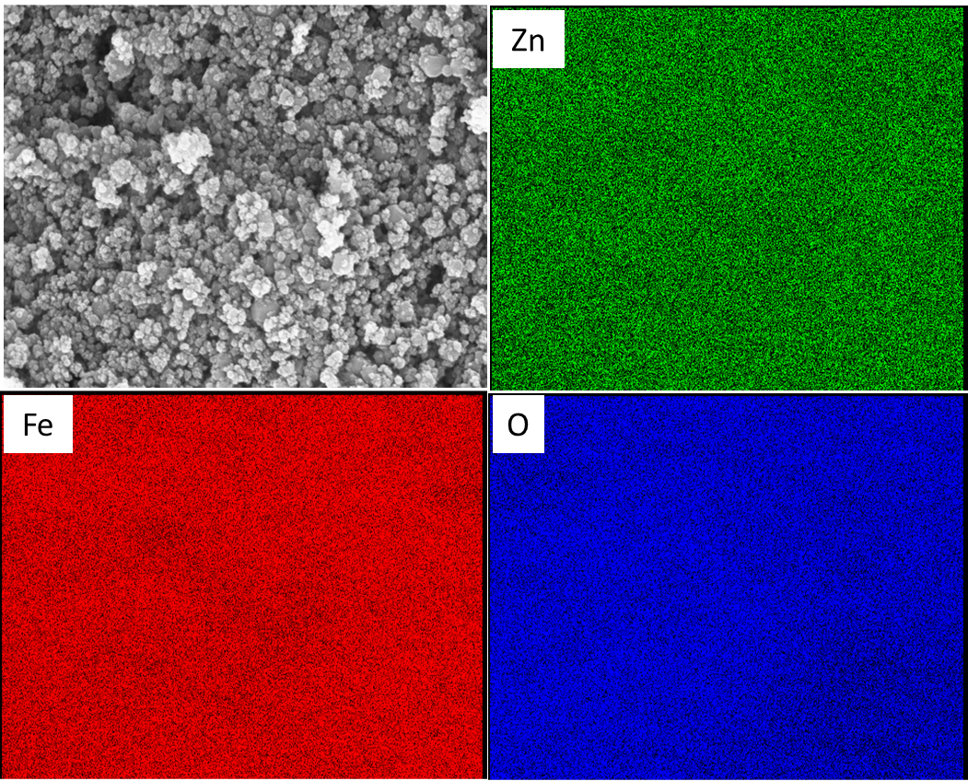
Figure S2. EDX mapping of the self-prepared ZnFe₂O₄ particles.

