HKUST-1 as a nanoporous metal organic framework for H₃PW₁₂O₄₀ encapsulation: Synthesis, characterization, stability and activity
Ezzat Rafiee^{,a, b}, Narges Nobakht ^{b}
ª Department of Inorganic Chemistry, Faculty of Chemistry, Razi University, Kermanshah, 67149, Iran
^{b} Institute of Nano Science and NanoTechnology, Razi University, Kermanshah, 67149, Iran

ABSTRACT
Hybrid composite material was obtained through encapsulation of H₃PW₁₂O₄₀ (PW) into HKUST-1 (Cu₃(BTC)₂, BTC=1,3,5-benzenetricarboxylic acid). The catalyst was characterized by various techniques including powder X-ray diffraction, Fourier transform infrared (FT-IR), scanning electron microscopy (SEM), energy dispersive X-ray (EDX), laser particle size analyzer. The acidity of the catalyst was determined by chemisorption of pyridine and potentiometric titration. This nano catalyst was successfully used for the synthesis of various β-keto enol ethers and was easily recycled and reused several times without significant loss of its activity. The presence of the PW in PW/HKUST-1 and reused PW/HKUST-1 structure, eliminating any doubt about collapse of the HKUST-1 after catalytic reaction and can be followed by FT-IR, XRD and SEM techniques. Brönsted and Lewis acidity of the PW/HKUST-1 catalyst was distinguished by studying the FT-IR. The strength and dispersion of the protons on PW/HKUST-1 was considerably high and active surface protons became more available for reactant.

Key words: Heteropoly acid; Metal-organic framework; β-Keto enol ethers; Heterogeneous catalysts; Hybrid composite material.

1. Introduction
In the last decade, Metal-organic frameworks (MOFs) as one of the most important families of material, constructed from metal containing nodes and organic linkers, are considered as in several applications such as gas storage/separation and catalysis. ¹⁻⁴ The crystalline, porous structure in combination with huge surface area and pore volumes results in unique properties of these materials. ² Up to now, several reactions have been carried out using MOFs as solid acid catalysts or catalyst supports but MOF materials usually do not possess Brönsted acidity, therefore some attempts have been made to introduce such functionality into them. ⁵ Heteropoly acids (HPAs) can act as excellent acid, redox, and bi-functional catalysts in a variety of synthetically useful selective transformations of organic substances, due to their strong Brönsted acidity and fast reversible multi-electron redox transformation activities. ⁶ The excellent catalytic performance of HPAs qualifies them as prime candidates for the designed construction of multi-functional materials combining porosity and catalytic activity. ⁷ However, applications of HPAs are limited by their low specific surface area and low stability under catalytic conditions. One of the strategies to overcome these drawbacks consists of their encapsulation within porous solid matrixes ⁸ such as MOFs. As a well-known MOF, a stable host HKUST-1, can encapsulated various Keggin-type HPAs, and attractive catalytic performance can be endowed by these HPAs/HKUST-1. ⁹⁻¹¹ The opportunity of incorporating HPAs in porous MOFs arises as an attractive pathway to exploit the catalytic activity of these species and opens the opportunity to create new catalytic systems. ¹² Among the different protocols for the synthesis of useful building blocks, we selected the synthesis of β-keto enol ethers because of their very high impact as synthons for the preparation of bioactive compounds, terpenoids, 4-alkylated-2-cyclohexenones, 2-aryl and 2-alkenyl-3- alkoxycyclohexenones and bicycle [2,2,2] octenones. ¹³⁻¹⁵ Also, they act as dienophiles in Diels–Alder reactions. ¹⁶ However, the synthesis of β-keto enol ethers has received little attention despite their wide range of applications ¹⁷⁻¹⁹ and developing a new, cost-effective and green protocol for this transformation is still a challenging task. The present work reports the use of H₃PW₁₂O₄₀ on HKUST-1 (PW/HKUST-1) as an active and recyclable catalyst in the synthesis of β-keto enol ethers.

2. Experimental
2.1 General
Copper(II) nitrate trihydrate (99−104%), 1,3,5-benzen-tricarboxylate acid (BTC) (98%), cetyl trimethylammonium bromide (CTAB) (99+%), PW (99+%) and other reagents and solvents used in this work were obtained from Merck, Aldrich or Fluka and used without further purification. Fourier transform infrared spectroscopy (FT-IR) was recorded as KBr pellets using a Shimadzu 470 spectrophotometer. Morphology of the catalyst was studied by scanning electron microscopy (SEM) and energy dispersive X-ray spectroscopy (EDX) on a model XL30 Philips. The size distribution of the samples was obtained using a laser particle size analyzer (HPPS 5001, Malvern, UK) and X-ray diffraction (XRD) pattern of the synthesized catalyst was obtained by using an X-ray diffractometer (Xpert MPD), Co Ka (k = 0.154 nm).

2.2 Preparation of the catalyst
For the synthesis of PW/HKUST-1, the mixture of 1,3,5-benzen-tricarboxylate acid (0.21 g) and 0.07 g of CTAB in absolute ethanol (12 mL) was prepared, then PW (0.1 g) and Cu(NO₃)₂·3H₂O (1.45 g) were dissolved in distilled water (10 mL). Both solutions were combined and mixed under vigorous stirring for approximately 30 min. The mixture was aged without stirring for 4 days at room temperature. The blue solid was then collected, washed with distilled water three times and dried at 60 °C for 24 h. CTAB was removed by Soxhlet extraction with ethanol performed for 24 h. The product was dried in air at 60 °C.

2.3 Acidity measurement
For the potentiometric titration, 0.05 g of solid was suspended in acetonitrile (90 mL) and stirred for 3 h. The suspension was titrated with a 0.05 mol/L solution of n-butylamine in acetonitrile. The potential variation was measured with a Hanna 302 pH meter using a double junction electrode.

2.4 Catalytic reaction
A mixture of dimedone (1.0 mmol) and alcohol (4 mL) was stirred in the presence of the catalyst (0.06 g) at 45 °C. After completion of the reaction as indicated by TLC, the catalyst was separated by decantation (or filtration). The excess alcohol in the filtrate was removed by rotary evaporator and the crude purified by column chromatography over silica-gel (ethyl acetate/hexane, 1:4). All products were identified by comparing of their spectral data with those of the authentic samples.¹⁹⁻²³

3. Results and discussion
3.1 Catalyst characterization
The presence of the PW in the HKUST-1 framework was established by FT-IR (Fig. 1). FT-IR spectroscopies confirmed that the structures of HKUST-1 and the PW are retained in the composite PW/HKUST-1. The vibrational spectra of the composite exhibit the characteristic bands of both the HKUST-1 support and the Keggin structure of the phosphotungstate anion. In particular, the FT-IR spectrum of PW contains bands at 1080 cm⁻¹ (PO₄), 982 cm⁻¹ (W=O), and 892 and 796 cm⁻¹ (W–O–W). For PW/HKUST-1 the PO₄ and W=O vibration bands are shifted in comparison to bulk PW. This shift discloses the confinement effect of PW inside the porous solid.

Fig. 1 FT-IR spectra of (a) PW, (b) PW/HKUST-1, (c) reused PW/HKUST-1, (d) PW/HKUST-1 after reaction with 0.1 mol of pyridine per gram of catalyst and (e) HKUST-1.

As depicted in Fig. 2, the SEM images of the PW/HKUST-1 samples show that the PW/HKUST-1 crystals have octahedral shape with average size of approximately 300 nm. The low angle XRD patterns of the PW/HKUST-1 was also evaluated (Fig. 3). According to XRD pattern, synthesis method applied in this study yielded crystalline PW/HKUST-1 materials and showed sharp reflections appearing at low angles (<5 °/2θ) suggesting a high degree of mesoscopic ordering. ²⁴ XRD patterns together with the SEM images showed that the HKUST-1 was highly crystalline. The size distribution of the PW/HKUST-1 derived from a laser particle size analyzer, illustrates in Fig. 4. PW/HKUST-1 has a mean diameter of 190 nm and a wide size distribution with a polydispersity of 0.8. EDX is used to determine distribution of PW in the hybrid material by monitoring the contents of W and P. The EDX elemental mapping images of PW/HKUST-1 show highly dispersed PW is successfully incorporated in HKUST-1 and uniform distribution of P and W (from PW) and Cu (from HKUST-1) is also illustrate (Fig. 5).

Fig. 2 SEM images of PW/HKUST-1 (Scale bar: 1 μm) (a), SEM images of reused PW/HKUST-1 (Scale bar: 1 μm) (b).

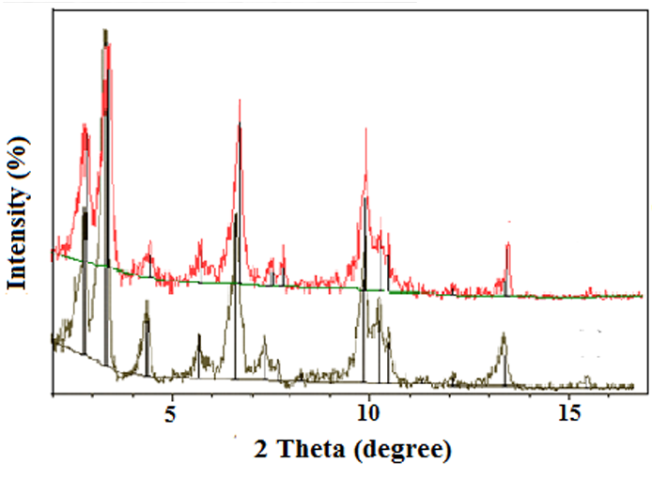
Fig. 3 Low angle XRD patterns of PW/HKUST-1 (bottom) and reused PW/HKUST-1(up).

Acidity of the PW/HKUST-1 catalyst was distinguished by studying the FT-IR spectrum of the catalyst after reaction with pyridine (Fig. 1(d)). Pyridine molecules were adsorbed on Lewis acid sites (1610 and 1450 cm⁻¹) and formed the pyridinium ion by interaction with Brönsted acid sites (1640 and 1540 cm⁻¹). Both types of adsorbed species contribute to the band at 1490 cm⁻¹. ²⁵ FT-IR spectrum of the catalyst shows contribution of pyridine adducts in the region 1400-1700 cm⁻¹. The formation of pyridinium ion was observed by absorptions at 1482, 1560 and 1605 cm⁻¹ (expanding region in Fig. 1). These results indicate that PW/HKUST-1 contains the strongest acid sites.

Fig. 4 Grain size distribution of PW/HKUST-1.

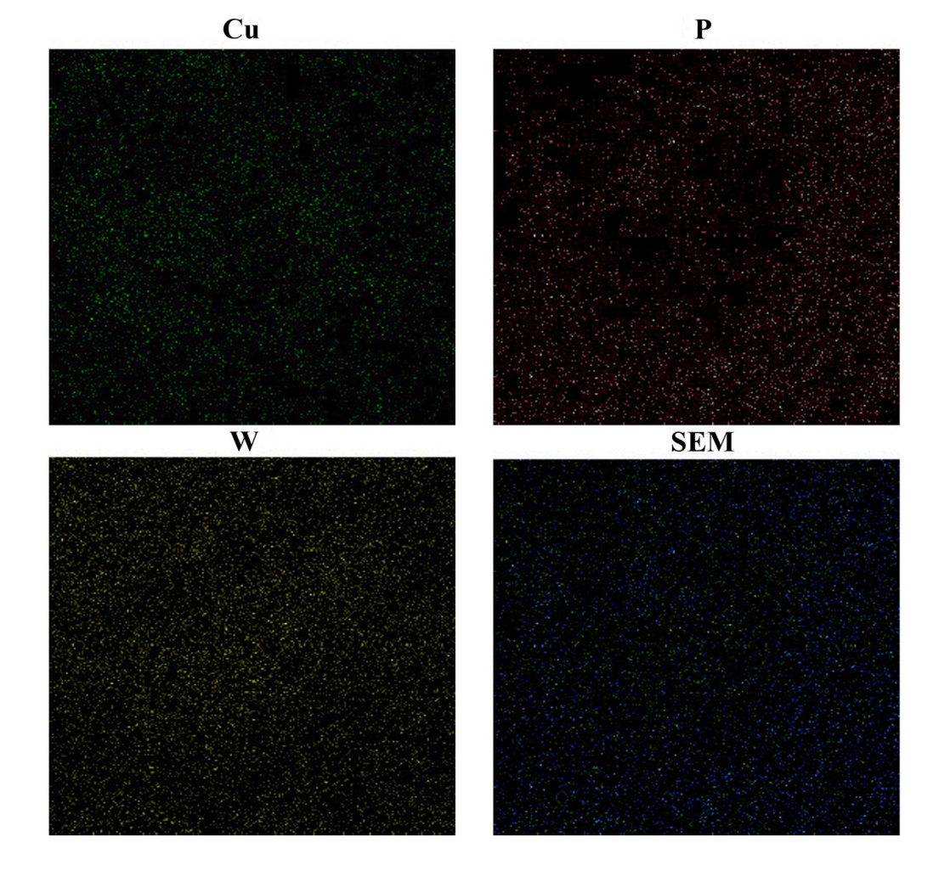
Fig. 5 EDX elemental mapping images for the composite material PW/HKUST-1.

Also, the potentiometric titration²⁶ curves obtained for HKUST-1, PW, PW/HKUST-1 are presented in Fig. 6. It is considered that the initial electrode potential (E_{i}) indicates the maximum strength of the acid sites and that the value from which the plateau is reached (mmol amine per g catalyst) indicates the total number of acid sites that are present in the titrated solid. PW and PW/HKUST-1 presented very strong acidic sites according to the classification ranges (E_{i} > 100 mV (very strong), 0 < E_{i} < 100 mV (strong), -100 < E_{i} < 0 mV (weak) and E_{i} < -100 mV (very weak) and more acidic in comparison with HKUST-1. PW is well dispersed on the support surface and does not leach during the reaction. Therefore, a larger fraction of active sites are exposed to the surface, and this catalyst may exhibit excellent activity in organic reactions, even with a low catalyst loading.

Fig. 6 Potentiometric titration curves of HKUST-1, PW, PW/HKUST-1.

3.2 Catalytic reaction
The model reaction was carried out for studying the effect of catalyst loading and temperature on the product yield (Scheme 1). Initially, the quantity of the catalyst used in this reaction was optimized (Fig. 7). Improvement in time of the reaction and yield was observed as the catalyst quantity increased from 0.02 to 0.06 g. Thus, 0.06 g of PW/HKUST-1 was the suitable choice for catalyst loading. Yield of the product was 64, 93, and 95% when reaction temperature was 25, 40, and 60 °C respectively. When the reaction temperature reached to 45 °C in the presence of 0.06 g of the catalyst the best result was obtained.

Scheme 1 Model reaction

Fig. 7 Effect of catalyst loading in the model reaction.

For comparison, the HKUST-1 material in the absence of PW, was used as a catalyst in the model reaction. The porous HKUST-1 itself shows 31% yield after 20 min. This observation revealed that Keggin PW species occluded in HKUST-1 pores significantly improved the catalytic activity of HKUST-1.
To evaluate the scope of the PW/HKUST-1 for the synthesis of β-keto enol ethers, different alcohols were used as reactants (Table 1). Primary, and secondary alcohols, reacted with dimedone without any significant difference to give the corresponding products in good to excellent yields. tert-Butanol was also reacted with dimedone to provide the corresponding β-keto enol ether in 50% yield (entry 6), while some previous approaches did not apply this alcohol or gave negative results for similar reactions. ^{20-23, 27, 28}

Table 1 Synthesis of β-keto enol ethers using PW/HKUST-1 as catalyst.
Entry | Alcohols | Time (min) | Yield )%(ª
1 | MeOH | 5 | 98
2 | EtOH | 10 | 98
3 | Propanol | 10 | 91
4 | Butanol | 75 | 86
5 |  | 30 | 92
6 |  | 75 | 51
7 |  | 25 | 98
8 |  | 75 | 94
9 |  | 20 | 93
10 |  | 15 | 92
11 |  | 30 | 64
12 |  | 55 | 71
ª Isolated yields, all products were identified by comparing their spectral data with those of the authentic samples. ^{20-23, 27, 28}

3.3 Catalyst recyclability
The recyclability of the PW/HKUST-1 was investigated to test the efficiency of this catalyst in consecutive cycles for the synthesis of β-keto enol ethers. The solid catalyst was recovered at the end of each reaction by simple filtration followed by washing with MeCN, dried at 60 °C and then reused in a fresh model reaction using the same experimental conditions. The results in Fig. 8 showed that the synthesis of product could reach 94% after being recycled for four times. It was observed that the catalytic system could be recycled at least four times with little decrease in catalytic activity and the amount of weight loosing was only 5.5 wt.%.

Fig. 8 Effect of catalytic reusability and weight recovery (after 10 min) in the model reaction.

3.4 Stability of the catalyst
The stability of the catalyst was evaluated by the characterization of the solid recovered after four consecutive cycles. Regarding the vibrational spectroscopy, the FT-IR spectra of the PW/HKUST-1 after catalytic reaction (Fig. 1(c)) are identical to the corresponding spectrum of fresh catalyst, displaying both the typical bands of HKUST-1 and the PW. The low angle XRD pattern of the reused PW/HKUST-1 exhibits an identical profile to the pattern of the composite before catalytic reaction (Fig. 3, up one). In fact, the main diffraction peaks of HKUST-1 are located at the same diffraction angles in both patterns, meaning that the crystalline structure of the HKUST-1 is retained after the catalytic cycles. Regarding the electronic microscopy studies, the morphology of the reused PW/HKUST-1 after four cycle observed in the SEM image (Fig. 2) is similar to that of the corresponding composite of fresh catalyst and significant changes in the crystal morphology of the nanosized PW/HKUST-1 was not observed by SEM.

4. Conclusions
The PW/HKUST-1 composite material in average size of approximately 300 nm was prepared using simple reaction technique. The synthesis of β-keto enol ethers catalyzed by PW/HKUST-1 as heterogeneous acid catalyst was investigated and showed high catalytic activity. The presence of the PW in PW/HKUST-1 and reused PW/HKUST-1 structure, eliminating any doubt about collapse of the HKUST-1 after catalytic reaction can be followed by FT-IR, XRD and SEM techniques. Brönsted and Lewis acidity of the PW/HKUST-1 catalyst was distinguished by studying the FT-IR. The strength and dispersion of the protons on PW/HKUST-1 was considerably high and active surface protons became more available for reactant.

Acknowledgements
The authors thank the Razi University Research Council and Iran National Science Foundation (INSF) for support of this work.

References
1. Y. Liu, J. Liu, Y. S. Lin, Micropor. Mesopor. Mater. 2015, 214, 242–245.
2. J. Lee, O.K. Farha, J. Robe, K.A. Scheidt, S.T. Nguyen, J.T. Hupp, Chem. Soc. Rev. 2009, 38, 1477–1504.
3. M. Zhao, S. Ou, C. D. Wu, Acc. Chem. Res. 2014, 47, 1199–1207.
4. M. Ranocchiari, J. A. van Bokhoven, Chem. Phys. 2011, 13, 6388–6396.
5. A. Micek-Ilnickaa, B. Gil, Dalton. Trans 2012, 41, 12624–12629.
6. C. L. Hill, C. M. Prosser-McCartha, Coord. Chem. Rev. 1995, 143, 407–455.
7. C. Zou, Z. J. Zhang, X. Xu, Q. H. Gong, J. Li, C. D. Wu, J. Am. Chem. Soc. 2012, 134, 87–90.
8. R. Yu, X.F. Kuanga, X. Y. Wu, C. Z. Lu, J. P. Donahue, Coord. Chem. Rev. 2009, 253, 2872–2890.
9. D. Y. Du, J. S. Qin, S. L. Li, Z. M. Su, Y. Q. Lan, Chem. Soc. Rev. 2014, 43, 4615–4632.
10. N. Janssens, L. H. Wee, S. Bajpe, E. Breynaert, C. E. A. Kirschhock, J. A. Martens, Chem. Sci. 2012, 3, 1847–1850.
11. H. Yang, J. Li, L. Wang, W. Dai, Y. Lv, S. Gao, Catal. Commun. 2013, 35, 101–104.
12. C. L. Hill, J. Mol. Catal. A: Chem. 2007, 262, 2–6.
13. H. Olivier-Bourbigou, L. Magna, D. Morvan, Appl. Catal. A: Gen. 2010, 373, 1–56.
14. M. Curini, F. Epifano, S. Genovese, Tet. lett. 2006, 47, 4697–4700.
15. A. S. Kende, J. Lan, D. Arad, Tet. Lett. 2002, 43, 5237 –5239.
16. M. F. Scott, T. P. Robinson, D. J. Goldsmith, J. P. Bowen, Tet. Lett. 1999, 40, 459–462.
17. B. Banerjee, S. K. Mandal, S. C. Roy, Chem. Lett. 2006, 35, 16–17.
18. Z. S. Cui, Z. H. Zhang, S. F. Liu, J. Chem. Res. 2006, 3, 390–393.
19. B. Das, K. Laxminarayana, B. Ravikanth, J. Mol. Catal. A: Chem. 2007, 271, 131–133.
20. K. Funabiki, T. Komeda, Y. Kubota, M. Matsui, Tetrahedron 2009, 65, 7457–7463.
21. P. Thirupathi, S. S. Kim, Tetrahedron 2010, 66, 2995–3003.
22. E. Rafiee, M. Khodayari, M. Joshaghani, Can. J. Chem. 2011, 89, 1533–1538.
23. E. Rafiee, M. Khodayari, M. Kahrizi, R. Tayebe, J. Mol. Catal. A: Chem. 2012, 358, 121–128.
24. G. Férey, C. Mellot-Draznieks, C. Serre, F. Millange, J. Dutour, S. Surblé, I. Margiolaki, Science 2005, 309, 2040–2042.
25. D. P. Sawant, A. Vinu, N. E. Jacob, F. Lefebvre, S. B. Halligudi, J. Catal. 2005, 235, 341–352.
26. E. Rafiee, M. Joshaghani, S. Eavani, S. Rashidzadeh, Green Chem. 2008, 10, 982–989.
27. R. Murugan, R. Kamakshi, B. S. R. Reddy, Aust. J. Chem. 2005, 58, 228–230.
28. P. Srihari, S. S. Mandal, J. S. S. Reddy, R. S. Rao, J. S. Yadav, Chin. Chem. Lett. 2008, 19, 767–770.

Captions:

Table 1 Synthesis of β-keto enol ethers using PW/HKUST-1 as catalyst.
Fig. 1 FT-IR spectra of (a) PW, (b) PW/HKUST-1, (c) reused PW/HKUST-1, (d) PW/HKUST-1 after reaction with 0.1 mol of pyridine per gram of catalyst and (e) HKUST-1.
Fig. 2 SEM images of PW/HKUST-1 (Scale bar: 1 μm) (a), SEM images of reused PW/HKUST-1 (Scale bar: 1 μm) (b).
Fig. 3 Low angle XRD patterns of PW/HKUST-1 (bottom) and reused PW/HKUST-1(up).
Fig. 4 Grain size distribution of PW/HKUST-1.
Fig. 5 EDX elemental mapping images for the composite material PW/HKUST-1.
Fig. 6 Potentiometric titration curves of HKUST-1, PW, PW/HKUST-1.
Fig. 7 Effect of catalyst loading in the model reaction.
Fig. 8 Effect of catalytic reusability and weight recovery (after 10 min) in the model reaction.
Scheme 1 Model reaction

Corresponding author. Tel./fax: +98-833-427-4559; e-mail: ezzat_rafiee@yahoo.com

