SUPPLEMENT:

The levels of detected organic compounds were expressed in relation to the injection standard hexatriacontane (HTA, n-C36) with the equation (1). We used the method of normalization in relation to the injection standard HTA.

Ci = (Ai / AHTA ) (1)

Ci: mass fraction of the compound i
Ai: peak area of compound i
A : peak area of hexatriacontane (HTA)
Statistical data calculations and graphical displays were performed using program IBM SPSS Statistics 21, Microsoft EXCEL was applied for the data preparation and generation of the results' outputs. The direct examination of any inter-relation between the two measured analytes was mostly realized by the correlation analysis when determining the extent to which the values of the two variables were mutually dependent. We carried out the test of normality by which we checked the assumption of the normal distribution of data. Because the data was normally distributed, we used the Pearson correlation analysis. Principal Components Analysis (PCA) is an important method for the characterization of different samples. This method was used for classifying samples of PM10 in dependence on the measured variables. We carried out the analysis of variance (ANOVA), a method used to determine whether there are any significant differences between the means of three or more groups. With ANOVA we compared the samples of PM10 in dependence of the measured variables.

- n-alkanes
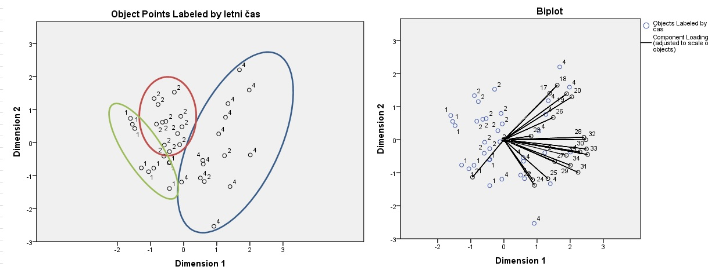
The homologue distribution of n-alkanes and their CPI values are useful tools to distinguish sources. We normalized chromatographic data. The peak area of individual organic compound was divided with peak area of standard compound hexatriacontane. We calculated the CPI values for n-alkanes. The sum of odd n-alkanes was divided by the sum of even n-alkanes. The average CPI in summer was 2.45 with a maximum at 8.03 pointing to increased biogenic emissions. In winter we calculated an average CPI of 1.07. These lower CPI values could be explained due to lower biogenic activity and increased use of fossil fuels because of the heating season in winter. We also observed that in winter the daily CPI was never higher than 1.5.
PCA analysis for n-alkanes labeled by season (1. summer, 2. spring, 4. winter).
From the data in figure 1 we can conclude that n-alkanes have greater concentrations in winter. From the calculated CPI (Table 1) we concluded that the main sources of n-alkanes in warmer seasons are biogenic emissions. In winter season the main source is burning of fossil fuels.
Table 1. Calculated CPI for n-alkanes
Season | Month | CPI
  1
  1
  1
  1
  1
  1
  1
  1
  1
  2
  2
  2
  2
  2
  2
  2
  2
  2
  2
  2
  2
  2
  2
  2
  4
  4
  4
  4
  4
  4
  4
  4
  4
  4
  4
  4
  7
  7
  7
  7
  7
  7
  7
  7
  7
  5
  5
  5
  5
  5
  5
  5
  5
  5
  5
  4
  4
  4
  4
  4
  12
  12
  12
  12
  12
  12
  12
  12
  12
  12
  12
  12
  2,1945
  1,577077
  2,548057
  2,11946
  7,143483
  8,031594
  2,844191
  3,941347
  3,334718
  1,960648
  1,708324
  1,499454
  2,066057
  1,516805
  6,495399
  0,722564
  0,550732
  0,628907
  0,550643
  1,825488
  1,585603
  1,199747
  1,383403
  1,412544
  1,083993
  1,219255
  1,356668
  1,70117
  1,52465
  1,926487
  1,16167
  0,629022
  0,629022
  0,527793
  0,527793
  0,595326

- Chromatographic determination of siloxanes
Qualitative and quantitative analyses were performed with a GC/MS system consisting of a HP 6890 Gas Chromatograph with a 5973 Mass Selective Detector (Agilent Technologies, CA, USA). For quantitative analysis of siloxanes, the instrument was operated in selected ion monitoring (SIM) mode. The selected ions for siloxanes were m/z 147 and m/z 221. The injected volume was 2 μL and the splitless technique was used. The ion source temperature was 230 °C. The injection port and transfer line were kept at 290 °C. The temperature program was the following: 0.75 min at a temperature of 105 ºC, 30 ºC /min up to 120 º C (0.1 min), 2.7 °C/min to 320 ºC (5 min). The carrier gas was helium (He 6.0, Messer Austria) at a constant flow of 0.9 ml/min. The ion source temperature was 250 °C. The injection port and transfer line were kept at 290 °C. The standard stock solution was constructed from the same Silicon-Hochvakuumfett grease (Merck 100g, CAS Nr. 107922) with which the impact plate of the instrument was greased. We prepared a standard stock solution STD with a concentration of 2 μg/μL. For the quantification of siloxanes calibration curves were constructed by analyzing aliquots of stock solution. The 4 points for the calibration curve were prepared by using calibrated syringes with which we pipetted different volumes of the standard stock solution and added a known amount of the external standard hexatriacontane. We daily prepared and measured calibration solutions, using STD and InjSTD to assure method linearity and precision.
The concentration of PM10 was gravimetrically determined. Filters were weighted before and after the sampling. The difference is the weight of PM10. The concentration of PM10 is expressed as weight per volume of 1 m³ of sampled air. The determined concentrations of siloxanes in sample extracts were divided with the volume of sampled air. Percentage of siloxanes was calculated by dividing mass of siloxanes with the mass of PM10.
Table 2. Calibration curve for siloxanes
Calibration curve points | InjSTD nC₃₆  c= 0,5 μg /μL | STD stock solution  c =2 μg/μL
K1 | 5000 ng - 10 μL | 2 μg - 1 μL
K2 | 5000 ng - 10 μL | 10 μg - 5 μL
K3 | 5000 ng - 10 μL | 20 μg - 10 μL
K4 | 5000 ng - 10 μL | 50μg - 25 μL

Table 3. Gravimetrically weighing and PM10 calculations according to EN12341 for summer sample extracts.
Location | Filter Nr. | The mass of the filter before weighing (g) | The mass of the filter after weighing (g) | Difference (μg) | Volume (m³) | C_{PM10} (μg/ m³)
MB VP | 3611 | 0,11134 | 0,11180 | 460 | 55,14 | 8,3
MB VP | 3612 | 0,11132 | 0,11184 | 520 | 55,13 | 9,4
MB VP | 3613 | 0,10880 | 0,10943 | 630 | 55,14 | 11,4
MB VP | 3614 | 0,11277 | 0,11340 | 630 | 55,13 | 11,4
Miklavž | 3625 | 0,11272 | 0,11338 | 660 | 54,54 | 12,1
Miklavž | 3626 | 0,11213 | 0,11338 | 660 | 57,89 | 11,4
Miklavž | 3627 | 0,10992 | 0,11076 | 840 | 54,54 | 15,4
Miklavž | 3628 | 0,11100 | 0,11190 | 900 | 54,54 | 16,5

Table 4. Calculated % of siloxanes for summer sample extracts.
Location | Filter Nr. | Calculated mass sum of siloxanes (μg) | ∑C_{siloxane} (μg/ m³) | C_{PM10} (μg/ m³) | % siloxanes compared to C_{PM10}
MB VP | 3611 | 47,03 | 0,94 | 8,3 | 11,34
MB VP | 3612 | 22,52 | 0,45 | 9,4 | 4,79
MB VP | 3613 | 28,84 | 0,58 | 11,6 | 5,09
MB VP | 3614 | 29,30 | 0,59 | 11,4 | 5,14
Miklavž | 3625 | 60,09 | 1,20 | 12,1 | 9,93
Miklavž | 3626 | 48,29 | 0,97 | 11,4 | 8,47
Miklavž | 3627 | 60,85 | 1,22 | 15,4 | 7,90
Miklavž | 3628 | 104,45 | 1,92 | 16,5 | 11,64

Table 5. Calculated % of siloxanes for silicone grease and polyphenyether.
Location | Date | Coating for impaction plate | Calculated mass sum of siloxanes (μg) | ∑C_{siloxane} (μg/ m³) | C_{PM10} (μg/ m³) | % siloxanes compared to C_{PM10}
Miklavž | 20.9.2015 | silicone grease | 11,32 | 0,21 | 9,4 | 2,23
Miklavž | 21.9.2015 | silicone grease | 19,33 | 0,36 | 11,4 | 3,14
Miklavž | 22.9.2015 | silicone grease | 16,74 | 0,31 | 11,4 | 2,74
MB VP | 20.9.2015 | silicone grease | 23,22 | 0,43 | 15,0 | 2,88
MB VP | 21.9.2015 | silicone grease | 18,9 | 0,35 | 16,3 | 2,13
MB VP | 22.9.2015 | silicone grease | 19,47 | 0,36 | 18,4 | 1,96
MB VP | 20.9.2015 | polyphenylether | 0,0 | 0,0 | 15,0 | 0,0
MB VP | 21.9.2015 | polyphenylether | 0,0 | 0,0 | 16,3 | 0,0
MB VP | 22.9.2015 | polyphenylether | 0,0 | 0,0 | 18,4 | 0,0

For the comparison of coatings for impaction plate we used 3 low-volume vacuum samplers at 2 locations. On 2 samplers we used silicone grease for impaction plate and on 1 we used polyphenyether (Santovac 5). Before any measurements were done, we cleaned all the sampler parts with toluene. Table 5 demonstrates the use of polyphenylether coating compared to silicone grease. The results show, that sample extracts for using silicone grease coating had an average of 2,51 μg/m³ of siloxanes per sample. We didn’t detect any siloxanes while using polyphenylether, but we detected polyphenylether as a “carryover” contaminant.

