SUPPLEMENTARY FILES

Application of “Click” chemistry in solid phase synthesis of alkyl halides

Diparjun Das, Tridib Chanda and Lalthazuala Rokhum*

Department of Chemistry, National Institute of Technology Silchar, Silchar-10, Assam, India
* Corresponding author. Tel.: +91 3842 242915; fax: +91 3842-224797; email address: lalthazualarokhum@gmail.com (L. Rokhum)

General Remarks
Milestones’ Start SYNTH microwave was used for all the reactions. IR spectra were recorded on a Perkin–Elmer Spectrum One FTIR spectrometer. ¹H and ¹³C NMR spectra were recorded on a Bruker (500 MHz and 400 MHz) spectrometer using TMS as internal reference. Chemical shifts for 1H NMR spectra are reported (in parts per million) relative to internal tetramethylsilane (Me₄Si δ= 0.0 ppm) with CDCl₃ as solvents. ¹³C NMR spectra were recorded at 125 MHz and 100 MHz. Chemical shifts for ¹³C NMR spectra are reported (in parts per million) relative to internal tetramethylsilane (Me₄Si δ = 0.0 ppm) with CDCl₃ as solvent. ¹H NMR data are reported in the order of chemical shift, multiplicity (s = singlet, d = doublet, t = triplet, dd = doublet of doublet, and m = multiplet), number of protons, and coupling constant in hertz (Hz). Mass spectra were obtained from Waters ZQ 4000 mass spectrometer by the ESI method, while the elemental analyses of the complexes were performed on a Perkin–Elmer-2400 CHN/S analyzer. TLC plates were visualized by exposing in iodine chamber, UV-lamp or spraying with KMnO₄ and heating.

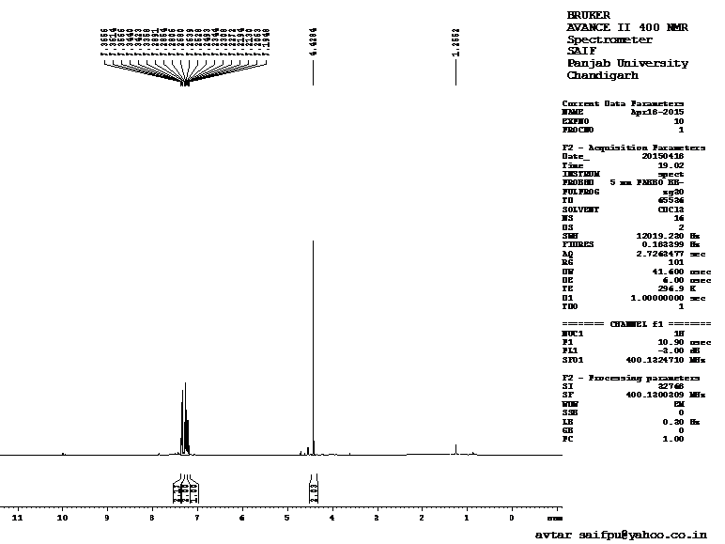
1
Benzyl iodide

Fig: ¹H NMR spectra of benzyl iodide, 1

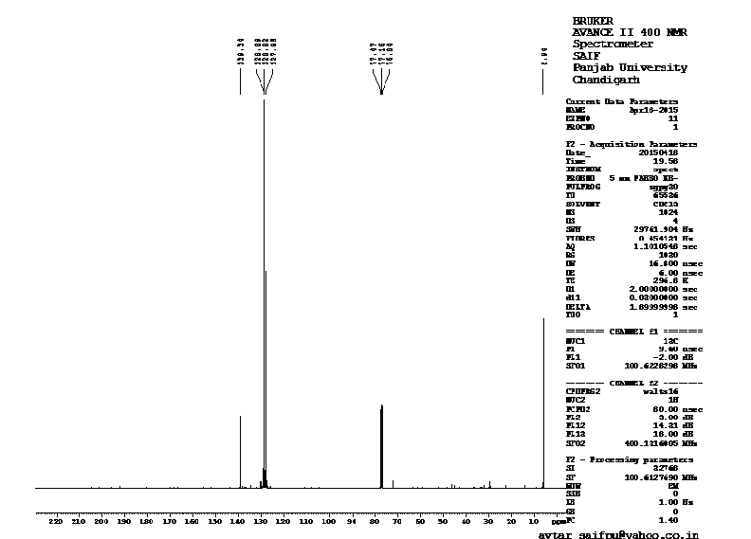
1
Benzyl iodide

Fig: ¹³C NMR spectra of benzyl iodide, 1

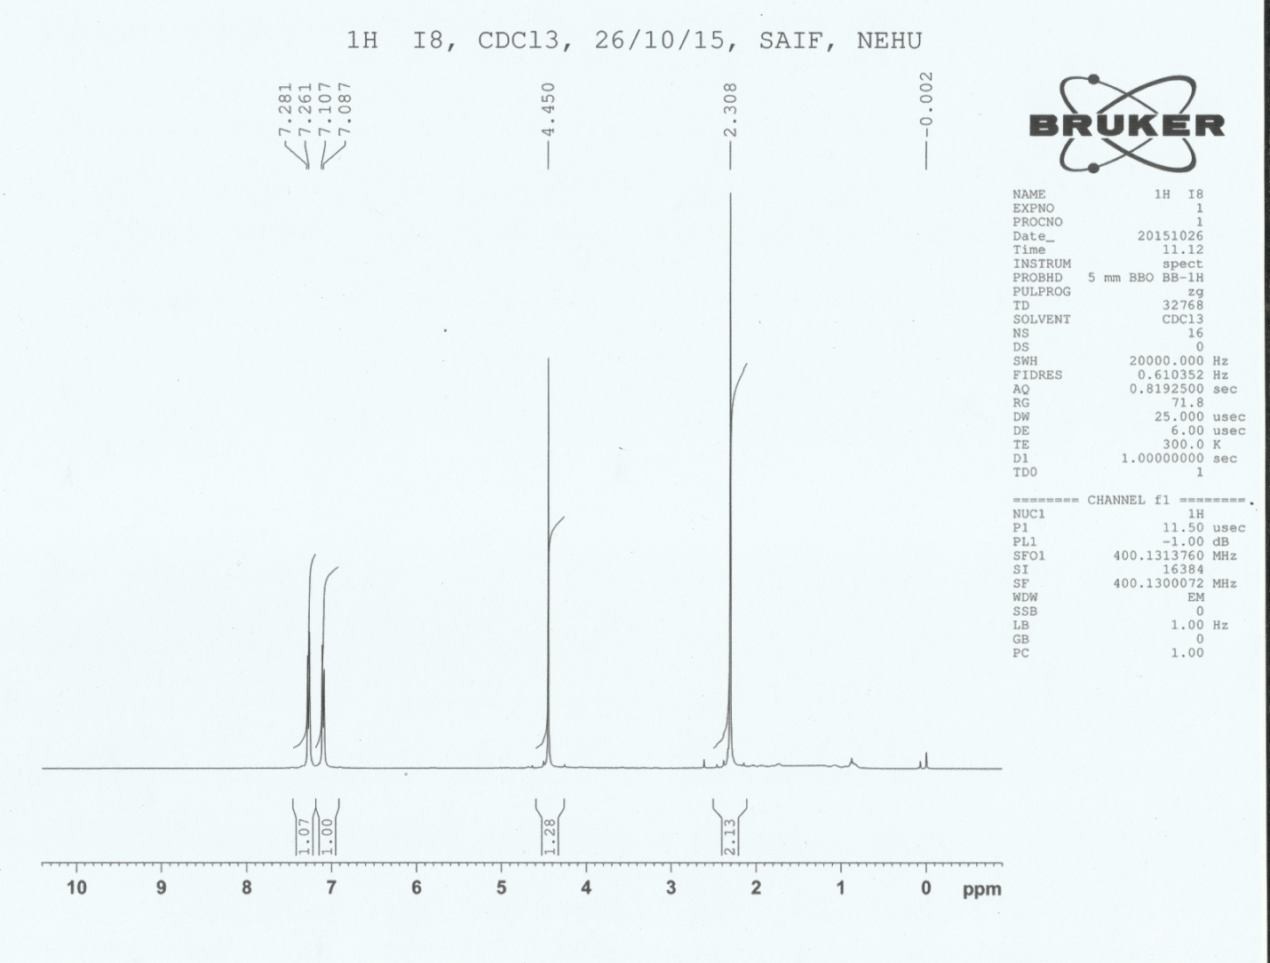
2
4-Methylbenzyl iodide

Fig: ¹H-NMR spectra of 4-methylbenzyl iodide, 2

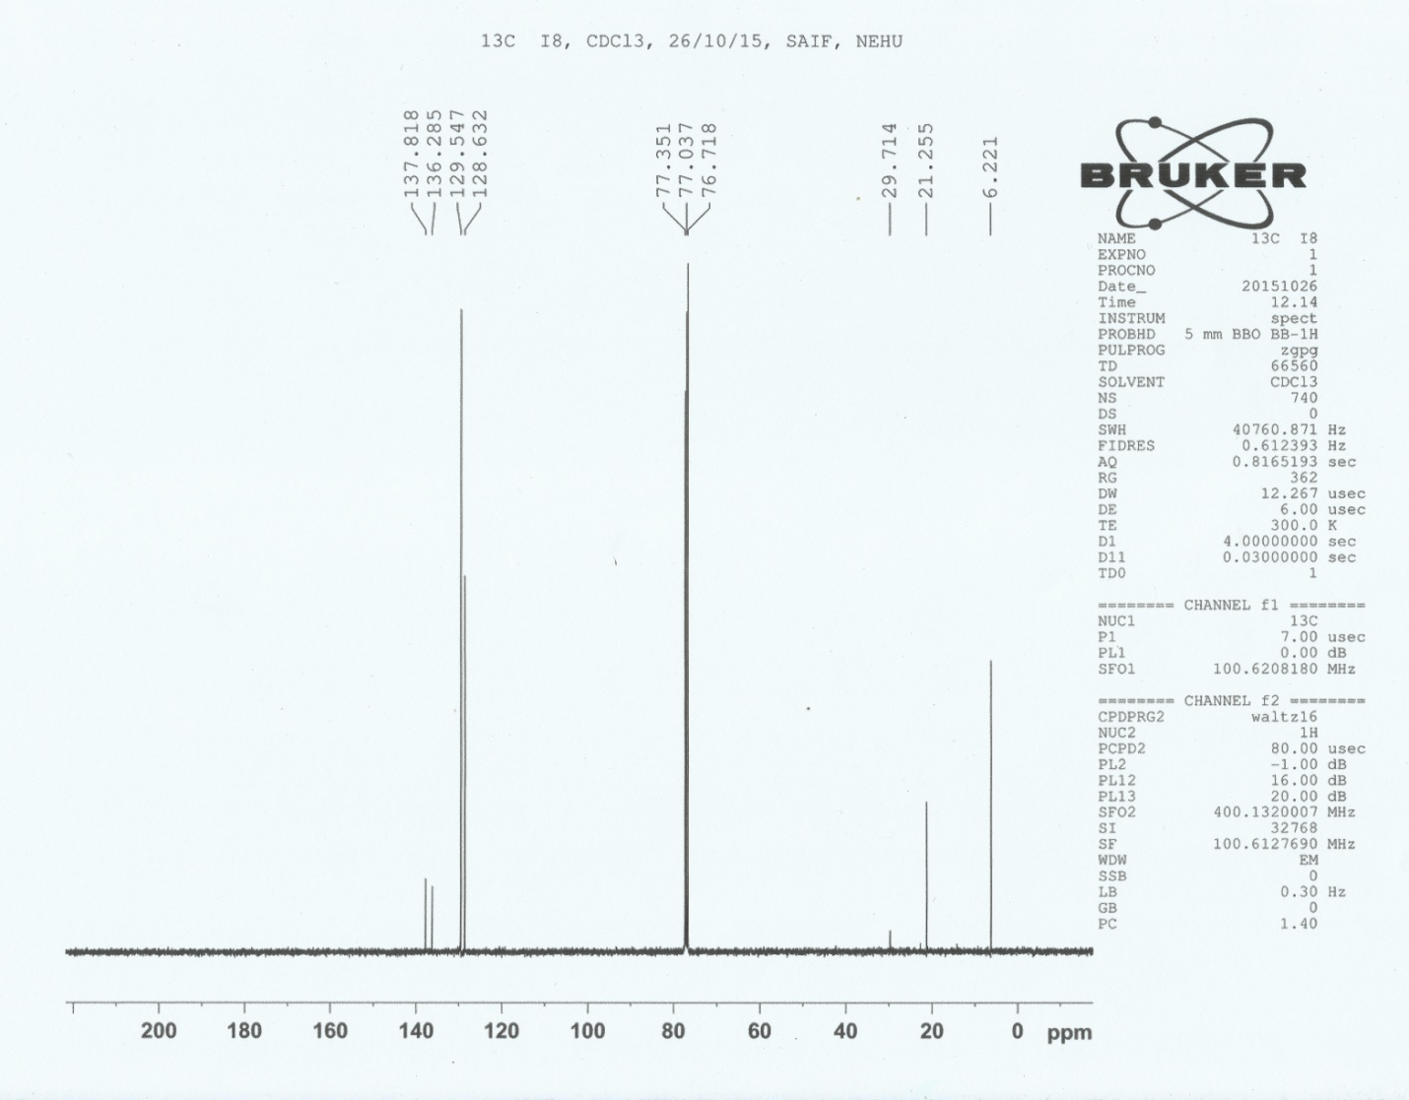
2
4-Methylbenzyl iodide

Fig: ¹³C-NMR spectra of 4-methylbenzyl alcohol, 2

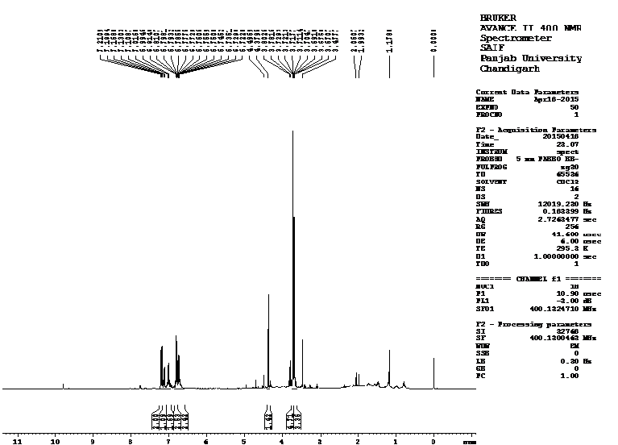
3
4-Methoxybenzyl iodide

Fig: ¹H NMR of 4-methoxy benzyl iodide, 3

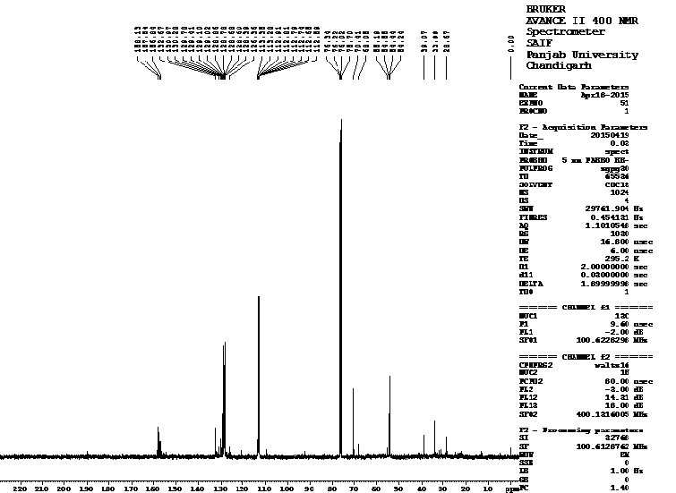
3
4-Methoxybenzyl iodide

Fig: ¹³C NMR of 4-methoxy benzyl iodide, 3

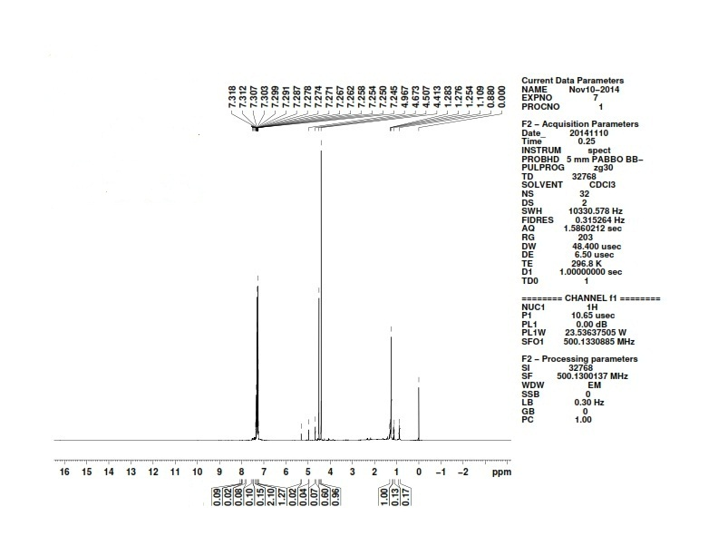
8
4-Chlorobenzyl iodide
Fig: ¹H NMR spectra of 4-chlorobenzyl iodide, 8
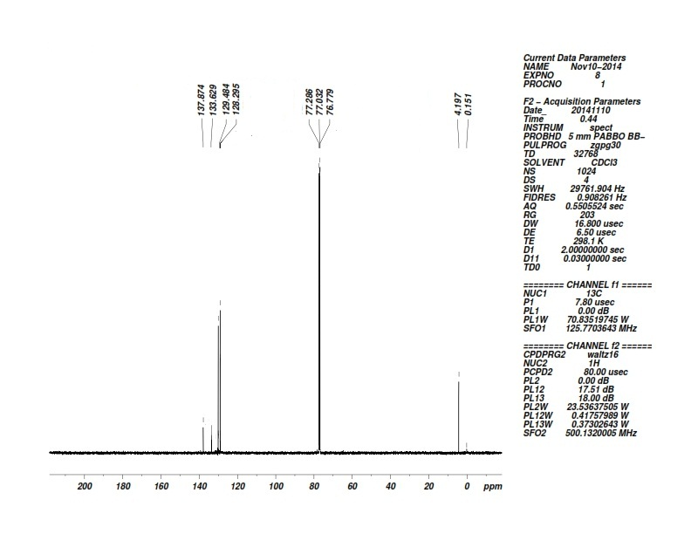
8
4-Chlorobenzyl iodide
Fig: ¹³C NMR spectra of 4-chlorobenzyl iodide, 8
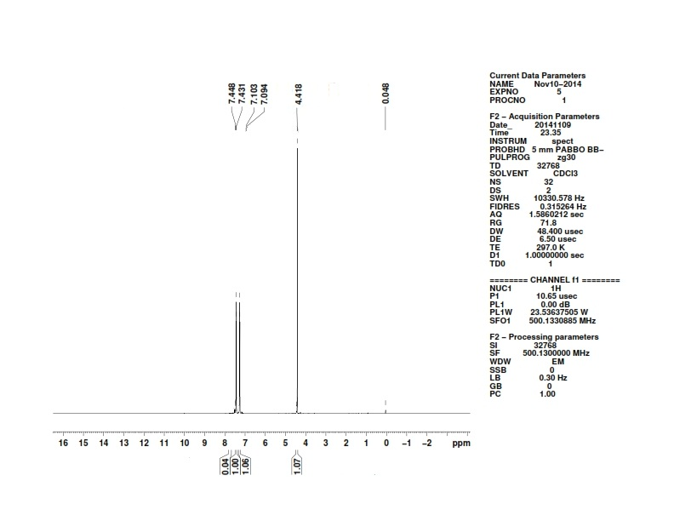
11
4-Bromobenzyl iodide

Fig: ¹H NMR spectra of 4-bromobenzyl iodide, 11
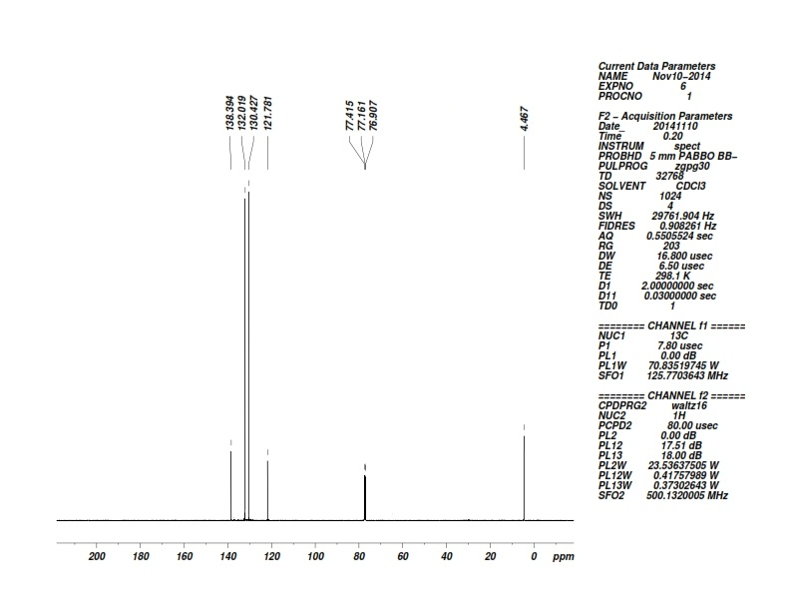
11
4-Bromobenzyl iodide

Fig: ¹³C NMR spectra of 4-bromobenzyl iodide, 11

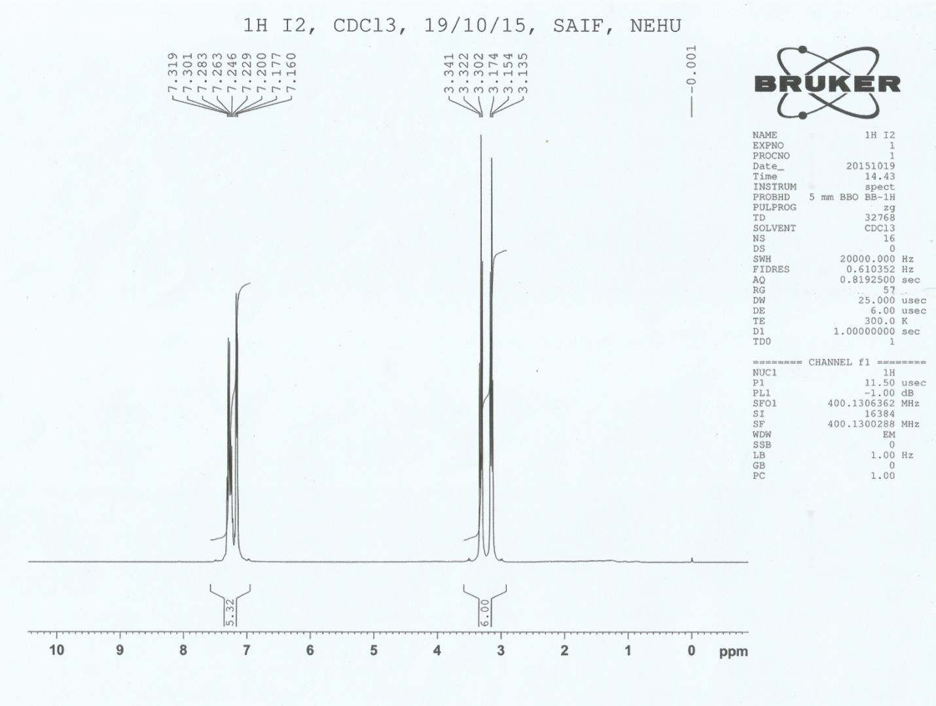
15
(2-iodoethyl)benzene

Fig: ¹H-NMR spectra of (2-iodoethyl)benzene, 15

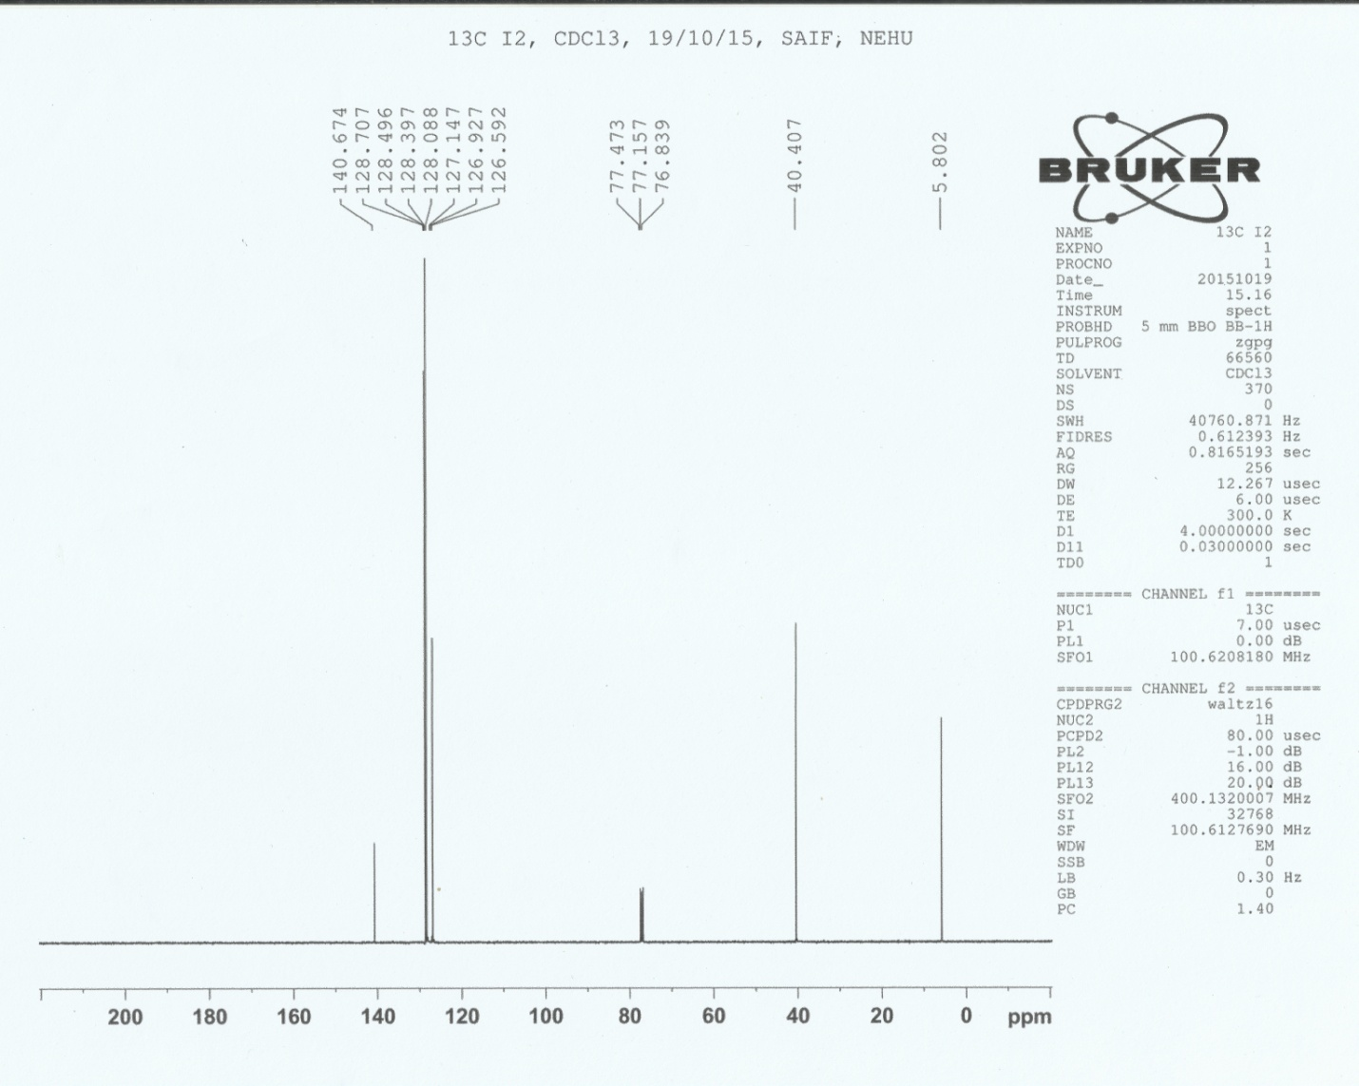
15
(2-iodoethyl)benzene

Fig: ¹³C-NMR spectra of (2-iodoethyl)benzene, 15

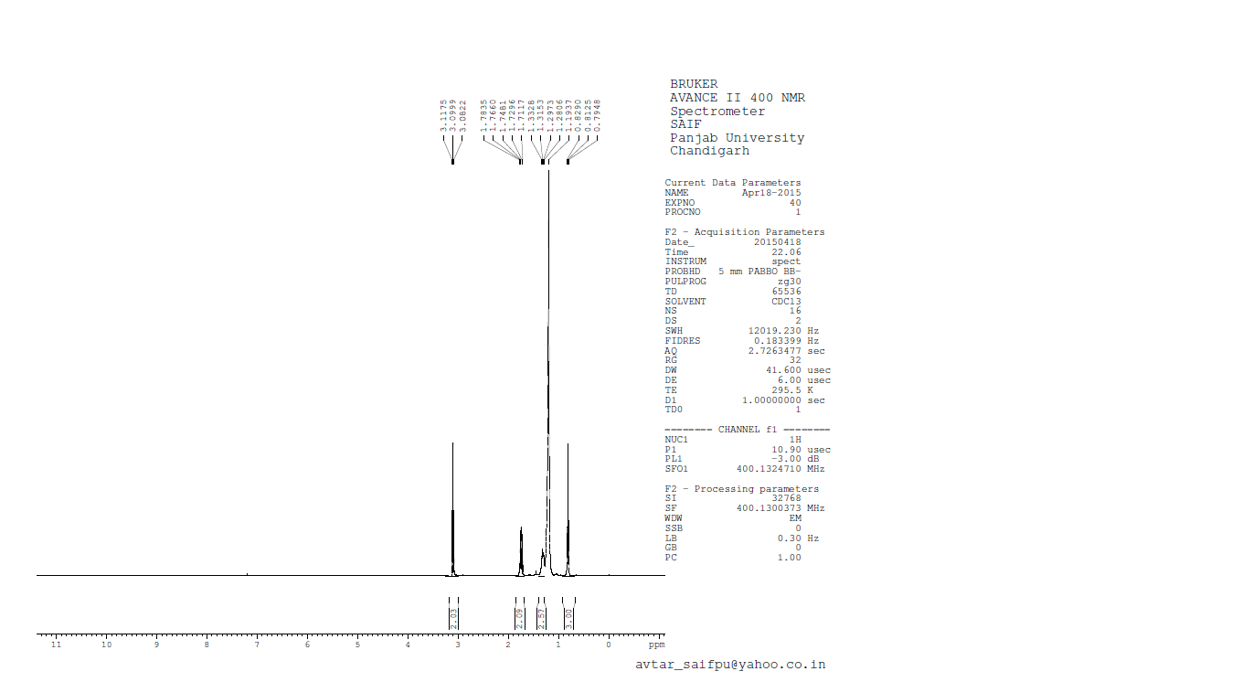
16
1-Iodooctadecane

Fig: ¹H-NMR spectra of 1-iodooctadecane, 16

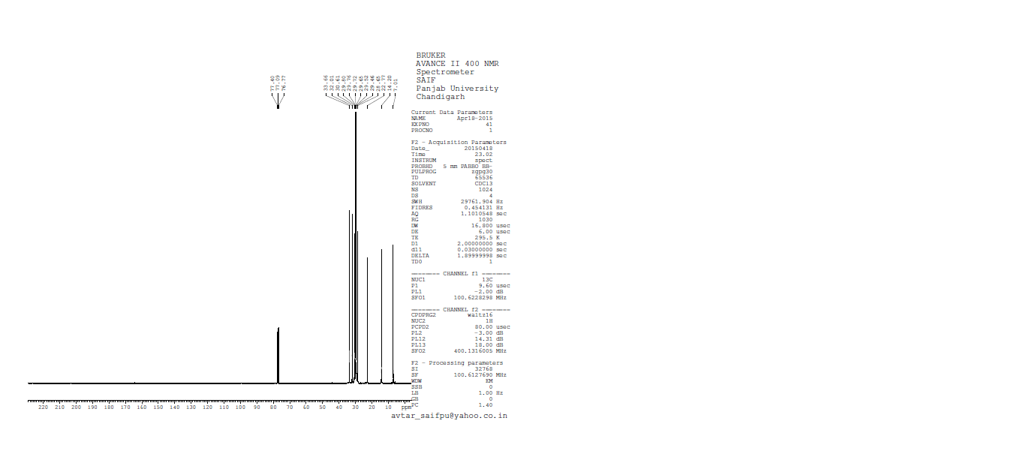
16
1-Iodooctadecane

Fig: ¹³C NMR Spectra of 1-iodooctadecane, 16

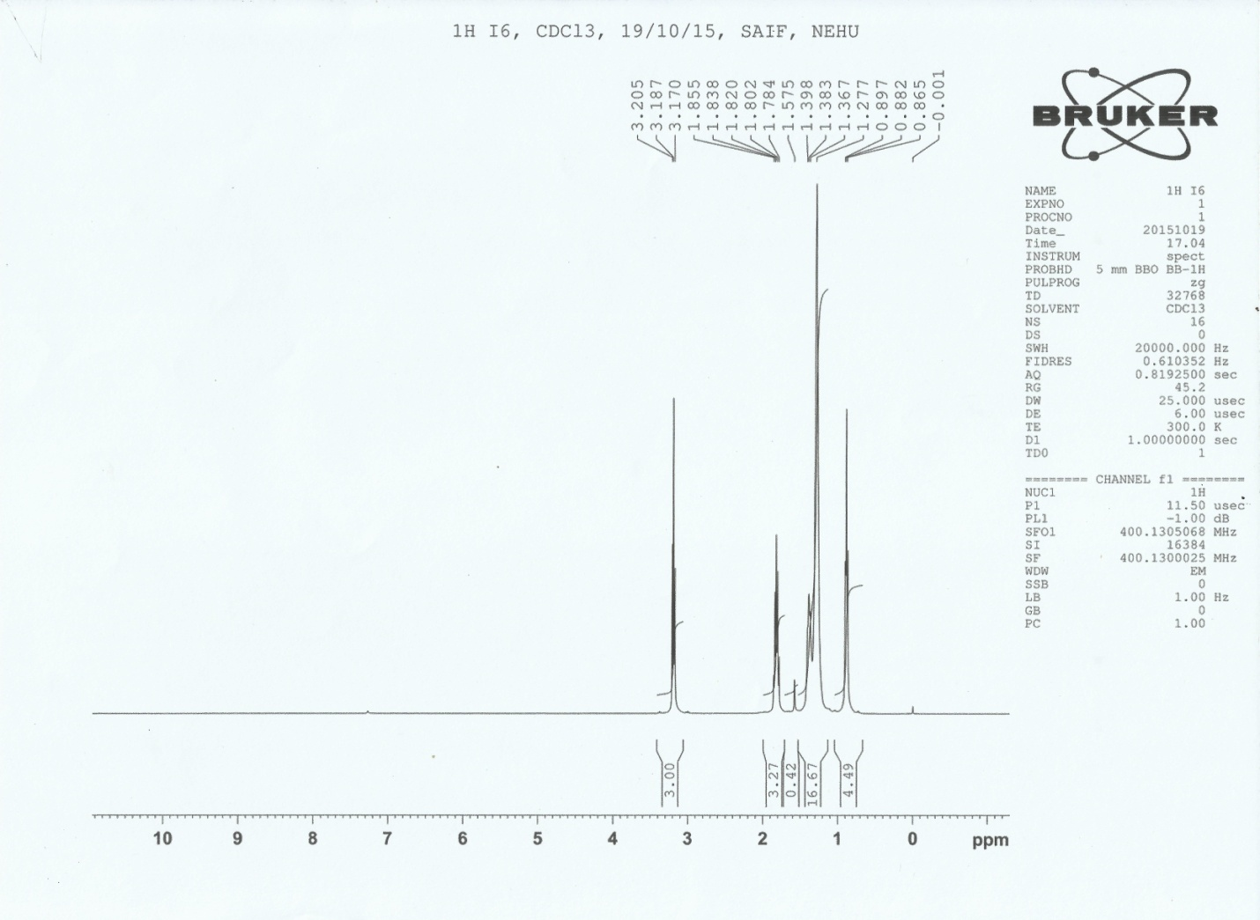
17
1-Iodooctane

Fig: ¹H-NMR spectra of 1-iodooctane, 17
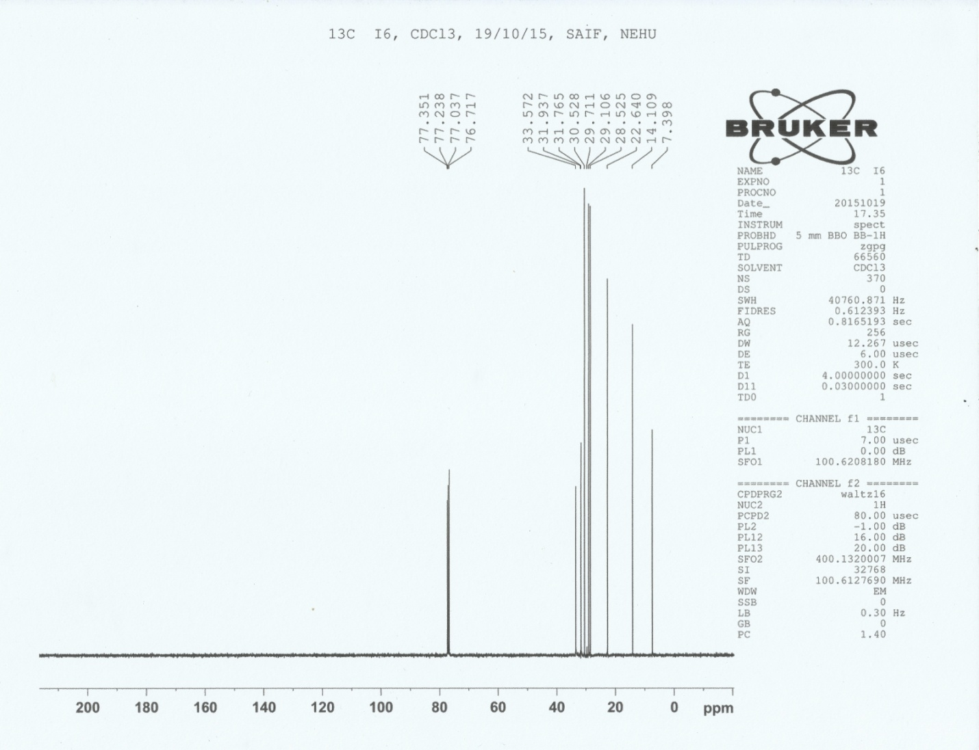
17
1-Iodooctane

Fig: ¹³C-NMR spectra of 1-iodooctane, 17

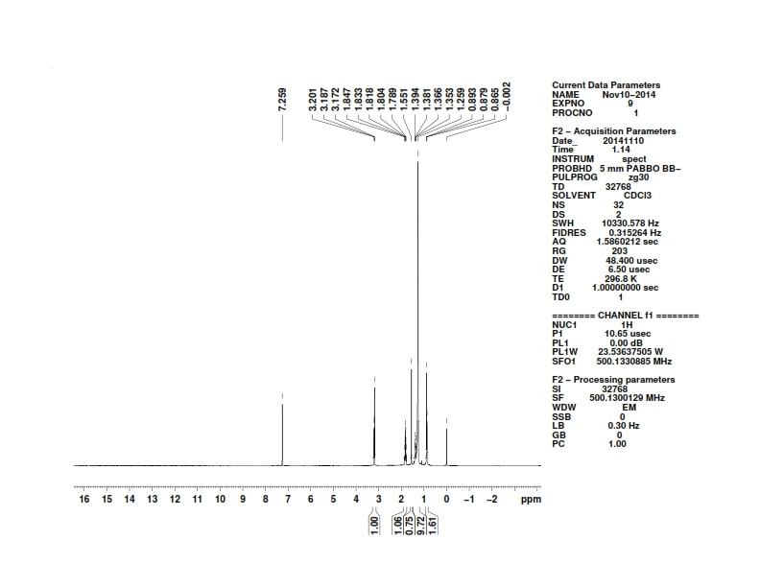
18
1-Dodecyl iodide
Fig: ¹H NMR spectra of 1-dodecyl iodide, 18

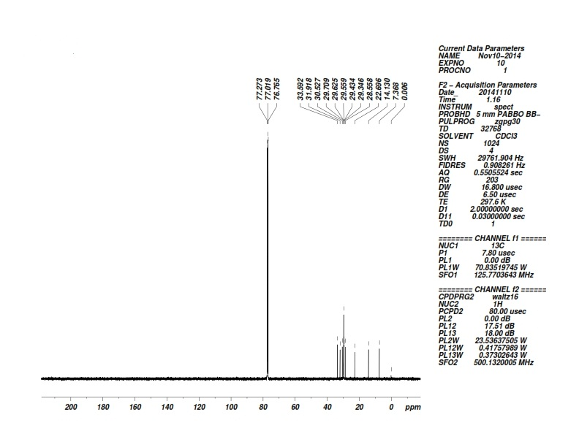
18
1-Dodecyl iodide

Fig: ¹³C NMR spectra of 1-dodecyl iodide, 18

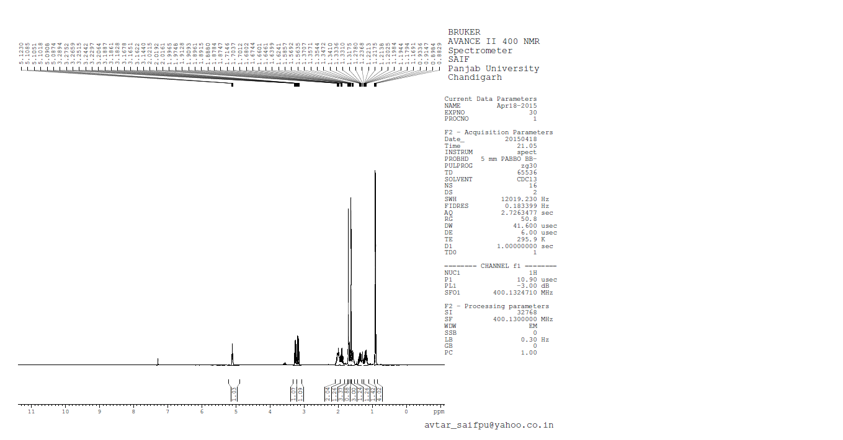
19
Citronellyl iodide

Fig: ¹H NMR Spectra of citronellyl iodide, 19

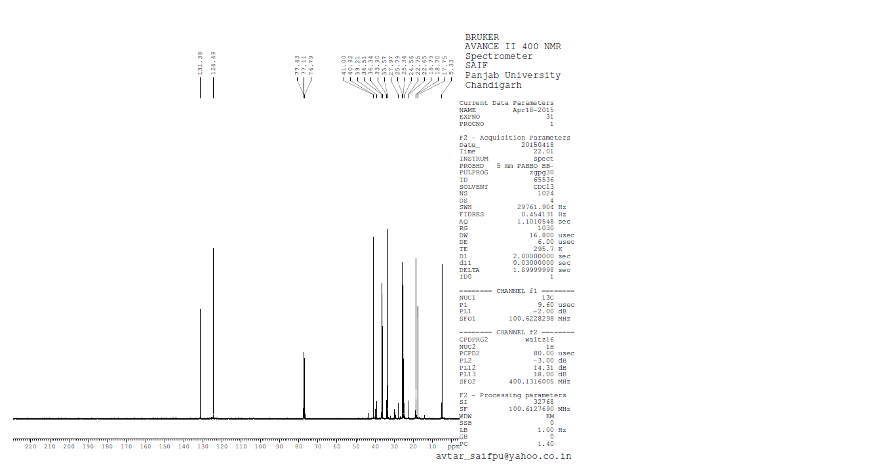
19
Citronellyl iodide
Fig: ¹³C NMR Spectra of citronellyl iodide, 19

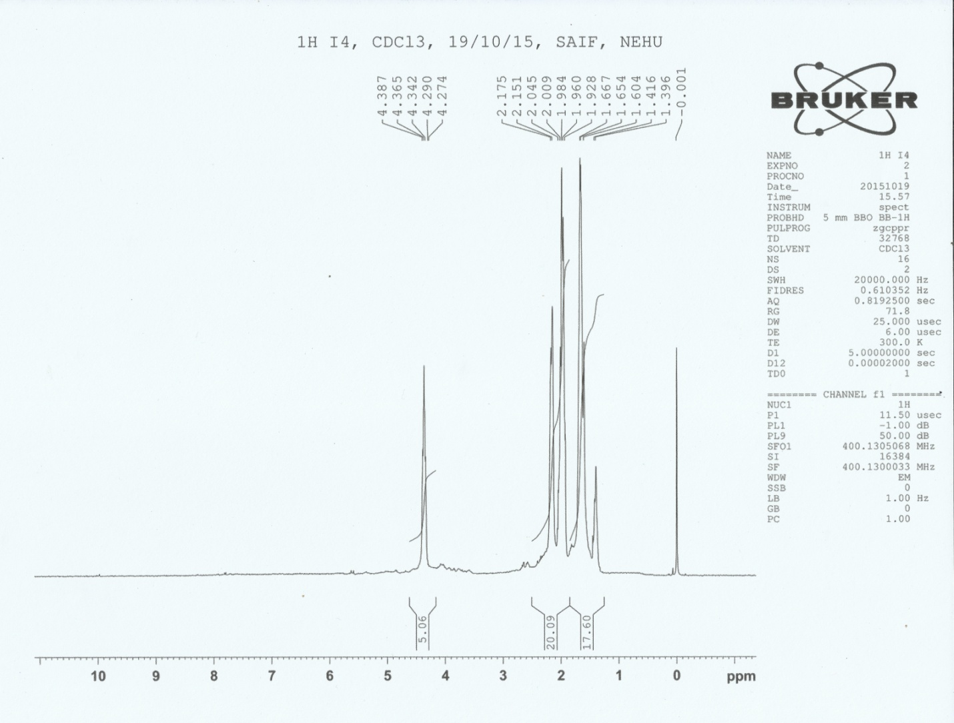
25
Iodocyclohexane

Fig: ¹H-NMR spectra of iodocyclohexane, 25

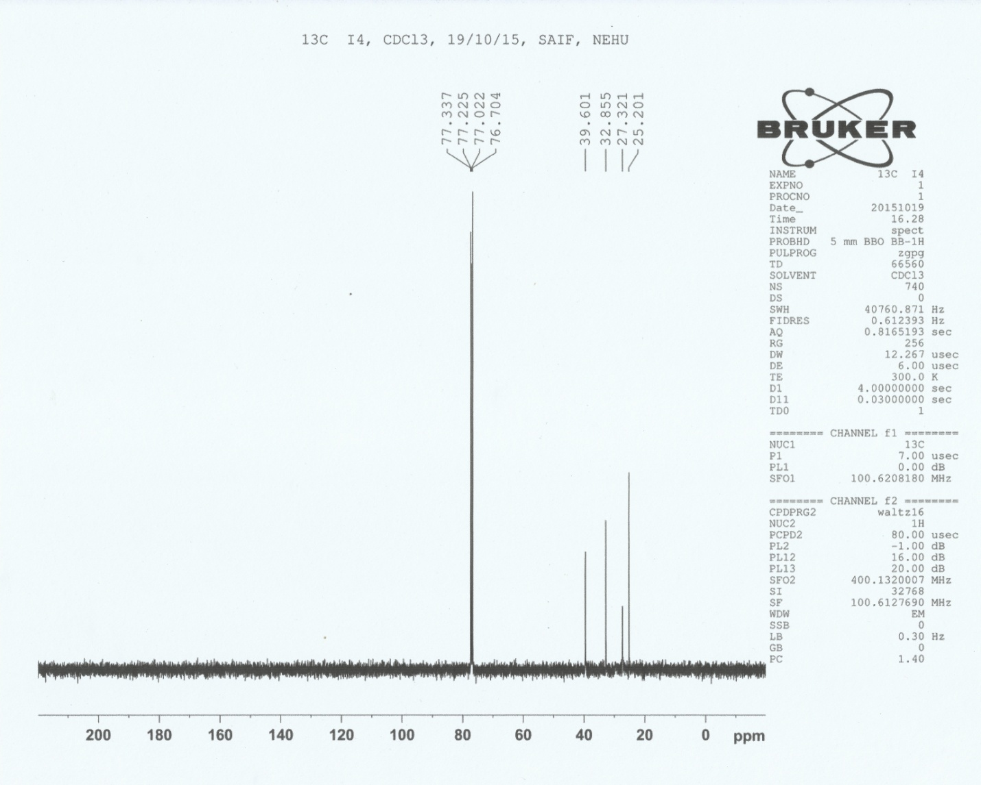
25
Iodocyclohexane

Fig: ¹³C-NMR spectra of iodocyclohexane, 25

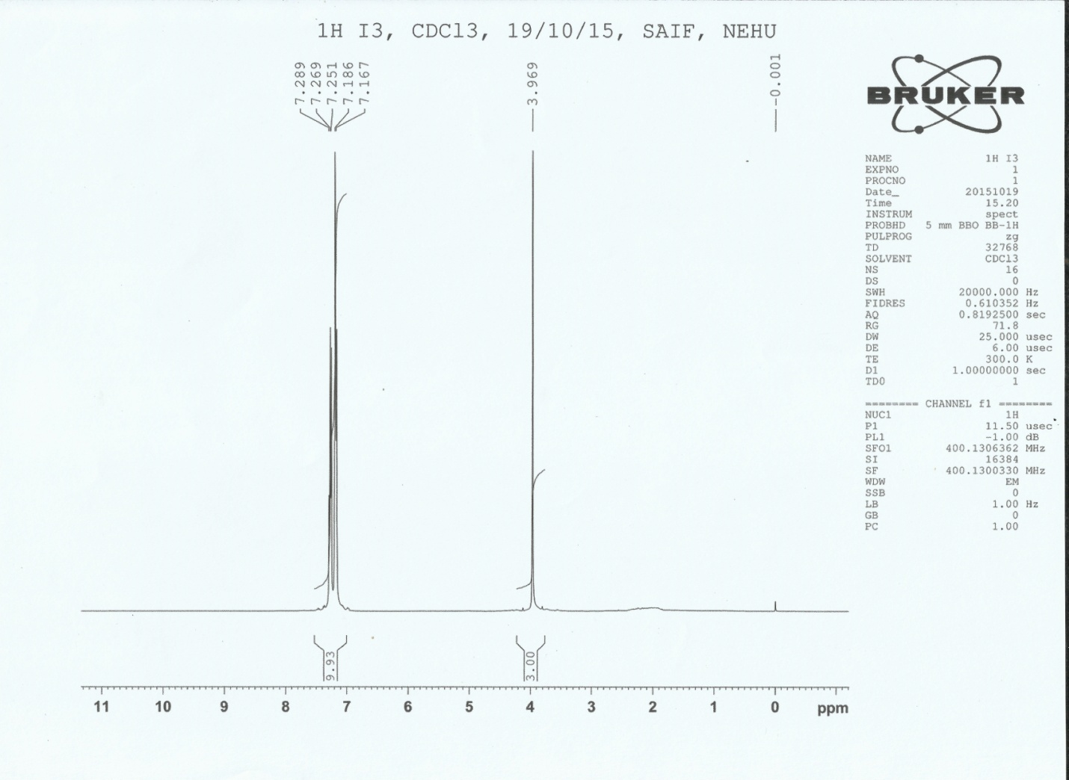
26
(Iodomethylene)dibenzene

Fig: ¹H-NMR spectra of (iodomethylene)dibenzene, 26

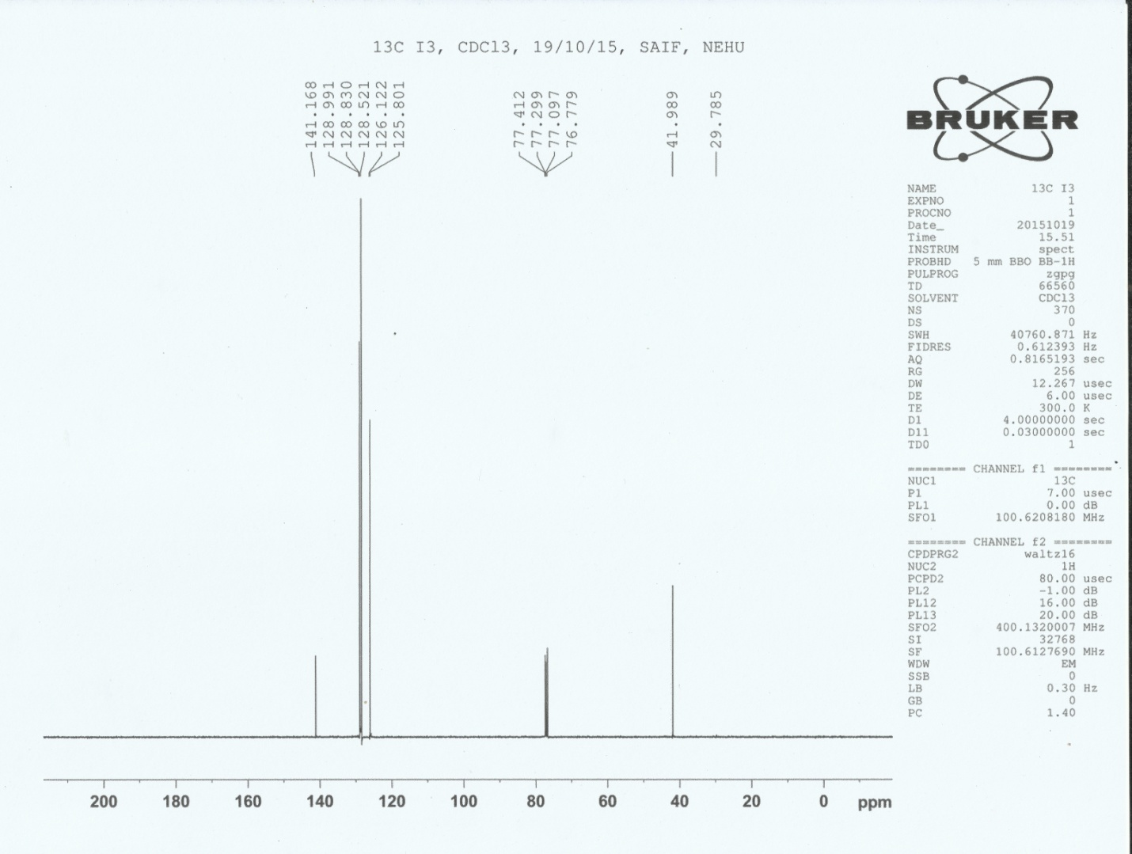
26
(Iodomethylene)dibenzene

Fig: ¹³C-NMR spectra of (iodomethylene)dibenzene, 26

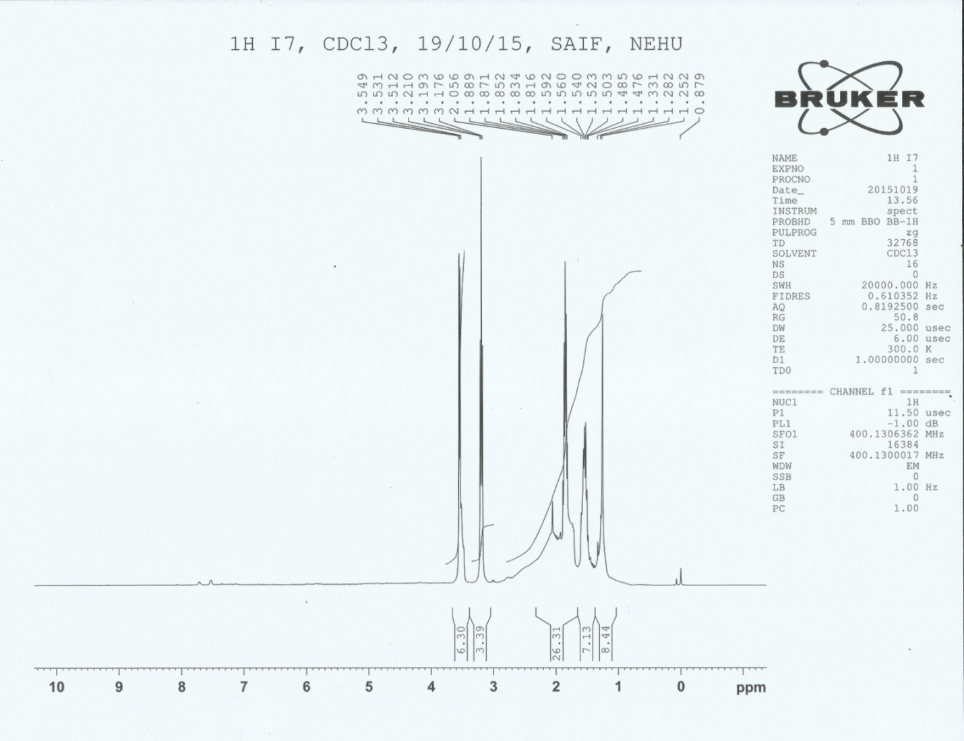
29
5-Iodopentan-1-ol

Fig: ¹H-NMR spectra of 5-iodopentan-1-ol, 29

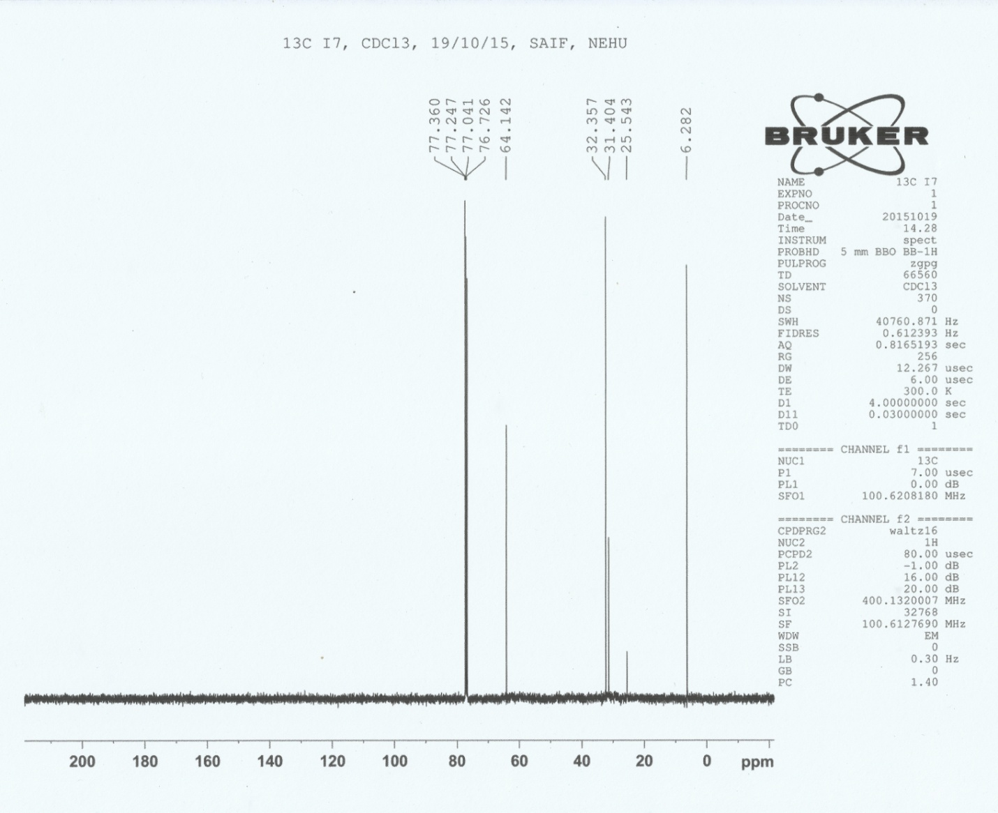
29
5-Iodopentan-1-ol

Fig: ¹³C-NMR spectra of i-Iodopentan-1-ol, 29

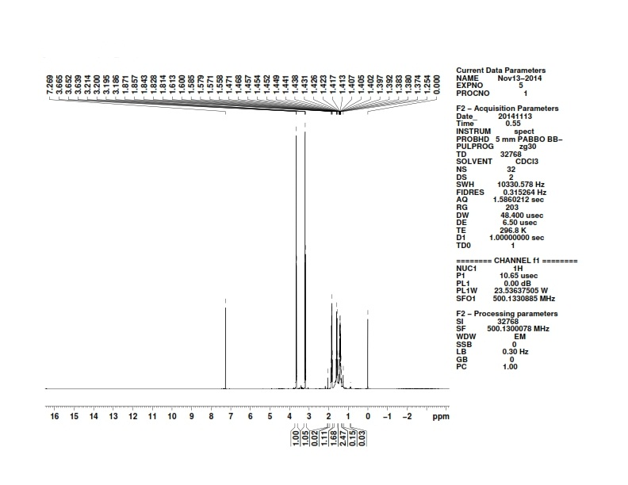
30
6-Iodohexan-1-ol
Fig: ¹H NMR spectra of 6-iodohexan-1-ol, 30

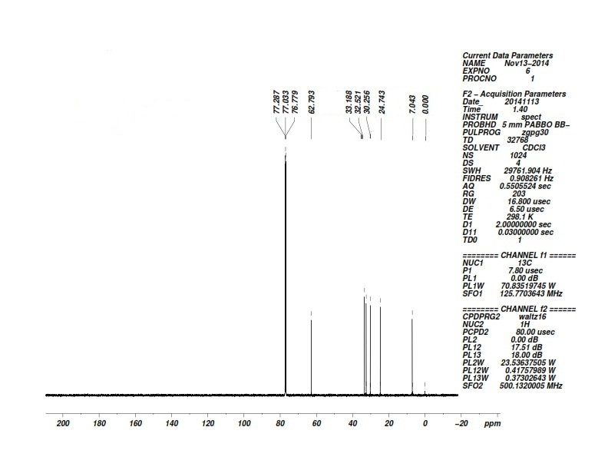
30
6-Iodohexan-1-ol

Fig: ¹³C NMR spectra of 6-iodohexan-1-ol, 31

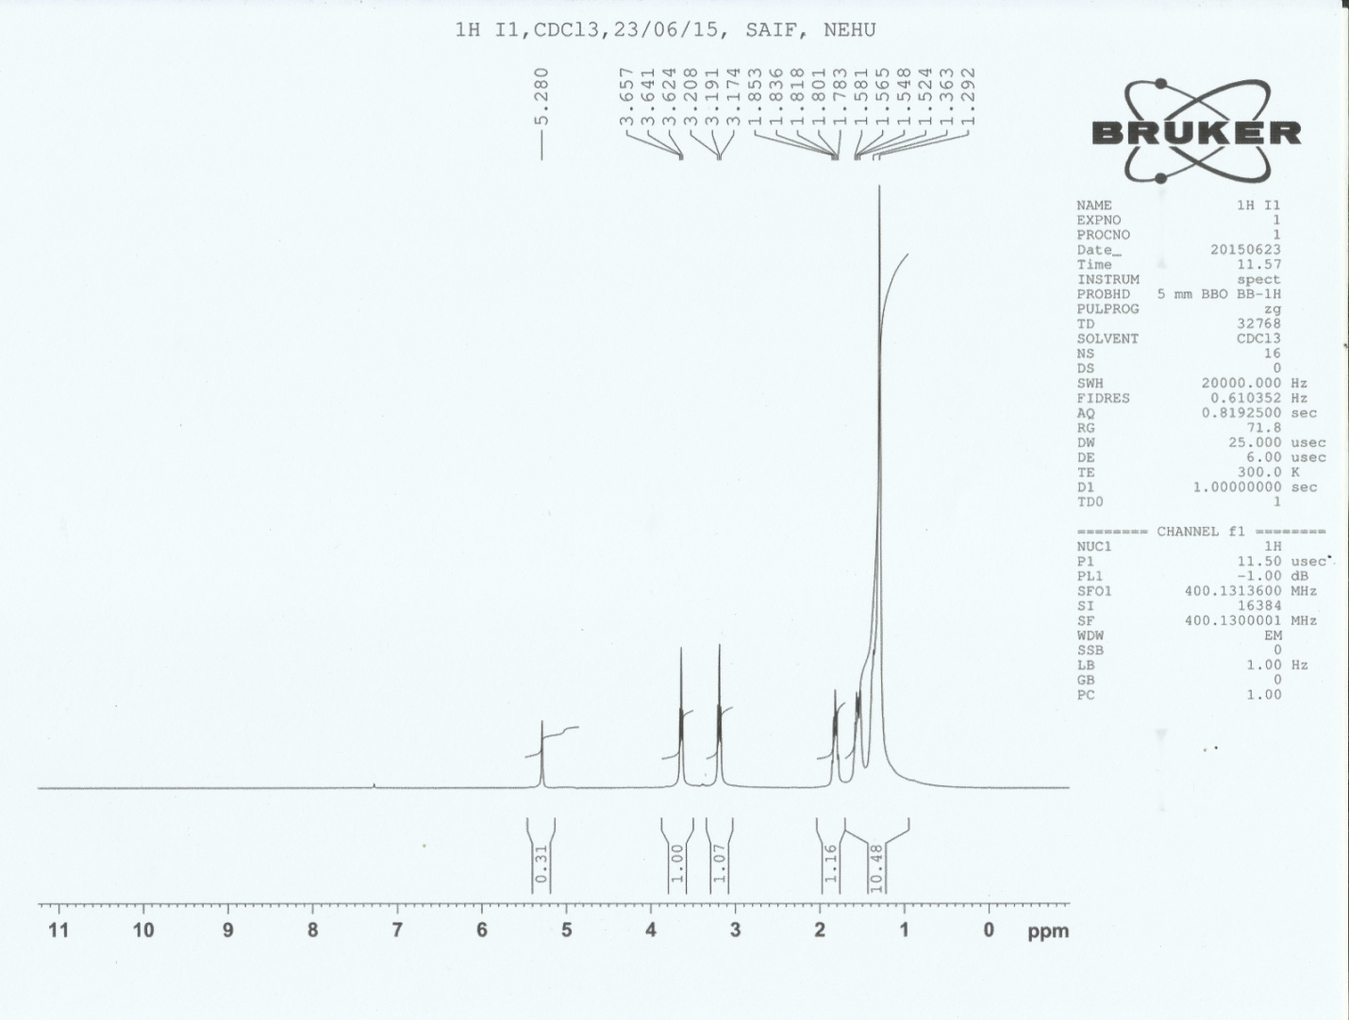
34
10-Iododecan-1-ol
Fig: ¹H-NMR spectra of 10-iododecan-1-ol, 34

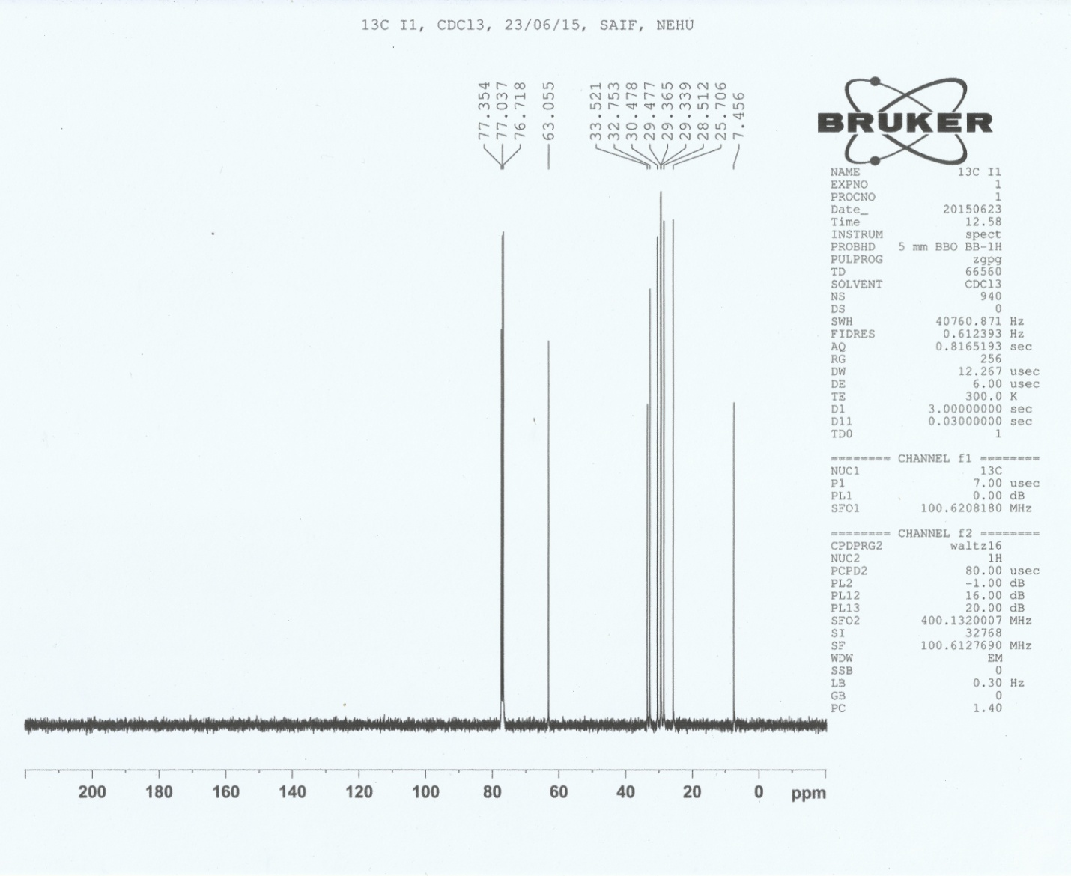
34
10-Iododecan-1-ol

Fig: ¹³C-NMR spectra of 10-iododecan-1-ol, 34

